**WORKSHEET 4**

**Student Name:** Vivek Kumar **UID:** 21BCS8129

**DOMAIN CAMP:** 16-01-2023 to 28-01-2023 **Section/Group:** DWWC-77

**Subject Name:** Database Management System

**Question1. Consider the following schema** Sample table: customer customer_id | customer_name | city | grade | salesman_id

-------------+----------------+------------+-------+------------- 3002 | Nick Rimando | New York | 100 | 5001

3007 | Brad Davis | New York | 200 | 5001

3005 | Graham Zusi | California | 200 | 5002

3008 | Julian Green | London | 300 | 5002

3004 | Fabian Johnson | Paris | 300 | 5006

3009 | Geoff Cameron | Berlin | 100 | 5003

3003 | Jozy Altidor | Moscow | 200 | 5007

3001 | Brad Guzan | London | 400 | 5005

Sample table: salesman

salesman_id | salesman_name | city | commision

-------------+------------+----------+------------

1. | James Hoog | New York | 0.15
2. | Nail Knite | Paris | 0.13
3. | Pit Alex | London | 0.11
4. | Mc Lyon | Paris | 0.14
5. | Paul Adam | Rome | 0.13

5003 | Lauson Hen | San Jose | 0.12

1. **Write a SQL statement to find the list of customers who appointed a salesman for their jobs who gets a commission from the company is more than 12%.**
2. **Write a SQL statement to find the list of customers who appointed a salesman for their jobs who does not live in the same city where their customer lives, and gets a commission is above 12%.**

**SOLUTION:**

CREATE TABLE CUSTOMER(CUSTOMER_ID NUMBER, CUSTOMER_NAME VARCHAR(20), CITY VARCHAR(20), GRADE NUMBER, SALESMAN_ID NUMBER);

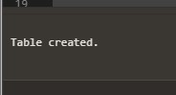

INSERT INTO CUSTOMER VALUES(3002,'CK RIMANDO','NEW YORK',100,5001);

INSERT INTO CUSTOMER VALUES(3007,'BRAD DAVIS','NEW YORK',200,5001);

INSERT INTO CUSTOMER VALUES(3005,'GRAHAM ZUSI','CALIFORNIA',200,5002);

INSERT INTO CUSTOMER VALUES(3008,'JULIAN GREEN','LONDON',300,5002);

INSERT INTO CUSTOMER VALUES(3004,'FABIAN JOHNSON','PARIS',300,5006);

INSERT INTO CUSTOMER VALUES(3009,'GEOFF CAMERON','BERLIN',100,5003);

INSERT INTO CUSTOMER VALUES(3003,'JOZY ALTIDOR','MOSCOW',200,5007); INSERT INTO CUSTOMER VALUES(3001,'BRAD GUZAN','LONDON',400,5005);

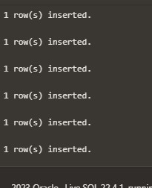

CREATE TABLE SALESMAN (SALESMAN_ID NUMBER, SALESMAN_NAME VARCHAR(20), CITY VARCHAR(20), COMMISION NUMBER);



INSERT INTO SALESMAN VALUES(5001,'JAMES HOOG','NEW YORK',0.15);

INSERT INTO SALESMAN VALUES(5002,'NAIL KNITE','PARIS',0.13);

INSERT INTO SALESMAN VALUES(5005,'PIT ALEX','LONDON',0.11);

INSERT INTO SALESMAN VALUES(5006,'MC LYON','PARIS',0.14);

INSERT INTO SALESMAN VALUES(5007,'PAUL ADAM','ROME',0.13);

INSERT INTO SALESMAN VALUES(5003,'LAUSON HEN ','SAN JOSE',0.12);



SELECT CUSTOMER.CUSTOMER_NAME AS "Customer Name", CUSTOMER.CITY,

SALESMAN.SALESMAN_NAME AS "Salesman", SALESMAN.COMMISION FROM CUSTOMER INNER JOIN

SALESMAN ON CUSTOMER.SALESMAN_ID=SALESMAN.SALESMAN_ID WHERE SALESMAN.COMMISION>.12;

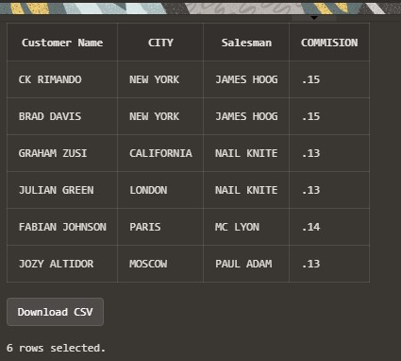

SELECT CUSTOMER.CUSTOMER_NAME AS "Customer Name", CUSTOMER.CITY,

SALESMAN.SALESMAN_NAME AS "Salesman", SALESMAN.CITY,SALESMAN.COMMISION FROM

CUSTOMER INNER JOIN SALESMAN ON CUSTOMER.SALESMAN_ID=SALESMAN.SALESMAN_ID WHERE

SALESMAN.COMMISION>.12 AND CUSTOMER.CITY<>SALESMAN.CITY;

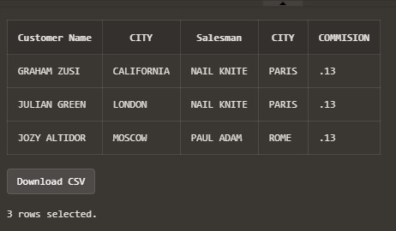

**Question3. Consider the following table structure** Sample table: customer customer_id | customer_name | city | grade | salesman_id

-------------+----------------+------------+-------+------------- 3002 | Nick Rimando | New York | 100 | 5001

3007 | Brad Davis | New York | 200 | 5001

3005 | Graham Zusi | California | 200 | 5002

3008 | Julian Green | London | 300 | 5002

3004 | Fabian Johnson | Paris | 300 | 5006

3009 | Geoff Cameron | Berlin | 100 | 5003

3003 | Jozy Altidor | Moscow | 200 | 5007

3001 | Brad Guzan | London | 400 | 5005

Sample table: salesman salesman_id | salesman_name | city | commision

-------------+------------+----------+------------ 5001 | James Hoog | New York | 0.15

5002 | Nail Knite | Paris | 0.13

1. | Pit Alex | London | 0.11
2. | Mc Lyon | Paris | 0.14
3. | Paul Adam | Rome | 0.13

5003 | Lauson Hen | San Jose | 0.12 Sample table: orders ord_no purch_amt ord_date customer_id salesman_id

---------- ---------- ---------- ----------- ----------- 70001 150.5 2012-10-05 3005 5002

70009 270.65 2012-09-10 3001 5005

70002 65.26 2012-10-05 3002 5001

70004 110.5 2012-08-17 3009 5003

70007 948.5 2012-09-10 3005 5002

70005 2400.6 2012-07-27 3007 5001

70008 5760 2012-09-10 3002 5001

70010 1983.43 2012-10-10 3004 5006

70003 2480.4 2012-10-10 3009 5003

70012 250.45 2012-06-27 3008 5002

70011 75.29 2012-08-17 3003 5007

**Write a SQL statement to make a report with customer name, city, order number, order date, order amount salesman name and commission to find that either any of the existing customers have placed no order or placed one or more orders by their salesman or by own.**

**SOLUTION:**

CREATE TABLE CUSTOMER(CUSTOMER_ID NUMBER, CUSTOMER_NAME VARCHAR(20), CITY VARCHAR(20), GRADE NUMBER, SALESMAN_ID NUMBER);



INSERT INTO CUSTOMER VALUES(3002,'NICK RIMANDO','NEW YORK',100,5001);

INSERT INTO CUSTOMER VALUES(3007,'BRAD DAVIS','NEW YORK',200,5001);

INSERT INTO CUSTOMER VALUES(3005,'GRAHAM ZUSI','CALIFORNIA',200,5002);

INSERT INTO CUSTOMER VALUES(3008,'JULIAN GREEN', 'LONDON',300,5002);

INSERT INTO CUSTOMER VALUES(3004,'FABIAN JOHNSON','PARIS',300,5006);

INSERT INTO CUSTOMER VALUES(3009,'GEOFF CAMERON','BERLIN',100,5003);

INSERT INTO CUSTOMER VALUES(3003,'JOZY ALTIDOR','MOSCOW',200,5007); INSERT INTO CUSTOMER VALUES(3001,'BRAD GUZAN','LONDON',400,5005);



CREATE TABLE SALESMAN (SALESMAN_ID NUMBER, SALESMAN_NAME VARCHAR(20), CITY VARCHAR(20), COMMISION NUMBER);



INSERT INTO SALESMAN VALUES(5001,'JAMES HOOG','NEW YORK',0.15);

INSERT INTO SALESMAN VALUES(5002,'NAIL KNITE','PARIS',0.13);

INSERT INTO SALESMAN VALUES(5005,'PIT ALEX','LONDON',0.11);

INSERT INTO SALESMAN VALUES(5006,'MC LYON','PARIS',0.14);

INSERT INTO SALESMAN VALUES(5007,'PAUL ADAM','ROME',0.13);

INSERT INTO SALESMAN VALUES(5003,'LAUSON HEN ','SAN JOSE',0.12);



Create Table orders(order_no number, purch_amt number(6,2), ord_date date, customer_id number, salesman_id number);



insert into orders values(70001, 150.5, to_date('18-05-2012', 'DD-MM-YYYY'),3005, 5002); insert into orders values(70009, 270.65, to_date('09-10-2012', 'DD-MM-YYYY'),3001, 5005); insert into orders values(70002, 65.26, to_date('10-05-2012', 'DD-MM-YYYY'),3002, 5001); insert into orders values(70004, 110.5,to_date( '18-08-2012', 'DD-MM-YYYY'),3009, 5003); insert into orders values(70007, 948.5, to_date('09-10-2012', 'DD-MM-YYYY'),3005, 5002); insert into orders values(70005, 2400.6,to_date( '27-07-2012', 'DD-MM-YYYY'),3007, 5001); insert into orders values(70008, 5760,to_date( '09-10-2012', 'DD-MM-YYYY'),3002, 5001); insert into orders values(70010, 1983.43,to_date( '10-10-2012','DD-MM-YYYY'), 3004, 5006); insert into orders values(70003, 2480.4, to_date('10-10-2012', 'DD-MM-YYYY'),3009, 5003); insert into orders values(70012, 250.45, to_date('27-06-2012', 'DD-MM-YYYY'),3008, 5002); insert into orders values(70011, 75.29, to_date('17-08-2012', 'DD-MM-YYYY'),3003, 5007); insert into orders values(70013, 3045.6,to_date( '25-04-2012', 'DD-MM-YYYY'),3002, 5001);



SELECT a.customer_name,a.city, b.order_no, b.ord_date,b.purch_amt AS "Order_Amount",

c.salesman_name,c.commision FROM customer a LEFT OUTER JOIN orders b ON a.customer_id=b.customer_id LEFT OUTER JOIN salesman c ON c.salesman_id=b.salesman_id;

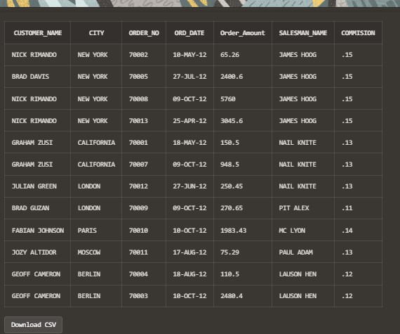

**Question4. For the given structure of following tables** Sample table: customer customer_id | customer_name | city | grade | salesman_id -------------+----------------+------------+-------+------------- 3002 | Nick Rimando | New York | 100 | 5001

3007 | Brad Davis | New York | 200 | 5001

3005 | Graham Zusi | California | 200 | 5002

3008 | Julian Green | London | 300 | 5002

3004 | Fabian Johnson | Paris | 300 | 5006

3009 | Geoff Cameron | Berlin | 100 | 5003

3003 | Jozy Altidor | Moscow | 200 | 5007

3001 | Brad Guzan | London | 400 | 5005

Sample table: salesman salesman_id | salesman_name | city | commision

-------------+------------+----------+------------ 5001 | James Hoog | New York | 0.15

5002 | Nail Knite | Paris | 0.13

1. | Pit Alex | London | 0.11
2. | Mc Lyon | Paris | 0.14
3. | Paul Adam | Rome | 0.13

5003 | Lauson Hen | San Jose | 0.12

Sample table: orders ord_no purch_amt ord_date customer_id salesman_id

---------- ---------- ---------- ----------- ----------- 70001 150.5 2012-10-05 3005 5002

70009 270.65 2012-09-10 3001 5005

70002 65.26 2012-10-05 3002 5001

70004 110.5 2012-08-17 3009 5003

70007 948.5 2012-09-10 3005 5002

70005 2400.6 2012-07-27 3007 5001

70008 5760 2012-09-10 3002 5001

70010 1983.43 2012-10-10 3004 5006

70003 2480.4 2012-10-10 3009 5003

70012 250.45 2012-06-27 3008 5002

70011 75.29 2012-08-17 3003 5007

**Write a SQL statement to make a list for all salesmen along with customer name, city, grade, order number, date, and amount. Condition for selecting list of salesmen : 1. Salesmen who works for one or more customer or, 2. Salesmen who not yet join under any customer, Condition for selecting list of customer : 3. placed one or more orders, or 4. no order placed to their salesman.**

**SOLUTION:**

CREATE TABLE CUSTOMER(CUSTOMER_ID NUMBER, CUSTOMER_NAME VARCHAR(20), CITY VARCHAR(20), GRADE NUMBER, SALESMAN_ID NUMBER);



INSERT INTO CUSTOMER VALUES(3002,'NICK RIMANDO','NEW YORK',100,5001);

INSERT INTO CUSTOMER VALUES(3007,'BRAD DAVIS','NEW YORK',200,5001);

INSERT INTO CUSTOMER VALUES(3005,'GRAHAM ZUSI','CALIFORNIA',200,5002);

INSERT INTO CUSTOMER VALUES(3008,'JULIAN GREEN', 'LONDON',300,5002);

INSERT INTO CUSTOMER VALUES(3004,'FABIAN JOHNSON','PARIS',300,5006);

INSERT INTO CUSTOMER VALUES(3009,'GEOFF CAMERON','BERLIN',100,5003);

INSERT INTO CUSTOMER VALUES(3003,'JOZY ALTIDOR','MOSCOW',200,5007); INSERT INTO CUSTOMER VALUES(3001,'BRAD GUZAN','LONDON',400,5005);



CREATE TABLE SALESMAN (SALESMAN_ID NUMBER, SALESMAN_NAME VARCHAR(20), CITY VARCHAR(20), COMMISION NUMBER);



INSERT INTO SALESMAN VALUES(5001,'JAMES HOOG','NEW YORK',0.15);

INSERT INTO SALESMAN VALUES(5002,'NAIL KNITE','PARIS',0.13);

INSERT INTO SALESMAN VALUES(5005,'PIT ALEX','LONDON',0.11);

INSERT INTO SALESMAN VALUES(5006,'MC LYON','PARIS',0.14);

INSERT INTO SALESMAN VALUES(5007,'PAUL ADAM','ROME',0.13);

INSERT INTO SALESMAN VALUES(5003,'LAUSON HEN ','SAN JOSE',0.12);



Create Table orders(order_no number, purch_amt number(6,2), ord_date date, customer_id number, salesman_id number);

 insert into orders values(70001, 150.5, to_date('18-05-2012', 'DD-MM-YYYY'),3005, 5002); insert into orders values(70009, 270.65, to_date('09-10-2012', 'DD-MM-YYYY'),3001, 5005); insert into orders values(70002, 65.26, to_date('10-05-2012', 'DD-MM-YYYY'),3002, 5001); insert into orders values(70004, 110.5,to_date( '18-08-2012', 'DD-MM-YYYY'),3009, 5003); insert into orders values(70007, 948.5, to_date('09-10-2012', 'DD-MM-YYYY'),3005, 5002); insert into orders values(70005, 2400.6,to_date( '27-07-2012', 'DD-MM-YYYY'),3007, 5001); insert into orders values(70008, 5760,to_date( '09-10-2012', 'DD-MM-YYYY'),3002, 5001); insert into orders values(70010, 1983.43,to_date( '10-10-2012','DD-MM-YYYY'), 3004, 5006); insert into orders values(70003, 2480.4, to_date('10-10-2012', 'DD-MM-YYYY'),3009, 5003); insert into orders values(70012, 250.45, to_date('27-06-2012', 'DD-MM-YYYY'),3008, 5002); insert into orders values(70011, 75.29, to_date('17-08-2012', 'DD-MM-YYYY'),3003, 5007); insert into orders values(70013, 3045.6,to_date( '25-04-2012', 'DD-MM-YYYY'),3002, 5001);



SELECT a.customer_name,a.city,a.grade, b.salesman_name AS "Salesman", c.order_no, c.ord_date, c.purch_amt FROM customer a RIGHT OUTER JOIN salesman b ON b.salesman_id=a.salesman_id RIGHT OUTER JOIN orders c ON c.customer_id=a.customer_id;

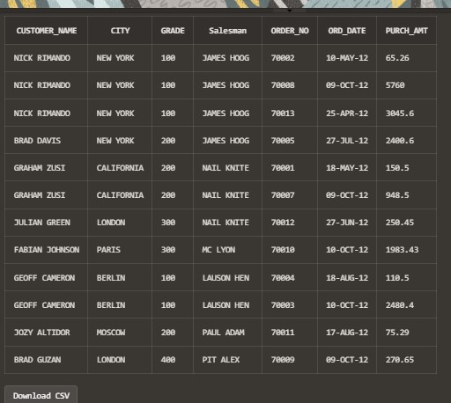

**Question5.** **Write a SQL statement to make a list for the salesmen who either work for one or more customers or yet to join any of the customer. The customer, may have placed, either one or more orders on or above order amount 2000 and must have a grade, or he may not have placed any order to the associated supplier. The database contains the following table** Sample table: customer customer_id | customer_name | city | grade | salesman_id

-------------+----------------+------------+-------+------------- 3002 | Nick Rimando | New York | 100 | 5001

3007 | Brad Davis | New York | 200 | 5001

3005 | Graham Zusi | California | 200 | 5002

3008 | Julian Green | London | 300 | 5002

3004 | Fabian Johnson | Paris | 300 | 5006

3009 | Geoff Cameron | Berlin | 100 | 5003

3003 | Jozy Altidor | Moscow | 200 | 5007

3001 | Brad Guzan | London | 400 | 5005

Sample table: salesman salesman_id | salesman_name | city | commision

-------------+------------+----------+------------ 5001 | James Hoog | New York | 0.15

5002 | Nail Knite | Paris | 0.13

1. | Pit Alex | London | 0.11
2. | Mc Lyon | Paris | 0.14
3. | Paul Adam | Rome | 0.13

5003 | Lauson Hen | San Jose | 0.12 Sample table: orders ord_no purch_amt ord_date customer_id salesman_id

---------- ---------- ---------- ----------- ----------- 70001 150.5 2012-10-05 3005 5002

70009 270.65 2012-09-10 3001 5005

70002 65.26 2012-10-05 3002 5001

70004 110.5 2012-08-17 3009 5003

70007 948.5 2012-09-10 3005 5002

70005 2400.6 2012-07-27 3007 5001

70008 5760 2012-09-10 3002 5001

70010 1983.43 2012-10-10 3004 5006

70003 2480.4 2012-10-10 3009 5003

70012 250.45 2012-06-27 3008 5002

70011 75.29 2012-08-17 3003 5007

**SOLUTION:**

CREATE TABLE CUSTOMER(CUSTOMER_ID NUMBER, CUSTOMER_NAME VARCHAR(20), CITY VARCHAR(20), GRADE NUMBER, SALESMAN_ID NUMBER);



INSERT INTO CUSTOMER VALUES(3002,'NICK RIMANDO','NEW YORK',100,5001);

INSERT INTO CUSTOMER VALUES(3007,'BRAD DAVIS','NEW YORK',200,5001);

INSERT INTO CUSTOMER VALUES(3005,'GRAHAM ZUSI','CALIFORNIA',200,5002);

INSERT INTO CUSTOMER VALUES(3008,'JULIAN GREEN', 'LONDON',300,5002);

INSERT INTO CUSTOMER VALUES(3004,'FABIAN JOHNSON','PARIS',300,5006);

INSERT INTO CUSTOMER VALUES(3009,'GEOFF CAMERON','BERLIN',100,5003);

INSERT INTO CUSTOMER VALUES(3003,'JOZY ALTIDOR','MOSCOW',200,5007); INSERT INTO CUSTOMER VALUES(3001,'BRAD GUZAN','LONDON',400,5005);



CREATE TABLE SALESMAN (SALESMAN_ID NUMBER, SALESMAN_NAME VARCHAR(20), CITY VARCHAR(20), COMMISION NUMBER);



INSERT INTO SALESMAN VALUES(5001,'JAMES HOOG','NEW YORK',0.15);

INSERT INTO SALESMAN VALUES(5002,'NAIL KNITE','PARIS',0.13);

INSERT INTO SALESMAN VALUES(5005,'PIT ALEX','LONDON',0.11);

INSERT INTO SALESMAN VALUES(5006,'MC LYON','PARIS',0.14);

INSERT INTO SALESMAN VALUES(5007,'PAUL ADAM','ROME',0.13);

INSERT INTO SALESMAN VALUES(5003,'LAUSON HEN ','SAN JOSE',0.12);



Create Table orders(order_no number, purch_amt number(6,2), ord_date date, customer_id number, salesman_id number);



insert into orders values(70001, 150.5, to_date('18-05-2012', 'DD-MM-YYYY'),3005, 5002); insert into orders values(70009, 270.65, to_date('09-10-2012', 'DD-MM-YYYY'),3001, 5005); insert into orders values(70002, 65.26, to_date('10-05-2012', 'DD-MM-YYYY'),3002, 5001); insert into orders values(70004, 110.5,to_date( '18-08-2012', 'DD-MM-YYYY'),3009, 5003); insert into orders values(70007, 948.5, to_date('09-10-2012', 'DD-MM-YYYY'),3005, 5002); insert into orders values(70005, 2400.6,to_date( '27-07-2012', 'DD-MM-YYYY'),3007, 5001); insert into orders values(70008, 5760,to_date( '09-10-2012', 'DD-MM-YYYY'),3002, 5001); insert into orders values(70010, 1983.43,to_date( '10-10-2012','DD-MM-YYYY'), 3004, 5006); insert into orders values(70003, 2480.4, to_date('10-10-2012', 'DD-MM-YYYY'),3009, 5003); insert into orders values(70012, 250.45, to_date('27-06-2012', 'DD-MM-YYYY'),3008, 5002); insert into orders values(70011, 75.29, to_date('17-08-2012', 'DD-MM-YYYY'),3003, 5007); insert into orders values(70013, 3045.6,to_date( '25-04-2012', 'DD-MM-YYYY'),3002, 5001);



SELECT a.customer_name,a.city,a.grade, b.salesman_name AS "Salesman", c.order_no, c.ord_date, c.purch_amt FROM customer a RIGHT OUTER JOIN salesman b ON b.salesman_id=a.salesman_id LEFT OUTER JOIN orders c ON c.customer_id=a.customer_id WHERE c.purch_amt>=2000 AND a.grade IS NOT NULL;

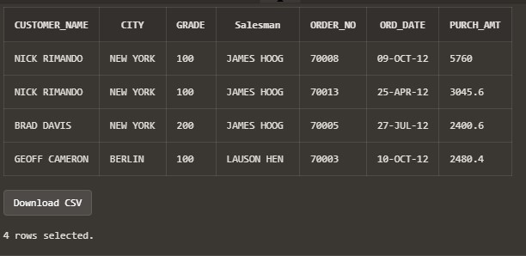

**Q11. Write a query to create a view for those salesmen belongs to the city New York. Sample table: salesman**

salesman_id | name | city | commission -------------+------------+----------+------------ 5001 | James Hoog | New York | 0.15

5002 | Nail Knite | Paris | 0.13

1. | Pit Alex | London | 0.11
2. | Mc Lyon | Paris | 0.14
3. | Paul Adam | Rome | 0.13

5003 | Lauson Hen | San Jose | 0.12

**SOLUTION:**

CREATE TABLE SALESMAN(SALESMAN_ID NUMBER, NAME VARCHAR(20), CITY VARCHAR(20), COMMISSION NUMBER);

INSERT INTO SALESMAN VALUES(5001, 'JAMES HOOG', 'NEW YORK', 0.15);

INSERT INTO SALESMAN VALUES(5002, 'NAIL KNITE', 'PARIS', 0.13);

INSERT INTO SALESMAN VALUES(5005, 'PIT ALEX', 'LONDON', 0.11);

INSERT INTO SALESMAN VALUES(5006, 'MC LYON', 'PARIS', 0.14);

INSERT INTO SALESMAN VALUES(5007, 'PAUL ADAM', 'ROME', 0.13);

INSERT INTO SALESMAN VALUES(5003, 'LAUSON HEN', 'SAN JOSE', 0.12);

CREATE VIEW PARIS_SALESMAN AS SELECT * FROM SALESMAN WHERE CITY='PARIS'; SELECT * FROM PARIS_SALESMAN;

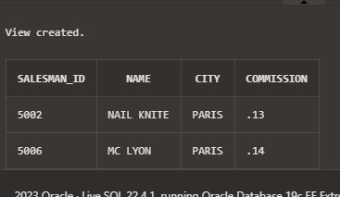

**Question12. Write a query to create a view for all salesmen with columns salesman_id, name, and city. Sample table: salesman**

salesman_id | name | city | commission -------------+------------+----------+------------ 5001 | James Hoog | New York | 0.15

5002 | Nail Knite | Paris | 0.13

1. | Pit Alex | London | 0.11
2. | Mc Lyon | Paris | 0.14
3. | Paul Adam | Rome | 0.13

5003 | Lauson Hen | San Jose | 0.12

**SOLUTION:**

CREATE TABLE SALESMAN(SALESMAN_ID NUMBER, NAME VARCHAR(20), CITY VARCHAR(20), COMMISSION NUMBER);

INSERT INTO SALESMAN VALUES(5001, 'JAMES HOOG', 'NEW YORK', 0.15);

INSERT INTO SALESMAN VALUES(5002, 'NAIL KNITE', 'PARIS', 0.13);

INSERT INTO SALESMAN VALUES(5005, 'PIT ALEX', 'LONDON', 0.11);

INSERT INTO SALESMAN VALUES(5006, 'MC LYON', 'PARIS', 0.14);

INSERT INTO SALESMAN VALUES(5007, 'PAUL ADAM', 'ROME', 0.13);

INSERT INTO SALESMAN VALUES(5003, 'LAUSON HEN', 'SAN JOSE', 0.12);

CREATE VIEW DETAILS_SALESMAN AS SELECT SALESMAN_ID, NAME, CITY FROM SALESMAN; SELECT * FROM DETAILS_SALESMAN;

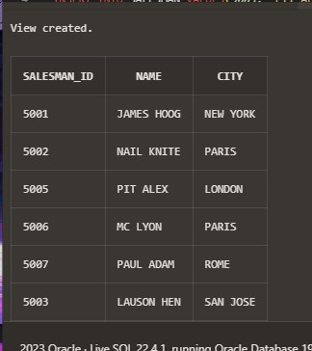

**Question13. Write a query to find the salesmen of the city New York who achieved the commission more than 13%.**

**Sample table: salesman**

salesman_id | name | city | commission -------------+------------+----------+------------ 5001 | James Hoog | New York | 0.15

5002 | Nail Knite | Paris | 0.13

1. | Pit Alex | London | 0.11
2. | Mc Lyon | Paris | 0.14
3. | Paul Adam | Rome | 0.13

5003 | Lauson Hen | San Jose | 0.12

**SOLUTION:**

CREATE TABLE SALESMAN(SALESMAN_ID NUMBER, NAME VARCHAR(20), CITY VARCHAR(20), COMMISSION NUMBER);

INSERT INTO SALESMAN VALUES(5001, 'JAMES HOOG', 'NEW YORK', 0.15);

INSERT INTO SALESMAN VALUES(5002, 'NAIL KNITE', 'PARIS', 0.13);

INSERT INTO SALESMAN VALUES(5005, 'PIT ALEX', 'LONDON', 0.11);

INSERT INTO SALESMAN VALUES(5006, 'MC LYON', 'PARIS', 0.14);

INSERT INTO SALESMAN VALUES(5007, 'PAUL ADAM', 'ROME', 0.13);

INSERT INTO SALESMAN VALUES(5003, 'LAUSON HEN', 'SAN JOSE', 0.12);

CREATE VIEW NEWYORK_SALESMAN AS SELECT * FROM SALESMAN WHERE CITY='NEW YORK' AND COMMISSION>.13;

SELECT * FROM NEWYORK_SALESMAN;

