**WORKSHEET 5**

**Student Name:** Vivek Kumar **UID:** 21BCS8129

**DOMAIN CAMP:** 16-01-2023 to 28-01-2023 **Section/Group:** DWWC-77

**Subject Name:** Database Management System

**1. PL/SQL program to check whether a number is positive, negative or zero.**

DECLARE

num1 NUMBER := 6;

BEGIN

IF num1 < 0 THEN

DBMS_OUTPUT.PUT_LINE ('The number '||num1||' is a negative number');

ELSIF num1 = 0 THEN

DBMS_OUTPUT.PUT_LINE ('The number '||num1||' is equal to zero');

ELSE

DBMS_OUTPUT.PUT_LINE ('The number '||num1||' is a positive number');

END IF;

END;

/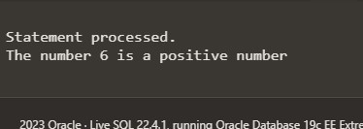

**2. Write a program in PL/SQL to print the prime numbers between 1 to 50**

DECLARE

i NUMBER(3);

j NUMBER(3);

BEGIN

DBMS_OUTPUT.PUT_LINE('The prime numbers are:');

i := 2;

LOOP

j := 2;

LOOP EXIT WHEN( ( MOD(i, j) = 0 ) OR ( j = i ) );

j := j + 1;

END LOOP;

IF( j = i )THEN

DBMS_OUTPUT.PUT_LINE(i||' ');

END IF;

i := i + 1;

EXIT WHEN i = 50;

END LOOP;

END;

/

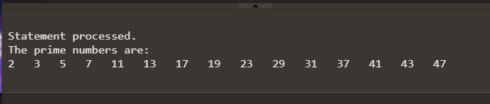

**3. Write a PL/SQL program for implementing while loop**

DECLARE

VAR1 NUMBER;

VAR2 NUMBER;

BEGIN

VAR1:=200;

VAR2:=1;

WHILE (VAR2<=10)

LOOP

DBMS_OUTPUT.PUT_LINE (VAR1*VAR2);

VAR2:=VAR2+1;

END LOOP;

END;

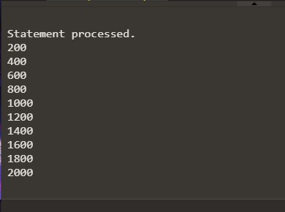

**4. Write a program in PL/SQL to print 1st n numbers with a difference of 3 and starting from 1.**

DECLARE

n number:= 20;

i number:=1;

m number:=1;

BEGIN

DBMS_OUTPUT.PUT_LINE ('The first '||n||' numbers are: ');

DBMS_OUTPUT.PUT_LINE (i||' ');

FOR i IN 1..n-1 LOOP

m:=m+3;

DBMS_OUTPUT.PUT_LINE(m||' ');

END LOOP;

END;

/

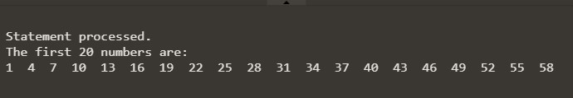

**5. Program of cursor to fetch id, name and address from customers table.**

create table Employees(E_id number, Name Varchar(20), Age number, Address Varchar(15), Salary number);

insert into Employees values(1,'Sam',23,'Allahabad',20000); insert into Employees values(2,'Mac',22,'Kanpur',22000); insert into Employees values(3,'Anna',24,'Noida',24000); insert into Employees values(4,'James',25,'Delhi',28000); insert into Employees values(5,'David',20,'Chandigarh',30000);

DECLARE

e_id Employees.E_id%type;

e_name Employees.Name%type;

e_addr Employees.Address%type;

CURSOR e_Employees IS SELECT E_id, Name, Address FROM Employees;

BEGIN

OPEN e_Employees;

LOOP

FETCH e_Employees INTO e_id, e_name, e_addr;

EXIT WHEN e_Employees%notfound;

DBMS_OUTPUT.PUT_LINE(e_id || ' ' || e_name || ' ' || e_addr);

END LOOP;

CLOSE e_Employees;

END;

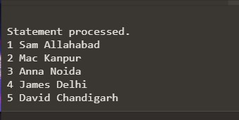

**6. Write a program in PL/SQL to retrieve the records from the employees table and display them using cursors**.

create table Employees(E_id number, Name Varchar(20), Age number, Address Varchar(15), Salary number);

insert into Employees values(1,'Sam',23,'Allahabad',20000); insert into Employees values(2,'Mac',22,'Kanpur',22000); insert into Employees values(3,'Anna',24,'Noida',24000); insert into Employees values(4,'James',25,'Delhi',28000); insert into Employees values(5,'David',20,'Chandigarh',30000);

DECLARE

e_id Employees.E_id%type;

e_name Employees.Name%type;

e_addr Employees.Address%type;

e_sal Employees.Salary%type;

CURSOR e_Employees IS SELECT E_id, Name, Address, Salary FROM Employees;

BEGIN

OPEN e_Employees;

LOOP

FETCH e_Employees INTO e_id, e_name, e_addr, e_sal;

EXIT WHEN e_Employees%notfound;

DBMS_OUTPUT.PUT_LINE(e_id || ' ' || e_name || ' ' || e_addr || ' ' || e_sal);

END LOOP;

CLOSE e_Employees;

END;

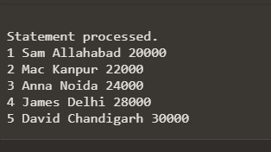

**7. Write a program in PL/SQL to FETCH single record and single column from a table.**

create table Employees(E_id number, Name Varchar(20), Age number, Address Varchar(15), Salary number);

insert into Employees values(1,'Sam',23,'Allahabad',20000); insert into Employees values(2,'Mac',22,'Kanpur',22000); insert into Employees values(3,'Anna',24,'Noida',24000); insert into Employees values(4,'James',25,'Delhi',28000); insert into Employees values(5,'David',20,'Chandigarh',30000);

DECLARE

emp_name VARCHAR2(50);

CURSOR Employees_name IS SELECT name FROM Employees WHERE Address = 'Chandigarh';

BEGIN

OPEN Employees_name;

FETCH Employees_name INTO emp_name;

DBMS_OUTPUT.PUT_LINE('The name of the customer is: ' || emp_name);

CLOSE Employees_name;

END;

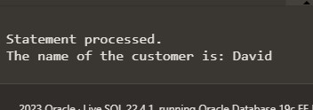

**8. Write a program in PL/SQL to FETCH more than one record and single column from a table.**

create table Employees(E_id number, Name Varchar(20), Age number, Address Varchar(15), Salary number); insert into Employees values(1,'Sam',23,'Allahabad',20000); insert into Employees values(2,'Mac',22,'Kanpur',22000); insert into Employees values(3,'Anna',24,'Noida',24000); insert into Employees values(4,'James',25,'Delhi',28000); insert into Employees values(5,'David',20,'Chandigarh',30000);

DECLARE

emp_name VARCHAR2(50); CURSOR Employees_name IS

SELECT name

FROM Employees;

BEGIN

OPEN Employees_name;

LOOP

FETCH Employees_name

INTO emp_name;

EXIT

WHEN Employees_name%NOTFOUND;

dbms_output.put_line('The name of the customer is: ' || emp_name);

END LOOP;

CLOSE Employees_name;

END;

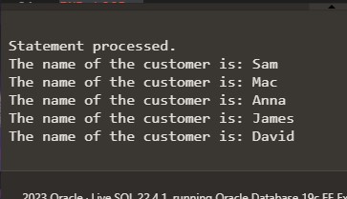

**9. Write a program in PL/SQL to FETCH multiple records and more than one column.**

create table Employees(E_id number, Name Varchar(20), Age number, Address Varchar(15), Salary number); insert into Employees values(1,'Sam',23,'Allahabad',20000); insert into Employees values(2,'Mac',22,'Kanpur',22000); insert into Employees values(3,'Anna',24,'Noida',24000); insert into Employees values(4,'James',25,'Delhi',28000); insert into Employees values(5,'David',20,'Chandigarh',30000);

DECLARE

emp_rec Employees%ROWTYPE;

CURSOR Employees_name IS

SELECT *

FROM Employees;

BEGIN

OPEN Employees_name;

LOOP

FETCH Employees_name

INTO emp_rec;

EXIT

WHEN Employees_name%NOTFOUND;

dbms_output.put_line('The name of the customer is: ' || emp_rec.name || ' Salary: '|| emp_rec.salary);

END LOOP;

CLOSE Employees_name;

END;

