A Project Report

On

**" Virtual Mouse "**

By

|  |  |
| --- | --- |
| Miss. Rutuja Shivaji Bhawar  Miss.Vishakha Dayanand Patil | 232705  232704 |
| Miss. Aditi Ajay Jagdale  Mr. Vinay Mahadev Patil | 221367  232700 |
| Mr. Vinay Nitin Khule. | 221204 |

Guide

**Prof. Anushka Joshi**



DEPARTMENT OF Computer ENGINEERING

**SRT’s**

#### SRTTC Campus

[2023-24]

**SRT’s**

### SRTTC Campus



[2023-24]

## C E R T I F I C A T E

This is to certify that **Miss Rutuja Shivaji Bhawar** has successfully completed the Project entitled **“Virtual Mouse**” under my supervision and Guidance in the Computer Engineering Department in academic year 2023-24 in the partial fulfillment of Engineering in AIDS Engineering offered by SPPU.

|  |  |  |
| --- | --- | --- |
| **Prof.**  **Anushka Joshi** | **Prof.**  **Anjali More** | **Prof.**  **J.B.Sankpal** |
|  |  |  |
| (Project Guide) | (HOD) | (Principal) |

**Internal Examiner External Examiner**

Date: Place: Pune

## SRT’s

**SRTTC Campus**



[2023-24]

## C E R T I F I C A T E

This is to certify that **Miss. Vishakha Dayanand Patil** has successfully completed the Project entitled **“Virtual Mouse**” under my supervision and Guidance in the AIDS Engineering Department in academic year 2023-24 in the partial fulfillment of Engineering in AIDS Engineering offered by SPPU.

**Prof. Prof. Prof.**

**Anushka Anjali More J.B.Sankpal**

**Joshi**

(Project

Guide) (HOD) (Principal)

**Internal Examiner External Examiner**

Date: Place: Pune

## SRT’s

**SRTTC Campus**



[2023-24]

## C E R T I F I C A T E

This is to certify that **Miss. Aditi Ajay Jagdale** is successfully completed the Project entitled **“Virtual Mouse**” under my supervision and Guidance in the AIDS Engineering Department in academic year 2023- 24 in the partial fulfillment of Engineering in AIDS Engineering offered by SPPU.

|  |  |  |
| --- | --- | --- |
| **Prof. Anushka Joshi** | **Prof.**  **Anjali More** | **Prof.**  **J.B.Sankpal** |
|  |  |  |
| (Project Guide) | (HOD) | (Principal) |

**Internal Examiner External Examiner**

Date: Place: Pune

## SRT’s

**SRTTC Campus**



[2023-24]

## C E R T I F I C A T E

This is to certify that **Mr Vinay Nitin khule** is successfully completed the Project entitled **“Virtual Mouse**” under my supervision and Guidance in the AIDS Engineering Department in academic year 2023- 24 in the partial fulfillment of Engineering in AIDS Engineering offered by SPPU.

|  |  |  |
| --- | --- | --- |
| **Prof. Anushka Joshi** | **Prof.**  **Anjali More** | **Prof.**  **J.B.Sankpal** |
|  |  |  |
| (Project Guide) | (HOD) | (Principal) |

**Internal Examiner External Examiner**

Date: Place: Pune

**SRT’s**

## SRTTC Campus



[2023-24]

## C E R T I F I C A T E

This is to certify that **Mr.Vinay Mahadev Patil** has successfully completed the Project entitled **“Virtual Mouse**” under my supervision and Guidance in the AIDS Engineering Department in academic year 2023-24 in the partial fulfillment of Engineering in AIDS Engineering offered by SPPU.

|  |  |  |
| --- | --- | --- |
| **Prof.**  **Anushka**  **Joshi** | **Prof.**  **Anjali More** | **Prof.**  **J.B.Sankpal** |
| (Project  Guide) | (HOD) | (Principal) |
| **Internal Examiner**  Date: |  | **External Examiner**  Place: Pune |

#### ACKNOWLEDGEMENT

I take this opportunity with awesome delight to express my profound feeling of appreciation towards our regarded control **Prof. Anushka Joshi** for her significant direction and unremitting support and co- operation reached out to us amid this Project work.

We might likewise want to express gratitude toward **Prof. Anjali More** (HOD Computer Engineering) and **Prof. J.B.Sankpal** (Principal SRT’s SRTTC Engineering , Pune) for their resolute help, support and participation amid the venture work.

I am likewise grateful to all the showing staff and non teaching staff of SRTTC Engineering , Pune for giving all departmental offices to this venture work and their opportunity to time profitable direction.

**Miss Rutuja Shivaji Bhawar**

**Miss Vishakha Dayanand Patil**

**Miss.Aditi Ajay Jagdale**

**Mr.Vinay Mahadev Patil**

**Mr. Vinay Nitin Khule.**

|  |  |  |  |
| --- | --- | --- | --- |
|  | | **Index** | |
| **Chapter 1** | | | |
|  | | **Introduction…………………….…….**   * 1. Abstract   2. Topic Introduction   3. Concept | |
| **Chapter 2** | |  | |
|  | | **Literature Survey…………………….**  2.1 Literature Survey | |
| **Chapter 3** | | **Objectives………….……...………....**  3.1 Objectives | |
| **Chapter 4** | | **Use Case Diagram** | |
| **Chapter 5** | | **Data Flow Datagram** | |
| **Chapter 6** | | **Future Scope** | |
| **Chapter 7** | | **Advantage & Disadvantage.** | |
| **Chapter 8**  **Chapter 9** | | **Resource Used.**  **Conclusion………………….** | |

### INTRODUCTION:

A Computer Mouse is an input device that helps to point and to interact with whatever that is being pointed. No Matter how much the accuracy of the mouse increases but there will always be limitations of the mouse as the mouse is a hardware input device and there can be some problems like mouse click not functioning properly and etc., as the mouse is a hardware device like any other physical object even the mouse will have a durability time within which is functional and after its durability time we have to change the mouse. As the technology increase everything becomes virtualized such as speech recognition.

Speech Recognition is used for recognition and translation of the spoken language into text. Thus, Speech Recognition can replace keyboards in the future, Similarly Eye Tracking which is used to control the mouse pointer with the help of our eye. Eye Tracking can replace mouse in the future.

**Literature survey**

The major aspect in today’s e-learning is the improvement in the methods of teaching by using technology dependent resourceful products to have a better communication and interaction between the teacher and the student. In favor of this, we have proposed a product which aims to be a virtual marker and also has additional advantage that it has features of a Mouse incorporated into it. The existing Virtual Marker is modified to function more than a marker and act as a mouse pointer also giving it the advantage of all the functionality of a mouse. In this paper, we have proposed a hardware implementation of a Virtual Mouse which has an improvement in performance of the existing “Virtual Marker” by making it highly responsive in real time. Key Words: Virtual Marker, Virtual Mouse,

**RESOURCES REQUIRED**

|  |  |  |  |
| --- | --- | --- | --- |
| **Sr.No.** | **Hardware** | **Software** | Language |
| 1. | Intel core i5  windows 10pro 64bit 8gb Ram  1TB | PyCharm | Python |

# 

# Objectives

Hand Gesture Recognition plays a key role in human-computer interactions. As we can see that there are so many new Technological advancements happening such as biometric authentication which we can see frequently in our smart phones, similarly hand gesture recognition is a modern way of humancomputer interaction i.e.,

we can control our system by showing our hands in front of webcam and hand gesture recognition can be useful for all kinds of people. Based upon this idea this paper is presented. This paper provides a detailed explanation to the algorithms and methodologies for the color detection and virtual mouse

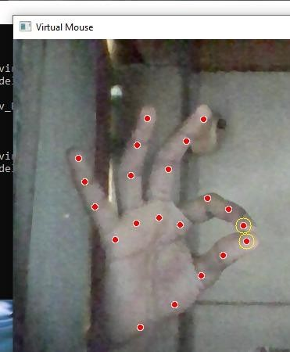**Result**

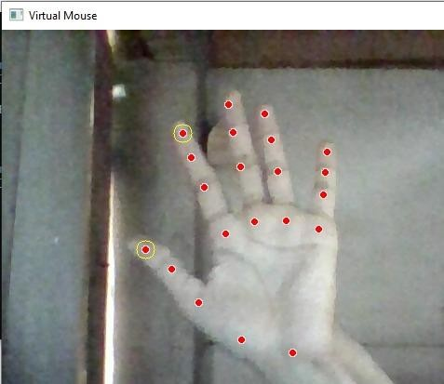

**Future scope :**

The development of these techniques and models are really vast. The color detection model can be developed if we want to identify a particular color out of a colored photo. And the mouse movement can be developed in such a way it can act like a real mouse that will help us for using system without even touching the system’s keyboard or mouse. The development can be in such a way it can be training on CNN’s that will help for a better performed model.

The Models can be developed in different ways by using some latest packages like ‘pyautoGUI’ that will help us to give commands which will identify an input and perform some function on the system. So if any separate color is detected it can perform special function or if an input from user is detected it will open any specific folder with ease without performing any actions, a simple gesture can do the job

**ADVANTAGES AND DISADVANTAGES**

**ADVANTAGES:-**

* It is a digital and virtual assistant with artificial intelligence
* System’s webcam is used for tracking hand gestures.
* Secure.
* It is very flexible and useful technology

**DISADVANTAGES:-**

* There will always be limitations of the mouse as the mouse is a hardware input device and there can be some problems like mouse click not functioning properly.
* the mouse is a hardware device like any other physical object even the mouse will have a durability time within which is functional

# PURPOSE:

As the technology increase everything becomes virtualized such as speech recognition. Speech Recognition is used for recognition and translation of the spoken language into text. Thus, Speech Recognition can replace keyboards in the future, Similarly Eye Tracking which is used to control the mouse pointer with the help of our eye. Eye Tracking can replace mouse in the future.

Gestures can be in any form like hand image or pixel image or any human given pose that require less computational difficulty or power for making the devices required for the recognitions to make work. Different techniques are being proposed by the companies for gaining necessary information/data for recognition handmade gestures recognition models. Some models work with special devices such as data glove devices and color caps to develop complex information about gesture provided by the user/human.

**Conclusion**

This model can conclude by using the topics of computer vision like open CV, it can form masks that can variate colors by using color variation techniques and also development of mouse movement by using certain packages like ‘mouse’ which will be used for the movement of mouse by using the coordinates that are linked to the detected color. This can provide ease use of systems and many other applications. So the open CV is helping the users with different accessible forms of models that will make ease life.