Created two VMs in AWS consoe

1. Jenkins+Ansible
2. Web server-apache

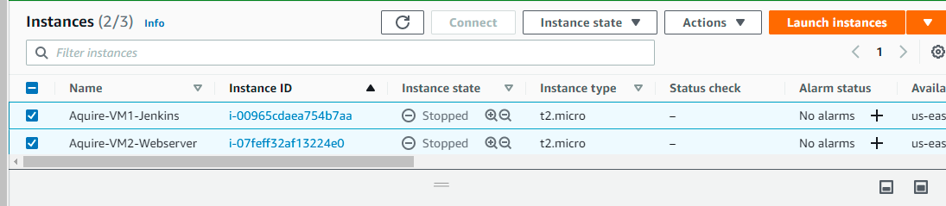

Here is the flow

When user commit on a git (branch) -🡪 Jenkins will clone the repo, get the index.html -🡪 Share it with Ansible 🡪 Ansible will push this file to webserver -🡪 webserver where app is running.

Ansible installed in Jenkins, will push file to web server

Jenkins clone the repo and copy the index.html to location where ansible can access

Webserver where application hosted

Every commit on git

When user commit a document: (Specially index.html)

@git

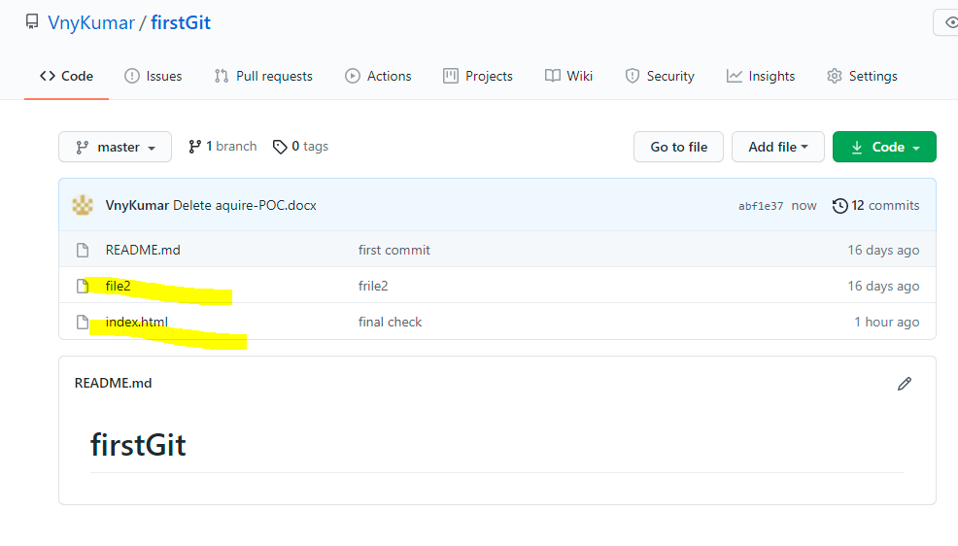

@index.html

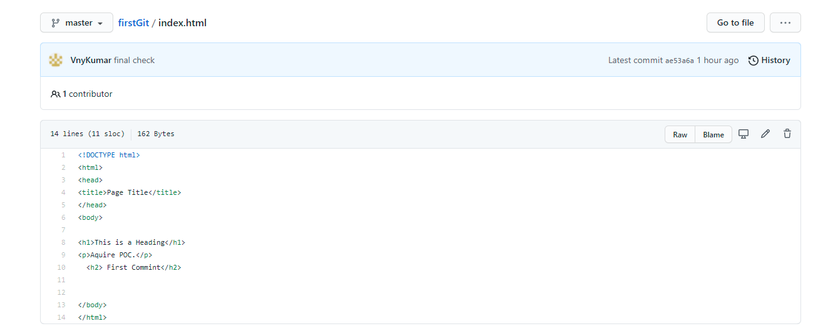

@jenkins:

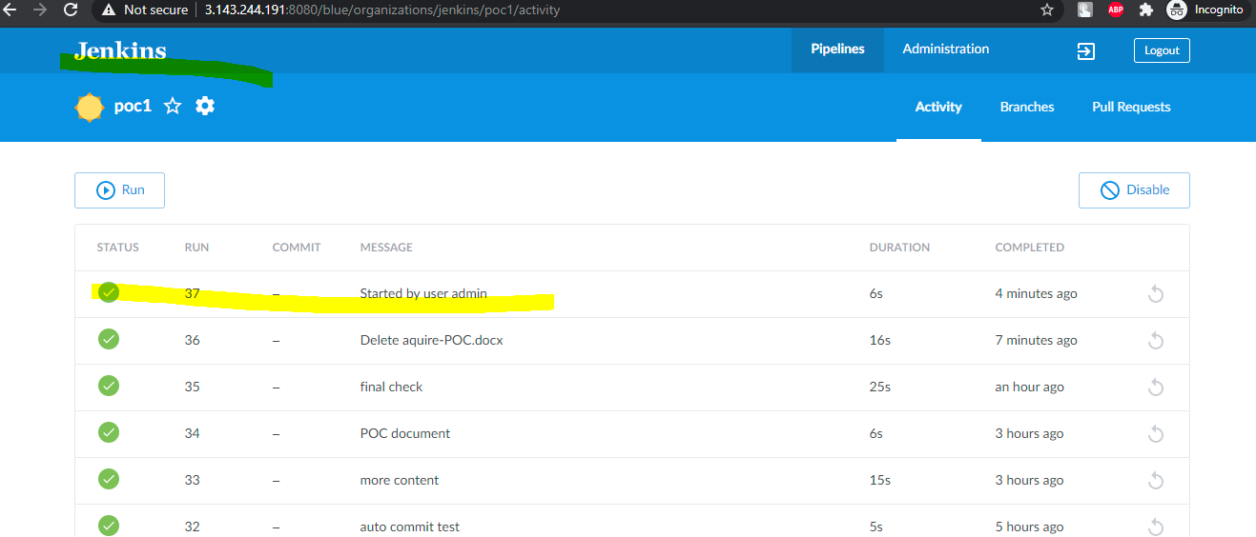

@webserver:

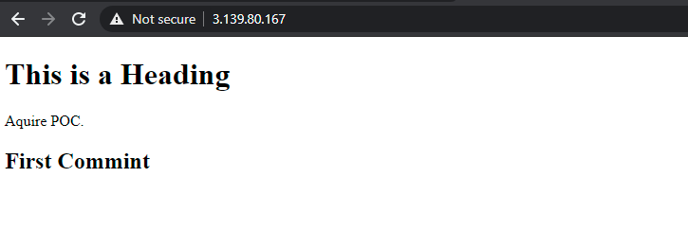

Now will do some changes in index.html, will auto trigger build 38

*Index.html*

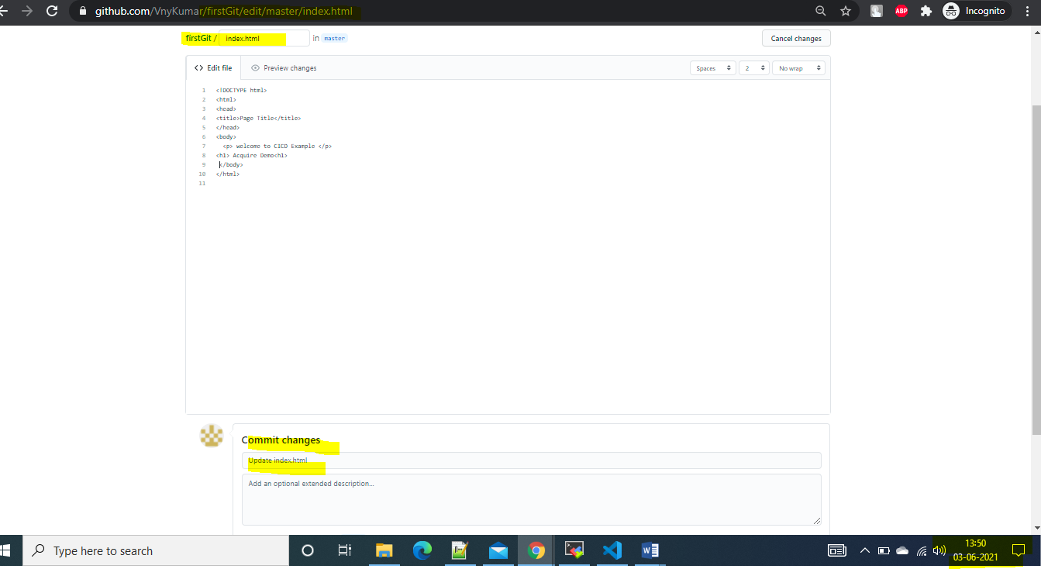

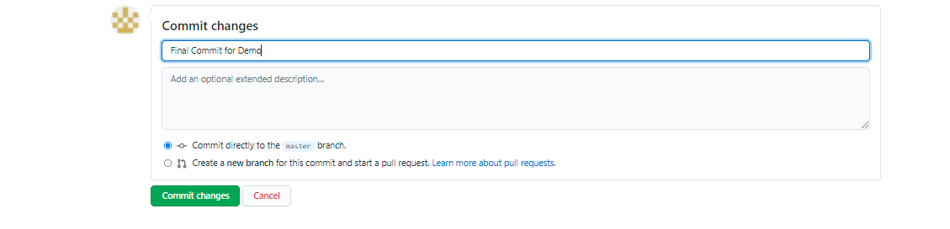

@jenkins,

Job started.

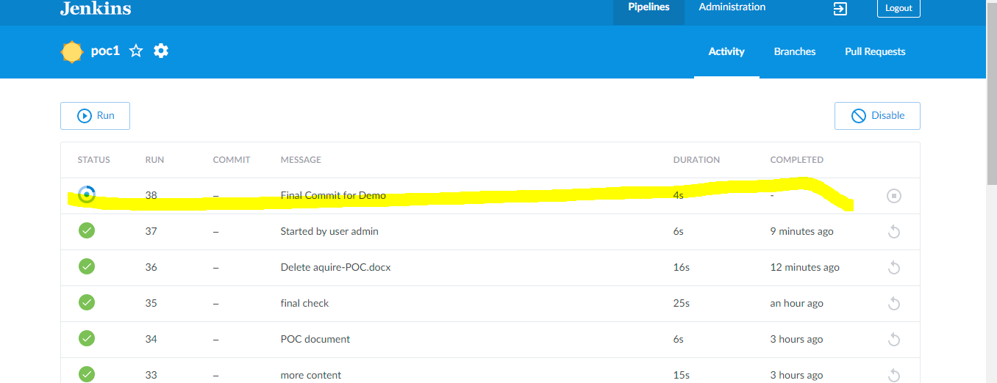

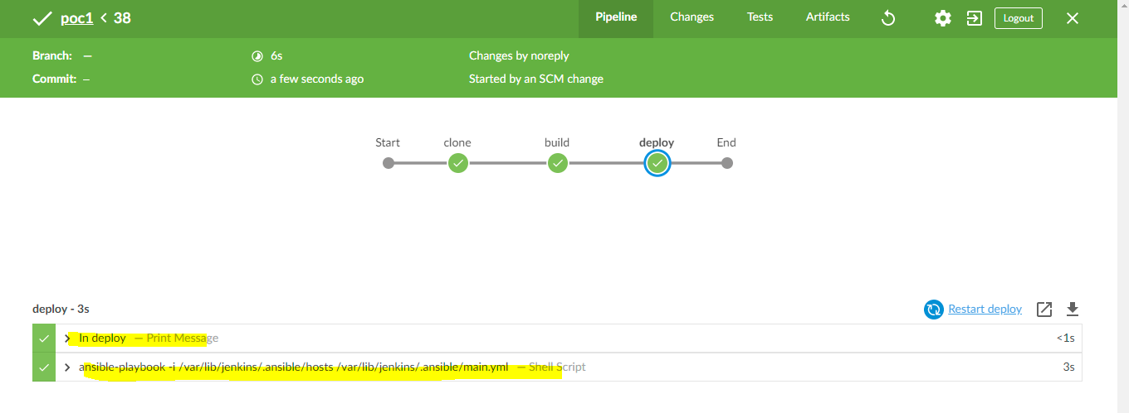

Now at webserver:

