Once jenkins is installed,,

8641ffb6997d4e448952015739101c26

f4b0bd804ce342689153283b086fb3d9

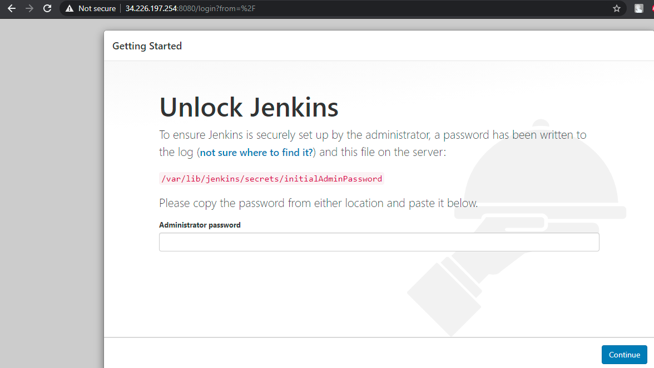

IF required we can create users here and can change default port,

