Mini E-commerce DevOps Platform
Architecture Description & Design Decisions
AWS ap-southeast-1 | EKS + GitOps + CI/CD + Observability

1. Project Overview
This document describes the architecture of the Mini E-commerce DevOps Platform, a portfolio project demonstrating end-to-end DevOps practices on AWS. The platform wraps the Google Online Boutique microservices application (happy-path services only) with a production-grade DevOps foundation.

Primary goal: Demonstrate Cloud/DevOps Intern capabilities — IaC, CI/CD, GitOps, observability, secrets management, and supply-chain security — using AWS as the ephemeral deployment target.

Ephemeral model: AWS resources are created before a demo and destroyed with terraform destroy afterwards. Monthly cost only applies while running (~$200/month).

Dimension | Technology
Cloud Provider | AWS ap-southeast-1 (Singapore)
IaC | Terraform >= 1.5 (modules)
Container Orchestration | Kubernetes EKS v1.30
CI/CD | GitHub Actions + OIDC (no static keys)
GitOps | Argo CD + Kustomize (2-repo model)
Observability | Prometheus, Grafana, CloudWatch
Secrets | AWS Secrets Manager + External Secrets Operator
Supply-chain Security | Trivy (image scan), Checkov (IaC), cosign + SBOM
App Languages | Go, C# .NET, Node.js, Python (gRPC)

2. Architecture Diagrams
The architecture is documented across two complementary diagrams, each answering a different question:

Diagram | Answers | File
Logical Architecture | What services exist? How do requests flow? How does CI/CD, GitOps, and secrets work? | architecture-diagram.png
Network Topology | Where do resources sit in the VPC? How does traffic enter and exit? Which subnets are public vs private? | architecture-network.png

2.1 Logical Architecture Diagram
The logical diagram uses color-coded arrows to distinguish four concurrent flows. Readers should follow arrows by number within each flow.

Color | Flow | Numbering | Description
Blue | Runtime Request Path | 1 -> 5 | End user HTTP request through ALB, Ingress, Service, frontend pod, then gRPC calls to backend services
Purple | Service Mesh | (no number) | Internal synchronous gRPC calls between microservices and Redis TCP connection
Pink | CI/CD Pipeline | A -> F | Developer git push triggers GitHub Actions: build image, sign, push to ECR, open image-bump PR
Green | GitOps Sync | (A -> F cont.) | Argo CD polls gitops repo, syncs Kustomize overlay, applies manifests to boutique namespace
Red | Secrets Flow | (no number) | ESO reads from Secrets Manager via IRSA, writes K8s Secret into the namespace
Orange | Observability | (no number) | Prometheus scrapes /metrics, CloudWatch receives RDS and ALB alarm metrics
Grey | Terraform / Infra | (no number) | GitHub Actions plan (read-only), developer applies locally, state stored in S3 + DynamoDB



2.2 Network Topology Diagram
The network diagram shows the physical placement of resources inside the VPC, across two Availability Zones, with public and private subnet tiers.

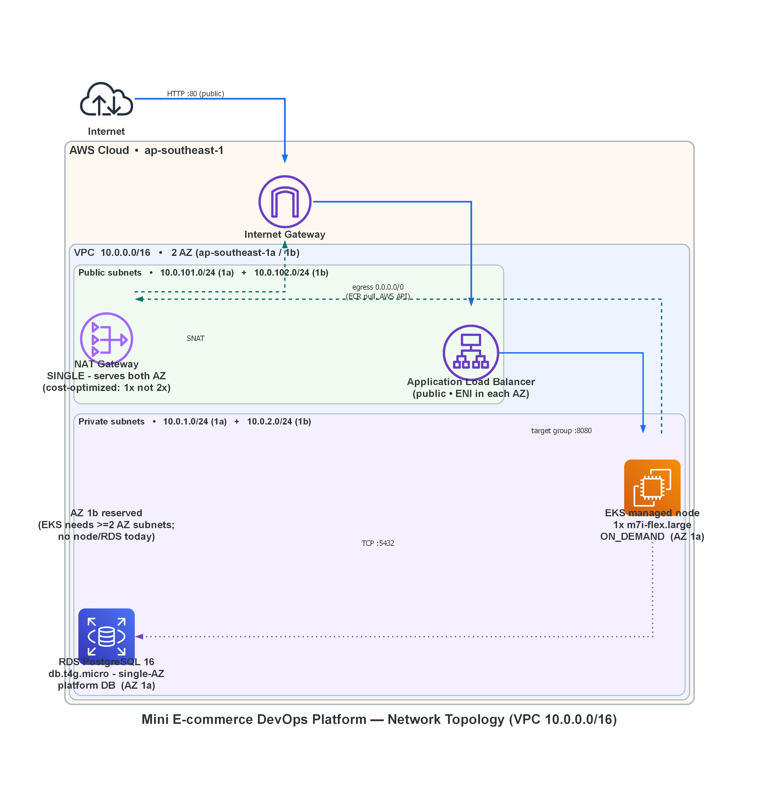

3. Component Descriptions
All values verified from infra/ Terraform code. Nothing in this section is assumed or guessed.

3.1 VPC and Network Topology
The VPC spans two Availability Zones (ap-southeast-1a and ap-southeast-1b), providing the minimum required for EKS. Resources are split across two subnet tiers:

Subnet Tier | CIDR | AZ | Contains
Public 1a | 10.0.101.0/24 | ap-southeast-1a | ALB ENI, NAT Gateway (SINGLE)
Public 1b | 10.0.102.0/24 | ap-southeast-1b | ALB ENI (no NAT here)
Private 1a | 10.0.1.0/24 | ap-southeast-1a | EKS managed node (1x m7i-flex.large), RDS PostgreSQL
Private 1b | 10.0.2.0/24 | ap-southeast-1b | Reserved — EKS requires >=2 private subnets; no node or RDS today

NAT Gateway — Single Instance Design
A single NAT Gateway is deployed in public subnet 1a. Both private subnets route outbound traffic (0.0.0.0/0) through this single NAT via their route tables.

Aspect | Detail
Design choice | single_nat_gateway = true in Terraform VPC module
Cost | ~$32/month (1 NAT) vs ~$64/month (2 NAT, one per AZ)
Trade-off | If AZ 1a fails, AZ 1b private subnet also loses egress (NAT is in AZ 1a)
Justification | Acceptable for demo/ephemeral deployment. Production would use one NAT per AZ.
Use cases for egress | EKS nodes pulling images from ECR, reaching AWS API endpoints, package downloads

3.2 Amazon EKS Cluster
The Kubernetes cluster is the central compute platform. Application workloads, GitOps agents, and observability tools all run here.

Property | Value
Cluster name | mini-ecommerce-devops
Kubernetes version | 1.30
API endpoint access | Public + Private (both enabled)
Public CIDR | 0.0.0.0/0 (unrestricted — restrict to your IP in production)
Node group type | Managed node group
Instance type | m7i-flex.large (Intel Flex — burstable, 2 vCPU / 8 GB RAM)
Capacity type | ON_DEMAND (not Spot — avoids eviction during demo)
Node count | desired = 1, min = 1, max = 1 (fixed, no autoscaling)
Node cost | ~$71/month (ON_DEMAND, ap-southeast-1)
OIDC provider | Auto-created — enables IRSA for LBC and ESO
Control plane logging | Not configured (CloudWatch cost not justified for demo)

Namespaces
Namespace | Purpose | Key Workloads
kube-system | Platform operators | AWS Load Balancer Controller, CoreDNS, kube-proxy, vpc-cni
external-secrets | Secrets management operator | External Secrets Operator
argocd | GitOps controller | Argo CD server, repo-server, application-controller
boutique | Application workloads | frontend, productcatalog, cartservice, checkout, Redis
monitoring | Observability stack | Prometheus, Grafana (kube-prometheus-stack Helm chart)

3.3 Application Services (namespace: boutique)
Only happy-path services are deployed to EKS. The full service mesh (currency, shipping, payment, email) runs locally in Docker Compose for development purposes only.

Service | Language | Port | Protocol | Storage | EKS Deployed
frontend | Go | 8080 | HTTP (inbound), gRPC (outbound) | None — orchestrates backends | Yes
productcatalogservice | Go | 3550 | gRPC | In-memory products.json | Yes
cartservice | C# .NET | 7070 | gRPC | Redis :6379 (in-cluster) | Yes
checkoutservice | Go | 5050 | gRPC | None — orchestrator | Yes
Redis | Redis | 6379 | TCP | In-memory (ephemeral) | Yes (in-cluster Deployment)
currencyservice | Node.js | 7000 | gRPC | currency_conversion.json | No — Compose only
paymentservice | Node.js | 50051 | gRPC | None (mock) | No — Compose only
emailservice | Python | 8080 | gRPC | None (mock) | No — Compose only
shippingservice | Go | 50051 | gRPC | None (mock) | No — Compose only

Redis is an in-cluster Kubernetes Deployment — NOT AWS ElastiCache. This is intentional: the cart data is ephemeral and does not require managed Redis for this demo scope.

frontend Service-to-Service Calls
The frontend makes outbound gRPC calls to multiple backend services on every page load. In EKS, only the happy-path services respond. In Docker Compose, all services are available.

frontend calls -> | Port | Call purpose | Available in EKS?
productcatalogservice | 3550 | List products, get product details | Yes
cartservice | 7070 | Add/view/clear cart | Yes
checkoutservice | 5050 | Place order | Yes
currencyservice | 7000 | Convert prices to user currency | No (Compose only)
shippingservice | 50051 | Get shipping quote | No (Compose only)
recommendationservice | 8080 | Product recommendations | No (not deployed anywhere)
adservice | 9555 | Display advertisements | No (not deployed anywhere)

checkoutservice Service-to-Service Calls
Checkout orchestrates the full order flow. In EKS, calls to non-deployed services would cause gRPC dial errors — these services only run in Docker Compose.

checkoutservice calls -> | Port | Call purpose | Available in EKS?
cartservice | 7070 | GetCart, EmptyCart | Yes
productcatalogservice | 3550 | GetProduct (for each item) | Yes
currencyservice | 7000 | Convert prices | No (Compose only)
shippingservice | 50051 | GetQuote, ShipOrder | No (Compose only)
paymentservice | 50051 | Charge credit card (mock) | No (Compose only)
emailservice | 8080 | SendOrderConfirmation (mock) | No (Compose only)

3.4 Application Load Balancer (ALB)
The ALB is NOT created by Terraform. It is provisioned dynamically by the AWS Load Balancer Controller (LBC), which watches Kubernetes Ingress objects and creates/updates the corresponding ALB in AWS.

Aspect | Detail
Who creates it | AWS Load Balancer Controller reacting to Ingress object in boutique namespace
When it is created | After Argo CD applies the Ingress manifest to the cluster (Phase 3 onwards)
ALB type | Internet-facing (public)
Subnets | Both public subnets (10.0.101.0/24, 10.0.102.0/24) — tagged kubernetes.io/role/elb=1
Target | EKS node on port 8080 (frontend pod)
Terraform involvement | None — only the LBC IAM role (IRSA) is created by Terraform

3.5 RDS PostgreSQL
RDS is provisioned as a platform DB shell — it exists to demonstrate the full IaC capability but is not used by any application service. App services use Redis (cart) and in-memory storage, following the upstream Online Boutique architecture.

Property | Value
Engine | PostgreSQL 16
Instance class | db.t4g.micro (Graviton2, 1 vCPU, 1 GB RAM)
Cost | ~$13/month (single-AZ, ap-southeast-1)
Storage | 20 GB gp3 (encrypted at rest)
Multi-AZ | No — single-AZ (AZ 1a only)
HA trade-off | AZ 1a failure = DB unavailable. Acceptable: demo ephemeral, app does not use RDS.
Public accessibility | No — private subnets only
Backup retention | 1 day (minimal — no final snapshot on destroy)
Deletion protection | Off (allows terraform destroy without manual intervention)
Credentials | Random 24-char password stored in Secrets Manager, synced to cluster via ESO

3.6 Secrets Management Flow
The secrets flow ensures no credentials are hardcoded anywhere — not in code, not in Kubernetes manifests, not in GitHub Actions.

Step | Component | Action
1 | Terraform (local apply) | Creates RDS, generates random password, stores in Secrets Manager as JSON: {username, password, host, port, dbname}
2 | External Secrets Operator | Runs in EKS with IRSA role (secretsmanager:GetSecretValue). Watches ExternalSecret CR in boutique namespace.
3 | ExternalSecret CR | Argo CD applies this manifest. It references the Secrets Manager secret path and maps keys to K8s Secret fields.
4 | K8s Secret | ESO creates/syncs the K8s Secret in boutique namespace. Pods mount it as environment variables or volume.
5 | GitHub Actions | Uses GitHub OIDC to assume IAM role (no AWS_ACCESS_KEY_ID stored in GitHub). Trust restricted to main branch (ECR push) or PR (TF plan).

3.7 CI/CD Pipeline (GitHub Actions)
Three workflows are defined. Only terraform-plan runs in CI — terraform apply is always manual local to prevent accidental infrastructure changes.

Workflow | Trigger | Steps | IAM Role Used
ci-build-push | push to main touching src/** | 1. Checkout 2. OIDC assume ECR-push role 3. Docker Buildx multi-arch 4. Trivy CRITICAL gate (fail if found) 5. cosign sign + SBOM 6. Push to ECR (sha + latest tags) 7. Open image-bump PR to gitops repo | github-actions-ecr (main branch only)
terraform-plan | PR touching infra/** | 1. OIDC assume TF-plan role (read-only) 2. terraform fmt -check 3. terraform validate 4. terraform plan 5. Checkov scan (baseline) 6. Post sticky PR comment with plan output | github-actions-terraform-plan (PR only, read-only)
security-scan | Schedule Mon 06:00 UTC + PR | 1. Checkov on terraform/ and k8s manifests 2. Trivy fs scan (HIGH + CRITICAL) 3. Upload SARIF to GitHub Security | None (read-only repo access)

terraform apply is deliberately NOT automated from CI. The developer runs it locally: cd infra/environments/aws && terraform apply tfplan. This prevents accidental infrastructure changes from CI.

3.8 GitOps (Argo CD + Kustomize)
A two-repository model separates application source code from deployment manifests. CI builds and signs images; GitOps manages what is deployed to the cluster.

Repository | Contains | Who writes to it
mini-ecommerce-devops (this repo) | src/ application code, infra/ Terraform, CI workflows, runbooks | Developers (git push), CI (terraform-plan comment)
mini-ecommerce-gitops (separate repo) | Kustomize base/ manifests + overlays/aws/ with ECR image tags | CI opens image-bump PR after each successful build; developer merges

GitOps Aspect | Detail
Sync method | Argo CD polls mini-ecommerce-gitops every 3 minutes (pull model — NOT webhook)
Manifest format | Kustomize overlay aws/ on top of base/
Image update flow | CI pushes to ECR -> opens PR to gitops repo with new image tag -> developer merges -> Argo CD picks up on next poll
Deploy trigger | Argo CD detects diff between cluster state and git state, applies missing/changed resources
Namespace deployed to | boutique (app pods, Ingress, Services, ExternalSecret)
What Argo CD does NOT deploy | Operators (LBC, ESO, Prometheus) — these are installed via Helm scripts before Argo CD is configured

3.9 Observability
The observability stack combines in-cluster metrics (Prometheus + Grafana) with AWS-native alarms (CloudWatch). Distributed tracing is code-wired but not yet active.

Component | Type | What it monitors | Status
Prometheus | In-cluster (kube-prometheus-stack) | Pod CPU/memory, K8s events, custom /metrics endpoints from app pods | Deployed
Grafana | In-cluster (kube-prometheus-stack) | Dashboards: cluster-overview.json (custom), default K8s dashboards | Deployed
CloudWatch Alarm: RDS CPU | AWS managed | RDS CPUUtilization > 80% for 2 periods of 5 minutes | Active (no SNS action — demo)
CloudWatch Alarm: RDS Storage | AWS managed | RDS FreeStorageSpace < 2 GB for 2 periods of 5 minutes | Active (no SNS action — demo)
CloudWatch Alarm: ALB 5xx | AWS managed | ALB HTTPCode_Target_5XX_Count > 10 per 5-minute period | Active once ALB is provisioned
OTel Collector | Planned — not deployed | Distributed traces from frontend (OTLP). Code wired in src/frontend/main.go | Inactive: ENABLE_TRACING=0

3.10 Amazon ECR
Repository | Scan on Push | Lifecycle Policy | Image Signing
mini-ecommerce/frontend | Yes (HIGH+CRITICAL reported) | Untagged images deleted after 7 days | cosign + SBOM (CI step 5)
mini-ecommerce/productcatalogservice | Yes | Untagged images deleted after 7 days | cosign + SBOM
mini-ecommerce/cartservice | Yes | Untagged images deleted after 7 days | cosign + SBOM
mini-ecommerce/checkoutservice | Yes | Untagged images deleted after 7 days | cosign + SBOM

4. Cost Analysis (When Running)
Ephemeral model: terraform destroy after each demo brings cost to $0. Costs below apply only while the stack is running.

Resource | Spec | Cost / Month | Optimization Applied
EKS Control Plane | Managed (AWS-managed masters) | ~$73 | Fixed — no way to reduce
EKS Node | 1x m7i-flex.large ON_DEMAND | ~$71 | ON_DEMAND for demo reliability (Spot would save ~65% = ~$25/mo)
NAT Gateway | 1 gateway + data transfer | ~$32 | Single NAT (not per-AZ) saves ~$32/mo
RDS PostgreSQL | db.t4g.micro single-AZ 20GB gp3 | ~$13 | Graviton2 cheapest tier; single-AZ saves ~$13/mo
ECR | 4 repos, storage + transfer | ~$3 | Lifecycle policy removes untagged after 7 days
S3 + DynamoDB (state) | Versioned bucket + lock table | ~$1 | DynamoDB PAY_PER_REQUEST
CloudWatch Alarms | 3 alarms, no log groups | ~$1 | No control plane logs (saves ~$5-10/mo)
Data transfer | ECR pulls, ALB, misc | ~$5-15 | S3 Gateway endpoint would eliminate ECR pull cost
TOTAL (estimated) |  | ~$200-210/month | Destroy when not in use -> $0

4.1 Cost Optimization Already Applied
- Single NAT Gateway (single_nat_gateway = true) — saves ~$32/month vs one-per-AZ
- RDS db.t4g.micro Graviton2 — cheapest RDS tier (~$13/month)
- RDS Single-AZ — saves ~$13/month vs Multi-AZ
- Fixed node count (1) — no idle node capacity
- gp3 storage — 20% cheaper than gp2 at same performance
- ECR lifecycle policy — prevents storage bloat from old images
- DynamoDB PAY_PER_REQUEST for state lock — no provisioned capacity cost
- No CloudWatch control plane logs — saves $5-10/month

4.2 Further Optimizations (Not Applied — Trade-offs Noted)
Optimization | Saving | Trade-off / Why Not Applied
Switch EKS node to Spot instances | ~$46/month (65% savings) | Spot can be interrupted. Demo requires stable 1-node cluster.
Add S3 Gateway VPC Endpoint (free) | Eliminates ECR pull NAT data costs | Minor saving — not implemented yet. Free to add.
Reduce RDS backup retention to 0 | ~$2/month | 0-day retention disables PITR entirely. Already at minimum (1 day).
Remove RDS entirely | ~$13/month | RDS is the platform DB shell — demonstrates IaC capability. Removing it undermines the portfolio scope.

5. Key Design Decisions

5.1 No Static AWS Credentials
GitHub Actions uses GitHub OIDC to assume IAM roles at runtime. No AWS_ACCESS_KEY_ID or AWS_SECRET_ACCESS_KEY is stored in GitHub Secrets.
- ECR-push role: trusted only for refs/heads/main (main branch commits)
- TF-plan role: trusted only for pull_request events (read-only permissions)
- EKS operators (LBC, ESO) use IRSA — IAM roles bound to K8s service accounts via OIDC

5.2 terraform apply is Manual — Never Automated
The CI workflow runs terraform plan on PRs (read-only). Terraform apply is always run manually from the developer's local machine. This prevents accidental infrastructure changes triggered by code pushes.

5.3 Two-Repository GitOps Model
Source code (this repo) and Kubernetes manifests (mini-ecommerce-gitops) are in separate repositories. This separation means:
- A code change does not automatically deploy — it goes through CI build -> PR review -> merge to trigger deployment
- Rollback is a git revert in the gitops repo — independent of application code
- Argo CD only has read access to the gitops repo, not the application repo

5.4 ALB Provisioned by Kubernetes — Not Terraform
The Application Load Balancer is created by the AWS Load Balancer Controller responding to a Kubernetes Ingress object. Terraform only creates the IRSA role for LBC. This demonstrates the GitOps principle: cluster state drives infrastructure, not the other way around.

5.5 Single NAT Gateway (Deliberate Trade-off)
Using one NAT Gateway instead of one-per-AZ saves ~$32/month. The trade-off (AZ 1a failure also breaks AZ 1b egress) is acceptable for this demo scope. Documentation in the network diagram makes this trade-off explicit.

6. Diagram Edge Color Legend
Color | Hex | Flow Type | Line Style
Blue | #1F6FEB | Runtime request path (HTTP, gRPC between services) | Solid
Purple | #6F42C1 | Internal service mesh (gRPC, Redis TCP) | Solid
Pink | #BF2A8A | CI/CD pipeline (build, push, PR) | Dashed (async)
Green | #198038 | GitOps sync (Argo CD poll & apply) | Dotted (poll/planned)
Red | #DA1E28 | Secrets flow (ESO reads SM, writes K8s Secret) | Solid
Orange | #F1620E | Observability (metrics scrape, CloudWatch alarms) | Dotted (scrape)
Grey | #6F6F6F | Terraform state, infra ops, OIDC auth | Dashed (async)
Teal | #0F766E | Network egress (private subnet -> NAT -> IGW) | Dashed (async)

Edge style convention:
- Solid line = synchronous request (caller waits for response)
- Dashed line = asynchronous or event-driven (trigger, push, image pull)
- Dotted line = polling, scraping, or planned-not-yet-active flow

