

**International School**

**Capstone Project 2**

## CMU-SE 451 – C2SE.12

**Database Design**

**Version 1.1 Date: March 15th, 2021**

**Movie ticket management system**

**Submitted by Vo Anh Tuan, Nguyen Gia Hoa, Le Quang Trai, Vo Hoang Mai Khanh**

**Approved by**

**MSc Huy, Truong Dinh**

**Proposal Review Panel Representative:**

Name Signature Date

## Capstone Project 2- Mentor:

Name Signature Date

**PROJECT INFORMATION**

|  |  |  |  |
| --- | --- | --- | --- |
| **Project acronym** | LET | | |
| **Project Title** | Learn English Together | | |
| **Start Date** | 26 Feb 2021 | **End Date** | 08 Jun 2021 |
| **Lead Institution** | International School, Duy Tan University | | |
| **Project Mentor** | MSc Huy, Truong Dinh | | |
| **Scrum master / Project Leader & contact details** | Ha, Le Thanh  Email: [lethanhhadtu@gmail.com](mailto:lethanhhadtu@gmail.com) Tel: 0334002818 | | |
| **Partner Organization** | Duy Tan University | | |
| **Project Web URL** |  | | |
| **Team members** | Name | Email | Tel |
| 1 | Vo Hoang Mai Khanh | [lethanhhadtu@gmail.com](mailto:lethanhhadtu@gmail.com) | 0334002818 |
| 2 | Vo Van Duc Tri | [xuanhieu.le.1999@gmail.com](mailto:xuanhieu.le.1999@gmail.com) | 0399706614 |
| 3 | Le Quang Trai | [ngongocmy851999@gmail.com](mailto:ngongocmy851999@gmail.com) | 0764497391 |
| 4 | Nguyen Gia Hoa |  |  |
| 5 | Vo Anh Tuan | [doanthong002@gmail.com](mailto:doanthong002@gmail.com) | 0886428208 |

# DOCUMENT APPROVALS

The following signatures are required for approval of this document.

|  |  |  |
| --- | --- | --- |
| Ha, Le Thanh  Student ID: 2321122516  *Scrum Master* | Signature | Date |
| Hieu, Le Xuan  Student ID: 2321124665  *Team Member* | Signature | Date |
| My, Ngo Ngoc  Student ID: 2321124970  *Team Member* | Signature | Date |
| Thong, Doan Trung Student ID: 2321124144  *Team Member* | Signature | Date |

**REVISION HISTORY**

|  |  |  |  |  |
| --- | --- | --- | --- | --- |
| **Version** | **Date** | **Comments** | **Author** | **Approval** |
| 1.0 | March 15th, 2021 | Initial Release | Ngoc My Ngo |  |
| 1.1 | April 20th, 2021 | Update | Ngoc My Ngo |  |

# TABLE OF CONTENT

1. Introduction 5
   1. Purpose 5
   2. Scope 5
   3. Introduction about MongoDB 5
2. Database Diagram 6
   1. Table Overview 6
   2. Entity Relationship Diagram 7
   3. Table Relationship Diagram 8
3. Database Design for Sprint 9
   1. Table Group 9
   2. Table User 9
   3. Table Frame 10
   4. Table PrivateMessage 11
   5. Table PublicMessage 11
   6. Table Events 11
   7. Table Course 12
   8. Table CourseVocabulary 12
   9. Table CourseOfUsser 13
   10. Table Rating 13
4. Hardware and software Requirements 14

## Introduction

This document describes the database design for a Cinema Ticket Management System. Its purpose is to ensure high performance during operations such as ticket booking, movie scheduling, user management, and complex data queries.

## Purpose

The purpose of the **Cinema Ticket Management System** is to provide an efficient, user-friendly, and automated solution for managing all ticket-related activities in a cinema. This includes the management of movies, showtimes, cinema rooms, seat arrangements, user bookings, and payment processes.

## Scope

The Database Cinema Ticket Management System has the following objectives:

* Manage users and login credentials.
* Manage movies, showtimes, and cinema rooms.
* Online ticket booking and payment processing.
* Admin panel for system administration.

## Introduction about MongoDB

MongoDB is a NoSQL database designed for scalability, performance, and high availability. Unlike traditional relational databases, MongoDB stores data in flexible, JSON-like documents, allowing it to handle complex and evolving data structures efficiently.

In the context of a movie ticket booking system, MongoDB provides several advantages:

* Flexible Schema Design: Entities such as users, movies, schedules, and bookings can be stored in collections with varying structures. For example, a booking document can embed user information and ticket details in a single record, making it easier to retrieve without performing complex joins.
* High Performance: With its document-based structure and support for indexing, MongoDB allows for fast read/write operations, which is essential for real-time features like seat selection, schedule browsing, and online ticket booking.
* Scalability: MongoDB supports horizontal scaling through sharding, which is useful when handling large volumes of data such as thousands of movie sessions, millions of users, and transactions.
* Built-in Replication: The use of replica sets ensures high availability and fault tolerance, which is crucial for a system that requires constant uptime.

{

user: " Nguyen Van A", ticketID: "T001",

movie: "Avengers: Endgame",  
cinema: "CGV Vincom",  
seat: D5",  
showTime: "2025-04-20T20:00:00",  
price: 95000,

}

Overall, MongoDB is a powerful choice for building a movie ticket booking system due to its ability to manage diverse data models, handle high traffic, and scale with user demand. Its document-oriented nature aligns well with the application's need for agility and fast development.

## Database Diagram

## Table Overview

|  |  |
| --- | --- |
| **Table Name** | **Short Description** |
| Group | Represents cinema staff groups or teams, such as customer service, ticketing, or operations teams. This table stores group names, roles, members, and related permissions. |
| User | Stores information about all users in the system, including customers and staff. It includes login credentials, contact details, roles, and account status. |
| Frame | Defines scheduling frameworks or time slots for movie screenings. It helps structure available time ranges in which showtimes can be configured. |
| PrivateMessage | Stores internal, private messages between staff members (e.g., between managers and ticket agents) for operational coordination. |
| PublicMessage | Contains announcements or public messages sent to users, such as movie promotions, event reminders, or cinema-wide notifications. |
| Quizz | Used for optional customer engagement—such as short quizzes or surveys about movies, cinema experiences, or promotional campaigns. |
| Event | Stores information about cinema-related events, including movie premieres, special screenings, fan meetings, or marketing events. Each event includes time, description, and organizer details. |

## Entity Relationship Diagram

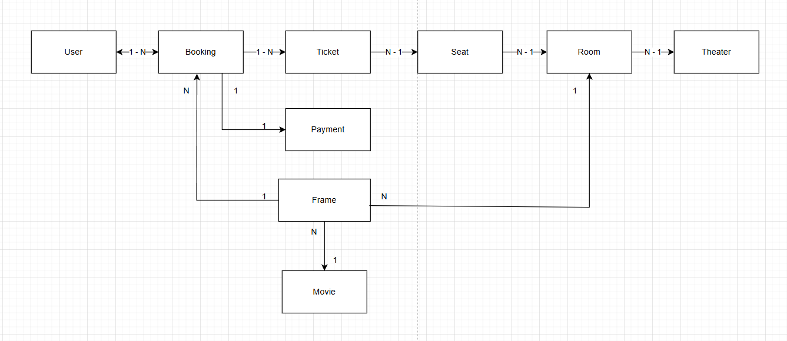

## Table Relationship Diagram

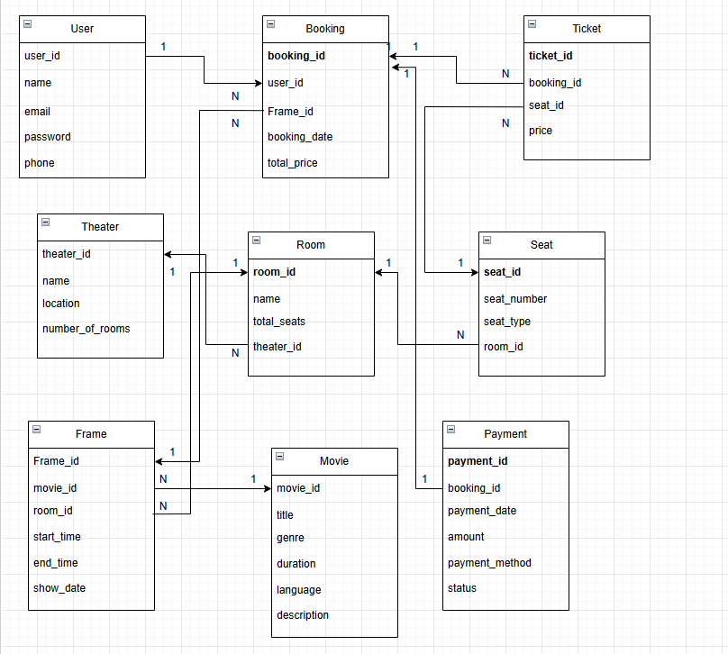

## Database Design for Sprint

## Table Group

|  |  |  |  |  |
| --- | --- | --- | --- | --- |
|  |  |  |  | Group |
| Id | Field | Type | Constrain | Description |
| 1 | _id | Object | Primary Key | Automatically generated ObjectId by MongoDB. |
| 2 | roomName | String | Not Null, Unique | Name of the cinema room. |
| 3 | roomCode | String | Unique | Unique code identifying the room. |
| 4 | managerId | Object | Foreign Key → User | ID of the staff managing this room. |
| 5 | seatLayoutId | Object | Foreign Key | Reference to seat layout configuration. |
| 6 | image | String | Optional | Image representing the cinema room. |
| 7 | scheduleInfo | String | Optional | Notes or schedule metadata for the room. |
| 8 | videoSystem | date | Optional | Description of video system. |
| 9 | audioSystem | String | Optional | Type of audio system used. |
| 10 | isActive | Boolean | Default: true | Room status (active/inactive). |
| 11 | createdAt | Date | Default: now | Timestamp when the room was added to the system. |
| 12 | updatedAt | Date | Updated on changes | Last modification timestamp. |
| 13 | createdBy | Object | Foreign Key → User | ID of the user who created this room record. |

## Table User

|  |  |  |  |  |
| --- | --- | --- | --- | --- |
| User | | | | |
| Id | Field | Type | Constrain | Description |
| 1 | _id | Object | Primary key | Auto-generated unique ID by MongoDB. |
| 2 | userName | String | Not Null | Display name of the user. |
| 3 | password | String | Encrypted, Not Null | Encrypted password for login. |
| 4 | email | String | Unique, Not Null | User's email address (used for login and password recovery). |
| 5 | phoneNumber | String | Optional | User’s phone number. |
| 6 | dob | Date | Optional | Date of birth. |

|  |  |  |  |  |
| --- | --- | --- | --- | --- |
| 7 | role | String | Default: "customer" | User role: admin, staff, or customer. |
| 8 | isActive | Boolean | Default: true | Account status (active/inactive). |
| 9 | avatar | String | Optional | URL or path to user avatar/profile picture. |
| 10 | registeredAt | String | Default: now | Date and time the account was created. |
| 11 | lastLogin | Date | Optional | Timestamp of the user’s most recent login. |
| 12 | address | String | Optional | User’s home or billing address. |
| 13 | bookings | Object | Foreign Key → Ticket | List of ticket IDs this user has booked. |

## Table Frame

|  |  |  |  |  |
| --- | --- | --- | --- | --- |
| Frame | | | | |
| Id | Field | Type | Constrain | Description |
| 1 | _id | Object | Primary key | Auto-generated unique ID for each showtime. |
| 2 | movieId | Object | Foreign Key → Movie | ID of the movie being shown. |
| 3 | roomId | Object | Foreign Key → Room | ID of the cinema room where the movie is screened. |
| 4 | startTime | Date | Not Null | Date and time the screening starts. |
| 5 | endTime | Date | Not Null | Date and time the screening ends. |
| 6 | price | Number | Not Null | Ticket price for this showtime. |
| 7 | isAvailable | Boolean | Default: true | Status indicating if the showtime is currently open for booking. |
| 8 | createdBy | Object | Foreign Key → User | ID of the staff/admin who created the showtime. |
| 9 | createdAt | Date | Default: now | Timestamp when the showtime was created. |
| 10 | updatedAt | Date | Optional | Timestamp when the showtime was last updated. |

## Table PrivateMessage

|  |  |  |  |  |
| --- | --- | --- | --- | --- |
| PrivateMessage | | | | |
| Id | Field | Type | Constrain | Description |
| 1 | _id | Object | Primary key | Auto-generated unique ID for the message. |
| 2 | senderId | Object | Foreign Key → User | ID of the user who sends the message (customer or staff). |
| 3 | receiverId | Object | Foreign Key → User | ID of the user who receives the message. |
| 4 | message | String | Not Null | Content of the private message. |
| 5 | createdAt | Number | Default: now | Timestamp when the message was created. |
| 6 | sentAt | Date | Optional | Datetime when the message was sent. |
| 7 | isRead | Boolean | Default: false | Whether the receiver has read the message or not. |
| 8 | ticketRefId | Object | Optional | Reference to a specific ticket if the message is about a booking. |

## Table PublicMessage

|  |  |  |  |  |
| --- | --- | --- | --- | --- |
| PublicMessage | | | | |
| Id | Field | Type | Constrain | Description |
| 1 | _id | Object | Primary Key | Auto-generated unique ID for the message. |
| 2 | authorId | Object | Foreign Key → User | ID of the user who created the message. |
| 3 | targetGroup | String | Optional | Target group of users. |
| 4 | title | String | Not Null | Title or subject of the message. |
| 5 | message | String | Not Null | Content of the public message. |
| 6 | createdAt | Number | Default: now | Timestamp when the message was created. |
| 7 | publishedAt | Date | Optional | Optional Human-readable date when the message was published. |
| 8 | isPinned | Boolean | Default: false | Whether the message is pinned or highlighted on the homepage. |
| 9 | status | String | Default: "active" | Status of the message: "active", "draft", "archived". |

## Table Events

|  |  |  |  |  |
| --- | --- | --- | --- | --- |
| Event | | | | |
| Id | Field | Type | Constrain | Description |
| 1 | _id | Object | Primary key | Auto-generated ID for the event. |
| 2 | eventName | String | Not Null | Name of the event. |
| 3 | description | String | Optional | Description or details about the event. |
| 4 | bannerImage | String | Optional | Path or URL to event promotional image/banner. |
| 5 | location | String | Optional | Location of the event |
| 6 | startTime | Date | Not Null | Start time and date of the event. |
| 7 | endTime | Date | Optional | End time and date of the event. |
| 8 | createdBy | Object | Foreign Key → User | ID of staff or admin who created the event. |
| 9 | createdAt | Number | Default: now | Timestamp when the event record was created. |
| 10 | updatedAt | Date | Optional | Last time the event information was updated. |
| 11 | isActive | Boolean | Default: true | Indicates whether the event is currently active or expired. |

## Table Course

|  |  |  |  |  |
| --- | --- | --- | --- | --- |
| Course | | | | |
| Id | Field | Type | Constrain | Description |
| 1 | _id | Object | Primary key | MongoDB auto-generates an ObjectId. Unique identifier for movie. |
| 2 | nameMovie | String | Not Null | Title of the movie. |
| 3 | description | String | Optional | Summary or plot of the movie. |
| 4 | genre | String | Optional | Genre of the movie |
| 5 | language | String | Optional | Language of the movie. |
| 6 | duration | Number | Not Null | Duration of the movie in minutes. |
| 7 | director | String | Optional | Director of the movie. |
| 8 | cast | String | Optional | List of main actors. |
| 9 | poster | String | Optional | URL to the movie poster image. |
| 10 | trailerLink | String | Optional | URL to the trailer video |
| 11 | releaseDate | Date | Optional | Official release date. |
| 12 | userCreate | Object | Foreign Key → User | ID of the staff who added the movie. |
| 13 | createdAt | Number | Default: now | Timestamp when the movie was added. |
| 14 | updatedAt | Date | Optional | Timestamp when the movie was last updated. |

## Table CourseVocabulary

|  |  |  |  |  |
| --- | --- | --- | --- | --- |
| CourseVocabulary | | | | |
| Id | Field | Type | Constrain | Description |
| 1 | _id | Object | Primary key | MongoDB auto-generates an ObjectId. Unique identifier for each tag. |
| 2 | movieId | Object | Foreign Key → Movie | ID of the movie this tag is associated with. |
| 3 | tagName | String | Not Null | Tag name or keyword |
| 4 | type | String | Optional | Type of tag |
| 5 | description | String | Optional | Additional notes or explanation of the tag. |
| 6 | iconImage | String | Optional | Optional icon or image related to the tag. |

|  |  |  |  |  |
| --- | --- | --- | --- | --- |
| 7 | userCreate | Object | Foreign Key → User | ID of the user who created this tag entry. |
| 8 | createdAt | Number | Default: now | Timestamp when the tag was created. |
| 9 | updatedAt | Date | Optional | Last update time of the tag. |

## Table CourseOfUsser

|  |  |  |  |  |
| --- | --- | --- | --- | --- |
| CourseOfUsser | | | | |
| Id | Field | Type | Constrain | Description |
| 1 | _id | Object | Primary key | MongoDB auto-generates an ObjectId. Unique identifier for the ticket. |
| 2 | showtimeId | Object | Foreign Key → Showtime | ID of the showtime the ticket is associated with. |
| 3 | userId | Object | Foreign Key → User | ID of the user who booked the ticket. |
| 4 | seatId | Object | Foreign Key → Seat | ID of the selected seat in the room. |
| 5 | bookingTime | Default: now | Default: now | Timestamp when the ticket was booked. |
| 6 | updatedAt | Date | Optional | Timestamp of the last update to the ticket. |
| 7 | price | Number | Not Null | Price of the ticket at the time of booking. |
| 8 | status | String | Default: "pending" | Booking status: "pending", "paid", "cancelled". |
| 9 | qrCode | String | Optional | QR code string used for check-in at the cinema. |

## Table Rating

|  |  |  |  |  |
| --- | --- | --- | --- | --- |
| Rating | | | | |
| Id | Field | Type | Constrain | Description |
| 1 | _id | Object | Primary key | MongoDB auto-generates an ObjectId. Unique ID for each rating. |
| 2 | userId | Object | Foreign Key → User | ID of the user who gave the rating. |
| 3 | movieId | Object | Foreign Key → Movie | ID of the movie being rated. |
| 4 | star | Number | Range: 1–5 | Star rating given by the user. |
| 5 | comment | String | Optional | Text review or comment provided by the user. |
| 6 | createdAt | Nummber | Default: now | Timestamp when the rating was created. |
| 7 | updatedAt | Date | Optional | Timestamp of the last update to the rating. |
| 8 | isPublic | Boolean | Default: true | Whether the review is publicly visible to other users. |

## Hardware and software Requirements

This section outlines the required technologies and environment to support the cinema ticket management system:

|  |  |
| --- | --- |
| **Attributes of Easy English WEBSITE** | |
| **Attributes** | **Descriptions** |
| **Database** | MongoDB |
| **Software** | Reactjs, Nodejs, Polling, Elasticsearch, Redis, Websocket, Mail gun |
| **Hardware** | Computer |
| **Library** | Hook, Redux, React hook form, Bootstrap 4, Fontawesome, Material ui, Express.js. |