PRACTICAL EXAMINATION
Subject code: MMA301 – SP26
Vo Dai Vy – DE180817 – SE18D08
How to use:
- Download: Folder PE_MMA301_VoDaiVy
- Install: Open the terminal in your project folder and run npm install.
- Start: Run npx expo start to launch the Expo server.
- Open: Scan the QR code with Expo Go (Android/iOS) or press i for the iOS simulator.
- Component structure:
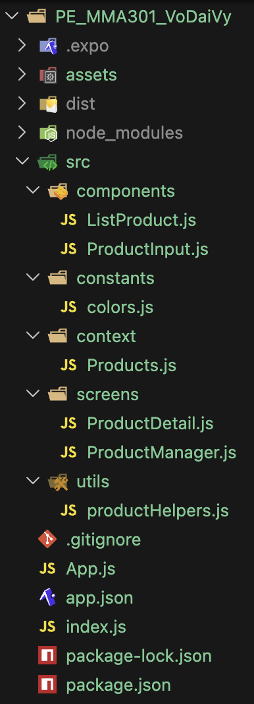

- Funtion features:
2.1 Add Product (ProductInput)
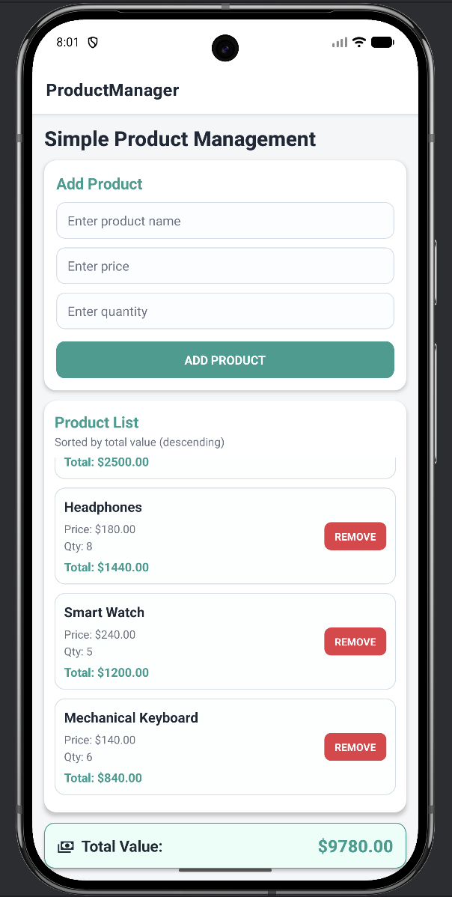 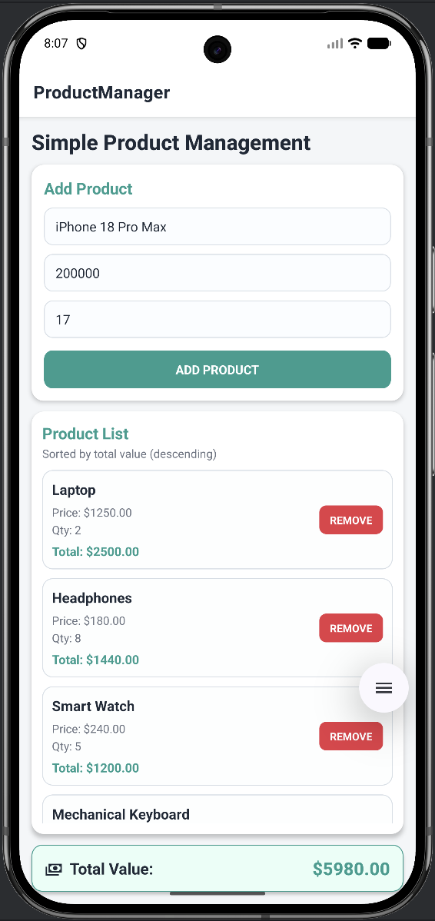 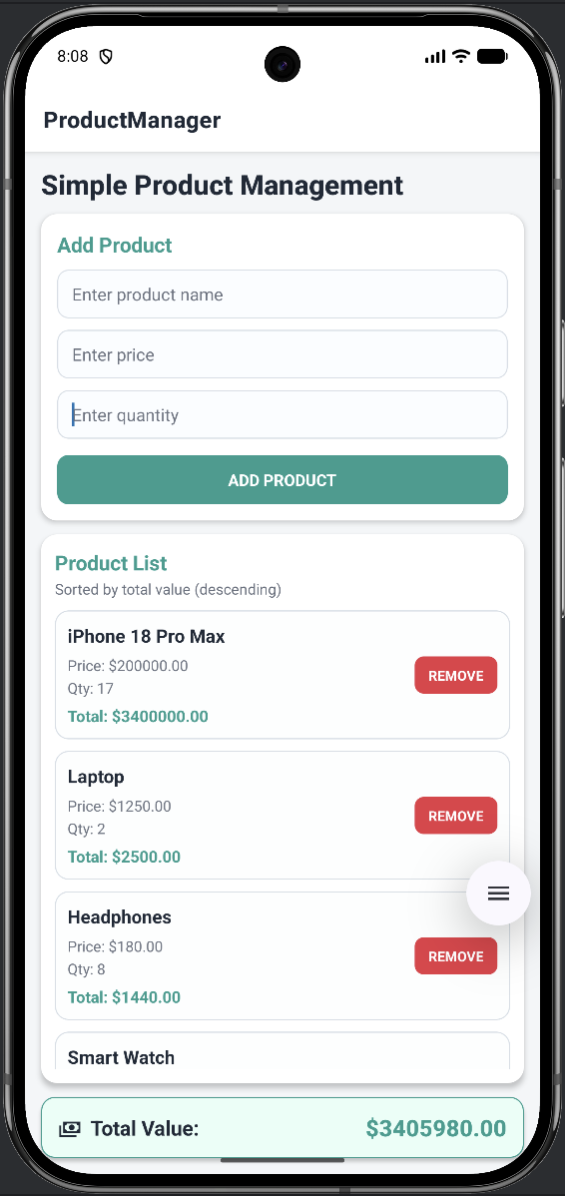
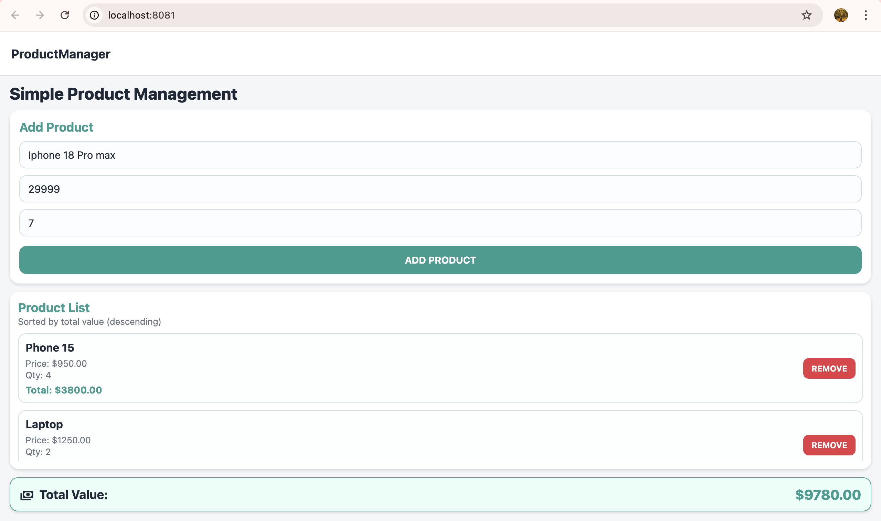 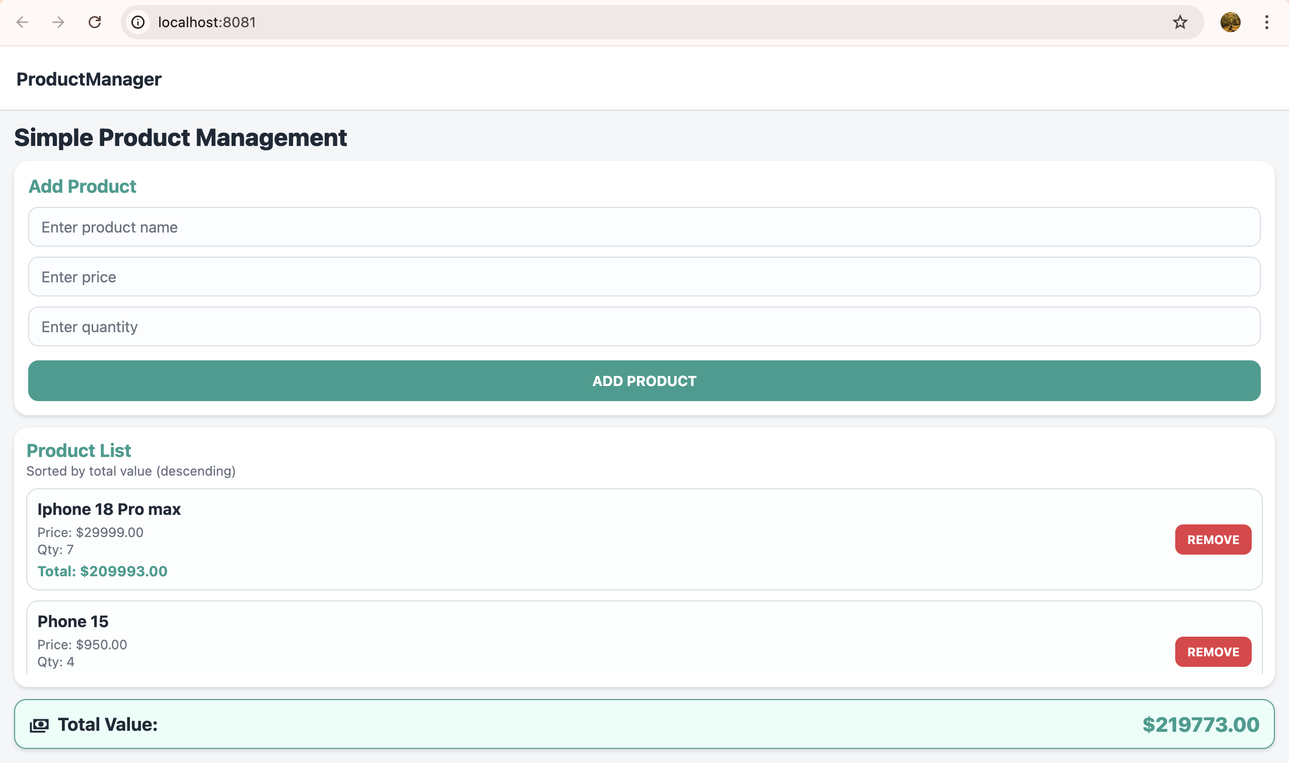
- Add Product: Enter Name, Price, and Quantity in ProductInput.js and tap ADD PRODUCT. The app calculates the total and adds it to the list.
2.2 Display Product List (ListProduct)
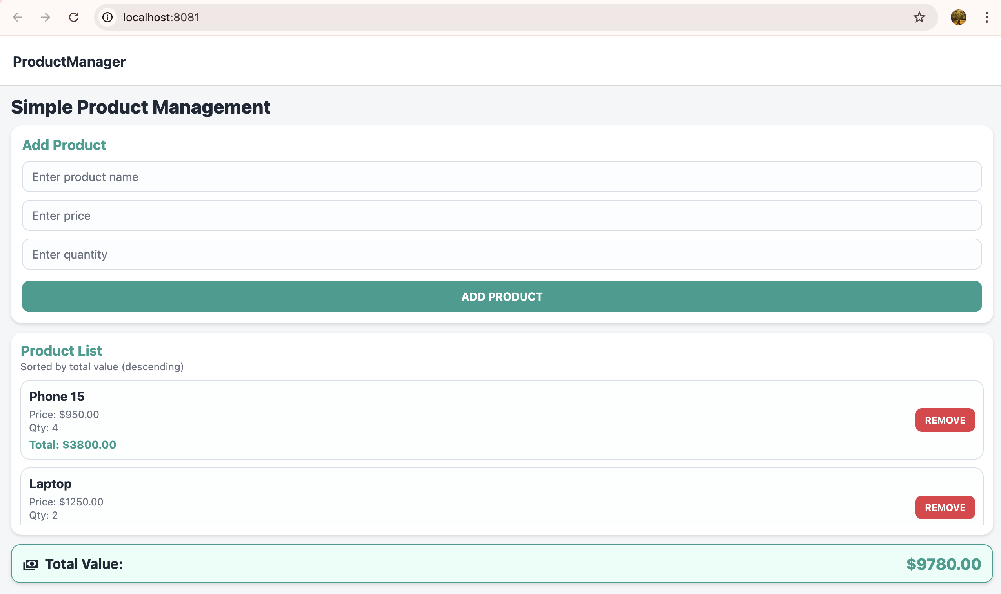
2.3 Product Details (ProductDetail)
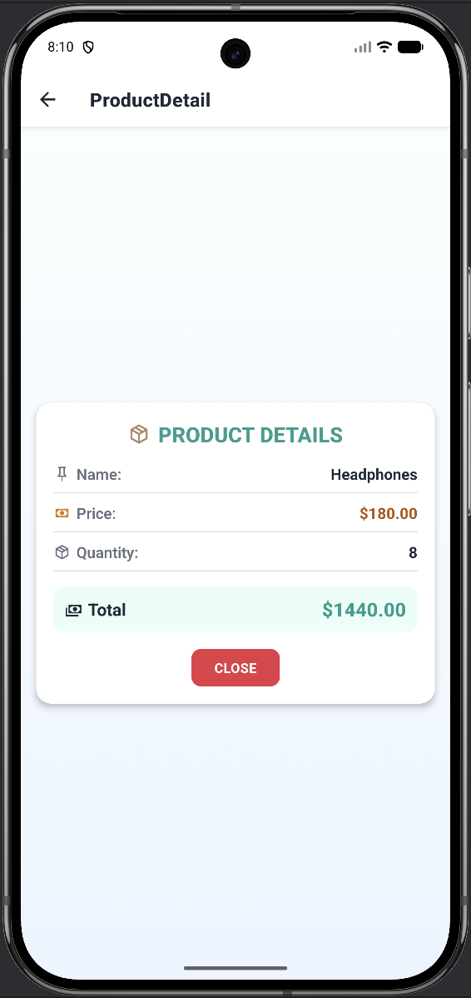 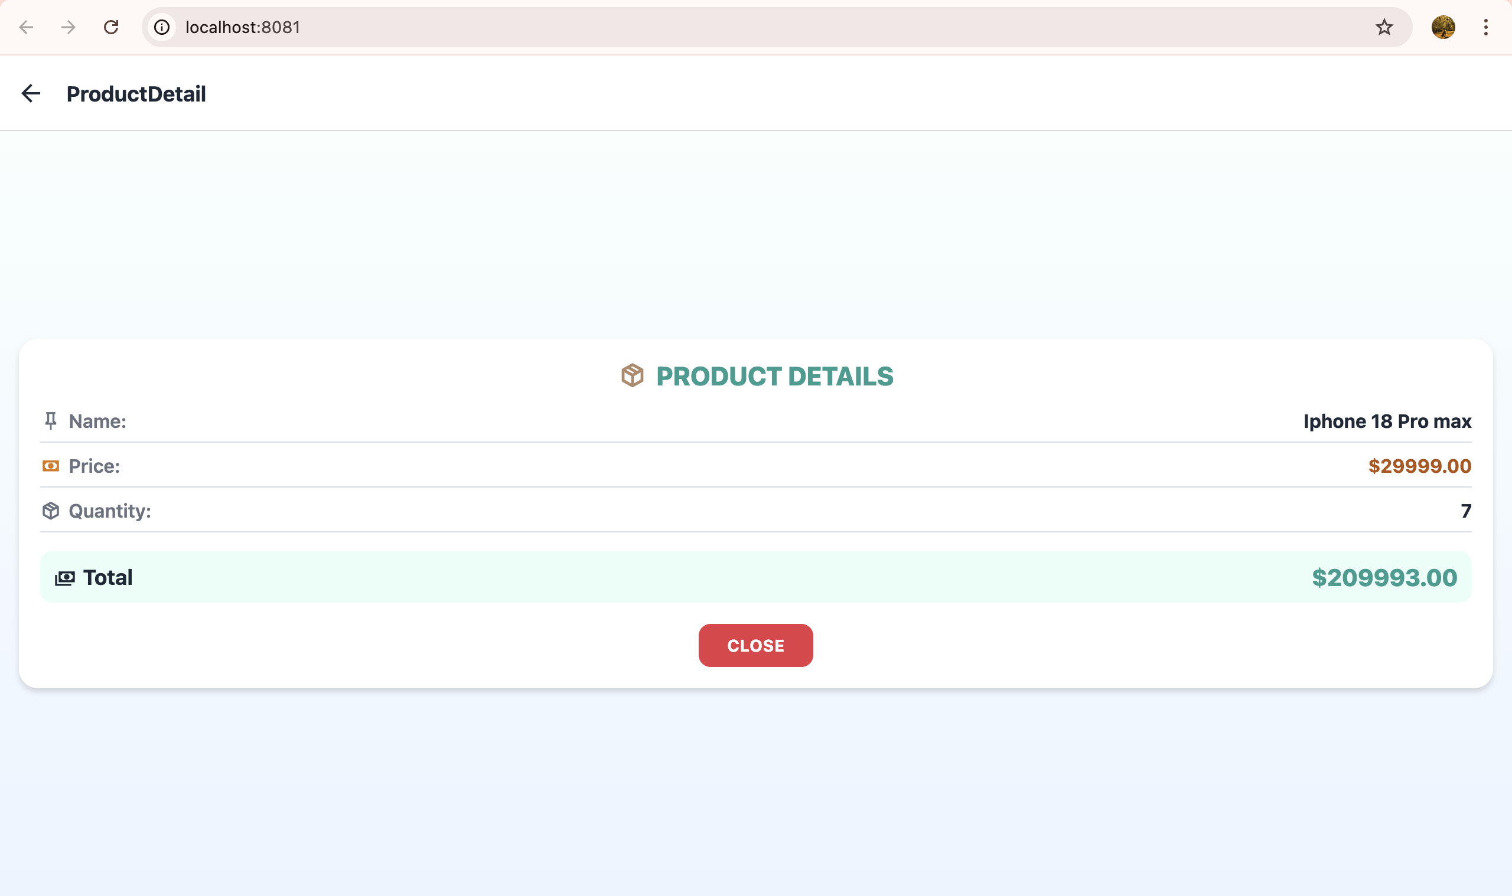
- Product Details: Tap a product to open ProductDetail. It displays the specific Name, Price, and Quantity for that item.
2.4 State Management (Products)
 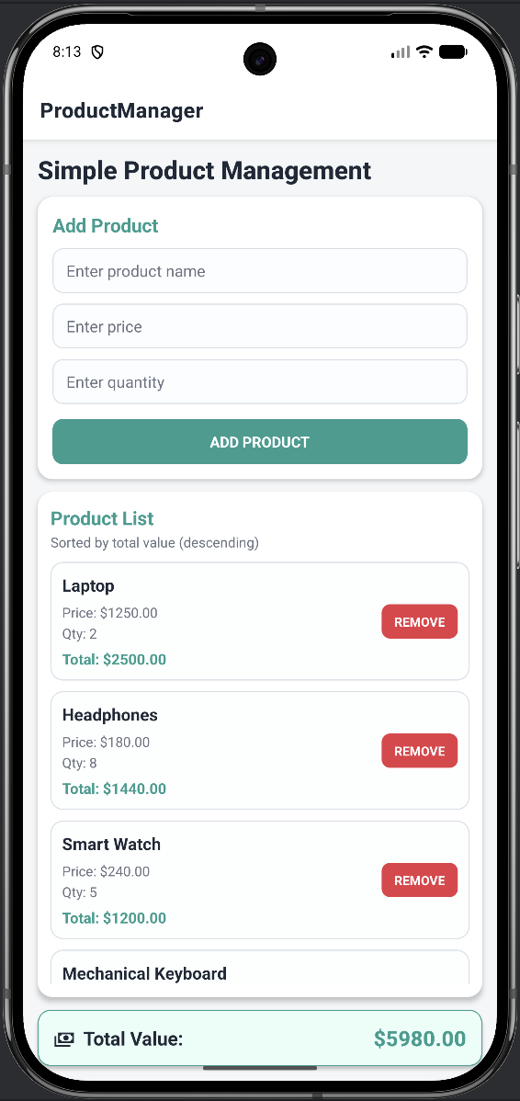 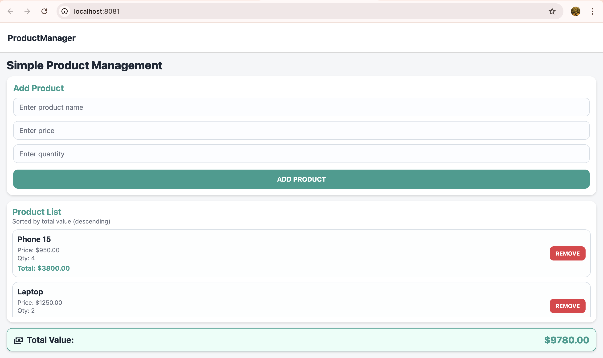

- Remove Product: Tap the red REMOVE button on any item in ListProduct.js. The total value at the bottom updates automatically.

2.5 Display Total Value (ProductManager)
 
- UI Requirements (Styles)
- Use StyleSheet for styling.
- The main components (Input, List, Product Details) should have:
+ Soft shadow effects for a modern look.
+ Rounded corners (borderRadius) for a smooth appearance.
+ Harmonious colors, suggested:
. Green (#2a9d8f) for positive elements.
. Red (#e63946) for alerts or product deletion.
. Proper spacing (padding/margin) for a clean layout.
- Total Value and Product Details should be highlighted using:
+ A different background color.
+ Larger font size for emphasis.

