There are usually three models of cloud service to compare: Software as a Service (SaaS), Platform as a Service (PaaS), and Infrastructure as a Service (IaaS). Each of these has its own benefits as well variances and it is necessary to understand the differences among SaaS, PaaS, and IaaS to know how to best choose one for your organization.

Summary of Key Differences

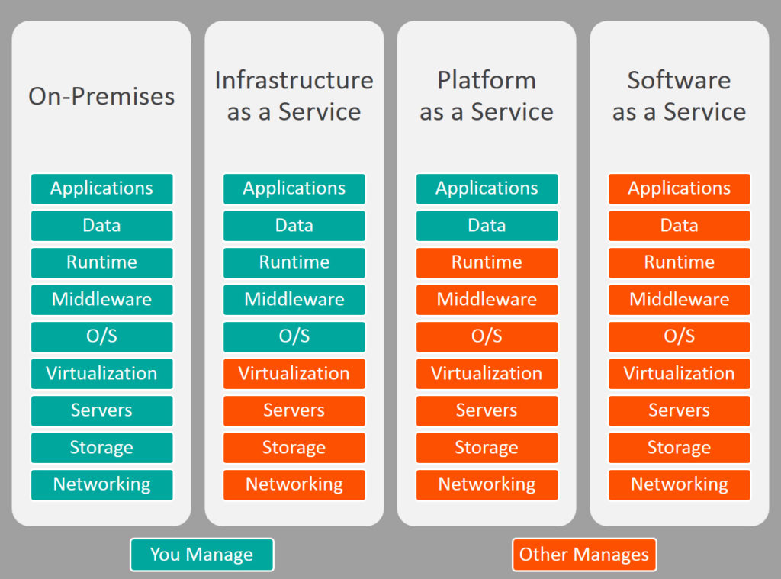

Common Examples of SaaS, PaaS, & IaaS

|  |  |
| --- | --- |
| **Platform Type** | **Common Examples** |
| **SaaS** | Google Apps, Dropbox, Salesforce, Cisco WebEx, Concur, GoToMeeting, Microsoft Office 365, DocuSign, Slack |
| **PaaS** | AWS Elastic Beanstalk, Windows Azure, Heroku, Force.com, Google App Engine, Apache Stratos, OpenShift |
| **IaaS** | DigitalOcean, Linode, Rackspace, Amazon Web Services (AWS), Cisco Metapod, Microsoft Azure, Google Compute Engine (GCE) |

**SaaS: Software as a Service**

Software as a Service, also known as cloud application services, represent the most commonly utilized option for businesses in the cloud market. SaaS utilizes the internet to deliver applications to its users, which are managed by a third-party vendor. A majority of SaaS applications are run directly through the web browser, and do not require any downloads or installations on the client side.

SaaS Delivery

Due to its web delivery model, SaaS eliminates the need to download and install applications on each individual computer; a nightmare for IT staff. With SaaS, vendors manage all of the potential technical issues, such as data, middleware, servers, and storage, while businesses can simply streamline their maintenance and support.

SaaS Advantages

SaaS provides numerous advantages to employees and companies by greatly reducing the time and money spent on tedious tasks such as installing, managing, and upgrading software. This frees up a lot of time for technical staff to spend on more pressing matters and issues within the organization.

SaaS Characteristics

There are a few ways to help you determine when SaaS is being utilized:

* Managed from a central location
* Hosted on a remote server
* Accessible over the internet
* Users not responsible for hardware or software updates

When to Use SaaS

There are many different situations in which SaaS may be the most beneficial, including:

* If you are a startup or small company that needs to launch ecommerce quickly and don’t have time for server issues or software
* For short-term projects that require collaboration
* If you use applications that aren’t in-demand very often, such as tax software
* For applications that need both web and mobile access

**Examples of SaaS**

Google Apps, Dropbox, Salesforce, Cisco WebEx, Concur, GoToMeeting, Microsoft Office 365, DocuSign, Slack

**Salesforce.com**

Arguably the quintessential Software as a Service application, Salesforce remains at the vanguard of the cloud computing revolution it helped create. The customer relations management solution enables businesses to collect all information on customers, prospects and leads within a single online platform, enabling authorized employees to access critical data on any connected device at any time.

**Microsoft Office 365**

Signature Microsoft productivity applications such as Word, Excel and PowerPoint are longtime staples of the workplace, but the cloud-based Microsoft Office 365 dramatically expands the Office suite’s parameters. Users now may create, edit and share content from any PC, Mac, iOS, Android or Windows device in real-time, connect with colleagues and customers across a range of tools from email to video conferencing and leverage a range of collaborative technologies supporting secure interactions both inside and outside of the organization.

**PaaS: Platform as a Service**

Cloud platform services, or Platform as a Service (PaaS), provide cloud components to certain software while being used mainly for applications. PaaS provides a framework for developers that they can build upon and use to create customized applications. All servers, storage, and networking can be managed by the enterprise or a third-party provider while the developers can maintain management of the applications.

Public PaaS is derived from software as a service (SaaS), and is situated in cloud computing between SaaS and infrastructure as a service (IaaS). SaaS is software that is hosted in the cloud, so that it doesn't take up hard drive from the computer of the user or the servers of a company. IaaS provides virtual hardware from a provider with adjustable scalability. With IaaS, the user still has to manage the server, whereas with PaaS the server management is done by the provider. Jelastic is the example of Public PaaS (still, the platform also provides Private and Hybrid types as well).

A private PaaS can typically be downloaded and installed either in a company's on-premises data center, or in a public cloud. Once the software is installed on one or more machines, the private PaaS arranges the application and database components into a single hosting platform.

Private PaaS vendors include Apprenda, which started out on the Microsoft .NET platform before rolling out a Java PaaS; Red Hat's OpenShift, Pivotal Cloud Foundry, Heroku and Platform.sh.[30]

Hybrid PaaS is typically a deployment consisting of a mix of public and private deployments.

PaaS Delivery

The delivery model of PaaS is similar to SaaS, except instead of delivering the software over the internet, PaaS provides a platform for software creation. This platform is delivered over the web, and gives developers the freedom to concentrate on building the software while still not having to worry about operating systems, software updates, storage, or infrastructure.

PaaS allows businesses to design and create applications that are built into the PaaS with special software components. These applications, or middleware, are scalable and highly available as they take on certain cloud characteristics.

PaaS Advantages

No matter what size of company you may be in, there are numerous advantages for using PaaS:

* Makes the development and deployment of apps simple and cost-effective
* Scalable
* Highly available
* Gives developers the ability to create customized apps without the headache of maintaining the software
* Greatly reduces the amount of coding
* Automates business policy
* Allows easy migration to the hybrid model

PaaS Characteristics

PaaS has many characteristics that define it as a cloud service, including:

* It is built on virtualization technology, meaning resources can easily be scaled up or down as your business changes
* Provides a variety of services to assist with the development, testing, and deployment of apps
* Numerous users can access the same development application
* Web services and databases are integrated

When to Use PaaS

There are many situations that utilizing PaaS is beneficial or even necessary. If there are multiple developers working on the same development project, or if other vendors must be included as well, PaaS can provide great speed and flexibility to the entire process. PaaS is also beneficial if you wish to be able to create your own customized applications. This cloud service also can greatly reduce costs and it can simplify some challenges that come up if you are rapidly developing or deploying an app.

Examples of PaaS

AWS Elastic Beanstalk, Windows Azure, Heroku, Force.com, Google App Engine, Apache Stratos, OpenShift

**IaaS: Infrastructure as a Service**

Cloud infrastructure services, known as Infrastructure as a Service (IaaS), are made of highly scalable and automated compute resources. IaaS is fully [self-service](https://www.bmc.com/blogs/self-service-thrives-clouds/) for accessing and monitoring things like compute, networking, storage, and other services, and it allows businesses to purchase resources on-demand and as-needed instead of having to buy hardware outright.

IaaS Delivery

IaaS delivers Cloud Computing infrastructure to organizations, including things such as servers, network, operating systems, and storage, through virtualization technology. These cloud servers are typically provided to the client through a dashboard or an API, and IaaS clients have complete control over the entire infrastructure. IaaS provides the same technologies and capabilities as a traditional data center without having to physically maintain or manage all of it. IaaS clients can still access their servers and storage directly, but it is all outsourced through a “virtual data center” in the cloud.

As opposed to SaaS or PaaS, IaaS clients are responsible for managing aspects such as applications, runtime, OSes, middleware, and data. However, providers of the IaaS manage the servers, hard drives, networking, virtualization, and storage. Some providers even offer more services outside of the virtualization layer, such as databases or message queuing.

IaaS Advantages

There are many benefits of choosing IaaS, such as that it:

* Is the most flexible cloud computing model
* Easily allows for automated deployment of storage, networking, servers, and processing power
* Hardware can be purchased based on consumption
* Gives clients complete control of their infrastructure
* Resources can be purchased as-needed
* Is highly scalable

IaaS Characteristics

Some characteristics to look for when considering IaaS are:

* Resources are available as a service
* The cost varies depending on consumption
* Services are highly scalable
* Typically includes multiple users on a single piece of hardware
* Provides complete control of the infrastructure to organizations
* Dynamic and flexible

When to Use IaaS

Just as with SaaS and PaaS, there are specific situations when it is the most advantageous to use IaaS. If you are a startup or a small company, IaaS is a great option so you don’t have to spend the time or money trying to create hardware and software. IaaS is also beneficial for large organizations who wish to have complete control over their applications and infrastructures, but are looking to only purchase what is actually consumed or needed. For rapidly growing companies, IaaS can be a good option as you don’t have to commit to a specific hardware or software as your needs change and evolve. It also helps if you are unsure what demands a new application will need as there is a lot of flexibility to scale up or down as needed.

Examples of IaaS

There are many examples of IaaS vendors and products. AWS offers storage services such as Simple Storage Services (S3) and Glacier, as well as compute services, including its Elastic Compute Cloud (EC2). GCP offers storage and compute services through Google Compute Engine (GCE), as does Microsoft Azure.

SaaS vs PaaS vs IaaS

Overall, each cloud model offers its own specific features and functionalities, and it is crucial for your organization to understand the differences. Whether you are looking for cloud-based software for storage options, a smooth platform that allows you to create customized applications, or are wanting complete control over your entire infrastructure without having to physically maintain it, there is a cloud service for you. No matter which option you choose, [migrating to the cloud](https://www.bmc.com/blogs/new-multi-cloud-world-means/) is the future of business and technology as we know it, and it is necessary to be properly informed.