**1. Introduction**

1.1.  Purpose and Scope

1.2.  Product Overview (including capabilities, scenarios for using the product, etc.)

1.3.  Structure of the Document

1.4.  Terms, Acronyms, and Abbreviations

**2. ProjectManagementPlan**

2.1.  Project Organization

Project Organization:

* Project Manager: Responsible for overseeing the project from start to finish, ensuring that it stays on track, meets its goals and objectives, and is delivered on time and within budget.
* Business Analyst: Responsible for gathering the requirements of the software, working closely with stakeholders to understand their needs, and documenting the requirements in a clear and concise manner.
* Development person: Responsible for developing the software, including front-end and back-end developers, database developers, and testers.
* Technical Writer: Responsible for documenting the software development process, including user manuals, technical specifications, and other documentation.
* Quality Assurance person: Responsible for testing the software to ensure that it meets the requirements, is free of bugs and errors, and is user-friendly.
* Deployment member: Responsible for deploying the software to the production environment, ensuring that it is installed and configured correctly, and that it is available to users.
* Support person: Responsible for providing technical support to users, including training, troubleshooting, and bug fixes.
* Stakeholders: The stakeholders of the project include the distributor, authorized resellers and agents, accountants, and end-users. They will provide input and feedback throughout the development process to ensure that the software meets their needs and requirements.

2.2.  Lifecycle Model Used

2.3.  Risk Analysis

- Delay in software development due to unexpected technical issues

- Misunderstanding of requirements leading to a software system that does not meet the needs of the distributor

- Inadequate user training leading to low user adoption and satisfaction

- Lack of communication between the development team and the distributor leading to misalignment in expectations

2.4.  Hardware and Software Resource Requirements

(Do not forget to describe what *new* software or hardware each team member learned during the project)

Hardware Requirements:

- Server hardware: A server to host the software system with enough storage capacity, processing power, and memory to handle the expected traffic and data storage needs.

- Workstations: Workstations for the accountants to access the system, create goods received, delivery notes, and view reports.

- Network hardware: Routers, switches, and cabling to connect the workstations and server.

Software Requirements:

- Operating System: A server operating system such as Windows Server or Linux to host the software system.

- Web Server: A web server such as IIS or Apache to host the web application for agents to place orders and view order status.

- Database Server: A database server such as SQL Server or MySQL to store the data of the system.

- Programming Languages: Depending on the chosen development platform, the software system can be developed using languages such as C#, Python, or Java.

- Development Tools: Integrated Development Environment (IDE) such as Visual Studio or Eclipse, to develop and debug the software system.

- Third-party libraries and frameworks: There are numerous third-party libraries and frameworks available to expedite development and add functionality to the software system.

2.5.  Deliverables and Schedule

- Project Start Date: May 15, 2023

- Project End Date: August 30, 2023

- Milestones:

- Requirements gathering and analysis: May 15-25, 2023

- Software design and architecture: May 26 - June 15, 2023

- Software development: June 16 - August 15, 2023

- User testing and quality assurance: August 16 - August 25, 2023

- Deployment and user training: August 26 - August 30, 2023

2.6.  Monitoring, Reporting, and Controlling Mechanisms

2.7.  Professional Standards

As a distributor selling mobile phone products to authorized reseller/agents, there are several professional standards that you need to adhere to. These include:

* Accuracy: You must ensure that all orders are accurate and processed in a timely manner. The software should have the ability to create Goods Received when the distributor imports goods, and warehouse receipts should include many items.
* Payment Options: Reseller/Agents should be able to place an order of items and choose a payment method such as Cash, bank transfer, or mobile money. The software should allow them to make online payments and see the status of their orders.
* Delivery: Accountants should be able to create Goods Delivery Note to deliver goods to agents and print delivery slips. They should also be able to update the status of orders as being transferred and update the payment status of agents.
* Reports: Accountants should be able to view incoming/outgoing stock reports, best-selling products, and revenue reports monthly. The software should have the ability to generate these reports in a user-friendly format, either as forms or reports.

Overall, the software should be user-friendly, secure, and efficient, with clear communication between the distributor, reseller/agents, and accountants. The Win Form or Web Form should be accessible to all parties involved, and the software should provide real-time updates and notifications on order status, payment status, and delivery status.

2.8.  Evidence all the artifacts have been placed under configuration management

2.9.  Impact of the project on individuals and organizations

(Include a description of what impact your project will have on individuals and society)

The impact of implementing this software project for a distributor selling mobile phone products to authorized reseller/agents can be significant for both individuals and the organization. Some of the potential impacts include:

* Increased efficiency: The software can streamline the entire ordering and delivery process, making it faster and more efficient. This will save time for both the distributor and the reseller/agents, allowing them to focus on other aspects of their business.
* Improved accuracy: The software will reduce the likelihood of errors in order processing and tracking, leading to improved accuracy in inventory management and financial reporting.
* Enhanced customer satisfaction: Reseller/Agents will be able to place orders and make payments easily and quickly, while also being able to track the status of their orders. This can lead to improved customer satisfaction and loyalty.
* Better financial management: The software will provide accountants with real-time data on incoming/outgoing stock, best-selling products, and revenue reports. This will enable better financial management and decision-making.
* Improved transparency: The software will enable better communication and transparency between the distributor, reseller/agents, and accountants. This can lead to a more collaborative and efficient working relationship between these parties.

Overall, implementing this software project can lead to significant benefits for the distributor and its stakeholders, including increased efficiency, improved accuracy, better financial management, enhanced customer satisfaction, and improved transparency.

**3. Requirement Specifications**

3.1.  Stakeholders for the system

The stakeholders for the system of a distributor selling mobile phones products to authorized reseller/agents with the aforementioned functions include:

* Distributor: The distributor is the primary stakeholder in this project. They will benefit from the software by streamlining the ordering and delivery process, improving inventory management, and enhancing financial reporting.
* Accountants: The accountants will use the software to manage the financial aspects of the distributor's business, including creating goods received and delivery notes, tracking payment status, and generating reports.
* Reseller/Agents: The reseller/agents will use the software to place orders, choose payment methods, make payments, and track the status of their orders.
* Customers: The end customers who purchase the mobile phone products from the reseller/agents will benefit indirectly from the system by receiving faster and more efficient service.
* Suppliers: The suppliers who provide the mobile phone products to the distributor will benefit from the system by having a more efficient and accurate ordering and delivery process.

Overall, the stakeholders for this system are diverse and include the distributor, accountants, reseller/agents, customers, and suppliers. The system will benefit all of these stakeholders by improving the ordering and delivery process, enhancing financial reporting, and providing faster and more efficient service to customers.

3.2.  Use case model

3.2.1.  Graphical use case model

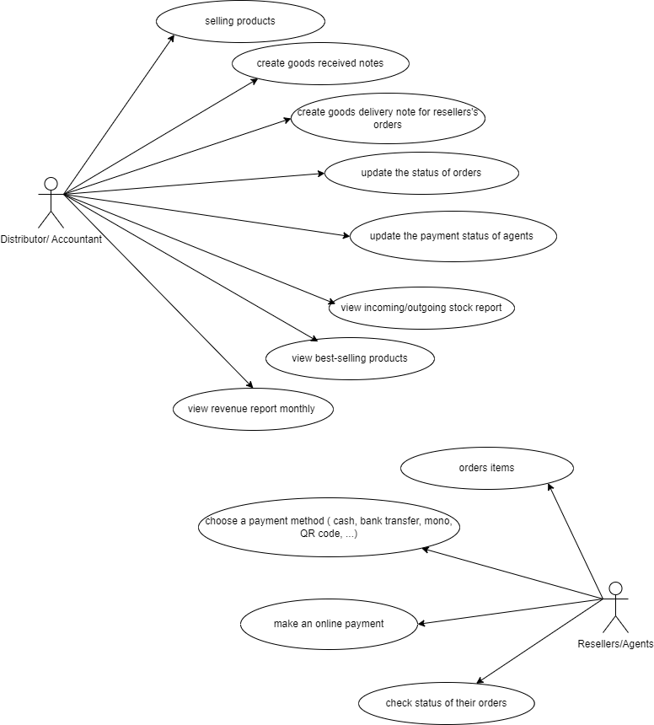

3.2.2.  Textual Description for each use case

1. Sell Goods: Allows the Distributor to sell products to Reseller/Agents.
2. Create Goods Received: Allows the Accountants to create Goods Received records when the Distributor imports goods.
3. Create Goods Delivery Note: Allows the Accountants to create Goods Delivery Note to deliver goods to Reseller/Agents.
4. View Stock Report: Allows the Accountants to view the stock report and monitor inventory levels.
5. View Best-Selling Products: Allows the Accountants to view the best-selling products report and optimize inventory based on demand.
6. View Revenue Report: Allows the Accountants to view the revenue report and monitor the financial performance of the system.
7. Place an Order of Items: Allows Reseller/Agents to place an order of items in the system.
8. Choose Payment Method: Allows Reseller/Agents to choose a payment method for their orders.
9. Make an Online Payment: Allows Reseller/Agents to make an online payment for their orders.
10. See Status of Orders: Allows Reseller/Agents to see the status of their orders in the system.

3.3.  Functional requirements

The following are the functional requirements for the software that a distributor selling mobile phones products to authorized reseller/agents needs to have:

* Goods Received Functionality:
  + Accountants should be able to create a Goods Received Note (GRN) when the distributor imports goods.
  + The GRN should include details of the received items, such as the product code, name, quantity, and unit price.
  + The system should allow the accountant to update the inventory and financial records upon receipt of the goods.
* Order Management Functionality:
  + Resellers/Agents should be able to place an order for items through a web form.
  + The system should allow them to select the products they want to order, choose a payment method, and see the status of their orders.
  + The system should allow the accountant to update the order status as being transferred and the payment status of agents.
  + The system should allow reseller/agents to make online payments.
* Goods Delivery Functionality:
  + Accountants should be able to create a Goods Delivery Note (GDN) to deliver goods to agents.
  + The GDN should include details of the delivered items, such as the product code, name, quantity, and unit price.
  + The system should allow the accountant to update the inventory and financial records upon delivery of the goods.
  + The system should allow the accountant to print delivery slips.
* Reports Functionality:
  + Accountants should be able to view incoming/outgoing stock reports, best-selling products, and revenue reports monthly.
  + The system should generate reports based on the data entered into the system.
  + The system should allow the accountant to filter and sort the data based on different criteria.

Overall, the functional requirements for the software should include the ability to manage the ordering and delivery process, track inventory, and generate financial reports. The system should be user-friendly and should provide the necessary functionalities to ensure smooth operations for the distributor, resellers/agents, and accountants.

3.4.  Non-functional requirements

Some non-functional requirements that might apply to this system include:

* Security: The system should have adequate security measures in place to prevent unauthorized access, data breaches, and other security threats.
* Reliability: The system should be reliable and available at all times, with minimal downtime or maintenance requirements.
* Scalability: The system should be designed to handle a growing number of users and transactions over time, without significant performance degradation.
* Usability: The system should be easy to use and intuitive, with a user-friendly interface that requires minimal training for users.
* Performance: The system should be able to handle a large volume of transactions and data processing quickly and efficiently, without significant delays or errors.
* Compatibility: The system should be compatible with a wide range of hardware and software platforms, to ensure that it can be used by all stakeholders.
* Maintainability: The system should be easy to maintain and upgrade over time, with a modular architecture and clear documentation to facilitate future changes and updates.

**4. Architecture**

4.1.  Architectural style(s) used

4.2.  Architectural model

4.3.  Technology, software, and hardware used

4.4.  Rationale for your architectural style and model

**5. Design**

5.1.  Database design

5.2.  Static model – class diagrams

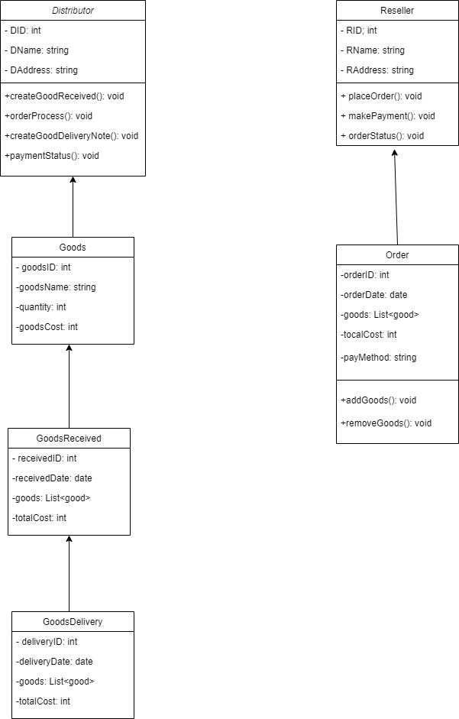

5.3 Dynamic model – sequence diagrams

In this sequence diagram, the Distributor and Reseller/Agent are represented as two actors. The sequence of interactions between the actors and the system is shown through arrows.

The first interaction is when the distributor creates a Goods Received record, which triggers the system to update the inventory. The reseller/agent can then place an order and choose a payment method, which is confirmed by the system. After payment confirmation, the system creates a Goods Delivery Note for the distributor to deliver the products to the reseller/agent.

The status of delivery and payment is updated in the system when goods are delivered, which helps in keeping track of the inventory and revenue. Finally, accountants can view reports on incoming/outgoing stock, best-selling products, and revenue on a monthly basis.

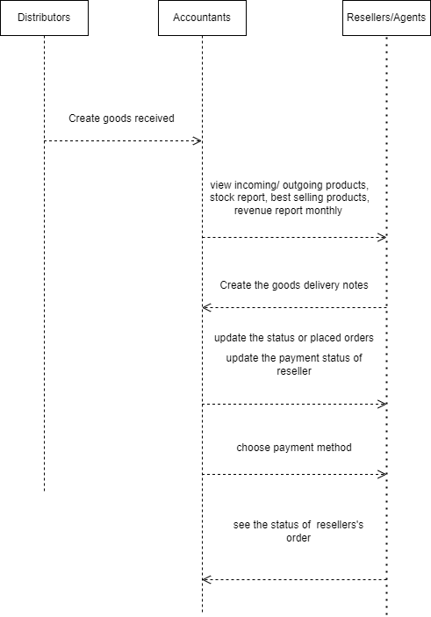

5.4. Rationale for your detailed design model  
5.5. Traceability from requirements to detailed design model

**6. TestPlan**

6.1.  Requirements/specifications-based system level test cases

6.2.  Traceability of test cases to use cases

6.3.  Techniques used for test generation

6.4.  Assessment of the goodness of your testsuite (Which metrics were used for such assessment?)

**7. Demo**

7.1.  Database

7.2.  Source code

7.3.  Testing