static_IP: String

login_page: class

login_form: class

device_series_number: String

device_ID: String

username: String

password: String

dashboard: class

onboard_IO: class

element[]: class

ID: String

description: String

value_state: integer 32 bit number (int/long – dependent on cpu)

alarm_control: String

external_device: class

element[]: class

ID: String

device_state: enum{QUESTION_MARK, PAUSE, PLAY} //detail image

device: String

tag_name: String

value_state: integer 32 bit number (int32_t)

alarm_control: String

event_log: class

element[]: class

date_time: DateTime

***type: enum{} //not sure which values inside the enum //detail image

message: String

sms_log: class

element[]: class

date_time: String

***type: enum{} //not sure which values inside the enum //detail image

message: String

IO_configuration: class

digital_input: class

element[]: class

input_description: String

open_status: String

delay_close_to_open: unsigned integer 32 bit number (uint32_t)

close_status: String

delay_open_to_close: unsigned integer 32 bit number (uint32_t)

alarm_state: enum{NONE, OPEN, CLOSE}

operation_contacts: class

contact_select[]: bool

select_all_contact: bool

disable_sms_email: bool

analog_input: class

element[]: class

description: String

unit: String

engineering_value_at_4mA: signed integer 32 bit number (int32_t)

engineering_value_at_20mA: signed integer 32 bit number (int32_t)

hysteresis_in_engineering_unit: signed integer 32 bit number (int32_t)

offset_value: signed integer 32 bit number (int32_t)

low_alarm: class

alarm_enable: bool

alarm_value: signed integer 32 bit number (int32_t)

high_alarm: class

alarm_enable: bool

alarm_value: signed integer 32 bit number (int32_t)

operation_contacts: class

contact_select[]: bool

select_all_contact: bool

disable_sms_email: bool

digital_output:

element[]: class

description: String

enable_logic: bool

remote_override: bool

logic_expession: String

output_type: enum{ON, PULSATING, DELAY_ON, ONE_SHOT}

pulsating: class

on_period: unsigned integer 32 bit number (uint32_t)

off_period: unsigned integer 32 bit number (uint32_t)

delay_on: unsigned integer 32 bit number (uint32_t)

one_shot_on: unsigned integer 32 bit number (uint32_t)

phone_group: class

operation_number: class

element[]: class

phone_number: String

email: String

name: String

escalation_number: class

element[]: class

phone_number: String

name: String

timer: unsigned integer 32 bit number (uint32_t)

authorized_number: class

phone_number: String

name: String

forwarding_number:

phone_number: String

name: String

modbus_configuration: class

modbus_setting: class

enable: bool

baud_rate: unsigned integer 32 bit number (uint32_t)

parity: enum{NODE, ODD, EVEN}

data_bits: unsigned integer 8 bit number (uint8_t)

stop_bits: unsigned integer 8 bit number (uint8_t)

modbus_device: class

element[]: class

device_name: String

device_ID: unsigned integer 8 bit number (uint8_t)

modbus_type: enum{RTU, TCP}

baud_rate : unsigned integer 32 bit number (uint32_t)

parity: enum{NODE, ODD, EVEN}

data: unsigned integer 8 bit number (uint8_t)

stop: unsigned integer 8 bit number (uint8_t)

timeout: unsigned integer 32 bit number (uint32_t)

polled: bool

interval: unsigned integer 32 bit number (uint32_t)

tag: class //detail image

element[]: class

ID: String

name: String

tag_address: unsigned integer 32 bit number (uint32_t)

tag_type: enum{BIT, UNSIGNED_INT_16BIT}

raw_value: unsigned integer 16 bit number (uint16_t)

parameterize: bool

modbus_IO_configuration: class

modbus_digital_input_channel: class

ID: String

device: String

tag (tag name): String

open_status: String

close_status: String

alarm_state: enum{NONE, OPEN, CLOSE}

operation_contacts: class

contact_select[]: bool

select_all_contact: bool

disable_sms_email: bool

modbus_register: class

ID: String

device: String

tag (tag_name): String

unit_mask: String

scale_offset: class

enable: bool

scale: unsigned integer 32 bit number (uint32_t)

offset: signed integer 32 bit number (int32_t)

hysteresis: signed integer 32 bit number (int32_t)

low_alarm: class

alarm_enable: bool

alarm_value: signed integer 32 bit number (int32_t)

high_alarm: class

alarm_enable: bool

alarm_value: signed integer 32 bit number (int32_t)

operation_contacts: class

contact_select[]: bool

select_all_contact: bool

disable_sms_email: bool

modbus_digital_output_channel: class

ID: String

device: String

tag (tag name): String

enable_logic: bool

remote_override: bool

logic_expression: String

output_type: enum{ON, PULSATING, DELAY_ON, ONE_SHOT}

pulsating: class

on_period: unsigned integer 32 bit number (uint32_t)

off_period: unsigned integer 32 bit number (uint32_t)

delay_on: unsigned integer 32 bit number (uint32_t)

one_shot_on: unsigned integer 32 bit number (uint32_t)

system_configuration: class

change_password: class

current_password: String

new_password: String

verified_password: String

change_device_ID: class

device_ID: String

change_date_and_time: class

yyyy: unsigned integer 16 bit number (uint16_t)

mm: unsigned integer 16 bit number (uint16_t)

dd: unsigned integer 16 bit number (uint16_t)

hh: unsigned integer 16 bit number (uint16_t)

mimi: unsigned integer 16 bit number (uint16_t)

ss: unsigned integer 16 bit number (uint16_t)

change_NTP_server_setting: class

enable: bool

server: String

time_zone: unsigned integer 16 bit number (uint16_t)

LAN_configuration: class

dynamic_IP _check: bool

IP_address: String

gateway: String

subnet_mask: String

DNS: String

auto_health_check:

enable: bool

*** auto_health_check_day: enum{} //not sure which values inside the enum

hh: unsigned integer 16 bit number (uint16_t)

mm: unsigned integer 16 bit number (uint16_t)

cellular_network_connection: class

sim_card_pin: String

data_access: class

APN: String

username: String

password: String

HTTP_publishing: bool

server: String

port: unsigned integer 16 bit number (uint16_t)

req_uri: String

interval: unsigned integer 16 bit number (uint16_t)

***report_format: enum{} //not sure which values inside the enum

reporting: class

enable: bool

TLS: bool

server: String

port: unsigned integer 16 bit number (uint16_t)

from_addr: String

username: String

password: String

SMS_setting: class

send_sms_to_mobie_phone: class

destination: String

message: String

repeat_sms_on_alarm_state: enum{UNLIMITED, NONE, ONE_TIME, TWO_TIME, THREE_TIME, FOUR_TIME}

SMS_repeat_interval: unsigned integer 16 bit number (uint16_t)

send_sms_when_status_returns_to_normal: bool

maintenance:

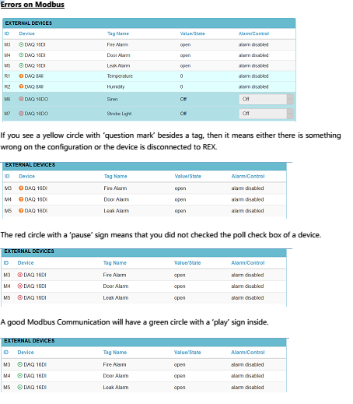

Hình : Modbus device state

