Câu 1

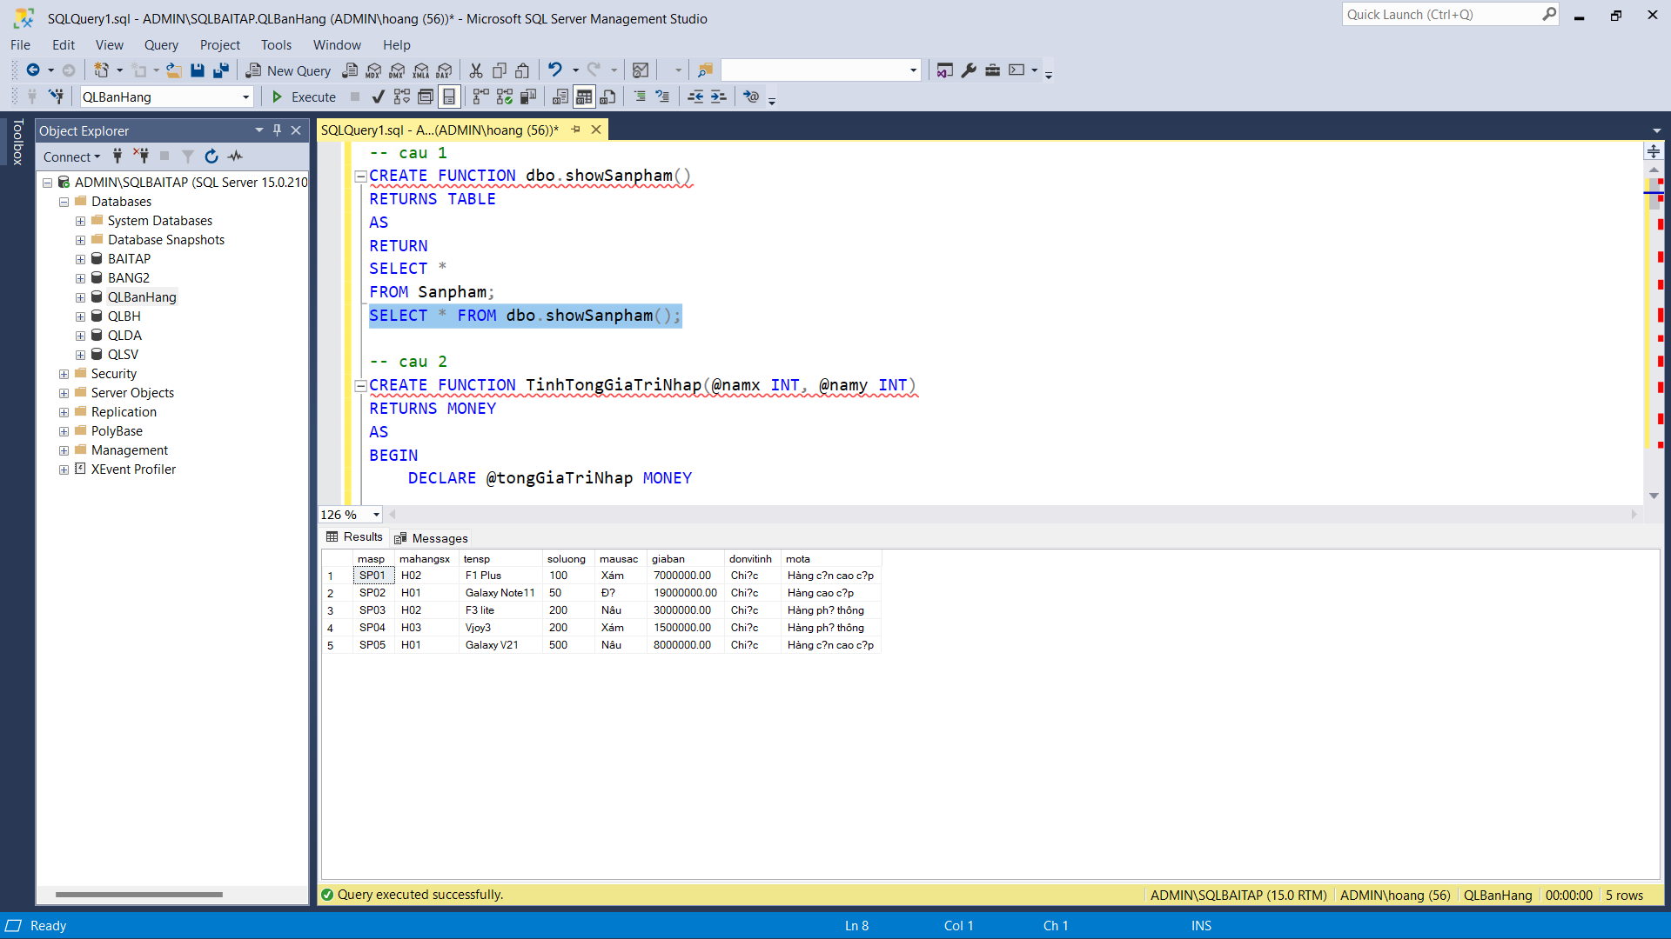

Câu 2

Câu 3

Câu 4

Câu 5

Câu 6

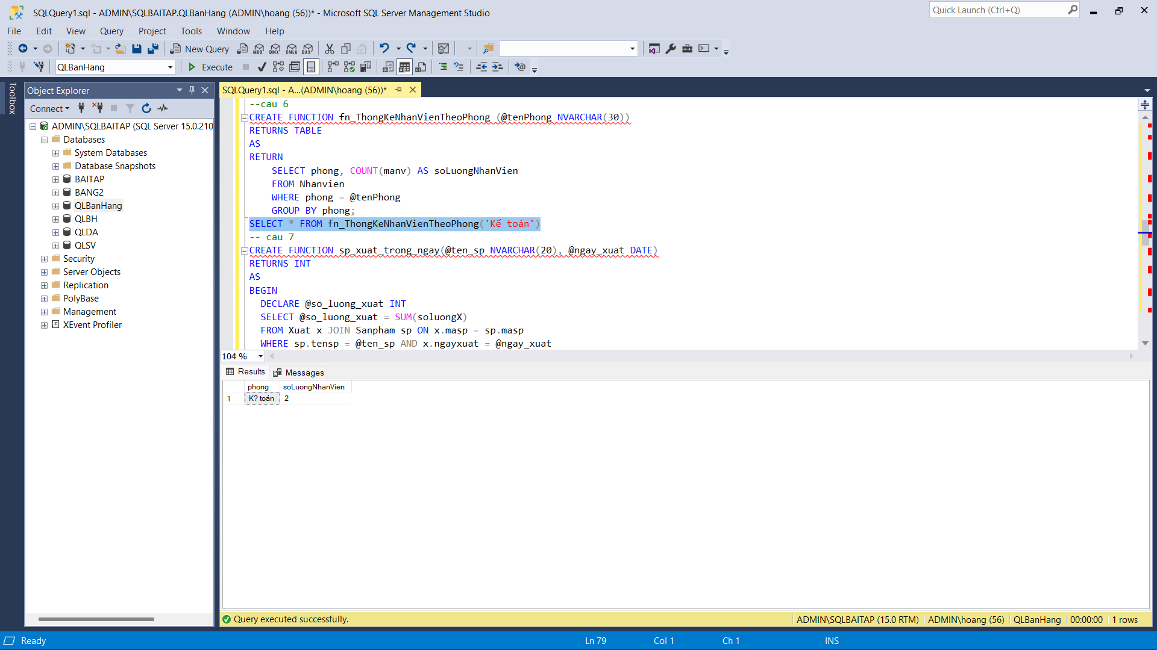

Câu 7

Câu 8

Câu 9

Câu 10

