Link Ref: <https://www.youtube.com/watch?v=SuZa2nv24HE&list=PL_qizAfcpJ-MTpfAPtayiKeJ0OexCcxvh>

Angular: Introduction, Versioning, Releases

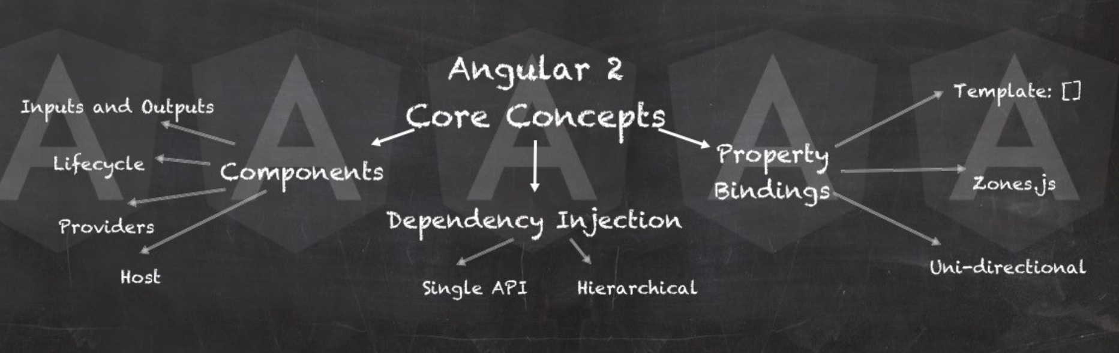

What is Angular?

Là 1 platform and framework for build client application in HTML and Typescript.

Phát triển bởi: Google

