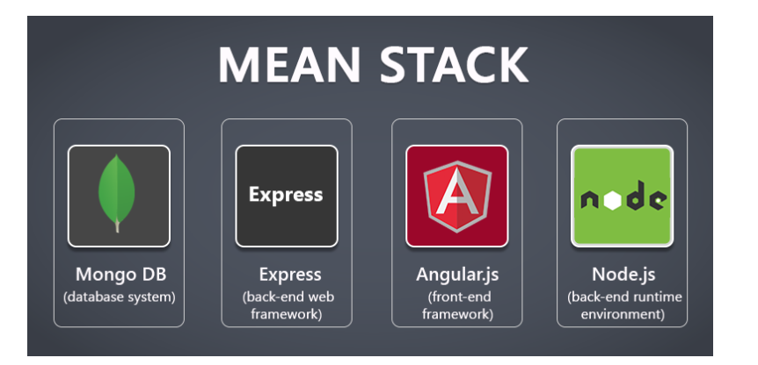

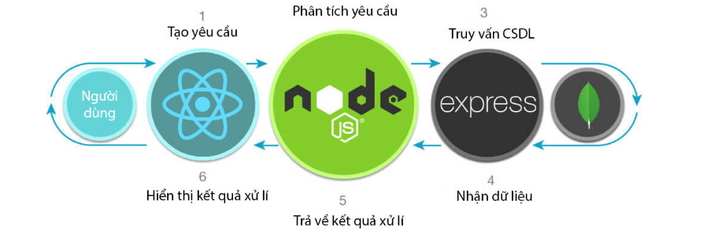

**Mobile Frontend**

React Native

**Desktop app**

ElectronJs