Link Ref: <https://gist.github.com/hofmannsven/9164408>

|  |  |
| --- | --- |
| B1: Mysql –u root –p |  |
| B2: Show databases; |  |
| B2: Create database test; | Create database: test |
| Use test; | Access to databse: test |
| Select database(); |  |
| Drop database if exists test; | Remove database |
| Describe student | Show information table: student |
| Select * from students; |  |
| Alter table test => add maxscore int not null after type |  |
| Alter table score change event_id student_id => int unsinged not null |  |
| Rename table => absence to absences; |  |
| Alter table absences => drop column test_taken |  |

**Create table:**

B1: use test

B2: 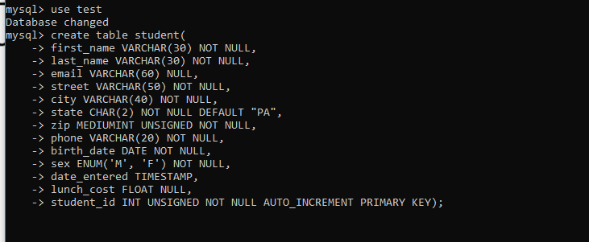

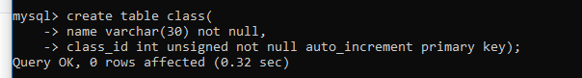

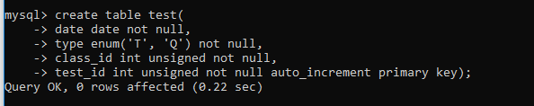

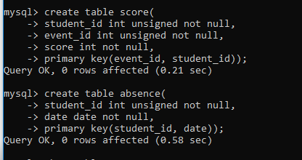

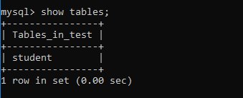

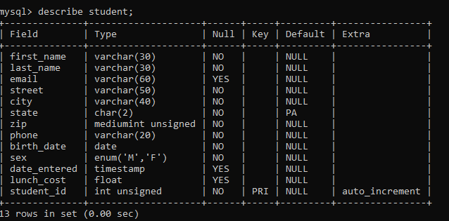

**Inset table**

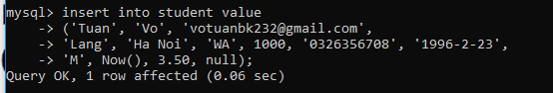

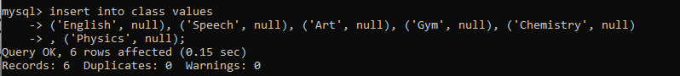



**Foreign Key:**

+ references to primary key of another table

+ tên có thể khác khóa chính

+ giá trị có thể null

+ là duy nhất

**Alter table**

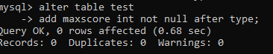

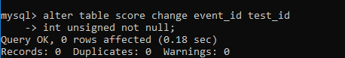

**Query:**

