**Link Ref:** <https://www.youtube.com/watch?v=PFmuCDHHpwk>

**4 Trụ cột**

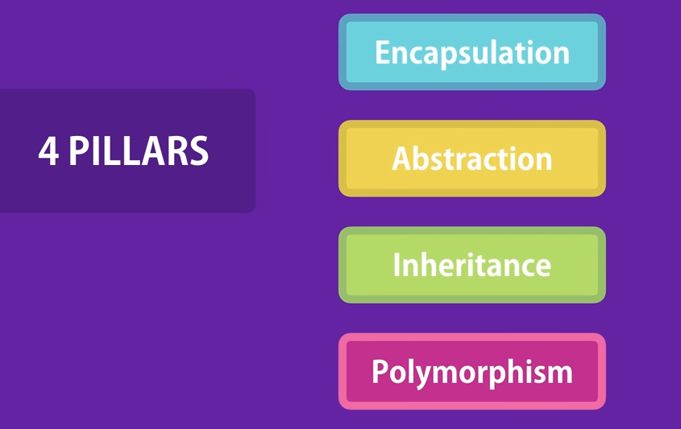

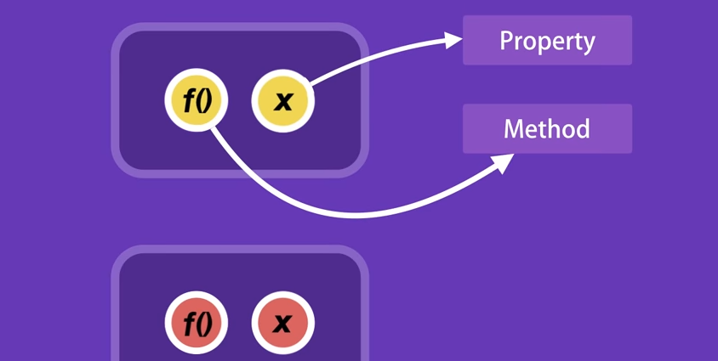

**The best function are those with no parameters**

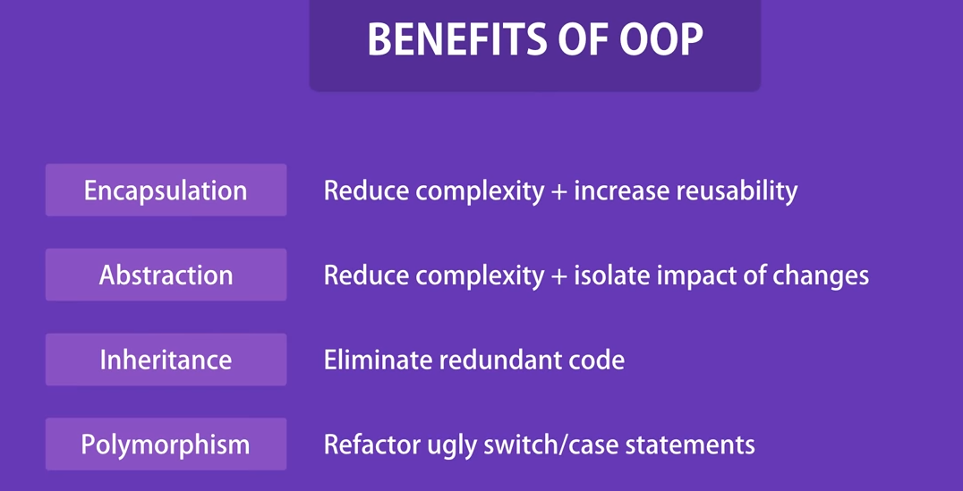

Object

