Dữ liệu tại foder Dump20241005



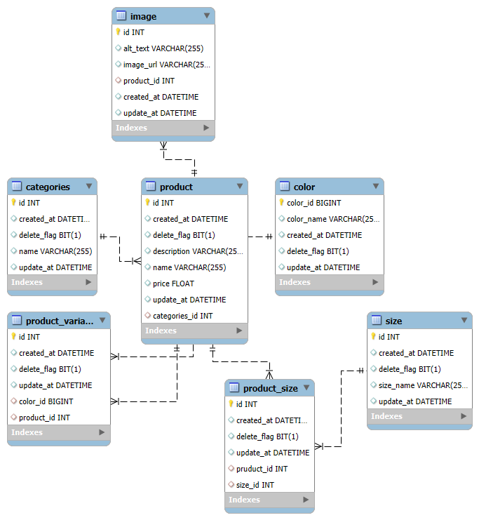

Categories

<http://localhost:8001/size/add>

<http://localhost:8001/categories/addAll>

Product

1.Api

// Add a single product @PostMapping("/add")

<http://localhost:8001/api/add>

//Add a new product @GetMapping("/{id}")

[http://localhost:8001/api/{id}](http://localhost:8001/api/%7bid%7d)

//Get product by ID @PostMapping

<http://localhost:8001/api>

//Add multiple products @PostMapping("/addAll")

<http://localhost:8001/api/addAll>

//Update a product @PutMapping("/{id}")

[http://localhost:8001/api/{id}](http://localhost:8001/api/%7bid%7d)

// Delete a product @DeleteMapping("/{id}")

[http://localhost:8001/api/{id}](http://localhost:8001/api/%7bid%7d)

2.Web

// Home @GetMapping("/home")

<http://localhost:8001/product/home>

//product detail @GetMapping("/detail/{id}")

[http://localhost:8001/product/detail/{id}](http://localhost:8001/product/detail/%7bid%7d)

Color

// Add multiple colors at once, @PostMapping("/addAll")

<http://localhost:8001/colors/addAll>

[ { "colorName": "Red", "deleteFlag": false }, { "colorName": "Blue", "deleteFlag": false }, { "colorName": "Green", "deleteFlag": false } ]

// Get all colors

<http://localhost:8001/colors>

// Get color by ID

[http://localhost:8001/colors/{id}](http://localhost:8001/colors/%7bid%7d)

// Add a single color

<http://localhost:8001/colors>

// Delete color by ID @DeleteMapping("/{id}")

<http://localhost:8001/colors>/{ id }