Mikko Karkkainen 2/2/2017

11740378

Homework 3

**2.9 Construct the potential-pH diagram for zinc using the following reactions and assuming the activity of all dissolved substances is $10^{-6}$. Assume any other reactions necessary to complete the diagram using the diagram for aluminium, Figure 2.11a, as a guide.**

**(1) $Zn=Zn^{2+}+2e^{-}$ $E^{0}=-0.763 V$**

**(2) $Zn+H_{2}O=ZnO+2H^{+}+2e^{-}$ $E^{0}=-0.439 V$**

**(3) $Zn+{2H}_{2}O=ZnO_{2}^{2-}+4H^{+}+2e^{-}$ $E^{0}=+0.441 V$**

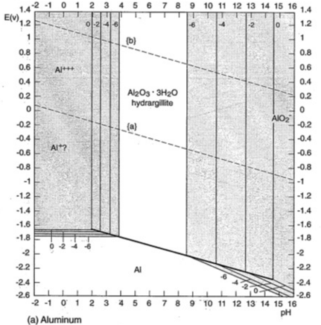

Figure 1. Pourbaix diagram for aluminum. Shaded areas indicate corrosion susceptibility. Labels 0, -2, -4 and -6 are the log of soluble ion activity for the indicated lines. Dashed line (b) is for reaction O2+4H+4e- = 2H2O. Dashed line (a) is for 2H+ + 2e- = H2. Source : M. Pourbaix, Atlas of Electrochemical equilibria in aqeous solutions, as referenced by Denny A. Jones: Principles and prevention of corrosion.

We notice that the standard potentials given in the assignment are the standard reduction potentials. Hence, we use the Nernst equation for the reduction equation:

|  |  |
| --- | --- |
| $$E=E^{0}-\frac{RT}{zF}\ln\left(\frac{a_{RED}}{a_{OX}}\right)$$ | (4) |

Where $a_{RED}$ is the activity of the reduction reaction, $a_{OX}$ is the activity of the oxidization reaction and $E^{0}$ is the standard reduction potential. Converting from ln to log, and assuming standard conditions:

$$E=E^{0}-2.30326\frac{RT}{zF}\log{\frac{a_{RED}}{a_{OX}}}=E^{0}-\frac{0.05916}{z}\log{\frac{a_{RED}}{a_{OX}}}$$

Applying equation 4 to reaction 1:

|  |  |
| --- | --- |
| $${E=E}^{0}-\frac{0.05916}{2}\log{\frac{a_{Zn} }{a_{Zn^{2+}}}}$$ | (5) |

Since the activity of pure substances is 1, and the activity of dissolved ions is given in the assignment as ${10}^{-6}$, and $E^{0}$ for oxidation is given as $-0.763 V$:

|  |  |
| --- | --- |
| $$E=-0.763 V-\frac{0.05916}{2}V⋅\log\left(\frac{1 }{{10}^{-6}}\right) =-0.9405 V$$ | (6) |

Similarly, we apply equation 4 to reaction 2. We use unit activity for water and zinc, and zinc oxide. We assume that the activity coefficient of $H^{+}$ is 1:

|  |  |
| --- | --- |
| $$E=E^{0}-\frac{0.05916}{2}V⋅\log\left(\frac{a_{H_{2}O}⋅a_{Zn}}{a_{ZnO}⋅a_{H^{+}}^{2}} \right)$$ | (7) |

|  |  |
| --- | --- |
|  | (8) |

We use the relation $\log\left(a^{b}\right)=b\log{a}$ and $\log\left(\frac{1}{a}\right)=-\log{a}$:

|  |  |
| --- | --- |
| $$E=-0.439 V+\frac{0.05916}{2}⋅2⋅log{[H^{+}]}$$ | (9) |

Since pH is defined as $pH=-\log\left(\left[H^{+}\right]\right)$, we can state the potential $E$ for reaction 2 as a function of pH:

|  |  |
| --- | --- |
| $$E=-0.439 V-0.05916 V⋅pH$$ | (10) |

Now we carry out the same operations for reaction 3, this time taking into account the activity of ZnO2- ions:

|  |  |
| --- | --- |
| $$E=E^{0}-\frac{0.05916}{2}V⋅\log\left(\frac{a_{H_{2}O}^{2}⋅a_{Zn}}{a_{ZnO^{2-}}⋅a_{H^{+}}^{4}} \right)$$ | (11) |

|  |  |
| --- | --- |
|  | (12) |

|  |  |
| --- | --- |
|  | (13) |

|  |  |
| --- | --- |
|  | (14) |

|  |  |
| --- | --- |
|  | (15) |

Now we have the equations for the oxidation potential of all 3 reactions (eqs 6, 10 and 15). Let’s truncate to 3 significant figures:

|  |  |
| --- | --- |
| $$E_{1}=-0.941 V$$ | (16) |

|  |  |
| --- | --- |
|  | (17) |

|  |  |
| --- | --- |
|  | (18) |

Let’s also add the reactions for water (E4) and hydrogen formation (E5), using values from the book:

|  |  |
| --- | --- |
| $$E_{4}=0.401 V-0.059 V⋅pH$$ | (19) |

|  |  |
| --- | --- |
|  | (20) |

We can construct the pourbaix diagram using Excel:

Figure 2. Plotted potential values in volts for equations 16,17,18,19 and 20

We can use an image editor (MsPaint) to edit the image to make it more clear, showing the phase with lowest potential in each pH and E area.

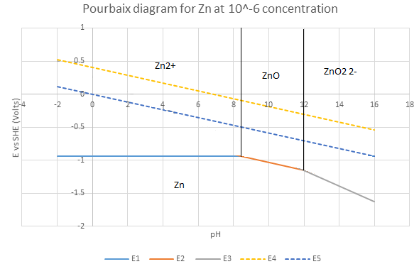

Figure 3. Pourbaix diagram for Zn at ${10}^{-6}$ concentration for all dissolved substances. ZnO and Zn areas are passive.

**2.11 Write the electrochemical half-cell reaction and corresponding Nernst equation for each of the lines separating the following phases in figure 2.11(g)**

**a. Ti and TiO**

**b. TiO and Ti2O3**

**b. Ti2+ and Ti2O3**

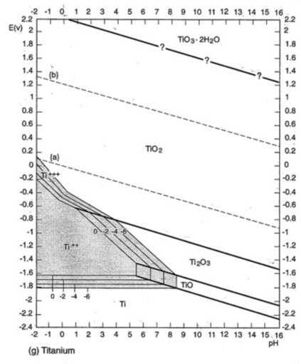

Figure 4. Pourbaix diagram for titanium from book (2.11g)

Constructing the half-cell reactions by using charge balance and element balance:

|  |  |
| --- | --- |
| $$TiO+2e^{-}+2H^{+}=Ti+H_{2}O$$ | (21) |

|  |  |
| --- | --- |
|  | (22) |

|  |  |
| --- | --- |
|  | (23) |

The Nernst equation can be written as follows in standard conditions for the reduction equation:

|  |  |
| --- | --- |
| $$E=E^{0}-\frac{0.05916}{z} V\log\left(\frac{a_{RED}}{a_{OX}}\right)$$ | (24) |

We can determine the value of $E^{0}$ for each reaction visually from the diagram. The equilibrium coefficient $\frac{a_{RED}}{a_{OX}}$ can be calculated using the reaction equations. Applying equation 24 to eq 21 and assuming that activity coefficients are 1, we get:

|  |  |
| --- | --- |
| $$E=E^{0}-\frac{0.05916}{2} V\log\left(\frac{1}{{\left[H^{+}\right]}^{2}}\right)$$ | (25) |

|  |  |
| --- | --- |
|  | (26) |

|  |  |
| --- | --- |
|  | (27) |

We can determine $E^{0}$ by reading the value of $E$ at $pH=16$ from the diagram and solving for $E^{0}$.

|  |  |
| --- | --- |
| $$-2.26 V=E^{0}-0.05916 V⋅5.5$$ | (28) |

|  |  |
| --- | --- |
|  | (29) |

We get the following equation for Ti/TiO:

|  |  |
| --- | --- |
| $$E=-1.31V-0.0592 V⋅pH$$ | (30) |

Using the same approach for TiO/Ti2O3:

|  |  |
| --- | --- |
| $$E=E^{0}-\frac{0.05916}{2} V\log\left(\frac{1}{{\left[H^{+}\right]}^{2}}\right)$$ | (31) |

We get the same slope, but a different value for $E^{0}$ (again determined from pH =16 from diagram), where $E$ is approximately -2.05 V:

|  |  |
| --- | --- |
| $$-2.05 V=E^{0}-0.05916 V⋅16$$ | (32) |

|  |  |
| --- | --- |
|  | (33) |

Thus we get the following equation for TiO/Ti2O3:

|  |  |
| --- | --- |
| $$E=-1.10V-0.0592 V⋅pH$$ | (34) |

For Ti2+/Ti2O3:

|  |  |
| --- | --- |
| $$E=E^{0}-\frac{0.05916}{2} V\log\left(\frac{{\left[Ti^{2+}\right]}^{2}}{{\left[H^{+}\right]}^{6}}\right)$$ | (35) |

|  |  |
| --- | --- |
|  | (35) |

Let us estimate the value $E^{0}$ at $\left[Ti^{2+}\right]=0$ and at PH 5.5 from the diagram. We get the equation:

|  |  |
| --- | --- |
| $$E^{0}=-1.42 V+\frac{0.05916V}{2}⋅\left(6*5.5\right)=-0.4439 V$$ | (36) |

The equation for Ti2+/Ti2O3 thus becomes:

|  |  |
| --- | --- |
| $$E=-0.44V-0.05916 V⋅(\log\left(\left[Ti^{2+}\right]\right)-3\log\left(\left[H^{+}\right]\right))$$ | (37) |

|  |  |
| --- | --- |
|  | (38) |

The diagram has 4 lines for this equation, corresponding to $\log\left(\left[Ti^{2+}\right]\right)=0,-2,-4$ and $-6$, which we can get by substituting the appropriate value in the place of $\log\left(\left[Ti^{2+}\right]\right)$.

**Answer:**

**a.**

|  |  |
| --- | --- |
| $$E=-1.31V-0.0592 V⋅pH$$ | (39) |

**b.**

|  |  |
| --- | --- |
| $$E=-1.10V-0.0592 V⋅pH$$ | (40) |

**c.**

|  |  |
| --- | --- |
| For $\log\left(\left[Ti^{2+}\right]\right)=0$: $$E=-0.44 V-0.177⋅pH$$ For $\log\left(\left[Ti^{2+}\right]\right)=-2 :$ $$E=-0.322 V-0.177⋅pH$$ For $\log\left(\left[Ti^{2+}\right]\right)=-4:$ $$E=-0.203 V-0.177⋅pH$$ For $\log\left(\left[Ti^{2+}\right]\right)=-6:$ $$E=-0.0848 V-0.177⋅pH$$ | (41) |

**2.14. A technician measured the potential of steel pipe with an analog multimeter in soil vs. a Cu/CuSO4 electrode as -0.5615 volts. Do you think his/her measurements are accurate? Explain briefly.**

First we must assume that the measurements were done close to standard conditions. The reduction potential of the Cu/CuSO4 electrode vs SHE is

|  |  |
| --- | --- |
| $$Cu^{2+}+2e^{-}=Cu E^{0}=+0.15 V$$ | (42) |

The oxidation potential of iron vs SHE is

|  |  |
| --- | --- |
| $$Fe =Fe^{2+}+2e^{-} E^{0}=+0.41 V$$ | (43) |

Adding the two values together gives a total cell potential of 0.56 V. His/her measurement has the wrong sign, and is thus inaccurate. Total cell potential should be positive for $ΔG$ to be negative, which is what happens when Cu and Fe form a cell: Fe oxidizes and Cu is reduced. I am not exactly sure how the analog multimeter in this case works, but it maybe that the technician has the positive and negative wires reversed.

**2.15 A corrosion potential of -0.229 V versus SCE was measured for a corroding alloy. What is the potential versus SHE? Ag/AgCl (saturated)? Cu/saturated CuSO4?**

Using the SHE values as reference, SCE has a potential of +0.244 V in standard conditions vs SHE. [1] Ag/AgCl (saturated) has a potential of +0.199 vs SHE. [1] Cu/saturated CuSO4 has a potential of +0.316 V vs SHE. [2]

Therefore, the corrosion potential vs SHE is given by:

|  |  |
| --- | --- |
| $$-0.229 V+0.244 V=0.015 V$$ | (44) |

The corrosion potential vs Ag/AgCl is given by subtracting the value for Ag/AgCL vs SHE from the calculated corrosion potential for SHE:

|  |  |
| --- | --- |
| $$0.0154 V-0.199 V=-0.184 V$$ | (45) |

Respectively, the corrosion potential vs Cu/CuSo4 is given by:

|  |  |
| --- | --- |
| $$0.0154 V-0.314 V=0.299 V$$ | (46) |

[1] ["Electrochemistry for Chemists, Second Edition"](http://www.consultrsr.net/bookstore/genl_echem.htm#sawyer), DT Sawyer, AJ Sobkowiak, J Roberts, Jr., John Wiley & Sons, NY (1995).

[2] "Reference Electrodes (Half-Cells)", J Lichtenstein, [Materials Performance](http://www.nace.org/NACE/Content/Publications/MaterialsPerformance.asp), Oct., 2001