Mikko Karkkainen 2/15/2017

11740378

Homework 4

1. **Using appropriate polarization diagrams, determine the effect of the following parameters on the corrosion potential and corrosion rate of a metal Mcorroding to dissolved M+ in an acid solution under activation control with all other parameters constant: (a) increasing i0 of the anodic reaction (b) increasing i0 of the cathodic reaction. (c) increasing the concentration of the dissolved H+ (d) increasing the Tafel constant of the anodic reaction.**
2. **Assume that the corrosion rate of Zn metal is 10-5 A/cm2. What would be the weight loss (in grams) for a period of 1 year**

Equation for corrosion rate from the book:

$$r=\frac{ia}{nF}$$

Values:

$$a=M\left(Zn\right)=65.39\frac{g}{mol}$$

$$i={10}^{-5}\frac{A}{cm^{2}}=\frac{{10}^{-5}C}{cm^{2}s}$$

$$n=2 (Zn→Zn^{2+})$$

$$F=96500\frac{C}{mol}$$

Inputting values:

$$r=\frac{\left({10}^{-5}\frac{C}{cm^{2}s}⋅65.39 \frac{g}{mol}\right)}{2⋅96500\frac{C}{mol}}=3.4⋅{10}^{-9}\frac{g}{cm^{2}s}$$

$$1 year = 3600 x 24 x 365 s = 3.1536⋅{10}^{7} s$$

$$r=3.4⋅{10}^{-9}⋅3.1536⋅{10}^{7}\frac{s}{yr}\frac{g}{ cm^{2}s }=0.107\frac{g}{yr cm^{2}}$$

**Answer: 0.107 grams**

1. **Galvanized steel is steel that is coated with Zn in order to reduce the corrosion rate of the steel. The Zn is ‘sacrificed’ and is corroded instead. How long (in years) would a Zn coating last if the thickness of the coating is 0.1 mm? Assume the same equivalent current (corrosion rate) as in problem 3 above.**

Corrosion rate from previous problem:

$$r=0.107\frac{g}{yr cm^{2}}$$

Density of zinc:

$$ρ_{Zn}=7.14\frac{g}{cm^{3}}$$

Corrosion rate divided by the density of zinc gives:

$$\frac{r}{ρ_{Zn}}=\frac{0.107}{7.14}\frac{g cm^{3}}{yr cm^{2} g}=0.014896\frac{cm}{yr}=0.14896\frac{mm}{yr}$$

To find out how long a coating of thickness of 0.1 mm lasts:

$$\frac{0.1 mm}{0.14896\frac{mm}{yr}}=0.667 yr$$

**Answer:** The coating will last for approximately 0.667 years.

1. **An important learning objective for this course is to understand and be able to read and interpret semi-log plots of E(V) vs log i. Units for i can vary, A/m2, mA/cm2, µA/m2, etc. The following questions are based upon Figures 3.15 and 3.16 in the text. Include in your homework either a copy of Fig. 3.15 or 3.16 as needed, OR a similar plot. Refer to these two figures to answer the following:**
2. **In Fig. 3.15, what’s the slope of the line labelled ‘cathodic’ (the dashed line)? Units will be V.**

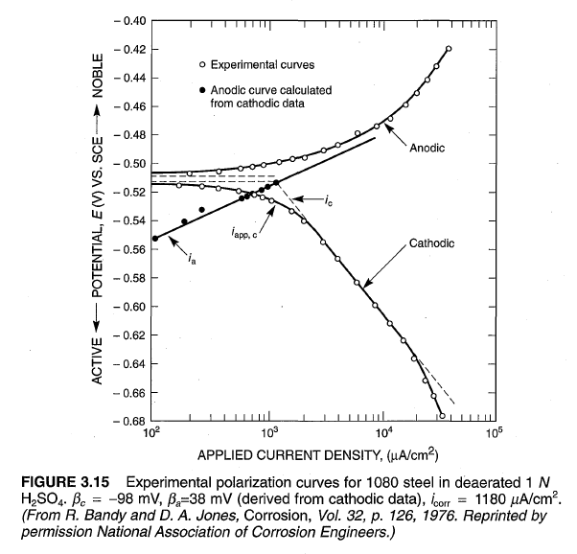

The slope of the line labelled cathodic is the derivative of the potential of the cathodic reaction $E_{c}$ with respect to current density : $\frac{∂E_{c}}{∂i}$