Roadmap: from chip to an embodied, closed-loop fly
What NeuroMPS builds next, after the final round. The plan below is a commitment, not a result: nothing in it has been run yet except where a number cites `outputs/metrics.json`. Everything it will produce is simulated, for research decision support; none of it is a claim about any compound's effect in any animal or person.
Slide message: Today we read a simulated fly brain as a chip and as an animal, through the neurons that drive behaviour. Next we give it a body and close the loop, so that the question "does the chip flag a drug before behaviour fails?" can be asked of movement itself, with sensory feedback in place. Each stage has a registered go/no-go test.
1. Why close the loop
The chip-to-animal study (report Act VII) reads behaviour as the firing of named neurons, down to the motor neurons of the male nerve cord. Three things it cannot see:
• Movement. A motor neuron firing faster is not a leg moving differently. Muscles, joints and contact with the ground turn firing into behaviour, and they can mask or amplify a change.
• Feedback. In a real fly, movement is sensed and fed back: leg proprioceptors report joint angles and loads to the nerve cord and brain. A drug that disturbs a circuit inside a loop can have effects an open-loop model misses, in either direction.
• The environment. Feeding is a sequence (find, taste, extend the proboscis), not a firing rate; grooming is a sequence of leg sweeps.
Our current results are the baseline the embodied model has to be compared against. On the simulated fly brain, the chip's firing rate ranks drugs by how much they disrupt behaviour (Spearman 0.863), but it raises the alarm late. At the motor neurons of the male nerve cord, the chip is later than motor output in 4 drug families, level in 1, and never earlier. And electrodes on the brain's output tract caught GABA block in time where a planar array did not (0.361 against 0.044 log2). The embodied model asks whether these conclusions survive movement and feedback.
2. What already exists
Layer | Status | Where
Whole-brain model (FlyWire), drug knobs by transmitter class | built, validated against the published sugar→MN9 result | src/neuromps/fly/model.py; report §23
Brain and nerve cord (MaleCNS, 165,122 neurons) | built; replicates the behaviour results | fly/malecns.py; §25
Virtual MEA scored by the chip's own extractor | built | fly/electrodes.py, features/mea.py
Motor-neuron readouts (proboscis, front legs, all motor neurons) | built, registered study done | fly/motor.py; §25
Neuron-to-muscle map | in the data: 260 of 381 leg motor neurons are typed by the muscle they drive | fly/roadmap_inventory.py
Feedback neurons | in the data: 1,030 proprioceptive sensory neurons in the nerve cord, among them 403 chordotonal-organ and 175 campaniform-sensilla neurons | fly/roadmap_inventory.py
Body and physics | available, not yet used: NeuroMechFly v2 (FlyGym) and flybody, both on MuJoCo, all Apache-2.0 | external

3. The loop we will close
1. Brain and nerve cord (MaleCNS, leaky integrate-and-fire, the drug knobs as now).
2. Motor neurons to muscles. Each leg motor neuron typed by its muscle drives that muscle's activation; the untyped ones are mapped by their connectivity to typed partners, or left out and reported.
3. Muscles to joints. Muscle activations become joint torques in the body model (NeuroMechFly v2's leg joints).
4. Body and world. MuJoCo integrates the body against the ground, with leg adhesion, and against a sugar spot for feeding.
5. Joints back to neurons. Joint angles and contact forces drive the matching proprioceptive sensory neurons (chordotonal organs for angles, campaniform sensilla for load), which re-enter the network.
The chip side does not change: the same virtual array, scored by the same extractor, read while the fly behaves.
4. Stages, each with a registered go/no-go test
Stage | When | Deliverable | Go/no-go test (registered before it runs)
1. Open-loop legs | weeks 1–3 | front-leg motor neurons drive NeuroMechFly's front legs | antennal drive produces front-leg sweeps toward the head that untreated, undriven runs do not
2. Feeding and walking | weeks 3–6 | proboscis extension from the proboscis pool; walking from descending commands | sugar drives proboscis extension and bitter suppresses it; a walking command produces an alternating gait
3. Close the loop | weeks 6–10 | proprioceptive feedback into the nerve cord | feedback measurably changes the movement (it stabilises or reshapes the rhythm) against the open-loop run
4. Drugs in the loop | weeks 10–14 | the registered chip-to-animal design rerun with movement as the readout | registered predictions, among them: does the chip still flag drugs after movement fails; does the output-tract electrode still lead
5. Check against real flies | weeks 14–18 | comparison with published fly pharmacology (feeding and grooming under GABA-A and GluCl drugs) | the direction of each published behavioural change is reproduced, or the mismatch is reported
6. Release | weeks 18–20 | open code, models and a paper | one command reproduces every number, as now

Each stage stops if its test fails, and the failure is reported, as every failed prediction in this project has been.
5. What it would change for organ-on-a-chip
The embodied model lets three chip-design questions be asked of behaviour itself rather than of neurons:
• Sensitivity. How small a firing-rate change must a chip resolve to flag each mechanism before movement fails? Today's answer comes from interneurons and motor neurons (report §24).
• Electrode placement. Does recording the connection between compartments (the output tract, a chip's microchannels) still lead a planar array when behaviour is movement under feedback?
• Screen thresholds. How does a regulatory screen's hit cutoff compare with the change at which movement, not firing, fails?
6. Risks, and how each is handled
Risk | Handling
Part of the neuron-to-muscle map is missing (motor neurons not typed by muscle) | map the rest by connectivity to typed partners; report coverage; test robustness by leaving the uncertain ones out
A leaky integrate-and-fire nerve cord may not generate rhythms (walking needs them) | stage 2's go/no-go test catches it; then add the intrinsic currents rhythm generation needs, as a stated change
The male nerve cord is over-excitable under the published weight (any drive recruits many motor neurons) | calibrate one weight against the untreated motor recruitment before stage 4, registered
Real fly pharmacology is sparse and in different units | stage 5 compares directions, not magnitudes, and says which comparisons were impossible
Compute | FlyGym 2 simulates on GPU; the GB10 runs the network and the body in parallel

7. Status, and what stage 1 changed
Stage 1 ran and failed its go/no-go test, as did its registered follow-up. The male-CNS network was wired to the FlyMimic leg (MuJoCo 3.16, the leg's 15 Hill-type muscles driven by 49 of the 68 left front-leg motor neurons, by name). Antennal drive moved the claw toward the head in every trial, but sugar drive moved it closer still (median closest approach 0.9386 against 1.1067 mm): the movement was not specific. Stage 1b rescaled the male-CNS weight by the ratio of synaptic input per neuron between the connectomes; at that weight sugar no longer drove the feeding motor neuron at all (0.0 Hz), so its leg results are uninterpretable, as registered.
What went wrong. The same sugar drive puts 251 neurons above 10 Hz in the published FlyWire model and 14,263 in the male CNS at the same weight, most of them central-brain neurons (11,082 of 32,160); at the rescaled weight still 7,586. The published model's parameters do not carry over to the second connectome's brain: there, activity avalanches, and lowering one global weight silences weak pathways before it stops the avalanche. This is itself a result for the paper, and it changes the plan.
The revised plan. Use each connectome where its model is validated:
• Stage 1c (next): drive the male nerve cord from its descending neurons alone, without the male brain. Activating the descending neurons the literature ties to antennal grooming should move the front leg toward the head; descending neurons for other behaviours should not. This tests the nerve cord, the muscle map and the leg without the brain's avalanche.
• Then: join the FlyWire brain, where the published model is validated, to the male nerve cord through descending neurons matched by cell type across the two connectomes.
Both steps are registered before they run, like every stage.
Stage 1c ran: three of five registered predictions pass. With the male brain removed and named descending neurons driven, the nerve cord is silent without drive, and the descending neurons the literature ties to antennal grooming (aDN1, aDN2) drive the left front-leg motor pool at 15.846 Hz, against 2.72 for the middle and 1.697 for the hind leg; no other descending neuron recruits the front leg as strongly (forward walking 3.601 Hz). The kinematic prediction failed: grooming drive brings the claw to 1.1345 mm of the antenna, but forward-walking drive reaches 1.154 mm at the low points of a rhythmic swing, so the closest approach does not separate the two. The figure shows the difference the readout missed: under grooming drive the claw goes to the head and stays there; under forward-walking drive it oscillates. That is the readout to register next (stage 1d, fresh seeds), not a reason to re-score this one.
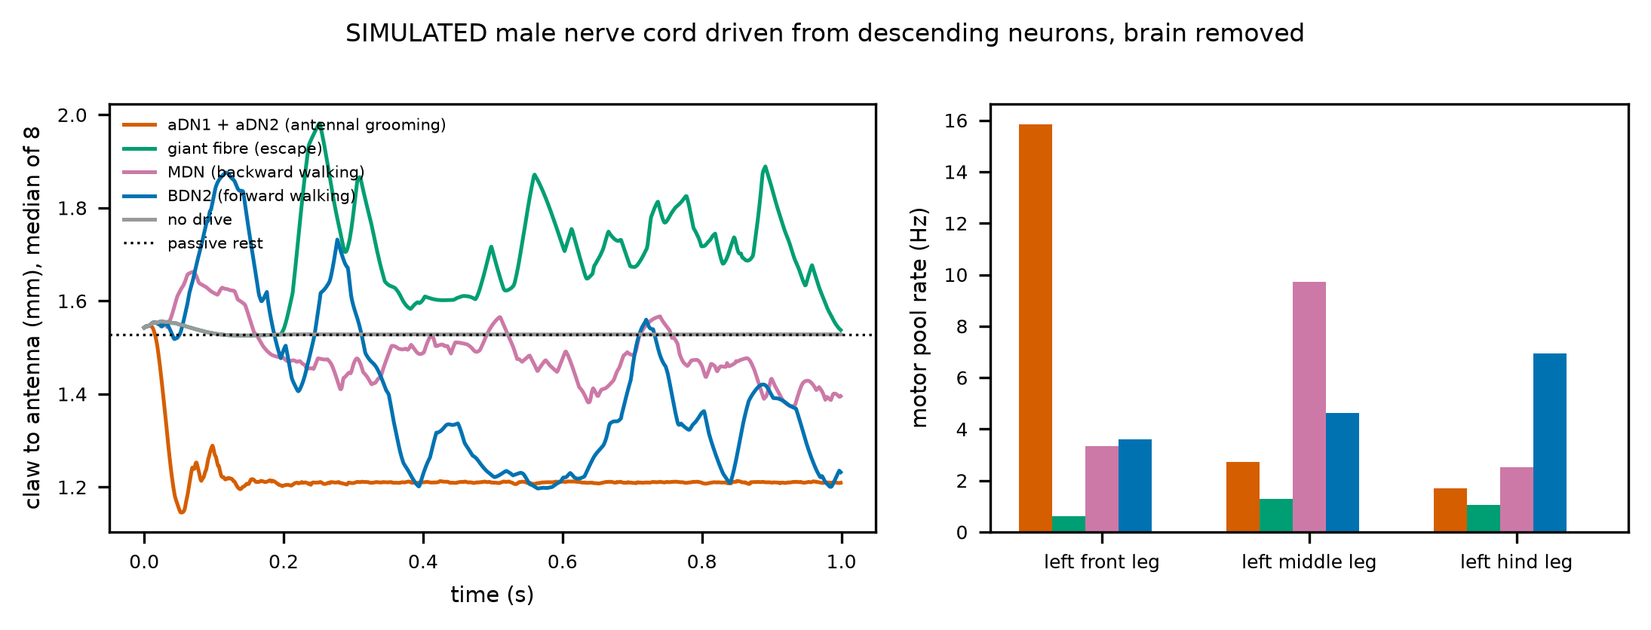
Figure 1. The SIMULATED male nerve cord, brain removed, driven from descending neurons: claw-to-antenna distance of the FlyMimic leg, and the motor pools of the three left legs, per drive.
Stage 1d: all four registered predictions pass, on fresh seeds. Read as the time the claw spends near the head and as the rhythmicity of its movement, the two drives separate cleanly: under grooming drive the claw is near the head for 0.9665 of the second, under forward-walking drive for 0.368, and never under the giant fibre or without drive; forward walking moves the leg more rhythmically (0.4599 against 0.2374); the result holds at every activation scale, and stage 1c's front-leg specificity replicates (front-leg pool 16.066 Hz under grooming drive). Rhythmicity alone does not mark walking: the giant fibre scores as high (0.4561), while keeping the claw away from the head. (Caveat found in stage 2e, below: this rhythmicity measure does not require an autocorrelation peak, so smooth movements without a rhythm also score high. The registered audit, below, re-scored D2 with a measure that requires a peak: forward walking drops to 0.0956 and the giant fibre to 0.1896, while grooming keeps 0.2374, so D2 fails under the corrected measure. The walking "swing" was an artefact; D1, the hold at the head, does not depend on the measure and stands.) Stage 1's question is answered for the nerve cord: the descending neurons that start antennal grooming in the fly move this leg to the head and hold it there, specifically. Next is the brain: the FlyWire brain joined to this nerve cord through type-matched descending neurons, so that sensory drive, not a stimulated command neuron, starts the movement.
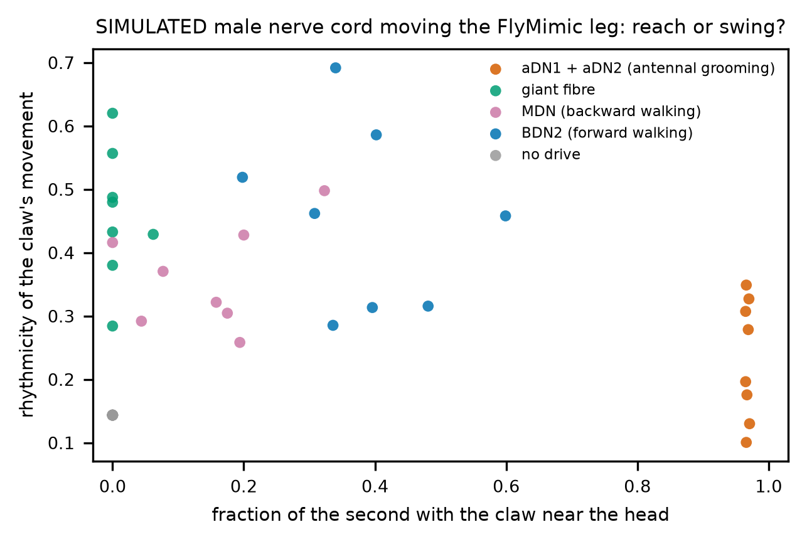
Figure 2. Time near the head against rhythmicity, one point per SIMULATED trial: the antennal-grooming drive holds the leg at the head; walking and escape drives move it away (the vertical axis is the registered rhythmicity, found by the audit to score smooth movements high).
Stages 1e and 1f: the FlyWire brain drives the male nerve cord, end to end. Each FlyWire descending neuron was paired with the male-CNS descending neuron of the same cell type and side (1,220 of 1,303 matched), the published brain model was run under antennal, sugar or no input, and its descending spikes were replayed into the male nerve cord, which moved the leg. Stage 1e's registered precondition, an absolute 10 Hz line for the grooming descending neurons, failed at 8.531 Hz, so its leg results are uninterpretable; it also showed that its time-near-head readout counted a mild flexion under sugar input as a reach. Stage 1f, registered with a relative precondition and the depth of reach as readout and run on fresh seeds, passes all five predictions. Antennal input brings the claw to 0.5369 mm of the antenna, sugar input to 0.9377 mm, no input leaves it at rest; the front-leg pool carries the movement; and removing the spikes of the two grooming descending neuron types alone (aDN1, aDN2; four neurons) returns the claw to 1.4793 mm. Stage 1 is complete: sensory input to a validated whole-brain model, carried by the descending neurons the fly uses for antennal grooming, moves a muscle-driven leg to the head; sugar input does not, and without those four neurons the movement is gone. Next is stage 2 (feeding and walking) and stage 3 (closing the loop).
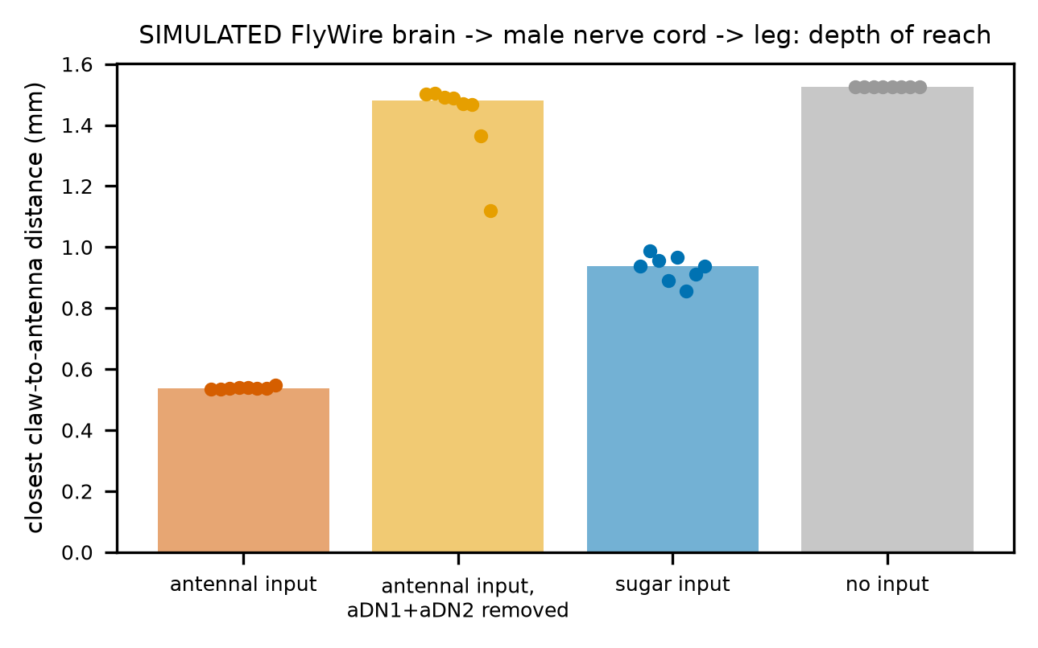
Figure 3. Depth of reach per condition in the SIMULATED relay (FlyWire brain -> matched descending neurons -> male nerve cord -> FlyMimic leg), one point per trial: antennal input reaches deepest; removing aDN1 and aDN2 abolishes the reach; sugar input flexes the leg only partway.
Stage 2a: no walking rhythm from the nerve cord alone (failed as registered). Before any body, stage 2a asked whether the male nerve cord turns its forward-walking command (BDN2, DNg100) into a motor rhythm: tibia flexors and extensors alternating within a leg, the two front legs alternating, and a tripod across legs, read from the twelve tibia motor pools of the six legs. Without drive the cord is silent (W0 passes). Under the walking command it is active but tonic: the left middle-leg tibia extensors fire at 54.12 Hz and the right hind-leg extensors at 34.12 Hz, while the tibia flexor pools of five of the six legs stay silent (left front flexors 0.0 Hz). The left front flexor pool has no rhythm (median rhythmicity 0.0), so no phase can be measured and W1 to W4 fail. Backward-walking drive (MDN) gives the same picture with different legs. This is the risk §6 names: a leaky integrate-and-fire nerve cord, with connectome weights and no intrinsic currents, has no half-centre oscillator. The next step is the one §6 commits to, a stated model change registered before it runs: add the intrinsic property rhythm generation needs (spike-frequency adaptation) and test again on fresh seeds, with the connectome-only result kept as the reference.
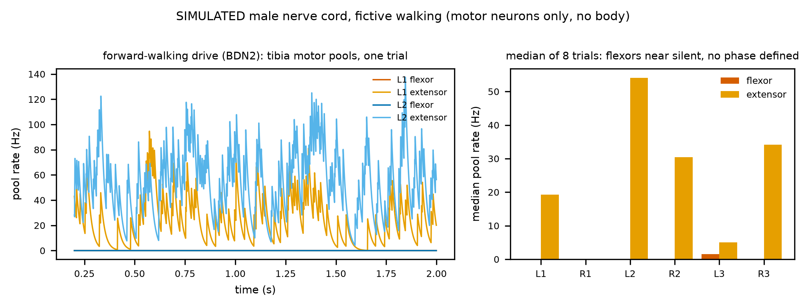
Figure 4. Tibia flexor and extensor pool rates on the six legs under the walking command, SIMULATED fictive walking in the male nerve cord: extensors fire tonically, flexors stay silent, and there is no alternation.
Stage 2b: sugar input to the FlyWire brain extends a simulated proboscis; bitter input gates it (six of six registered predictions pass). Every proboscis motor neuron that McKellar et al. (2020) tie to a muscle has a FlyWire cell type (through the male-CNS cross-reference). The rostrum protractor (MN9) and its retractors (MN1, MN2) set the rostrum's command; the haustellum extensors (MN4) and flexors (MN3) set the haustellum's. Both commands drive the proboscis of the flybody whole-fly model. Under sugar input the extending pools reach activations of 0.9644 (rostrum) and 0.8858 (haustellum), their antagonists 0.0561 and 0.0, and the proboscis extends fully (0.3431 mm peak; full extension is 0.3428 mm). Bitter input alone, antennal input and no input leave it at rest. Adding bitter input to sugar input halves the peak (0.1618 mm) and cuts the time-averaged extension from 0.3054 to 0.0488 mm: the proboscis starts to extend, then is held back to brief flicks. The result holds at the other activation scales. Only the MN9 part of this was seen before registration (it is the published model's result); the haustellum pools and their antagonists were not. Exploratory, not scored: sugar input recruits only feeding motor neurons (neck, eye, antennal and crop motor neurons stay silent), and the bitter gate acts on the proboscis pools (other proboscis motor neurons 52.25 Hz under sugar, 2.75 with bitter added) far more than on the ingestion pool (24.58 and 19.98 Hz). Stage 2's feeding test passes; its walking test (2a) does not. The body is held fixed and its joints are position servos, so this is the motor command made visible, not a muscle-level proboscis.
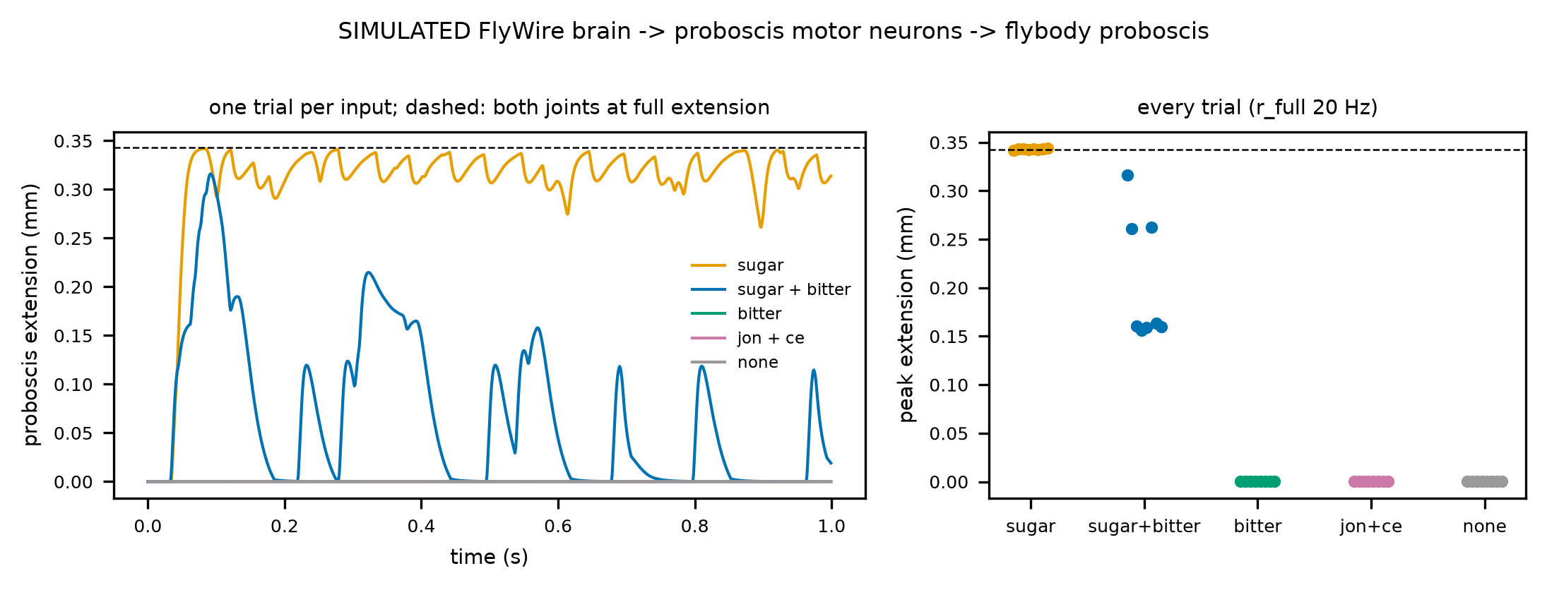
Figure 5. Proboscis extension in the SIMULATED FlyWire brain -> proboscis motor neurons -> flybody chain: sugar extends the proboscis fully and holds it; adding bitter input lets it start and then holds it back; bitter, antennal or no input leave it at rest.
Stage 2c: adding spike-frequency adaptation does not make the nerve cord walk (stopped as registered). §6 committed to adding an intrinsic property if stage 2a failed. Adaptation's two parameters have no published fly value, so they were swept over a registered grid of 36 cells. The registration fixed in advance a rule for choosing one cell and a confirmatory test on fresh seeds, with a rewired control and a comparison with the published step period. No cell passes any of the four walking tests (rhythm: 0 cells), so the rule selects nothing, the stage stops, and its seven predictions fail. Adaptation does act: the tibia extensor pools fall from 21.3 Hz (weakest, fastest adaptation) to 0.55 Hz (strongest, slowest). But the flexor pools never exceed 0.22 Hz in any cell, so there is nothing for the extensors to alternate with. An exploratory diagnostic (not registered; exploration seeds) shows why. With every inhibitory connection removed the flexor pools fire at 151.341 Hz, so excitation does reach them. Of the neurons the walking command activates, each flexor motor neuron receives 274.73 inhibitory against 130.78 excitatory synapses, while each extensor motor neuron receives 754.17 excitatory against 698.17 inhibitory. GABA alone (182.68 per flexor neuron) outweighs that excitation. Whether the flexors stay net-inhibited if glutamate excites depends on the model's rule that every glutamate synapse inhibits (92.05 per flexor neuron). Under the model's signs, the walking command's population holds the flexors down and drives the extensors. A rhythm then needs something that periodically releases the flexors, which uniform adaptation does not provide. Candidates for a registered next step are the glutamate sign rule (glutamate excites through some receptors in the fly nerve cord), sensory feedback from the leg (stage 3), or a different intrinsic property (post-inhibitory rebound).
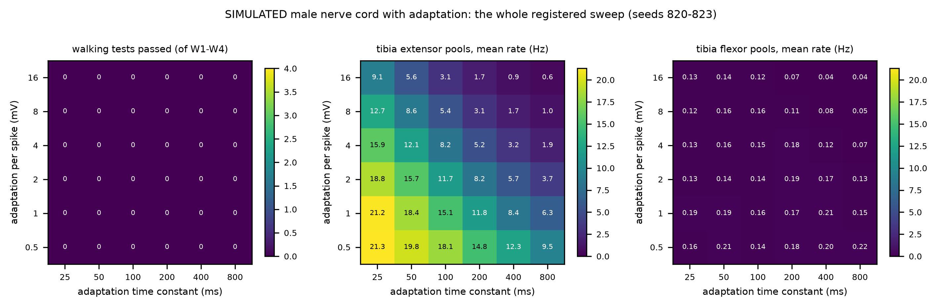
Figure 6. The whole registered SIMULATED adaptation sweep: no cell passes a walking test; adaptation lowers the tibia extensor pools smoothly, while the flexor pools stay near zero everywhere.
Stage 2d: the glutamate sign rule is not what keeps the cord from walking (1 of 7 at the selected cell). The model, like the published one, treats every glutamate synapse as inhibitory, and the stage-2c diagnostic showed that the flexors' net inhibition depends on that rule. No settled rule says where fly glutamate excites, so stage 2d registered two bounds. Glutamate onto motor neurons became excitatory in one; glutamate everywhere in the other. Each ran without adaptation and over stage 2c's grid (37 cells per rule), with the same selection rule and confirmation. Onto motor neurons only, the flexors stay weak (1.76 Hz without adaptation) and no cell passes any walking test. Everywhere, the flexors switch on (40.4 Hz), but the cord becomes far more active (7,118 neurons at 1 Hz or more, against 2,136 with glutamate onto motor neurons only). A rhythm appears in 5 cells, as slow waves of the whole population, but no cell alternates antagonists or legs (0 cells). The rule selected the one cell that passed the tripod test on exploration seeds; on fresh seeds that pass did not replicate. The left front flexor and extensor fire in phase there (distance 0.49 from the alternation target), the right front flexor stays silent, the rhythm's period is 317.5 ms, slower than a walking fly's, and only silence without drive passes. Three registered attempts now agree. The male nerve cord's wiring, run as leaky integrate-and-fire neurons under the walking command, does not produce alternation: not as published (2a), not with adaptation (2c), not with either glutamate rule (2d). This is a result for the paper. A connectome alone, in this model class, does not contain a working walking rhythm generator. The roadmap's own answer is the next stage, sensory feedback from the legs (stage 3), which the fly also needs to walk.
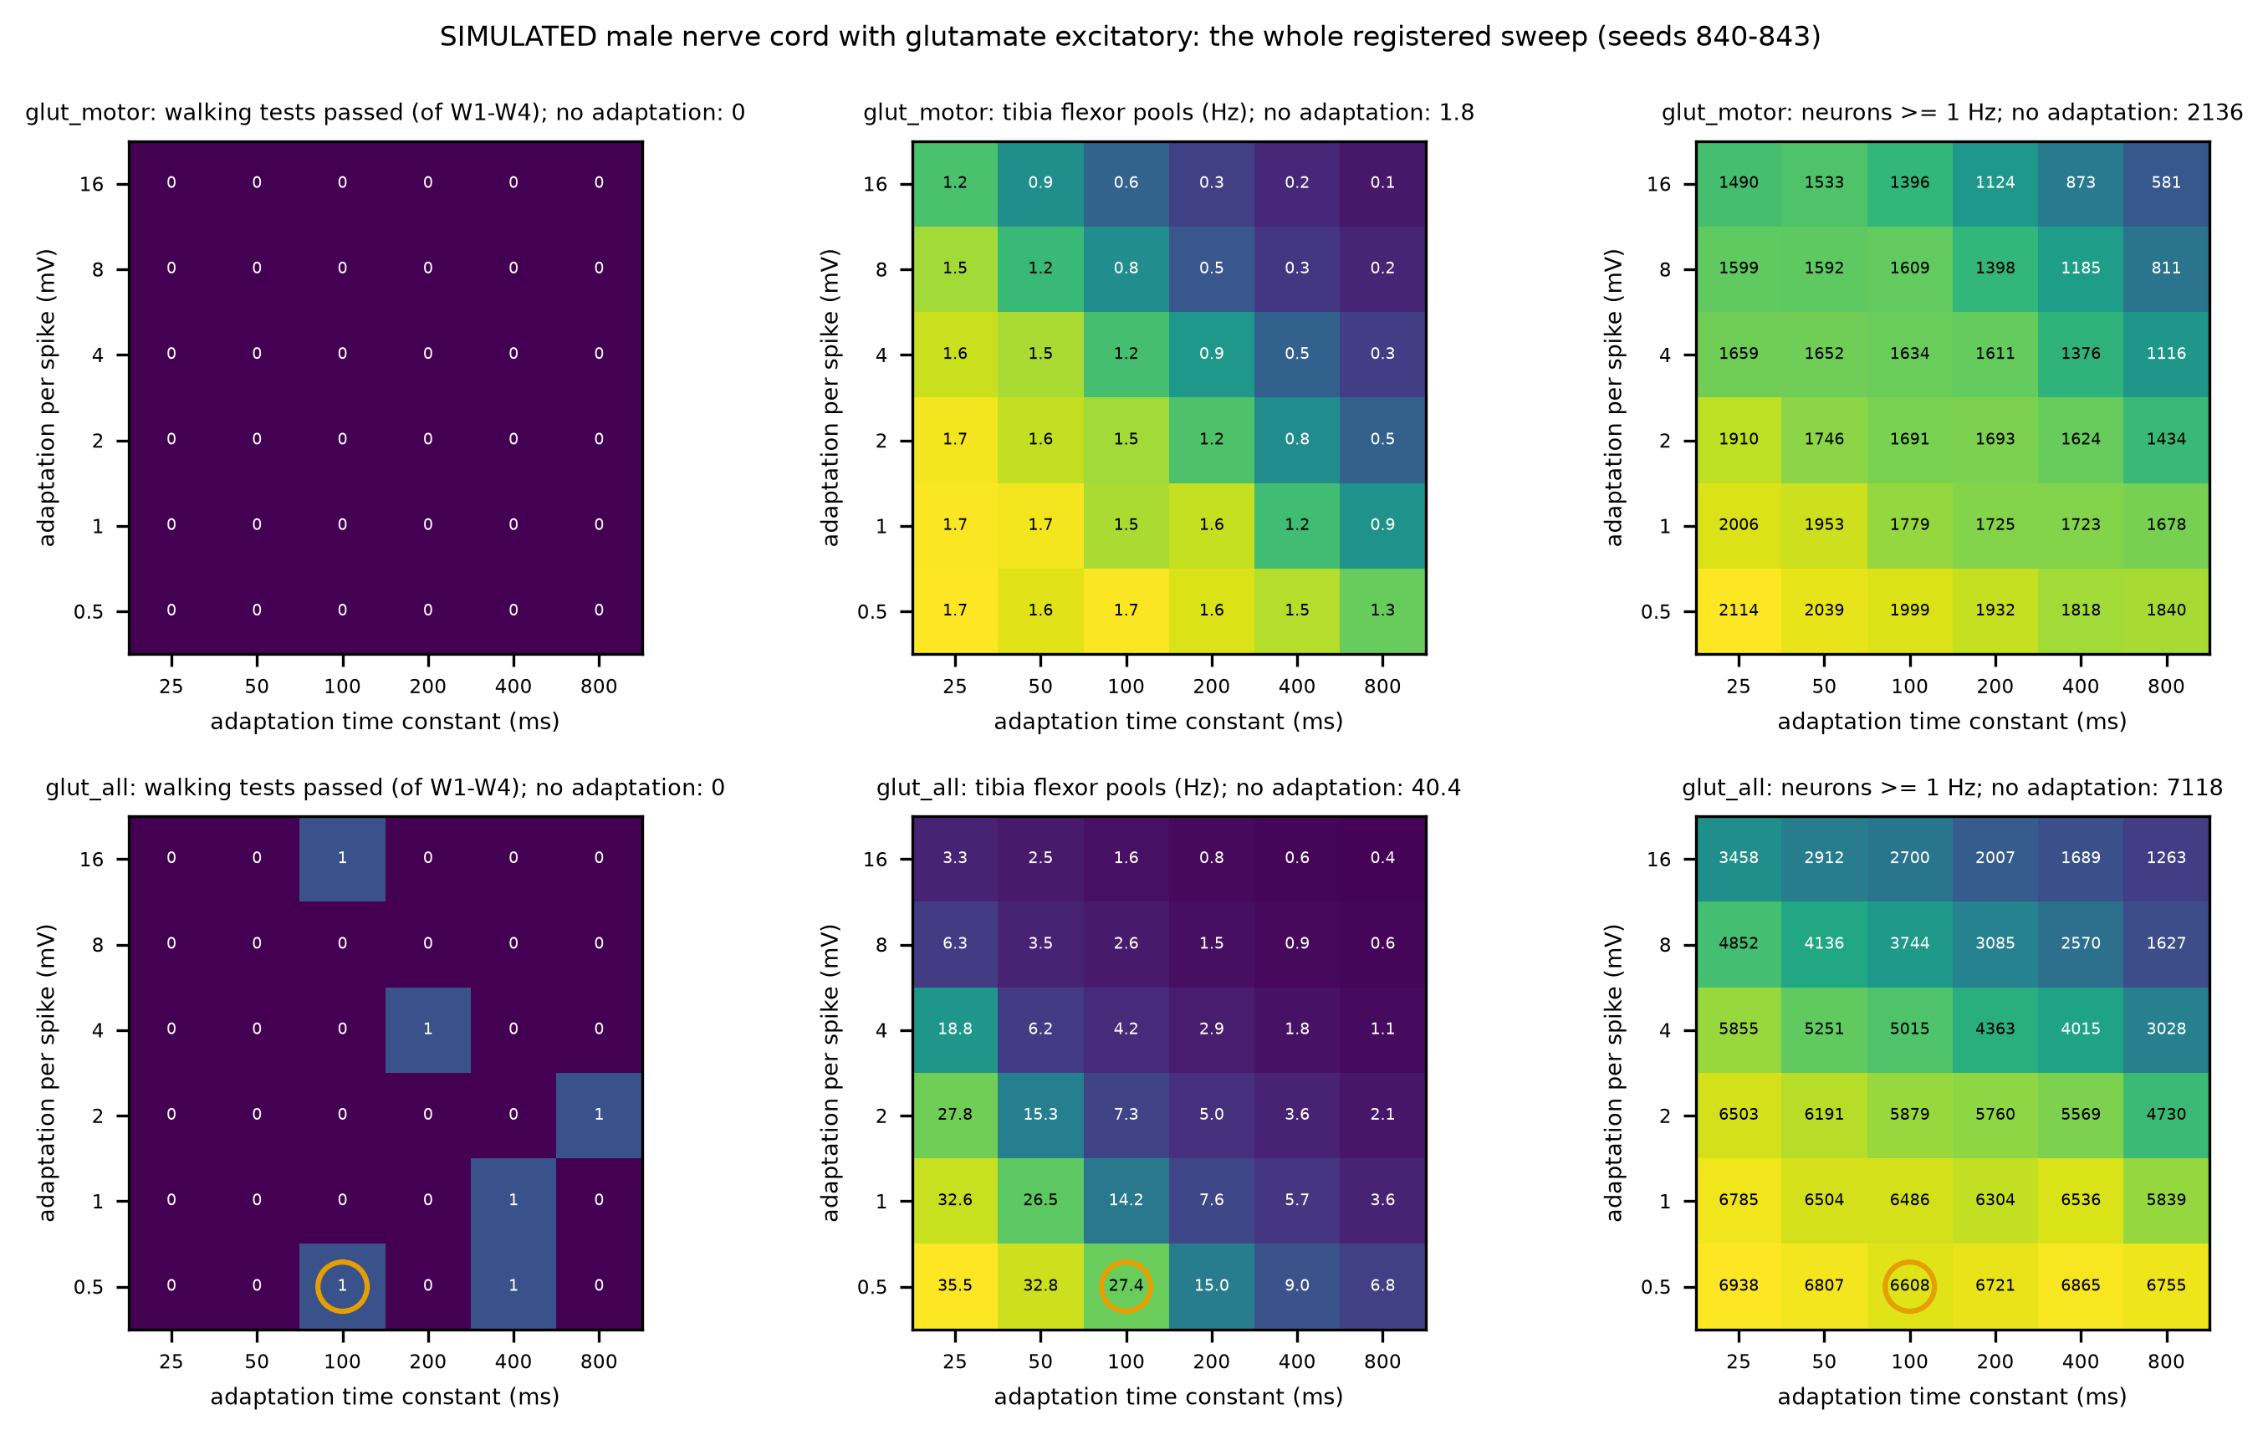
Figure 7. The whole registered SIMULATED stage-2d sweep, both glutamate rules: walking tests passed, tibia flexor rate and the number of active neurons in every cell. Glutamate onto motor neurons leaves the flexors weak; glutamate everywhere turns them on with a large rise in activity, and no cell alternates.
Stage 2e: the Pugliese et al. firing-rate model (2 of 8, one of them vacuous), and a flaw in our rhythm measure. Neither of the walking flies circulating online comes from a connectome. Eon Systems drives a NeuroMechFly walking controller trained by imitation, with a few descending neurons as handles. flybody (Google DeepMind with Janelia) walks with a trained policy. The one study that finds a walking rhythm in nerve-cord wiring is Pugliese et al. (2025). They use a firing-rate model with saturating, heterogeneous neurons. Steady drive to DNg100 produces leg rhythms through a three-neuron circuit (IN17A001, INXXX466, IN16B036). Stage 2e reimplemented that model from the paper and its configuration, ran it with their parameter distributions on the male nerve cord (32 draws), and registered eight predictions before any run. Silence without drive passes. Under DNg100 drive almost nothing happens: only 11 neurons become active, and the rhythm predictions fail. The silenced-circuit prediction passes, but vacuously: there was no rhythm to remove. The cause is a stated deviation. The male CNS release has no neuron volumes, so size, which scales each neuron's threshold, was taken as total synapse count. That makes DNg100 one of the largest neurons in the cord (17.8 times the median, in the top 1 %, which starts at 11.86). Under the registered input it reaches only 6.54 Hz, against 49.32 Hz for a grooming neuron. So this run does not test Pugliese et al.'s result. Grooming and DNb08 drive, which reach their neurons, recruit about 7,055 neurons each. DNb08 scores a median rhythmicity of 0.7367, with a "period" of 50.0 ms in every draw, the shortest lag the measure looks at. The figure shows why. The left front flexor fires one burst and falls silent, and the extensor rises to a plateau; there is no rhythm. The rhythmicity measure registered since stage 1d is flawed. It takes the largest autocorrelation within lags of 50 to 500 ms without requiring a peak, so any smooth, slowly varying signal scores high at the 50 ms edge. Registered outcomes stay as registered, but three readings are now suspect:
• stage 1d's D2 (forward walking "swings" the leg; scored on the smooth claw distance);
• stage 2d's five "rhythmic" cells;
• every grooming comparison value.
The audit (registered before any corrected value was computed on stage data). The corrected measure counts a rhythm only at a genuine autocorrelation peak: a local maximum at least 0.1 above the trough it rises from. Its period is that peak's lag, and phases use that period. It was calibrated on synthetic signals only and passes its registered validation: smooth signals without a rhythm score 0, and a sine keeps its value. Stages 1d, 2a, 2c, 2d and 2e were re-simulated with their own code and seeds, and every trial was measured both ways. The registered measure reproduces every recorded outcome. Under the corrected measure:
• one registered outcome changes: stage 1d's D2 now fails (above);
• in stage 2d the cells with a rhythm drop from 5 to 1, and the selection rule would pick a different cell (glutamate everywhere, 16 mV, 100 ms); it is not confirmed here, since that would need fresh seeds;
• in stage 2e, DNb08's rhythmicity falls from 0.7367 to 0.0, and the share of rhythmic leg motor neurons from 0.699 to 0.01.
Stages 2a and 2c are unchanged. Registered outcomes stay recorded as they fell; this paragraph and the figure carry both. From now on, every new stage registers the corrected measure. Next, a registered stage-2e follow-up in which each command neuron gets enough drive to fire, so that Pugliese et al.'s result is actually tested.
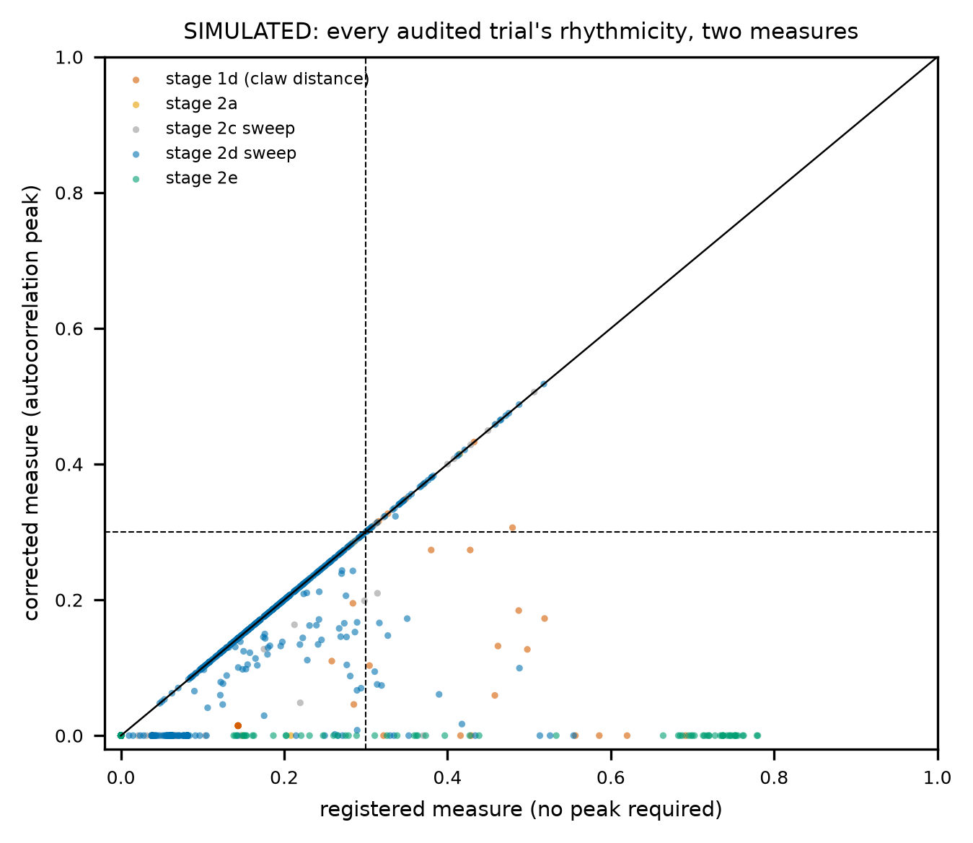
Figure 8. SIMULATED: every audited trial's rhythmicity under the registered measure (no peak required) against the corrected one (an autocorrelation peak). Genuine rhythms lie on the diagonal; smooth signals the old measure scored as rhythmic fall to zero.
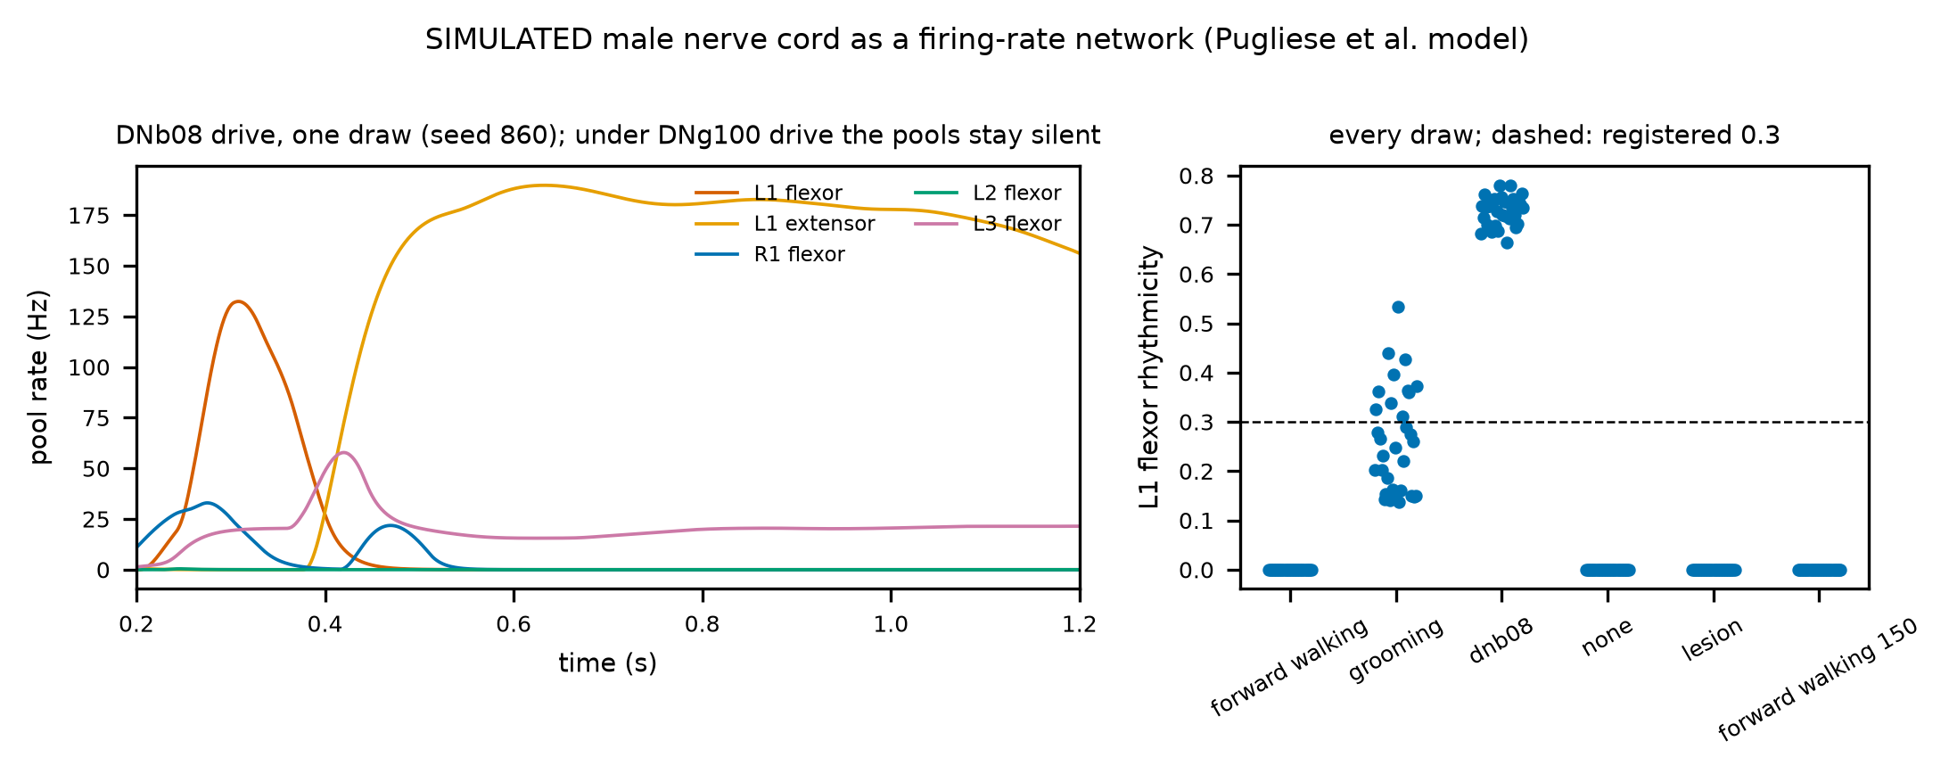
Figure 9. SIMULATED firing-rate model of the male nerve cord. Left: DNb08 drive, one draw: one flexor burst, then a tonic extensor, scored as "rhythmic" by the flawed measure. Right: rhythmicity per draw and condition; DNg100 drive leaves the pools silent.
Stage 2f: every command neuron driven alike; the walking command is switched off by the activity it starts (precondition failed in both size rules). Stage 2f gave each driven neuron the input that alone brings it to 50 Hz, computed from its own drawn parameters. It ran two size rules (synapse count, as in stage 2e, and none), used the audit's corrected rhythm measure, and added a precondition that DNg100 actually fires near its target. The precondition fails in both rules: DNg100's median rate is 0.18 Hz with synapse-count sizes and 0.0 Hz without size scaling, so every other prediction is uninterpretable. An exploratory trace of one registered draw (not scored) shows why. DNg100 starts at 42.67 Hz and recruits 443 neurons within 50 ms. The cord then tips into a self-sustained state, and by 0.25 s the inhibitory input onto DNg100 is -4452.5 against 2165.1 excitatory, which silences it. Thereafter 5,247 neurons stay active with the command off. The comparison with Pugliese et al. explains the difference. Their network is not the whole cord but the front leg's motor neurons, the premotor neurons onto them and the descending neurons onto those (4,604 neurons). Their input is halved whenever more than 500 neurons are recruited; such runs are treated as infeasible. Their positive result is a rhythm within the front leg, and they report no consistent left-right phase and no tripod. Our whole-cord runs sit far outside that regime, and our coordination tests ask for more than their model produces. The faithful test is their own construction on the male CNS: the front-leg network, the 5-to-500 recruitment rule, and their within-leg predictions. It is registered next as stage 2g.
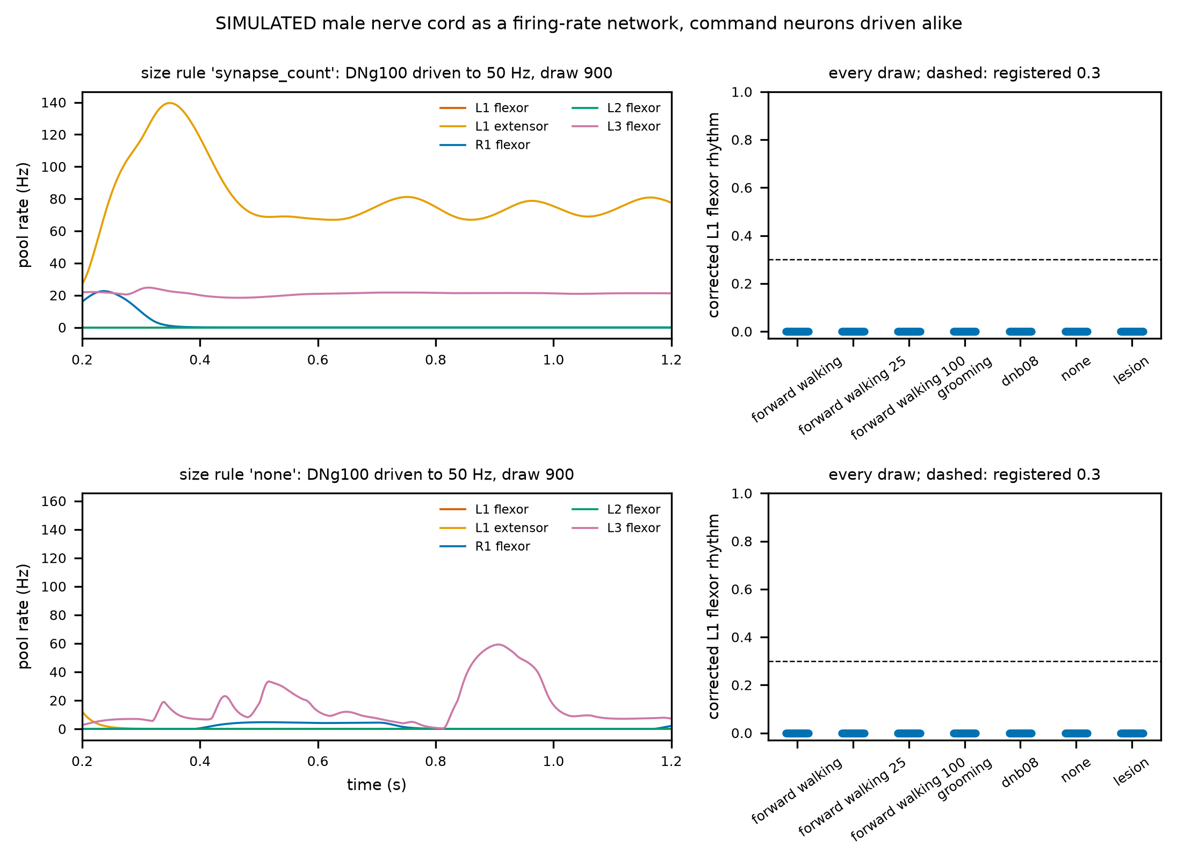
Figure 10. SIMULATED firing-rate network of the male nerve cord with each command neuron driven to 50 Hz, both size rules: no corrected rhythm in any condition; the cord's own activity silences the walking command.
Stage 2g: Pugliese et al.'s front-leg network on the male CNS (precondition failed narrowly; suggestive, not yet a test). Stage 2g rebuilt their network from the male CNS: the left front leg's motor neurons, the premotor neurons onto them and the descending neurons onto those (2,133 neurons). It used their recruitment rule: start at 250, halve the input above 500 recruited neurons, double it below 5, for up to 10 runs. Rhythm was scored with the corrected measure. The registered precondition, a working input in at least 16 of 32 draws, fails narrowly in both size rules: 12 draws with synapse-count sizes, 15 without size scaling. So every prediction is uninterpretable as registered. The rule fails because this network is close to all-or-none. In 20 draws (synapse-count sizes) and 11 (none), halving and doubling flip between almost nothing and about 1,044 recruited neurons, never landing between 5 and 500. What the feasible draws show is exploratory, not a test. A genuine, regular oscillation appears in the few motor neurons that are active (median 1.0 and 2.0, as their own "2-5 motor neurons"). Its corrected score is 0.8145 and 0.8747, with periods of 80.5 and 154.0 ms, within a walking fly's range. The rates are low (a few Hz). Without size scaling, silencing the three-neuron circuit removes the rhythm (median 0.0); with synapse-count sizes it does not (0.8145), so there the rhythm runs through another path. The tibia flexor and extensor pools are silent in these draws. The next registered step keeps their 5-500 criterion but searches the input finely (bisection between the last input that recruited too few and the first that recruited too many), on fresh draws. Then their within-leg result can be tested on every draw that has a working input at all.
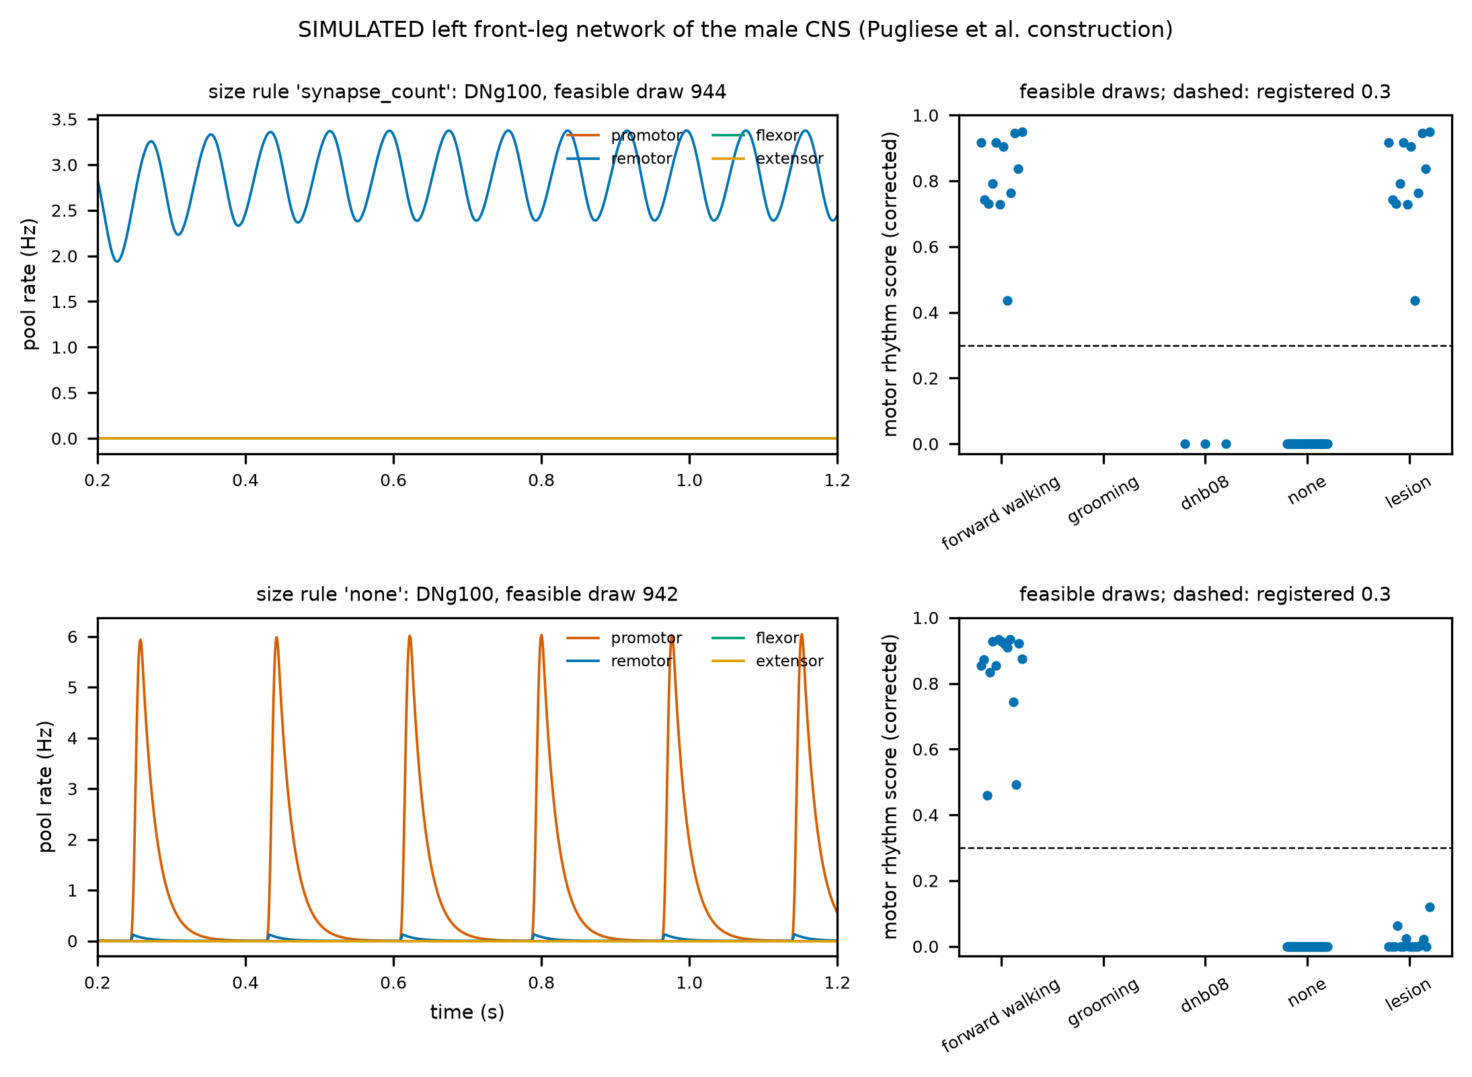
Figure 11. SIMULATED left front-leg network of the male CNS (Pugliese et al.'s construction). Left: one feasible draw per size rule under DNg100: a regular low-rate oscillation in one or two motor-neuron pools. Right: corrected motor rhythm score over feasible draws, per condition.
Stage 2h: with a fine input search, the walking command drives a front-leg rhythm. Without size scaling, that rhythm needs Pugliese et al.'s circuit; within-leg alternation still fails. Stage 2h kept stage 2g's network, criterion and predictions on fresh draws and changed only the input search. Once a draw had an input recruiting too few neurons and one recruiting too many, the next input was their geometric mean. A working input now exists in 32 of 32 draws with synapse-count sizes and in 18 without size scaling. In the draws without one, the bracket closes to a ratio of 1.0000001652591795: the network jumps from almost nothing to about 1,040 recruited neurons, a true discontinuity. Registered outcomes:
• the walking command drives a leg rhythm in both size rules (0.6808 and 0.8886), at a fly-like period (94.5 and 196.5 ms);
• silencing the three-neuron circuit removes it without size scaling (0.0) but not with synapse-count sizes (0.6808);
• no reliable promotor-remotor offset and no tibia alternation in either rule: the remotor and tibia pools are rarely active together with the promotor;
• the comparison with grooming "passes" vacuously in both rules, because no grooming draw found a working input and the code scored the empty group as zero.
The one assumption that could make the lesion result wrong is that IN17A001 is the only neuron receiving DNg100's input, so silencing it cuts the command's path rather than the rhythm. An exploratory check (not registered) settles this for the no-size rule. With IN17A001 kept and only INXXX466 and IN16B036 silenced, the network becomes more active (474.5 recruited neurons against 27.0), yet the rhythm is gone (0.0483). The rhythm sits mainly in the coxa promotor motor neurons (33 rhythmic instances). With synapse-count sizes no silencing variant changes anything: that rhythm runs through another path. What this adds up to: in an independent reimplementation on the male CNS, Pugliese et al.'s central claim holds without size scaling. A walking command drives a front-leg motor rhythm at a fly-like period, and the rhythm needs their inhibitory and excitatory interneurons, not just the relay. It depends on the size rule, and it does not give the antagonist alternation a walking leg needs. That is what our stage-2 question asked for and what Pugliese et al. also stop short of.
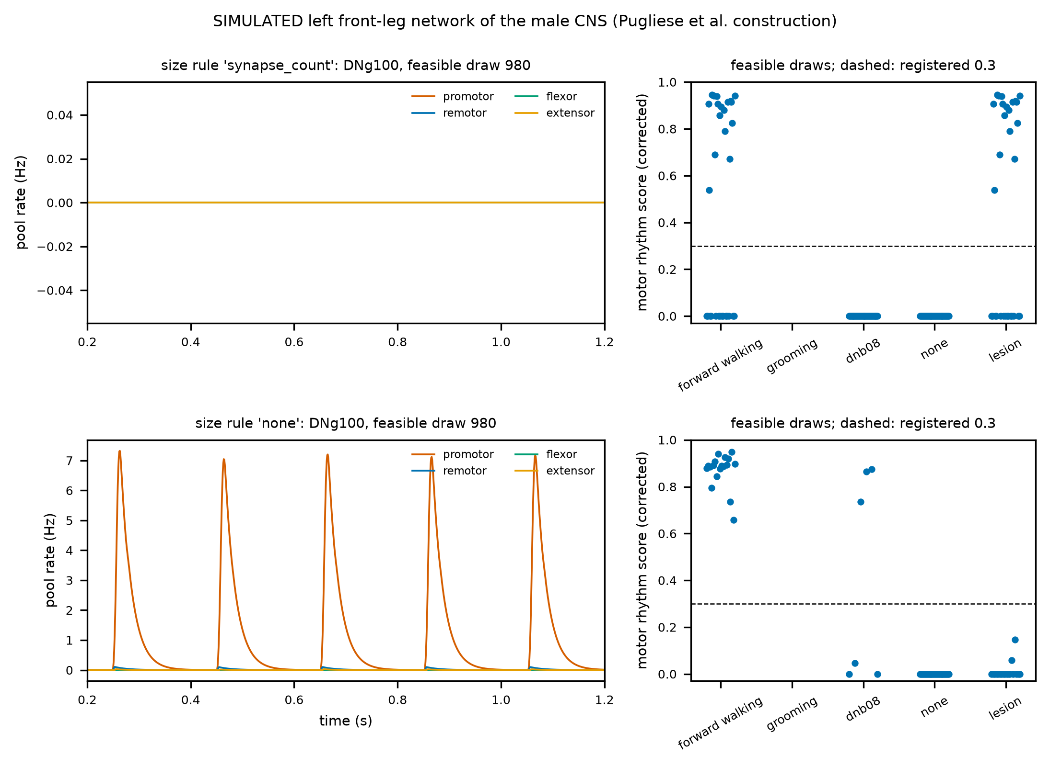
Figure 12. SIMULATED left front-leg network of the male CNS with the fine input search. Left: one draw per size rule under DNg100 (no size scaling: regular promotor bursts about every 200 ms). Right: corrected motor rhythm score over feasible draws; without size scaling the lesion removes the rhythm.
Stage 3a: the first closed loop. Claw-neuron feedback shifts the motor pools toward resistance but barely moves a held leg (go/no-go failed; 3 of 5). The male nerve cord and the muscle-driven left front leg now run together, one millisecond at a time. The leg's femur-tibia angle drives the four left front-leg claw neurons, the femoral chordotonal organ's position sensors, identified by type in the male CNS. The two types are wired differently: SNpp51 excite the tibia flexors, SNpp50 the extensor. Which type senses flexion is unknown, so a resistance assignment, its opposite and a non-contingent sham bracket it. Under the antennal-grooming drive, whose open-loop reach holds the tibia near full extension, resistance feedback moves the tibia by only 0.0054 rad, against the registered 0.1. The go/no-go fails, so the contingency test is uninterpretable. The loop stays silent without drive, the opposite assignment does not resist, and the reach survives with the loop closed (claw near the head for 0.968 of the second). At the motor level the feedback does act in the resisting direction: tibia extensor rates fall from 43.25 to 31.75 Hz and flexor rates rise from 0.1 to 3.4 Hz. But the sham does almost the same (33.25 and 3.0 Hz). In a held extension the claw neurons fire at a nearly constant rate (90.5232 Hz), so contingent and non-contingent feedback are the same input. An exploratory check (not registered) rules out muscle saturation as the reason the leg does not move. At a full-activation rate of 80 Hz, resistance moves the tibia from 0.6546 to 0.6705 rad and the sham to 0.6711. What it means: a static hold cannot show a reflex. The classic test, as in insect physiology, perturbs the joint and asks whether the loop pushes back faster than the same input delivered blind. That is the next registered step (stage 3b): a brief imposed flexion of the tibia during the held reach, with recovery time as the readout.
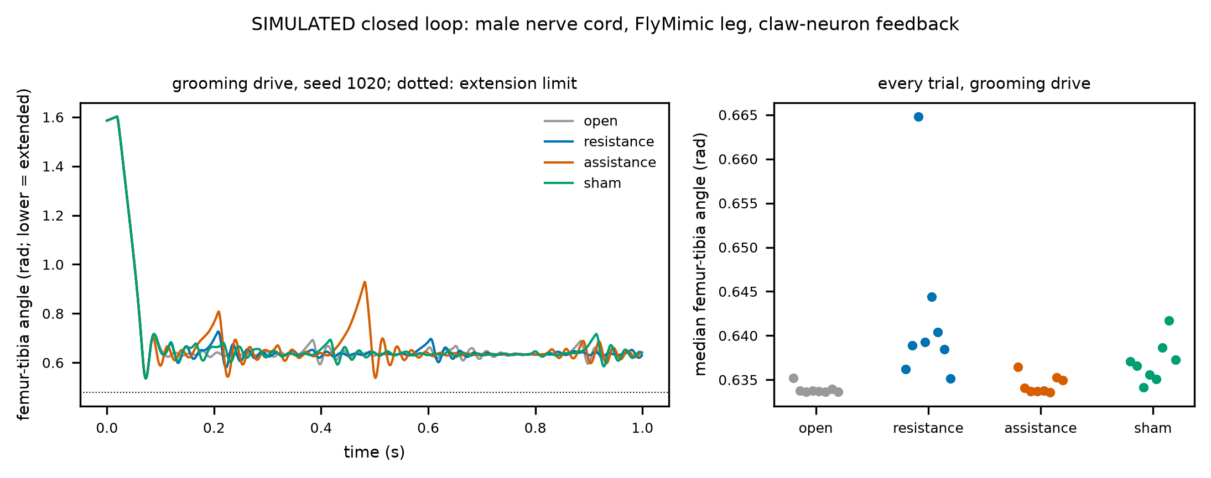
Figure 13. SIMULATED closed loop (male nerve cord, FlyMimic leg, claw-neuron feedback), grooming drive. Left: femur-tibia angle over one trial per arm. Right: every trial's median angle; resistance and sham shift it by thousandths of a radian.
8. What carries over unchanged
Pre-registration before every run; licensed data with checksums in the manifest; every reported number written by a script and checked against the documents that cite it; failed predictions reported beside the passed ones; and a demo anyone can open.

