**HOMEWORK**

LOGIC REVIEW BEFORE MIDTERM EXAM

**Exercise 1:**

The alphabet is given below to help you:

a b c d e f g h i j k l m n o p q r s t u v w x y z

**Q1** a w b s c o

**Q2** e e z j j y o o

**Exercise 2:**

**Q1** An ASCII represents 245 characters. What is the size (in bits) of an ASCII? *(Justify your answer)*

If ASCII represents 1characters = 8 bits so 245 characters = 245*8

= 1960 bits

**Q2** with 8 bytes, how many values can be represented? *(Justify your answer)* ​

1byte = 8 bites

If 8 bytes = 8*8

= 64 bits

So 8 bytes = 2^64

**Q3** How many bits to store alphabet and number in keyboard 0…9, A…Z and a…z

0...9= 10 charater, A...Z= 26 charater, a...z= 26 charater

So we have 62 charater we store in 6 bites

Because 2^6= 64

**Exercise 3:**

**Q1** What is the result of this operation with binary numbers? ​

1011 0101

Becaus 1-1=0

1-0=1

- 0101 1110

________________

0101 0111

**Q2** What is the result of this operation with binary numbers? ​

1111 0011

0111 0110

0011 1011

0011 1011

1111 0011

0111 1101

0111 0110

- 0111 1101

- 0011 1011

_________________

0011 1011

**Q3** What is the result of this operation with binary numbers? ​

1011 0011

0001 1011

0001 1000

0000 0011

0101 0110

0011 1011

0001 1011

1011 0011

0101 1101

0101 0110

- 0101 1101

- 0011 1011

- 0001 1000

________________

0000 0011

**Q4** What is the result of this operation with binary numbers? ​

1011 0101

Because 1+1=10

1+0=1

0+1=1

+ 0111 1111

________________

100110100

**Q5** What is the result of this operation with binary numbers? ​

1111 0011

1 1001 0000

+0111 1011

1000001011

1111 0011

+1001 1101

110010000

+ 1001 1101

+ 0111 1011

_________________

1000001011

**Q6** What is the result of this operation with hexadecimal numbers?

D2F7

1 1010 0010 0111 1011

+0011 1100 1101 1110

1 1101 1111 0101 1001

1101 0010 1111 0111

+1100 1111 1000 0100

11010 0010 0111 1011

+ CF84

+ 3CDE

_____________

1DF59

**Exercise 4:**

Compute the following conversions

|  |  |
| --- | --- |
| Base 2 | Base 10 |
| 101101 | *Explanation:*101101=1*2^5+0*2^4+1*2^3+1*2^2+0*2^1+1*2^0  = 32+0+8+4+0+1  = 45 |

|  |  |
| --- | --- |
| Base 2 | Base 16 |
| 101101 | *Explanation:*101101  = 1101 = D  = 0010 = 2  = 2D |

|  |  |
| --- | --- |
| Base 16 | Base 8 |
| D8F | *Explanation*: D8F = 1101 1000 1111  111=7, 001=1, 110=6, 110=6  So D8F= 6617 |

|  |  |
| --- | --- |
| Base 16 | Base 2 |
| D8F | *Explanation*: D8F= D=1101, 8=1000, F=1111  So D8F= 1101 1000 1111 |

**Exercise 5:**

**Q1. Rules:**

* First 3 characters “AOU”, repeated many times (max repetition is 20)
* In the end you can have X, Y or Z, only one letter

Examples:

AOUAOUX

AOUY

AOUAOUAOUAOUX

1. Explain your encoding

|  |  |  |
| --- | --- | --- |
| meaning | EDD | EDB |
| ចំនួនAOU | 1, 2, 3, ...20 | 01,10,11,...10100 |
| latter | X=1  Y=2  Z=3 | 01  10  11 |

1. Give examples

Ex: AOUAOUAOUAOUAOUAOU=110

AOUXYZ=01 01 10 11

1. Explain the size

AOU=5bites

X,Y,Z=2bits

So 5*2=10bites

**Q2. Rules:**

* 3 signs: @, #, %
* The sign is any order
* Each sign is repeated the same number of times, maximum of repetition is 5
* In the end you can have A, B or C, only one letter

Examples:

@@###A

%%@@@@@#B

1. Explain your encoding, give the example and your explanation

|  |  |  |
| --- | --- | --- |
| Meaning | EDD | EDB |
| ចំនួនsigns | 1-5 | 001...101 |
| signs | @=1  #=2  %=3 | 01  10  11 |
| Letter | A=0  B=1  C=3 | 00  01  10 |

1. For this example, **%%%%%**C, what is the littlest size possible with your encoding?

%%%%%C=101 11 10

1. Explain the size

ចំនួនsigns=3bites

Signs=2bites

Letter=2bites

So 3+2+2 = 7bites

**EXERCICE 6: Encoding problem**

**Rules:**

* 4 letters: A, B, C, D
* Any order
* Maximum of repetition is 14

Examples:

ABCD

DBCAA

ADABCAA

1. Explain your encoding

|  |  |  |
| --- | --- | --- |
| Meaning | EDD | EDB |
| Letter A  Letter B  Letter C  Letter D | 1  2  3  4 | 001  010  011 |
| 100 |
| Maximum of repetition | 1-14 | 0001-1110 |

1. Give examples

001 0010 = AA

1. Explain the size

**EXERCICE 7: Encoding problem**

**Rules**:

* First 2 characters “AB”, repeated many times (max repetition is 5)
* Then 1 character “*”, repeated many times (max repetition is 5)
* Then 1 number (0-9)

Examples:

ABABAB***8

AB*****7

ABABAB*****3

1. Explain your encoding
2. Give examples
3. Explain the size

**EXERCICE 8: Encoding problem**

**Rules:**

* 4 letters: A, E, O, U
* Each letter is repeated minimum 0 time and maximum 7 times.
* The letters are always in the alphabetic order: A then E then O then U

Examples:

AAAAEEEOOU

EEEUUUUUUU

AAEEOOUU

1. Find an encoding of maximum **12 bits**. Explain the method, explain the size and give examples.
2. Is your encoding lossless or loosely?

**EXERCICE 9: Encoding problem**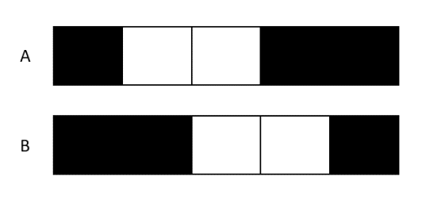

**Rules:**

* The image has only 2 options A & B

Question - Find an encoding

|  |  |  |
| --- | --- | --- |
| Meaning | EDX | EDB |
| Black position: one left and three right  : three left and one right | 1  2 | 01  10 |

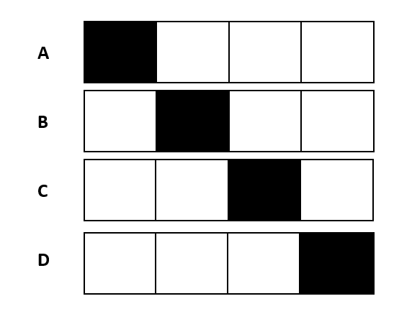

**EXERCICE 10: Encoding problem**

**Rules:**

* The image has only 4 options A, B, C, D

Question - Find an encoding

|  |  |  |
| --- | --- | --- |
| meaning | EDX | EDB |
| Black position | 0=w  1=b | 0  1 |
| Black position | 0=w  1=b | 0  1 |
| Black position | 0=w  1=b | 0  1 |
| Black position | 0=w  1=b | 0  1 |

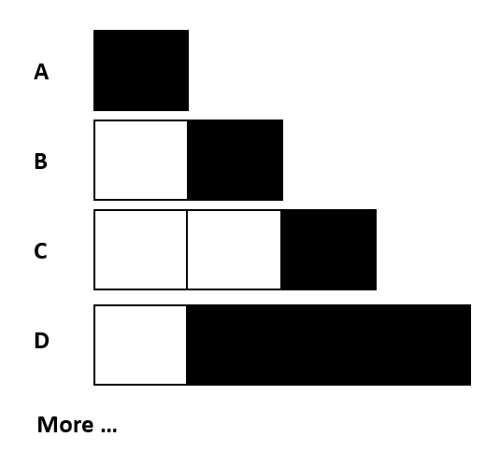

**EXERCICE 10: Encoding problem**

**Rules:**

* The image has 1 to 4 pixels
* 1 to 3 black pixels
* The black pixels shall be together

Question - Find an encoding

|  |  |  |
| --- | --- | --- |
| Meaning | EDX | EXB |
| ចំនួនpixels | 1-4 | 001...100 |
| ចំនួនcolor | 1-3 | 01...11 |
| Position color | 1-4 | 001...100 |

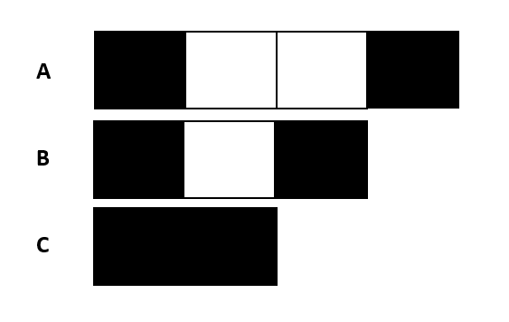

**EXERCICE 11: Encoding problem**

**Rules:**

* The white pixels have 0 to 2
* Black pixel always first and last cells

Question - Find an encoding

|  |  |  |
| --- | --- | --- |
| Meaning | EDX | EDB |
| ចំនួន white pixel | 0-2 | 00...10 |
| Position black pixel: first  last | 1  2 | 01  10 |