1. **Introduction and research question**

A growing number of GPS-tagged migratory birds could provide possibilities to study navigation in birds (Guilford et al., 2011), for example in magnetic navigation which has been shown to play a role in birds (Wiltschko & Wiltschko, 2022). Thus, we ask whether the spring migration route of young, alone migrating raptors (Red kites *Milvus milvus*, and Egyptian vulture *Neophron percnopterus*) lies within the magnetic envelopes (defined by inclination, declination and intensity) they already experienced during their first autumn migration. If so, we could not exclude magnetic cues to play a role in navigatoion for Egyptian vultures and Red kites.

1. **Methods**

We created a spatial representation of the magnetic field which a naïve young raptor experienced during the first autumn migration for the first spring migration. With this transfer of the autumn migration on the altered magnetic field in spring combined with the travelled routes in spring we could check whether young birds stay during spring migration in the magnetic envelopes they knew already from the autumn migration. More in detail, we performed the following steps:

We used tracking data of 22 Red Kites and 92 Egyptian Vultures and selected young birds with at least one complete migratory circle (from the hatching location to the wintering sites and back to the breeding region). We classified migratory periods on a weekly (Red kites) and monthly (Egyptian vulture) basis using a random forest model implemented in ranger::ranger explicitly trained with manually annotated migratory periods on each species from the same data set (Wright & Ziegler, 2017). Afterwards, we used the International Geomagnetic Reference Field (IGRF) 13 provided by the function oce::magneticField to extract magnetic field values each bird experienced during the first autumn migration (Alken et al., 2021; Kelley & Richards, 2024). These magnetic field values were rounded to an assumed sensitivity of birds of 0.5 for inclination and declination and 200 for intensity (Schneider et al., 2023). Furthermore, we created a raster with the magnetic field values of each bird individual during the intermediate time of the first spring migration of this individual bird. Finally, we extracted all grid cells of the spring migration which lied within the range of the magnetic field from the autumn migration, an approach used already elsewhere (Schneider et al., 2023). This produces a representation of the magnetic field experienced during autumn transferred to the changed magnetic field during the spring migration and can be seen as envelopes. The spring migration routes were plotted on these bird specific magnetic field envelopes.

All data and code are available at <https://github.com/Vogelwarte/MagneticNavigation>.

1. **Results and Discussion**

Most Egyptian Vultures and Red Kites stayed within the scope of a known magnetic field from autumn migration during their first return journey in spring. However, few young raptors left the known magnetic field to a significant extend, as for example the Egyptian vultures Polya, Sanie, Oriana, Iliaz, Boyana, and Zara as well as the Red kites 926 and to lesser extend 487. Thus, we cannot exclude magnetic cues to play a role in orientation of Egyptian vultures and Red kites.

However, deviations from the autumn migration magnetic envelopes during spring migration could originate from various sources: Random spatial patterns of Egyptian vultures during a varying period of juvenile roaming lead to difficulties in the distinction between migratory and juvenile erratically periods (see Figure 1, for example Iliaz and Zara). Furthermore, we annotated migratory periods on a monthly basis which might introduce classification errors as for example in the Egyptian vulture Elizabeth (see Figure 1). In comparison, migration annotation in Red kites was done weekly and possible migratory routes are spatially restricted on the Iberian peninsula leading to less diverse migration routes with all but one Red kite 928 staying within the known magnetic envelopes (see Figure 2).

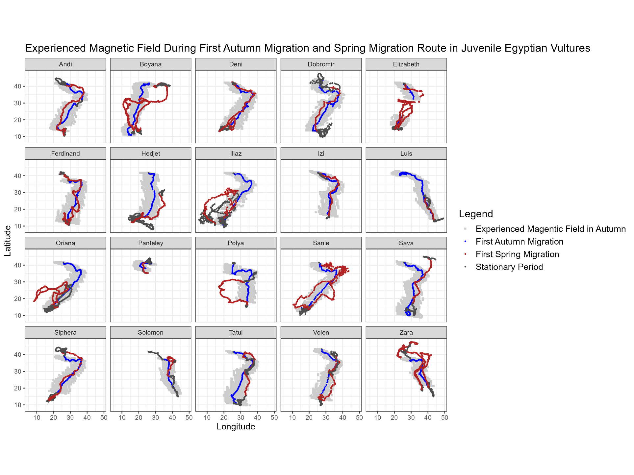

**Figure 1:** Experienced Magnetic Field During First Autumn Migration in Juvenile Egyptian Vultures. The grey shade represents the magnetic field (given by inclination, declination and intensity plus an uncertainty) from the first autumn migration transferred to a mean date during spring migration. Line represents movements of Egyptian vultures where red is first spring migration, blue is first autumn migration and dark grey is stationary behaviour.

Additional plots can be accessed at <https://github.com/Vogelwarte/MagneticNavigation/tree/master/output>.

1. **Conclusion**

Even though our findings cannot support either the use nor disprove the application of magnetic navigation in young Egyptian vultures and Red kites it offers the possibility for further research on magnetic navigation in birds. Notably, cases where raptors left the magnetic envelopes could provide the opportunity to investigate whether disruptions of the magnetic field or other events such as meteorological weather could have led to disorientation of naïve raptors. Therefore, the investigation of an index for the global geomagnetic activity (for example Kp) might provide further interesting insights (Matzka, Bronkalla, et al., 2021; Matzka, Stolle, et al., 2021).

**Figure 2:** Experienced Magnetic Field During First Autumn Migration in Juvenile Red KItes. The grey shade represents the magnetic field (given by inclination, declination and intensity plus an uncertainty) from the first autumn migration transferred to a mean date during spring migration. The red line represents the movements of Red kites during their first spring migration.

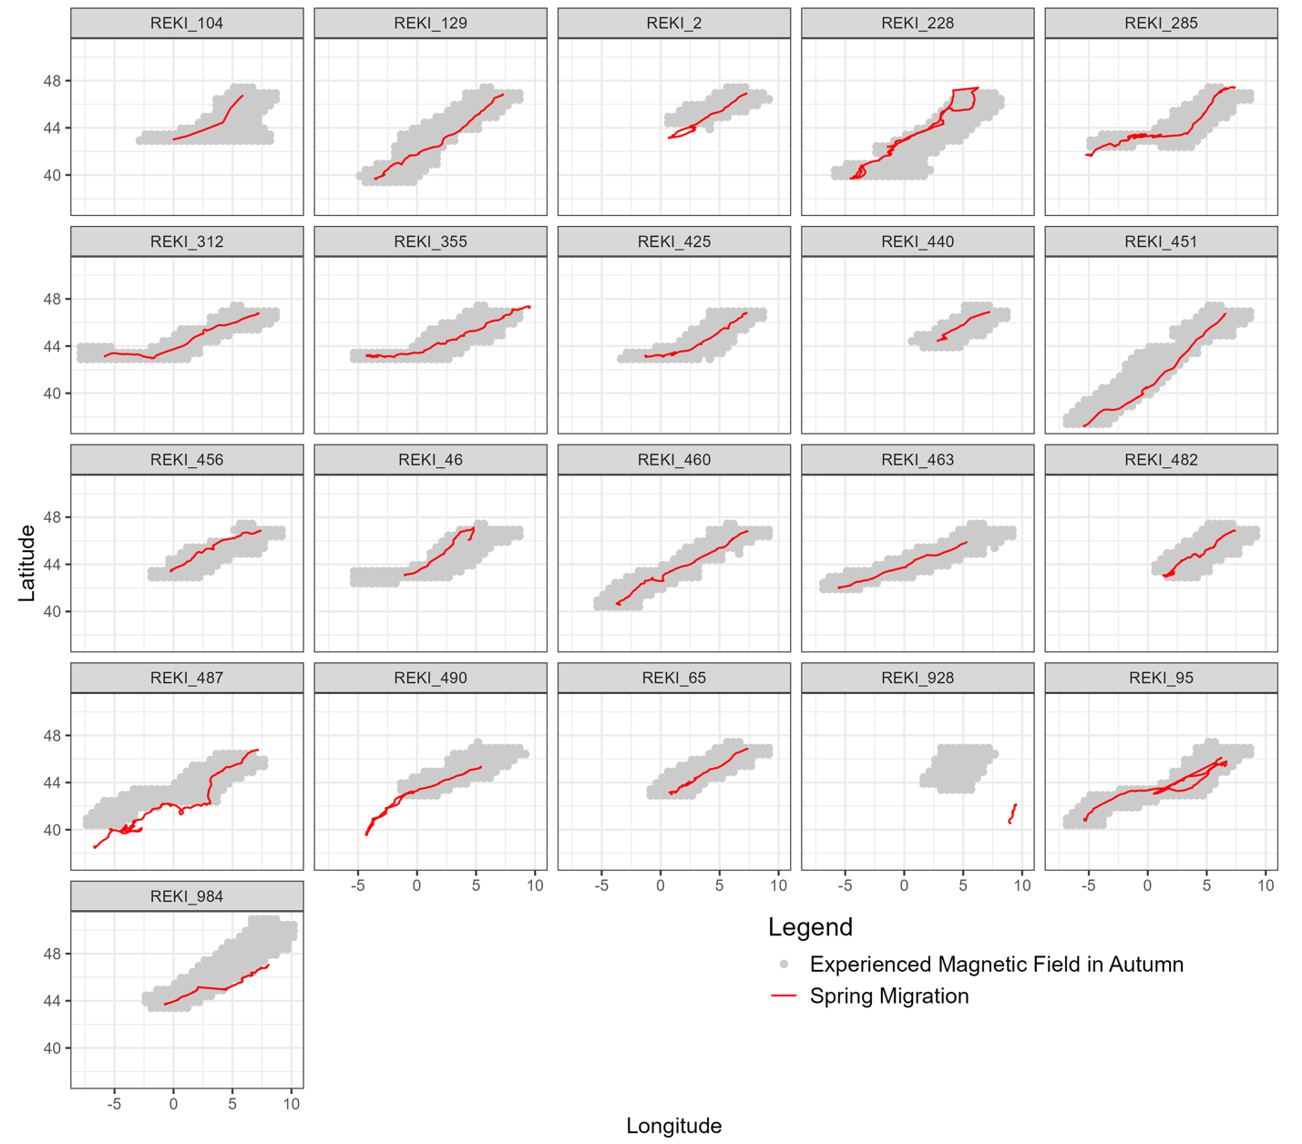

1. **References**

Alken, P., Thébault, E., Beggan, C. D., Amit, H., Aubert, J., Baerenzung, J., Bondar, T. N., Brown, W. J., Califf, S., Chambodut, A., Chulliat, A., Cox, G. A., Finlay, C. C., Fournier, A., Gillet, N., Grayver, A., Hammer, M. D., Holschneider, M., Huder, L., … Zhou, B. (2021). International Geomagnetic Reference Field: The thirteenth generation. *Earth, Planets and Space*, *73*(1), 49. https://doi.org/10.1186/s40623-020-01288-x

Guilford, T., Åkesson, S., Gagliardo, A., Holland, R. A., Mouritsen, H., Muheim, R., Wiltschko, R., Wiltschko, W., & Bingman, V. P. (2011). Migratory navigation in birds: New opportunities in an era of fast-developing tracking technology. *Journal of Experimental Biology*, *214*(22), 3705–3712. https://doi.org/10.1242/jeb.051292

Kelley, D., & Richards, C. (2024). *oce: Analysis of Oceanographic Data* (Version 1.8-3) [R]. https://CRAN.R-project.org/package=oce

Matzka, J., Bronkalla, O., Tornow, K., Elger, K., & Stolle, C. (2021). *Geomagnetic Kp index* (Version 1.0) [Dataset]. GFZ Data Services. https://doi.org/10.5880/KP.0001

Matzka, J., Stolle, C., Yamazaki, Y., Bronkalla, O., & Morschhauser, A. (2021). The Geomagnetic Kp Index and Derived Indices of Geomagnetic Activity. *Space Weather*, *19*(5), e2020SW002641. https://doi.org/10.1029/2020SW002641

Schneider, W. T., Packmor, F., Lindecke, O., & Holland, R. A. (2023). Sense of doubt: Inaccurate and alternate locations of virtual magnetic displacements may give a distorted view of animal magnetoreception ability. *Communications Biology*, *6*(1), 1–8. https://doi.org/10.1038/s42003-023-04530-w

Wiltschko, R., & Wiltschko, W. (2022). The discovery of the use of magnetic navigational information. *Journal of Comparative Physiology A*, *208*(1), 9–18. https://doi.org/10.1007/s00359-021-01507-0

Wright, M. N., & Ziegler, A. (2017). ranger: A Fast Implementation of Random Forests for High Dimensional Data in C++ and R. *Journal of Statistical Software*, *77*(1). https://doi.org/10.18637/jss.v077.i01