**Do raptors migrate within their previously experienced magnetic field?**

*Filibert Heim and Steffen Oppel, Swiss Ornithological Institute*

1. **Background**

A growing number of GPS-tagged migratory birds could provide possibilities to study navigation in birds (Guilford et al., 2011), for example to test whether observed routes are consistent with predictions based on magnetic cues being used for navigation (Wiltschko & Wiltschko, 2022).

Here, we explored whether the first spring migration route of young, solitary migrating raptors (Red Kite *Milvus milvus*, and Egyptian Vulture *Neophron percnopterus*) was contained within the magnetic envelopes (defined by inclination, declination and intensity) they had already experienced during their first autumn migration.

This was an exploratory investigation – if birds use routes with vastly different magnetic fields then it would be unlikely that previously experienced magnetic cues were vital for their navigation. This exploratory analysis was entirely opportunistic: we happened to have large GPS tracking datasets of both species, but because these two species are diurnal soaring migrants, it is entirely possible that visual cues (coastlines, mountains) play a much stronger role for navigation in these two species.

1. **Methods**

We first extracted the magnetic field experienced by a young naïve raptor during its first autumn migration using daily GPS locations and the International Geomagnetic Reference Field (IGRF) 13 using the R function oce::magneticField (Alken et al., 2021; Kelley & Richards, 2024).

We then created a spatial raster across the flyway domain of each individual bird and extracted the magnetic field values for each grid cell (50 km) at an intermediate time of the first spring migration of this individual bird. These magnetic field values were rounded to an assumed sensitivity of 0.5 for inclination and declination and 200 for intensity (Schneider et al., 2023). We then filtered all grid cells of the spring migration which had magnetic field values within the range of the magnetic field experienced during the autumn migration by the same individual (Schneider et al., 2023). The spring migration routes were plotted on these individual-specific magnetic field envelopes, and the proportion of migratory locations within this ‘experienced magnetic envelope’ was calculated.

We used tracking data of 132 Red Kites and 25 Egyptian Vultures with at least one complete migratory circle (from the hatching location to the wintering sites and back to the breeding region). We classified migratory periods on a weekly (Red Kites) and monthly (Egyptian Vulture) basis using a random forest model explicitly trained with manually annotated migratory periods on each species from the same data set. For Red Kites, we paired the first autumn migration of each bird with the first spring migration in the following year; for Egyptian Vultures, we paired the first autumn migration with the first 2 spring migrations in any following year due to the sometimes protracted vagrancy of Egyptian Vultures on wintering grounds (first return migration often at ages > 2 years).

All data and code are available at <https://github.com/Vogelwarte/MagneticNavigation>.

1. **Results**

Most Red Kites stayed within the envelope of their previously experienced magnetic field during their first return journey in spring, with an average of 18% of spring migration locations outside the previously experienced magnetic envelope (range 0 – 88%).

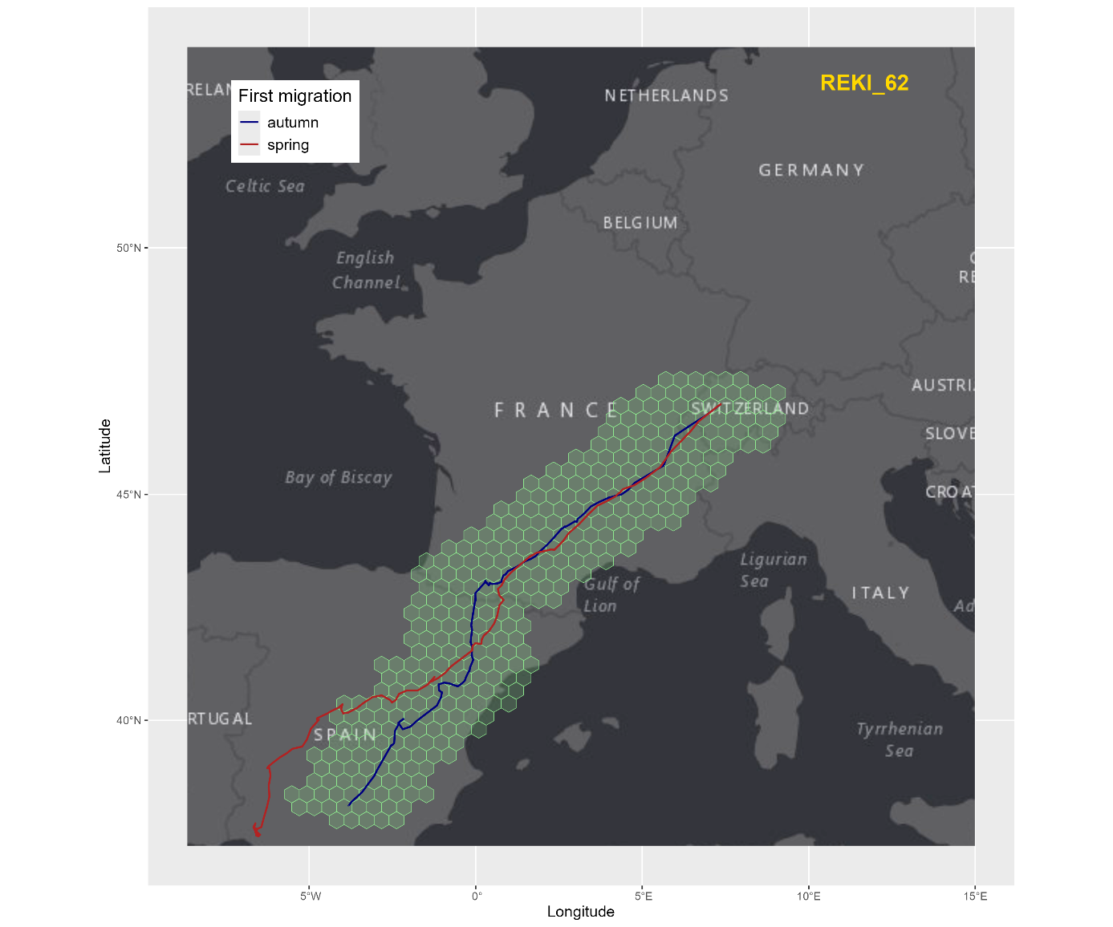

*Fig. 1. Example of the first outbound (blue) migration of a Red Kite (REKI_62), and the first return (red) migration in the following spring. The green grid is the magnetic field that the bird would have experienced during its first outbound migration at the time of the first return migration.*

Egyptian Vultures had on average 53% of spring migration locations outside the previously experienced magnetic envelope (range 1 - 100%).

*Fig. 2. Example of the first outbound (blue) migration of an Egyptian Vulture (Boyana, in 2018), and the first return (red) migration in 2020. The green grid is the magnetic field that the bird would have experienced during its first outbound migration at the time of the first return migration. Note that this individual is one of the few ‘survivors’ that succeeded in crossing the Mediterranean Sea (with tailwind), which is an unlikely route for this soaring migrant (and was therefore avoided during the return migration).*

Raw output tables are here for [Red Kites](https://github.com/Vogelwarte/MagneticNavigation/blob/master/output/REKI_first_mig_summaries.csv) and for [Egyptian Vultures](https://github.com/Vogelwarte/MagneticNavigation/blob/master/output/EGVU_first_mig_summaries.csv).

All plots are collated here for Red Kites and for Egyptian Vultures.

1. **Limitations**

Deviations from the autumn migration magnetic envelopes during spring migration could originate from various sources:

* Birds explore geographic areas outside of distinct ‘migration’ periods. Thus, by focussing only on migratory periods we may miss periods of exploration for some young birds that may have exposed them to a broader magnetic field.
* For young Egyptian Vultures determining the first return migration is difficult due to a protracted period of vagrancy/roaming in Africa (up to 3-4 years). These movements lead to difficulties in determining migratory periods, and the birds obviously expand their envelope of experienced magnetic fields during those roaming phases as well.
* Red kite migratory routes are spatially restricted on the Iberian peninsula leading to less diverse migration routes and the confinement to the previous magnetic envelope may be coincidental.

1. **Next steps**

Staying within the experienced magnetic field during the first spring migration appears to be the rule rather than exception.

Hence, the next steps could be to explore the exceptions when raptors left the magnetic envelopes to investigate whether disruptions of the magnetic field or other events such as meteorological weather could have led to disorientation of naïve raptors. For Egyptian Vultures, severe dust storms in the Sahara may occasionally lead to abrupt route changes irrespective of navigational cues (escape movements). Therefore, the investigation of an index for the global geomagnetic activity (for example Kp) might provide further interesting insights (Matzka, Bronkalla, et al., 2021; Matzka, Stolle, et al., 2021).

1. **References**

Alken, P., Thébault, E., Beggan, C. D., Amit, H., Aubert, J., Baerenzung, J., Bondar, T. N., Brown, W. J., Califf, S., Chambodut, A., Chulliat, A., Cox, G. A., Finlay, C. C., Fournier, A., Gillet, N., Grayver, A., Hammer, M. D., Holschneider, M., Huder, L., … Zhou, B. (2021). International Geomagnetic Reference Field: The thirteenth generation. *Earth, Planets and Space*, *73*(1), 49. https://doi.org/10.1186/s40623-020-01288-x

Guilford, T., Åkesson, S., Gagliardo, A., Holland, R. A., Mouritsen, H., Muheim, R., Wiltschko, R., Wiltschko, W., & Bingman, V. P. (2011). Migratory navigation in birds: New opportunities in an era of fast-developing tracking technology. *Journal of Experimental Biology*, *214*(22), 3705–3712. https://doi.org/10.1242/jeb.051292

Kelley, D., & Richards, C. (2024). *oce: Analysis of Oceanographic Data* (Version 1.8-3) [R]. https://CRAN.R-project.org/package=oce

Matzka, J., Bronkalla, O., Tornow, K., Elger, K., & Stolle, C. (2021). *Geomagnetic Kp index* (Version 1.0) [Dataset]. GFZ Data Services. https://doi.org/10.5880/KP.0001

Matzka, J., Stolle, C., Yamazaki, Y., Bronkalla, O., & Morschhauser, A. (2021). The Geomagnetic Kp Index and Derived Indices of Geomagnetic Activity. *Space Weather*, *19*(5), e2020SW002641. https://doi.org/10.1029/2020SW002641

Schneider, W. T., Packmor, F., Lindecke, O., & Holland, R. A. (2023). Sense of doubt: Inaccurate and alternate locations of virtual magnetic displacements may give a distorted view of animal magnetoreception ability. *Communications Biology*, *6*(1), 1–8. https://doi.org/10.1038/s42003-023-04530-w

Wiltschko, R., & Wiltschko, W. (2022). The discovery of the use of magnetic navigational information. *Journal of Comparative Physiology A*, *208*(1), 9–18. https://doi.org/10.1007/s00359-021-01507-0