Geographic origin of woodcocks (Scolopax rusticola) from hunting bags in Switzerland assessed by isoscape origin models
PD Dr. Christian C. Voigt, Dr. Stephanie Kramer-Schadt

Leibniz Institute for Zoo and Wildlife Research, Evolutionary Ecology Research Group, Alfred-Kowalke-Str. 17, 10315 Berlin, Germany;
Questions about isotopic analysis: email: voigt@izw-berlin.de, phone: ++49-30-5168-517
Questions about isotopic origin models: Email: kramer@izw-berlin.de, phone: ++49-30-5168-714
Objectives: The goal of this work was to estimate the place of origin (place of feather production) of Eurasian woodcock (Scolopax rusticola) collected from hunting bags in Switzerland.
Methods: We measured stable isotope ratios in non-exchangeable hydrogen of keratin of feathers collected from woodcocks in Swiss hunting bags as outlined in the section Laboratory methods. We then used an isoscape origin approach based on stable isotope ratios of non-exchangeable hydrogen of feather keratin (δ²H_{K.B}). In order to make δ²H_{K.B} values obtained from the Berlin based IZW laboratory comparable with those of previous studies, which were scaled to other keratin standards, we used the following conversion equation:
δ²H_{K.C} = 0.979 * δ²H_{K.B} + 20.701
We then separated juveniles from non-juveniles (adults and subadults) and converted δ²H_{K.C} to δ²H_{P} of the likely place of origin using a specific equation for juveniles and for adult woodcocks.
Equation for juvenile woodcocks (from Powell 2013 cited in Hobson et al. 2013a)
δ²H _{K.C} = 0.8 * δ²H _{P} - 24.22 (δ²H _{P}= 1.25 * δ²H _{K.C} + 30.275)
Equation for adult woodcocks (from Powell 2013 cited in Hobson et al. 2013a)
δ²H _{K.C} = 0.8 * δ²H _{P} + 4.51 (δ²H _{P}= 1.25 * δ²H _{K.C} – 5.6375)
Individual woodcocks were then assigned to isotopic bins according to their specific δ²H_{K.C} value. Isotopic bins were defined over 10‰ ranges starting at -10‰ (note: labeling of isotopic bins do not refer to the same area of origin in juvenile and adult animals). We used the Gamma error distribution around the values as published in Voigt et al. (2012) for more than 12 measures per locations (shape: 5.22, scale: 1.32)
For each isotopic bin, we established a probability map for the likely origin of animals assigned to the specific isotopic bin. These probability maps were calculated for adult and juveniles separately.
Results: Assignments in isotopic bins are listed for juvenile woodcocks in Waldschn_juvenil_bin.xls and for adult woodcocks in Waldschn_adult_bin.xls (column O labeled MYINDEX).
Juvenile woodcocks The isotopic bin with the largest number of juvenile woodcocks (128 out of 422 in total; 30.3%) were assigned to the isotopic bin 8 (Table 1), which represents an area reaching from Denmark to northern Poland and southern Belarus and also at higher altitudes in the Alpes (Figure 1). Probability maps of all other isotopic bins are provided in the supplement.
Table 1: Total numbers and percentages of juvenile woodcocks assigned to isotopic bins. The largest isotopic bin was highlighted in bold.
Isotopic bin* | 3 | 4 | 5 | 6 | 7 | 8 | 9 | 10 | 11
Number and  percentage  of juvenile woodcocks | 7  1.7% | 21  5.0% | 34  8.1% | 39  9.2% | 76  18.0% | 128  30.3% | 74  17.5% | 33  7.8% | 6  1.4%
*note: isotopic bins with less or equal than 2 individuals are not listed.
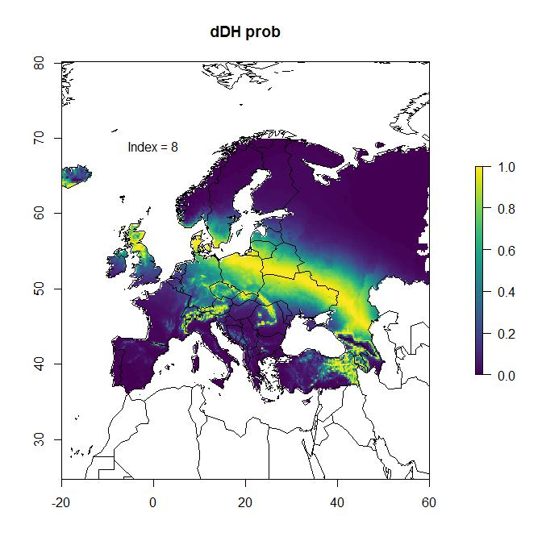
Figure 1: Cumulative probability map of juvenile woodcocks assigned to isotopic bin 8. (0 = unlikely origin, 1 = most likely origin).

Adult woodcocks: The isotopic bin with the largest number of adult woodcocks (37 out of 153 in total; 24.2%) were assigned to the isotopic bin 8 (Table 2), which represents an area reaching from Fennoscandia to Russia (Figure 2). Probability maps of all other isotopic bins are provided in the supplement.
Table 2: Total numbers and percentages of adult woodcocks assigned to isotopic bins. The largest isotopic bin was highlighted in bold.
Isotopic bin* | 3 | 4 | 5 | 6 | 7 | 8 | 9 | 10 | 11
Number and  percentage  of adult woodcocks | 5  3.3% | 17  11.1% | 16  10.5% | 12  7.8% | 24  15.7% | 37  24.2% | 22  14.4% | 13  8.5% | 3  2.0%
*note: isotopic bins with less or equal than 2 individuals are not listed.
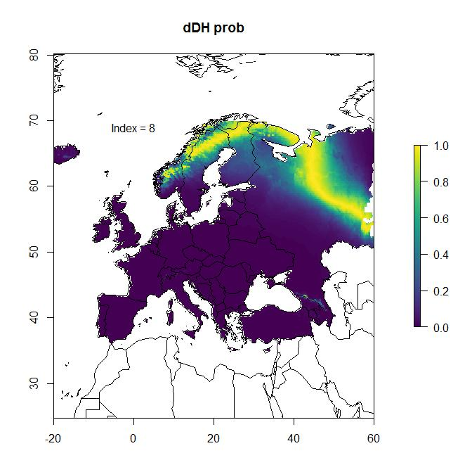
Figure 2: Cumulative probability map of adult woodcocks assigned to isotopic bin 8. (0 = unlikely origin, 1 = most likely origin).

We then calculated a cumulative probability map for all woodcocks (juvenile and adults) based on the transfer function for juveniles. Based on this approach, most animals originated from Poland and adjacent countries (Figure 3).
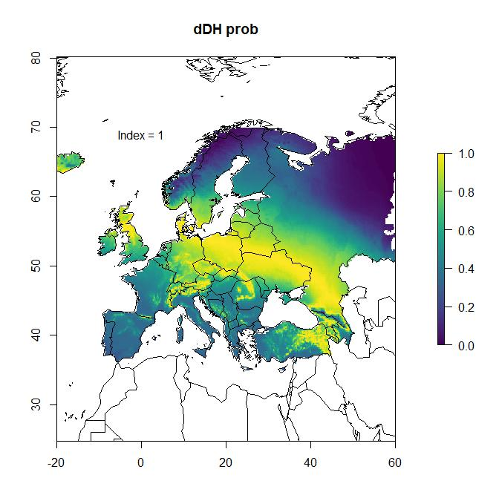
Figure 3: Cumulative probability map of all 575 woodcocks collected from hunting bags in Switzerland (0 = unlikely origin, 1 = most likely origin).

Discussion: Results for the likely origin of juvenile woodcocks hunted in Switzerland are similar to those reported for juvenile woodcocks hunted in France (Hobson et al. 2013a) and Spain (Hobson et al. 2013b). In the French study, about 50% of animals originated from an area ranging from northern Poland, Baltic countries, Belarus to western Russia (bins 8 and 9 in Table 1, equaling 47.8% of all juvenile woodcocks from this study). The other major area of origin covers Central Europe (bins 7 in table 1, equaling 18.0% of all juvenile woodcocks). In the Spanish study, the likely geographical origin of juvenile woodcocks revealed also similar results, yet the origin of animals were more shifted to Central Europe.
To the best of our knowledge, we are lacking any data about the potential place of origin of adult woodcocks hunted in Central Europe. A comparison of the likely geographic origin between juvenile and adult woodcocks shows that adult animals of our study seem to originate from more northeastern areas than juveniles (Fig. 1 and 2). Also, geographical assignments were more uniformly distributed in adult compared with juvenile woodcocks. In adult woodcocks we observed a bimodal distribution of bin assignments, with a second peak of number of animals assigned to Central Europe (bins 4 and 5 in Table 2). Potentially, these animals are of local origin from Switzerland. We are unsure why none of the previous studies included adult woodcocks (Hobson et al. 2013a,b). We also noted the transfer equation for juvenile and adult woodcocks is largely deviating, leading to more northeastern places of origin in adult than in juvenile woodcocks. Since we do not have access to the original data published in the PhD study by A. Powell, we are unable to evaluate the quality of the regression function for adult woodcocks. Using the regression for juvenile woodcocks as well for adults individuals results in similar assignments for both adult and juveniles.
We have neglected outliers in our data interpretation because isoscape origin models yielded no or very deviating geographical places as the likely place of origin for these individuals. We are unsure about the underlying causes for the potentially biased isotopic values, yet we rule out analytical problems. Instead, we speculate that some woodcocks grew feathers in a local habitat which might have been isotopically contrasting to the larger area.

Literature cited:
Hobson, K.A., Van Wilgenburg, S.L., Ferrand, Y., Gossman, F., Bastat, C. (2013a) A stable isotope (d2H) approach to deriving origins of harvested woodcock (Scolopax rusticola) taken in France. Eur. J. Wild. Res. 59: 881-892.
Hobson, K.A., Van Wilgenburg, S.L., Guzmán J.L. Arroyo, B (2013b) Origin of juvenile woodcock (Scolopax rusticola) harvested in Spain inferred from stable hydrogen isotope (d2H) analyses of feathers. J. Ornithol. 154: 1087-1094.
Lehnert, L.S., Kramer-Schadt, S., Schönborn, S., Lindecke, O., Niermann, I., Voigt, C.C. (2014) Wind farm facilities in Germany kill noctule bats from near and far. PLOSONE 9: e103106
Popa-Lisseanu, A.G., Soergel, K., Luckner, A., Wassenaar, L.I., Ibáñez, Kramer-Schadt, S., C., Ciechanowski, M., Görföl, T., Niermann, I., Beuneux, G., Myslajek, R., Juste, J., Fonderflick, J., Kelm, D.H., Voigt, C.C. (2012) A triple isotope approach to predict breeding origins of European bats. PLoS ONE 7: e38083
R Core Team (2016). R: A language and environment for statistical computing. R Foundation for Statistical Computing, Vienna, Austria. URL https://www.R-project.org/.
Wassenaar, L.I., Hobson, K.A. (2003) Comparative equilibration and online technique for determination of non-exchangeable hydrogen of keratins for use in animal migration studies. Isotopes Environment and Health Sciences 39:211-217
Voigt, C.C., Popa-Lisseanu, A.G. Niermann, I., Kramer-Schadt, S. (2012) The catchment area of wind farms for European bats: A plea for international regulations. Biological Conservation 153 (2012) 80–86

Supplement:
Abbreviations:
δ²H_{K.B} = stable hydrogen isotope ratios of keratin scaled to Berlin-based laboratory standards
δ²H_{K.C} = stable hydrogen isotope ratios of keratin scaled to Canada-based laboratory standards (Hobson et al. 2013a, b).
δ²H_{P} = stable hydrogen isotope ratios of precipitation (P)
Laboratory methods:
Stable isotope analyses followed the procedures described in Popa-Lisseanu et al. (2012). A minute piece of feather was put into a small silver foil capsule (IVA Analysetechnik e.K. Meerbusch, Germany). Capsules were folded with forceps to form about 1mm³ sized packets each and sorted into 96 port microtiter trays, in which they were allowed to equilibrate with ambient air over more than a week. Afterwards, the tray was placed in a drying oven over 24 hours at 50°C. Then, samples were analyzed as a sequence consisting of spaced repetitions of four in-house keratin standards (sheep and goat fur), interspersed with 66 samples of feather samples. Keratin standards with the following δ²H_{K} values were used to measure the non-exchangeable hydrogen stable isotope ratios: -167.9‰ for SWE-SHE (Swedish sheep), -136.8‰ for GER-SHE (German sheep), -108.3‰ for ESP-SHE (Spanish sheep) and -66.3‰ for TAN-GOAT (Tanzanian goat). δ²H values of non-exchangeable hydrogen for these standards were previously obtained by using the comparative equilibration method (Wassenaar and Hobson, 2003) with keratin laboratory standards from Leonard I. Wassenaar (pers. communication). We placed silver capsules in a Zero Blank autosampler (Costech Analytical Technologies Inc., Cernusco, Italy) above the elemental analyzer (HT Elementar-Analysator HEKAtech GmbH, Wegberg, Germany). For at least 1 hour before combustion, samples were flushed in the autosampler with chemically pure helium (Linde, Leuna, Germany). We used a Delta V Advantage isotope ratio mass spectrometer (ThermoFischer Scientific, Bremen, Germany) that was connected in continuous flow via an interface (Finnigan Conflo III, ThermoFisher Scientific, Bremen, Germany) with the elemental analyzer. Stable hydrogen isotope ratios of feather keratin (δ²H_{K}) are given as δ-values, which express the parts per mille (‰) deviation of the sample isotope ratio from that of the international standard, i.e. Vienna-Standard Mean Ocean Water (V-SMOW). We used the δ²H_{K} of non-exchangeable hydrogen of the in-house keratin standards to correct measured feather keratin δ²H of birds for the effect of exchangeable hydrogen. For this, we calculated a least-squares linear regression for the measured and expected δ²H of laboratory keratin standards, and then used the derived regression equation to correct measured δ²H of keratin in bird feather. Analytical precision based on the repeated analyses of laboratory keratin standards was always better than 1‰ (1 standard deviation).
Modelling the geographical origin of migrant woodcocks based on δ²H_{P}: To delineate the origins of migratory woodcock in the δ²H_{p} isoscape of Europe, we used an extrapolation approach. For this, we used the transferfunctions previously established for woodcocks (Powell cited in Hobson et al. 2013a,b). For each individual, we simulated 10,000 possible δ²H_{p} values of the measured δ²H_{K.C..} Subsequently, a final value was drawn from a normal distribution with the mean corresponding to the regression value and the standard deviation randomly generated from the gamma distribution. We then created standardized probability density functions (PDFs; R package MASS) ranging between 0 and 1. The PDFs were used to reclassify the δ²H_{p} map into isoscape origin probability maps (R package raster) for 6 isotopic range classes. All analyses were conducted in R v. 3.3.2 (R Core Team 2016); we also used R to visualize the reclassified raster surface with a resolution of 10’ x 10’ (arc minutes).

List of supplement files
Source data and isotopic bins of adult and juvenile woodcocks:
Waldschn_juvenil_bin.xls
Waldschn_adult_bin.xls
Probability maps: Note: Numbers indicate the corresponding isotopic bin
ICON_Waldschn_juvenile_bin-Waldschn_juv1 - … juv11.jpg
ICON_Waldschn_adult_bin-Waldschn_ad1 - … juv11.jpg

