AI620: Fundamentals of Data Engineering

Assignment 1: Building a Modern ELT Pipeline

27100004 – Abdullah Khurram Vohra

Theme: Pakistan’s Digital Payments Landscape

The project aimed to extract, load, and visualize specific datasets and data sources related to digital banking and payments, specifically in the context of Pakistan.

With the State Bank of Pakistan promoting and encouraging the usage of mobile wallets and digital portals as a key method of transitioning into a mostly cashless economy, the adoption of digital payments has seen a sharp rise in Pakistan, democratizing access to fast, secure, and traceable transactions from the palm of your hand.

To understand this trend, the project built an EL Pipeline, which gets data from 3 different sources:
- The Global Findex Dataset 2025 – World Bank
- Google Search Trends for various digital-payment-related keywords (5 years, till Jan 1, 2026, via pytrends).
- News articles related to digital payments in Pakistan (via NewsAPI).

After data is extracted from the sources, processed and cleaned, and loaded into suitable formats (CSV and JSON), the project also includes an exploratory analysis notebook that examines search-keyword trends and specific indicator data from the World Bank Findex dataset.
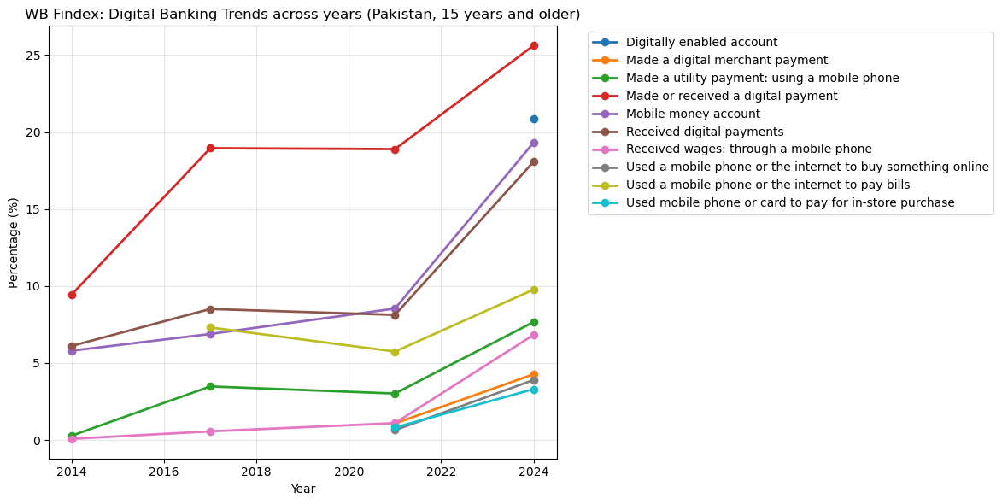
Figure 1: An example visualisation showing yearly trends for various indicators (exploratory_analysis.py). This shows that the indicators show a significant increase from 2021 to 2024, suggesting wider adoption of digital payment platforms in Pakistan.
While completing this project, one major challenge was obtaining accurate, relevant news articles as the third data source. For unclear reasons, requesting news articles using similar keywords as for Google Search Trends (and other permutations) resulted in totally irrelevant, sometimes non-Pakistani and non-English news articles. This proved to be a major setback in visualizing the extracted text from the news articles. A plausible reason for this could be the usage of the free tier of NewsAPI.

Overall, the project taught a lot about the processes of extraction, loading, transformation, and visualization for data engineering pipelines.

