ME EN 510: Compressible Flow Lab

  - Ezra Lamoreaux
  - Dr. Gorrell
  - 10/16/2026

Results
Eight back-pressure settings were recorded in this experiment. Two different regimes were studied: pre-choked flow and choked flow.
For the unchoked cases, the exit pressure was set equal to the measured back pressure. The exit Mach number came from Eq. 3.16, and the reference area was solved using Eq. 3.23, giving A* = 0.0912 in² (case 1) and 0.1280 in² (case 2), both smaller than the 0.150 in² geometric throat. The isentropic subsonic solution was then evaluated at each tap. Tap 1, in the converging section, uses an effective area of 0.159 in² inferred from the choked-case pressure.
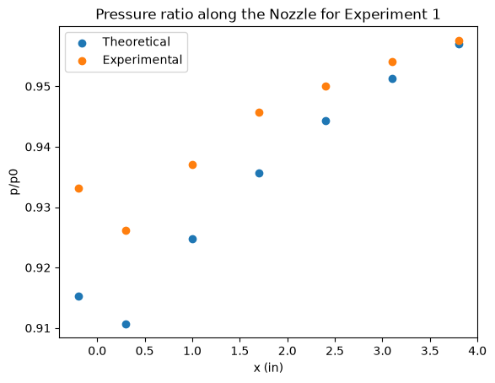
Figure 1: Pre-choked flow through CD nozzle, with a backpressure of 12.015821 psi
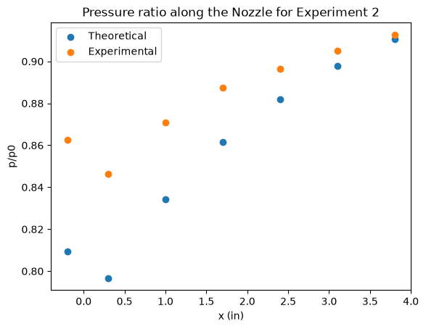
Figure 2: Pre-choked flow through CD nozzle, with a backpressure of 11.477283 psi
Figure 1 and 2 clearly show the theoretical pressure ratios being much lower than the experimental ratios. The theory and experiment match at the exit, since A* was calculated using the exit pressure. However for the other 6 upstream pressure taps, the points diverge, with a maximum difference at tap 2. This is mainly due to the diverging section of the nozzle acting as a diffuser since velocities are subsonic. This causes an adverse pressure gradient, which thickens boundary layers. Increased friction and mixing causes this reduction in velocity and a lower stagnation pressure. Additionally the 1d assumption breaks down in the throat, as the boundary layers are extremely influential and the pressure tap is recording only on the wall, not truly in the middle of the flow.

For cases 5-8, choked flow was observed. This resulted in a normal shock developing in the diverging section of the nozzle. The Theoretical shock position didn’t match up with the observed positions. Since stagnation pressure is lower than the isentropic assumption, the shock progresses up the nozzle quicker than expected.
Table 1: Theoretical Shock location for supersonic flow conditions.
Data Collection | Theoretical Shock position (in)
Measurement 5 | 2.23771833623432
Measurement 6 | 2.9399181942435892
Measurement 7 | 3.948264355146177
Measurement 8 | 6.120338733302304

Appendix I: Data Used
 | 1 | 2 | 3 | 4 | 5 | 6 | 7 | 8
Pre-Choked | 11.68312 | 11.594428 | 11.731856 | 11.839267 | 11.893583 | 11.944832 | 11.988889 | 12.015821
Pre-Choked | 10.79801 | 10.595885 | 10.901870 | 11.109147 | 11.222773 | 11.331713 | 11.427644 | 11.477283
Pre-Choked | 9.588802 | 9.138658 | 9.766297 | 10.134424 | 10.341041 | 10.531211 | 10.693390 | 10.763375
Just Choked | 8.645082 | 6.461065 | 8.544944 | 9.089083 | 9.413062 | 9.689256 | 9.908963 | 10.001945
Choked | 8.627993 | 5.461119 | 5.183658 | 7.936973 | 8.572519 | 8.952542 | 9.214922 | 9.342434
Choked | 8.639989 | 5.461083 | 4.724287 | 4.579938 | 7.348316 | 8.194938 | 8.584234 | 8.749715
Choked | 8.623316 | 5.461056 | 4.715105 | 4.164715 | 3.699364 | 6.574609 | 7.476679 | 7.914763
Choked | 8.614622 | 5.460794 | 4.761722 | 4.171156 | 3.652592 | 3.288184 | 5.409716 | 6.085637

Appendix II: Code
See Lab1/Lab1Calcs.ipynb in GitHub for printouts and code used to calculate values.

Link:
https://github.com/VoicefulEmu/Labs/tree/a544bfdc611e4f299c933675d40c8715dea2c9ac/Lab1

