Voicyou Avatar Documentation

Functionality:

This is Magento 2 module to add new functionality of customer profile image.Customer can upload his profile image (avatar) during customer registration process or during customer edit form. Profile image (avatar) is visible in the customer dashboard page.

Steps to install this module:
- composer require “voicyou/avatar:1.0.0”
- php bin/magento setup:upgrade
- Go to customer registration page, you see the option to upload the customer avatar(profile picture)
- In customer dashboard you can see the avatar, you can edit this avatar in the customer information edit page.

Sample Screenshots:

Customer Registration Form:
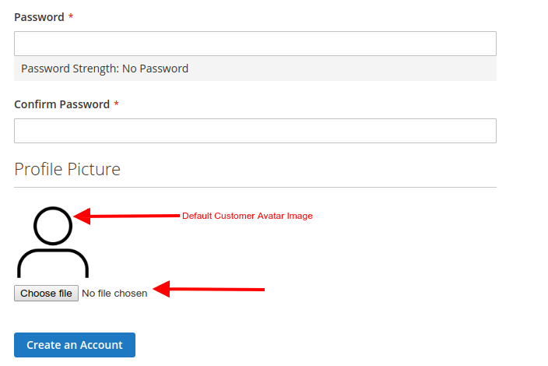

Customer Dashboard Page:
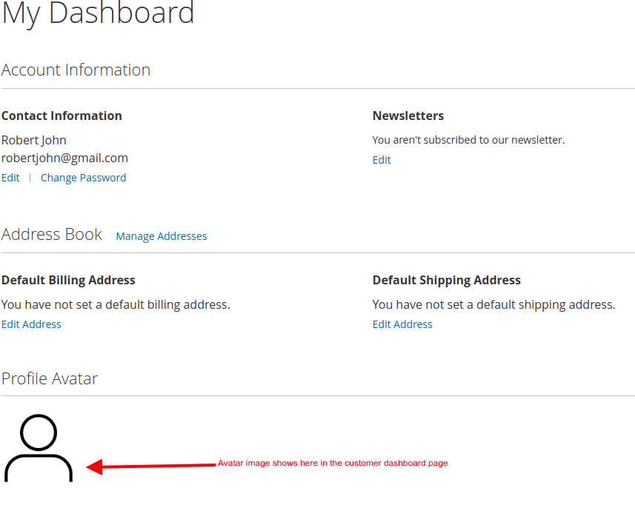

Customer Account Information Edit Page:

