Documentation

Functionality:

It is a Magneto 2 module to approve and disapprove the customer from being able to login or not.

Steps to install this module:
- composer require “sourabhcoder/customerapprove:1.0.0”
- php bin/magento setup:upgrade
- Go to magento backend and click on the Customers menu
- Click on the on All Customers
- You can see all customers.
- Click on the edit customer link.
- You can see in the form buttons a new button is added to approve customer if the customer is disapproved and disapprove customer button if the customer is approved.

Sample Screenshots:

Backend Approve Customer Demo Image:

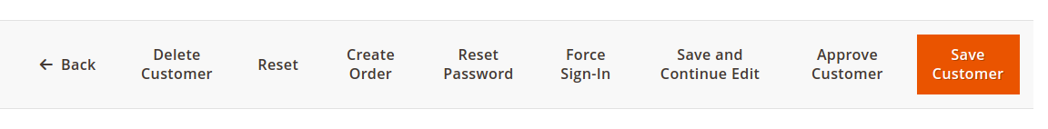
Backend Disapprove Customer Demo Image:

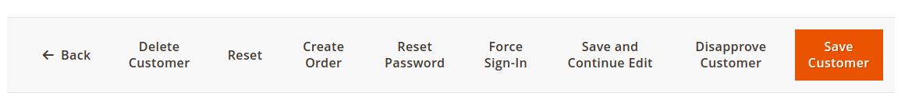
Frontend Customer Example Demo Image:

