# **Exercise 5**

1. Create a CSS file called styletext.css and save it inside your CSS folder

Copy the code bellow .

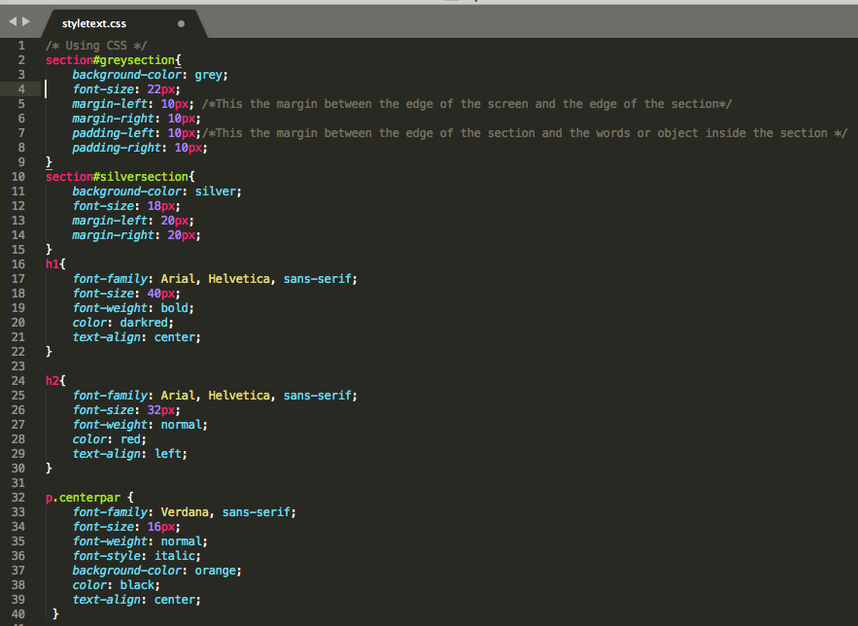

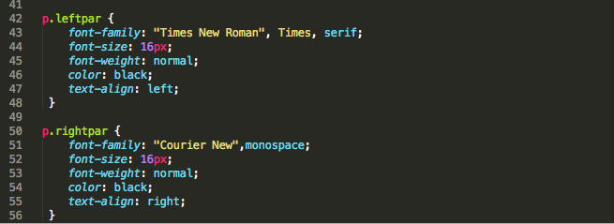

2. Create a HTML file called exc5formatext.html

Copy the code bellow

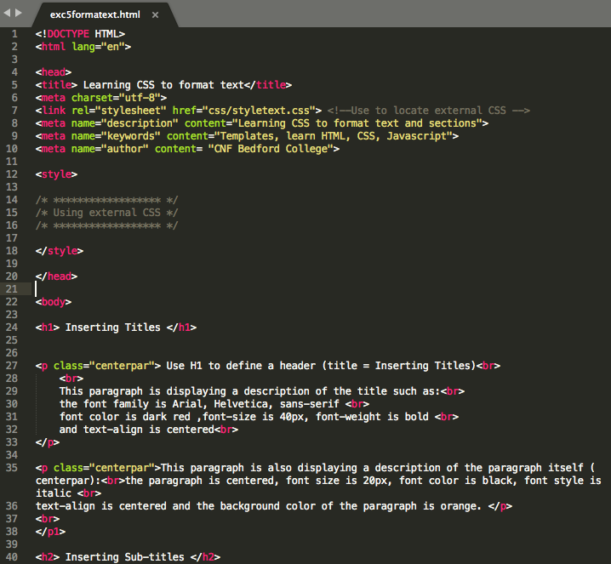

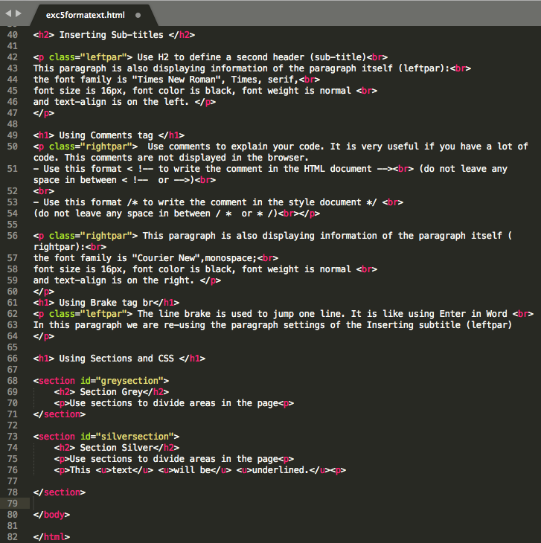



Your website should look like the picture bellow.

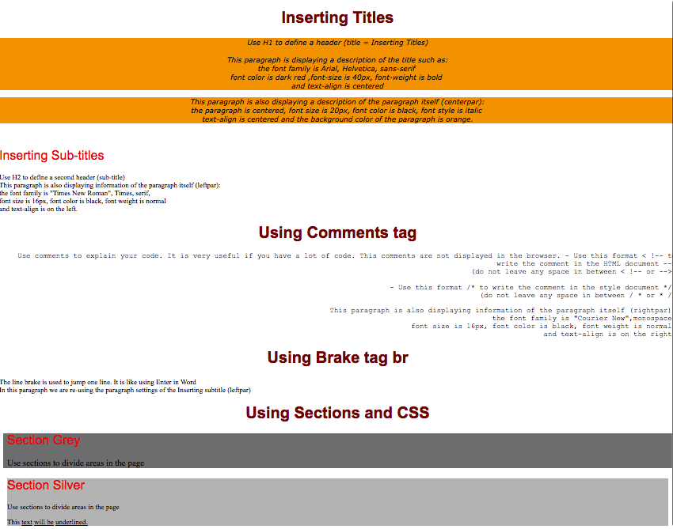

# Learning CSS

|  |  |  |
| --- | --- | --- |
| **Property** | **Value** | **Description** |
| **font-family:** Arial, Helvetica, sans-serif; |  | Font-family sets a specific type of font |
| **font-size:** 40px; | Number px;  Small , medium , large;  Percentage%; 10%;  Inherit;  (other) | Change the size of the font |
| **font-weight**: bold; | Normal, bold, bolder, lighter | It sets how thick or thin characters in text should be displayed. |
| **font-style:** italic; | normal|italic|oblique|  initial|inherit; | This property specifies the font style for a text. |
| **color** :red; | Red, blue, etc  #92a8d1 (grade of blue) | This property specifies the colour of text. |
| **text-align**: center; | left|right|center|justify |initial|inherit; | This property specifies the horizontal alignment of text in an element. |
| **background**-color: orange; | Red, blue, etc  #92a8d1 (grade of blue) | This property sets the background color of an element. |
| **Margin**:10px; margin-top: auto; margin-right: 5%; margin-bottom: 5px; margin-left: 5px; | Number px;  Auto;  Percentage%; 10%;  Inherit; | These properties are used to create space around elements, outside of any defined borders. |
| **padding:** 10px;  padding-top: auto; padding-top: 5%; padding-bottom: 5px; padding-left: 5px; | Number px;  Auto;  Percentage%; 10%;  Inherit; | These properties are used to generate space around an element's content, inside of any defined borders. |