Executive summary
This report documents a password brute-force attack conducted against the login form at http://localhost/labs/a0x01.php. Using automated credential testing, the account was fully compromised due to the absence of rate limiting, account lockout, or CAPTCHA protections. This represents a Critical-severity finding.

Scope & Methodology
- Target: http://localhost/labs/a0x01.php (local lab environment, not live/authorized external target)
- Methodology: Manual request inspection via browser developer tools, followed by automated credential brute forcing using ffuf against a known username

Finding: Weak password and no brute-force protection
- Severity: Critical. 10,000 login attempts were completed with no lockout, delay, or blocking observed, allowing unlimited credential guessing.
- Description: Application does not implement lockout, rate limiting, or CAPTCHA on the login endpoint, which allows unlimited login attempts
- Impact: Full access to the compromised user account, potentially exposing any data or functionality gated behind this login

Steps to Reproduce
Step 1: Capture login request via browser dev tools:
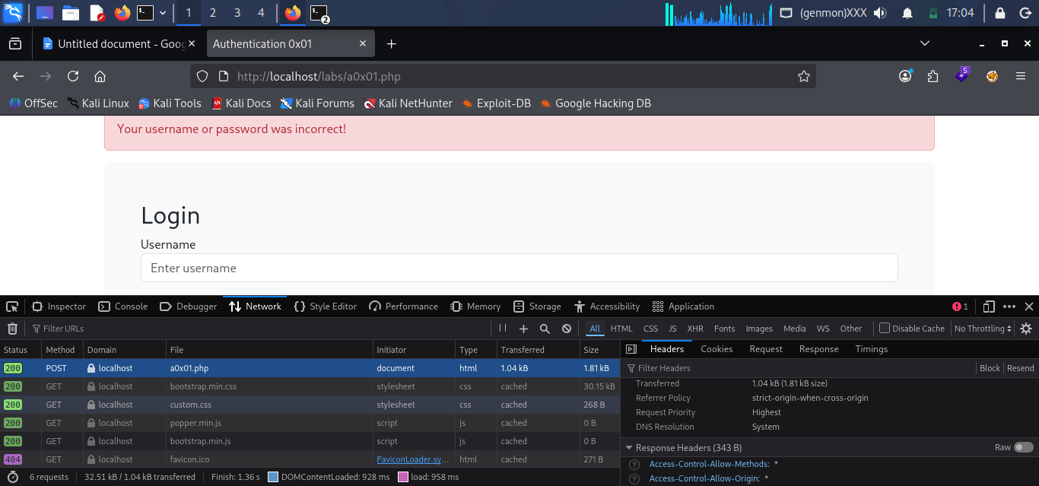
Step 2: Identified POST parameters (username, password)

Step 3: Constructed ffuf command:
ffuf -u http://localhost/labs/a0x01.php -X POST -d "username=jeremy&password=FUZZ" -H "Content-Type: application/x-www-form-urlencoded" -w /usr/share/seclists/Passwords/Common-Credentials/xato-net-10-million-passwords-10000.txt -mc all

Step 4: Ran baseline scan with -mc all to establish the failed login fingerprint. Autocalibration (-ac) could have achieved this in a single pass

Step 5: Status code was the same, therefore I could not determine which entry was valid. Noting the response size change meant there was an anomaly which led to spotting the target

Step 6: Filtered with -fs 1814, isolated the outlier
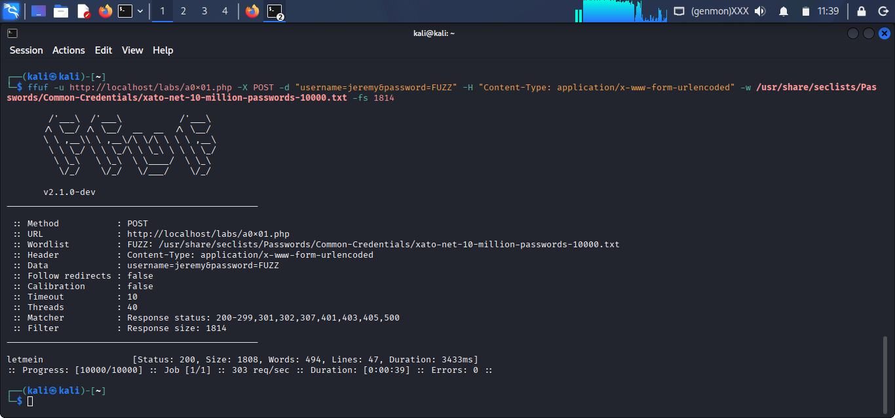

Step 7: Confirmed credentials by manually logging in
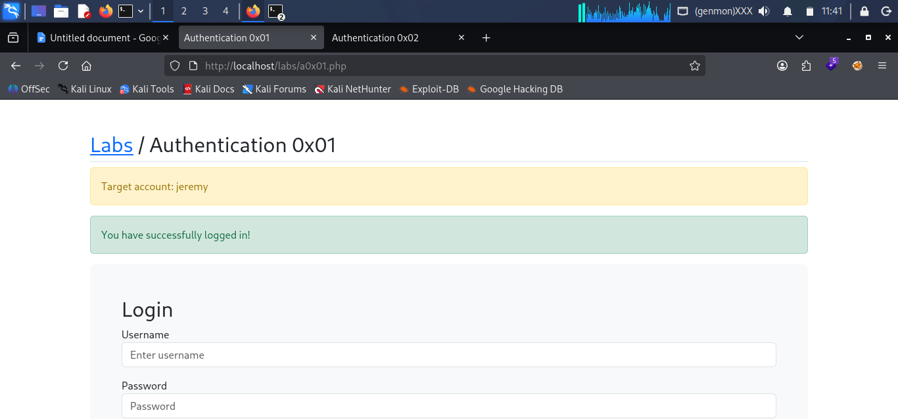

Remediation
- Add account lockout after a set number of failed attempts
- Add rate limiting on the login endpoints
- Add a CAPTCHA after a few failed login attempts
- Stronger password policy
- Require MFA

Reference
https://cwe.mitre.org/data/definitions/307.html

