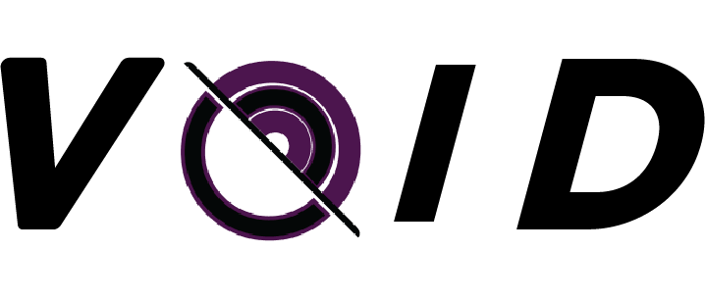

VOIDDEV - Team Lead Dashboard

Sprint Information
Sprint
Team Lead
Date

Team Task Management
Member | Task | Priority | Start | Deadline | Est. Time | Status

Time Tracking
Member | Estimated | Actual | Difference

Blockers
Member | Problem | Waiting For

Next Weak Tasks
Member | Task | Deadline

