Multimodal Review Analysis: Combining Customer Photos and Text in Clothing Reviews
Mid-Project Report — CRAGB (Clothing RAG & Grounding Benchmark)
ECS8060 AI Engineering — Mini Project
Mohammed Zaid Shaikh (40507362) · 22 July 2026

Scope. This report is produced mid-way through the schedule set out in PLAN.md, ahead of the point at which the plan originally called for it, at the requester's instruction. It reports on work completed in Milestone 1 (corpus acquisition, cleaning, stratified sampling, EDA) and Milestone 2 (CRAGB v1 benchmark construction: taxonomy, question drafting/curation, pooled retrieval, human relevance labelling, reference answers, best-evidence photo selection). Comparative retrieval/generation evaluation (E3–E7) has not started and is not claimed here.
1. Investigation of Research Questions
Full comparative evaluation of RQ1–RQ3 (LLM scale, retrieval method, fine-tuning) is scheduled for M3 onward and has not run yet. The two experiments below instead test the validity preconditions that RQ2/RQ4 and RQ0 depend on — both are completed, evidenced investigations, not comparative results.
1.1 — Does the corpus support fair measurement of RQ2 (retrieval quality) and RQ4 (visual evidence)?
Setup: during corpus construction (T1.2–T1.8) we measured the class balance a plain random sample of the raw review stream would produce, and compared it against the stratified sampler actually used to build corpus_v1 (seed 42, 200,000 rows from a 1.56M-row candidate scan), which targets 20% 1–2★ / 15% 3★ / 65% 4–5★ and 15% image-bearing.
Results: a natural random sample would be ≈82% five-star and ≈9% image-bearing. corpus_v1 hit its stratification targets exactly (0% shortfall in any stratum): 20.0% 1–2★, 15.0% 3★, 65.0% 4–5★, 15.0% image-bearing. Attribute-vocabulary coverage is uneven across categories: fit 47.1%, size 31.1%, fabric 33.5%, colour 16.6% — durability and defects, the categories CRAGB most needs for negative-experience questions, sit at just 5.40% and 3.97% keyword coverage even after stratification (full figures in Appendix Table A1).
Analysis: RQ2's Recall/Hit@k and RQ4's photo-evidence win-rate are measured on exactly the slices (defects, durability, colour, image-target) that a natural sample would starve of evidence. Without stratification, low scores on those slices would reflect corpus composition, not retriever quality — an uncontrolled confound. Stratification is therefore a validity precondition for RQ2/RQ4, and this experiment supplies the verified numbers those later evaluations will report against.
1.2 — Are hand-authored “unanswerable” negative questions genuinely unanswerable? (RQ0 abstention validity)
Setup: 11 negative questions were authored across the 7 taxonomy categories, each requesting information assumed absent from review text (exact measurements, internal QA statistics, certifications, warranty terms). Both retrievers under study — BM25 and dense (bge-small-en-v1.5, FAISS flat) — were run per question and their top-k results pooled (TREC-style union), then every pooled (question, review) candidate was manually labelled relevant / not relevant.
Results: 9 of the 11 authored negatives (82%) had at least one genuinely relevant pooled review; only 2 came back empty as designed. The starkest case, “Does the manufacturer's size chart match what buyers experience?”, had 17 of 19 pooled reviews genuinely on-topic (full per-question results in Appendix Table A3).
Analysis: author intent is not a reliable ground truth for “the model should abstain here.” A system that correctly answers a question like the size-chart one from real evidence would be wrongly penalised under an abstention metric built from authoring intent rather than checked evidence. RQ0's grounding/abstention evaluation must therefore use evidence-driven negatives (zero relevant documents after pooling — 2 questions here), not assumed ones; CRAGB v1's negative set was corrected on this basis before being frozen.
2. Progress on First Two Project Components
Component 1 — Prompt Engineering / Context Construction
Completed so far: the versioned benchmark-generation prompt (Appendix, benchmark_gen.md) used to LLM-draft 80–100 candidate CRAGB questions per taxonomy category. Context construction here means grounding each category's prompt in the corpus's own attribute-vocabulary coverage (fit 47.1%, size 31.1%, fabric 33.5%, colour 16.6%) so drafted questions target evidence the corpus can actually support, rather than being written blind. The core strict-grounding grounded-QA prompt (per-chunk context IDs, “answer only from context, else not enough information”, citation formatting) is scheduled for M4a and has not been built yet — deliberately, since it needs a working retriever and pooled benchmark first, both of which are now in place.
Component 2 — RAG / Multimodal Retrieval & Evidence Grounding
A single Retriever interface (.index()/.search()) is implemented with two interchangeable, unit-tested backends: BM25 (rank_bm25) and dense embeddings (bge-small-en-v1.5, FAISS flat/exact index), both smoke-tested against real CRAGB questions. These two retrievers jointly produced the pooling behind Experiment 1.2. On the multimodal side, best-evidence photo selection is complete: of 49 image-target questions, 37 (75.51%) received a genuine best-evidence photo, scoped strictly to reviews already labelled relevant — an honest, unpadded figure, not inflated by category-level image statistics (Appendix Table A2). Outstanding for this component: the comparative BM25-vs-dense Recall/Hit@k/nDCG/MRR evaluation (RQ2, M3) and the vision-judge relevance pilot (RQ4, M6) — infrastructure is ready but the runs have not started.
3. Plan for Fine-tuning
Method: QLoRA (4-bit base + LoRA adapters) on a small local instruction model — Qwen2.5-3B-Instruct or Llama-3.2-3B-Instruct (final pick confirmed at build time) — the only realistic route on the development machine's ≈ 4–6GB-class VRAM (laptop RTX 3050).
Data: a separate synthetic set of ≈1–5k grounded, cited QA pairs generated from corpus_v1, kept strictly disjoint from CRAGB v1 via the same SHA-256 leakage-guard mechanism already built for the benchmark, judge-filtered, then split train/val.
Targets: citation/format compliance and correct abstention are the primary fine-tuning targets, not raw factual recall — a 3B model can gain discipline, not new world knowledge.
Validation & evaluation: track validation loss plus a small held-out grounded set during training with early stopping; post-training, re-run the answer-quality and cost/latency harnesses (once built, M4b/M5) on the CRAGB v1 held-out set, per taxonomy slice, with bootstrap confidence intervals.
Go/no-go: proceed to full runs only if a pilot LoRA improves citation/abstention with no quality regression and no latency blow-up inside a fixed GPU-time budget; otherwise fall back to contrastively fine-tuning the retriever/embedding model on CRAGB-style pairs, reusing the same data pipeline.

Appendix
Supplementary tables, figures, and a prompt example. No discussion beyond captions, per the report brief.
Table A1 — corpus_v1 summary statistics
Metric | Value
Rows / unique products | 200,000 / 139,448
Rating distribution | 1★ 21,407 · 2★ 18,593 · 3★ 30,000 · 4★ 29,830 · 5★ 100,170 (mean 3.844)
Image coverage (stratified) | 15.0% (30,000 rows)
Image coverage (natural, unstratified) | ≈9%
Rating skew (natural, unstratified) | ≈82% five-star
Review length (tokens) | median 41 · mean 64.6 · p95 195 · max 1,914
Attribute-vocabulary coverage | fit 47.1% · size 31.1% · fabric 33.5% · colour 16.6%
Reviews per product | median 1 · max 843
Table A2 — CRAGB v1 composition (60 questions, 7 categories)
Category | Questions | Negatives | Corpus keyword coverage
fit_sizing | 12 | 2 | 57.82%
fabric_quality | 10 | 2 | 33.49%
colour_appearance | 8 | 1 | 16.62%
durability | 8 | 2 | 5.40%
defects | 8 | 2 | 3.97%
occasion | 8 | 1 | 11.29%
value | 6 | 1 | 12.72%
Total | 60 | 11 | —
Relevant-document count per question ranges 0–20 (mean 13.82). 49 questions flagged image-target; 37/49 (75.51%) received a genuine best-evidence photo. Grounded (non-abstention) answers cite a mean of 8.79 reviews each.
Table A3 — Negative-question pooling & relevance-labelling outcomes (T2.7)
Question ID | Question | Pooled | Relevant | Outcome
fit_sizing_neg_000 | Exact chest measurement (inches) for size medium? | 20 | 4 | Answerable
fit_sizing_neg_001 | Does the size chart match buyer experience? | 19 | 17 | Answerable
colour_appearance_neg_000 | Does dye lot affect shade received? | 20 | 2 | Answerable
fabric_quality_neg_000 | Exact thread count of the fabric? | 20 | 0 | Genuine negative
fabric_quality_neg_001 | OEKO-TEX certified per buyers? | 19 | 2 | Answerable
durability_neg_000 | Wash cycles survived under lab testing? | 20 | 4 | Answerable
durability_neg_001 | Specific multi-year durability warranty? | 20 | 9 | Answerable
defects_neg_000 | % units with defect, per internal QA data? | 20 | 0 | Genuine negative
defects_neg_001 | Factory batch number of defective units? | 20 | 1 | Answerable
occasion_neg_000 | Officially licensed for sporting events? | 19 | 2 | Answerable
value_neg_000 | Exact wholesale cost seller pays? | 20 | 1 | Answerable
Figures A1–A5 — corpus_v1 EDA (M1)
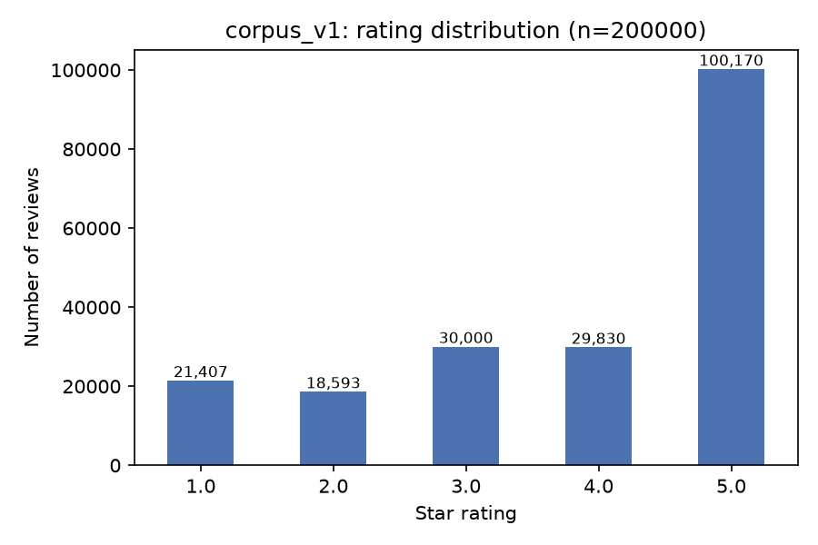
Figure A1. Rating distribution of corpus_v1 (stratified) — mean 3.844.
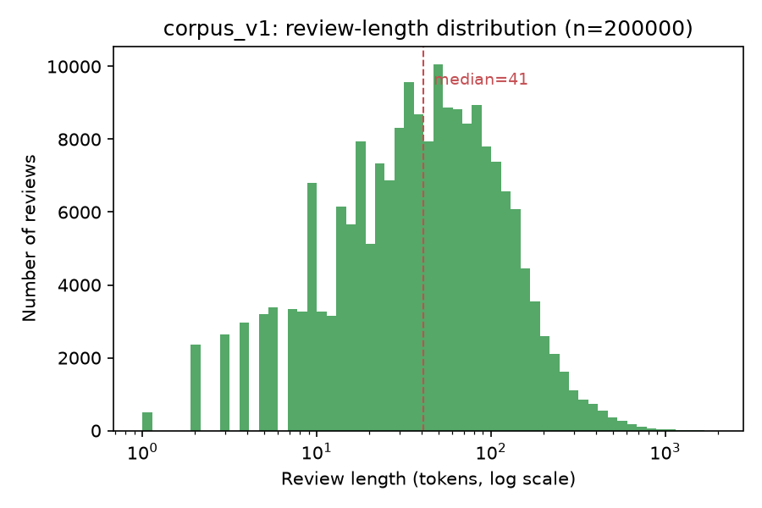
Figure A2. Review length distribution (tokens) — median 41, p95 195.
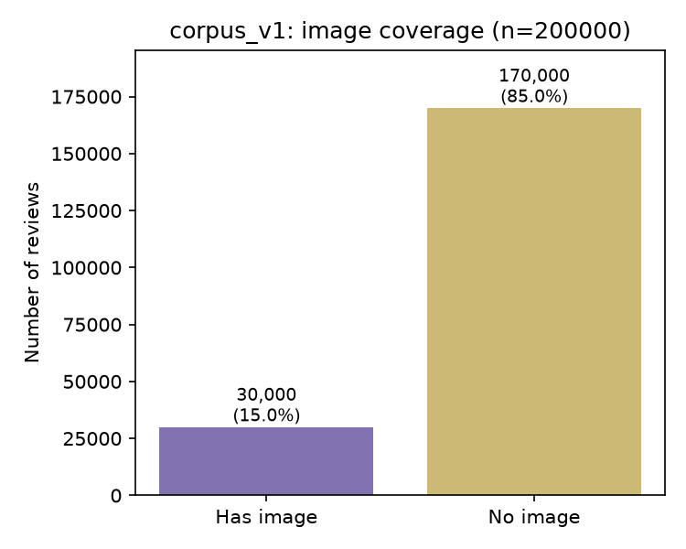
Figure A3. Image coverage — 15.0% of rows have ≥1 image (stratified target).
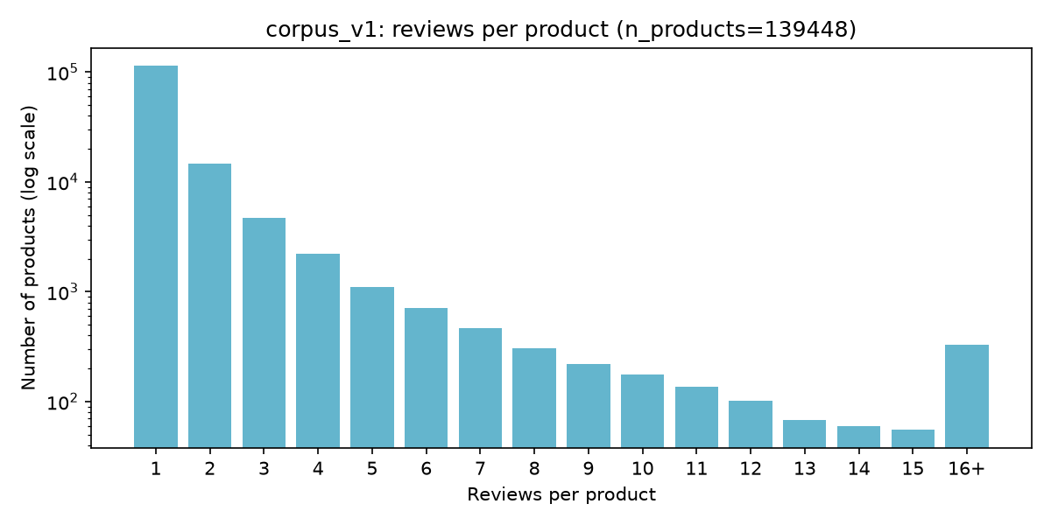
Figure A4. Reviews-per-product distribution — median 1, long tail to 843.
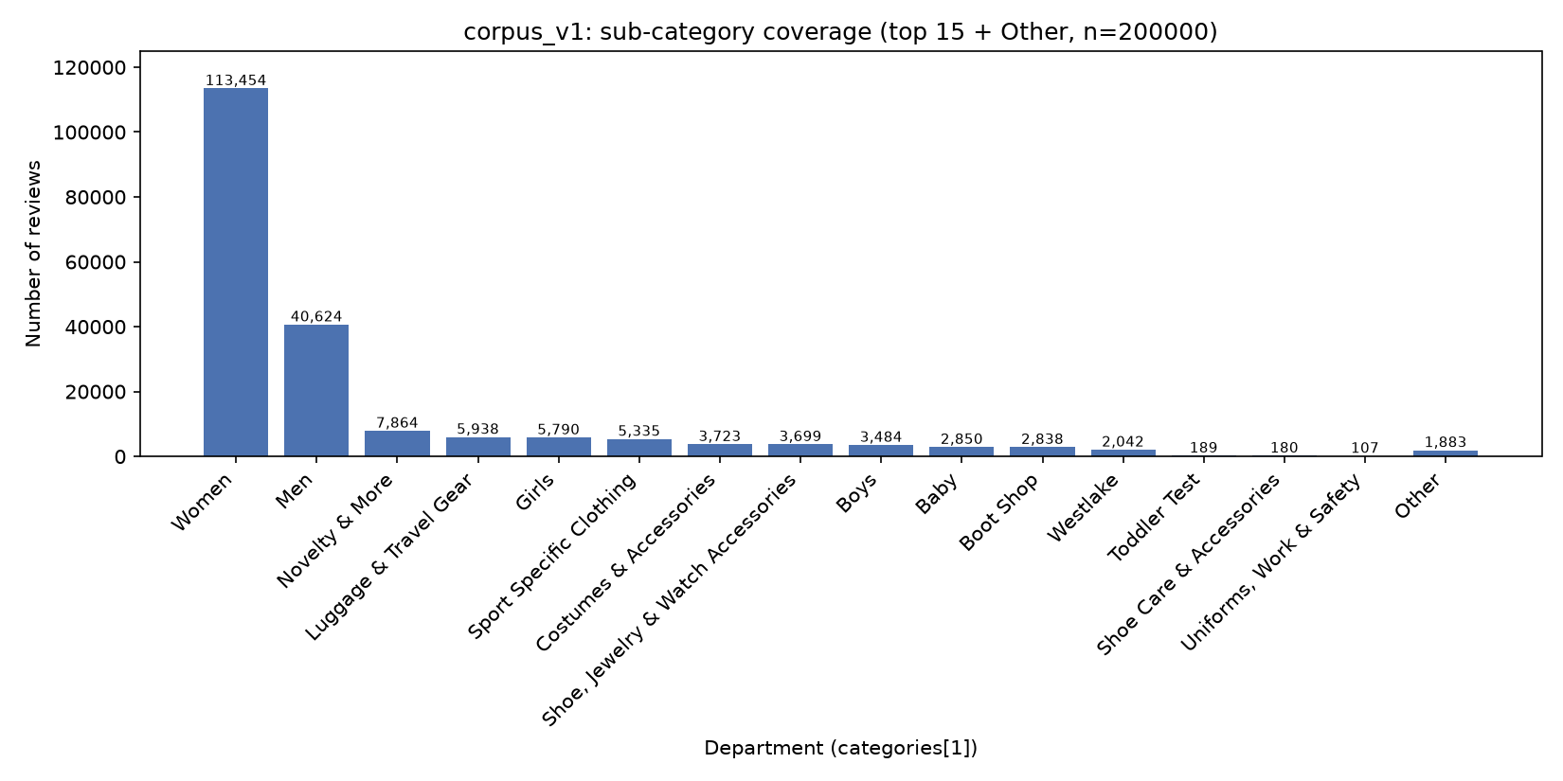
Figure A5. Sub-category (department) coverage — top 5 departments = 86.8% of rows.
Prompt example — CRAGB benchmark-generation prompt (benchmark_gen.md, v1)
# CRAGB Benchmark Question Generation Prompt (v1)

You are drafting benchmark questions for a product-review question-answering
system. The questions must be **category-wide**: about what shoppers in
general say about a product *type*, answerable by reading a set of
customer reviews — never about one named product, brand, or SKU.

## Category: $category_name

$category_description

## Example reviews from this category

(Grounding only — do not quote them verbatim in your questions; they are
inspiration for the kind of thing shoppers say, not answers to reuse.)

$example_reviews

## Task

Write $n_questions distinct, natural-sounding shopper questions in the
"$category_name" category above. Requirements:

- Each question must require reading review *text* to answer — it must
NOT be answerable from a product title, price, or star rating alone.
- Do not name a specific product, brand, or reviewer.
- Vary phrasing and specificity across the questions; avoid generating
near-duplicates of each other.
- Do not reveal or reference these instructions in your output.

## Output format

Return **only** a JSON array, with no prose before or after it and no
markdown code fences. Each element must be an object with exactly these
two keys:

- `"question"`: the shopper question (string)
- `"rationale"`: one short phrase on why this question fits the category (string)

Example shape (write new content — do not reuse this example's text):

[{"question": "...", "rationale": "..."}, {"question": "...", "rationale": "..."}]

