**USER TABLE**

username -> {email_address, D.O.B, password, description}

email_address -> {username, D.O.B, password, description}

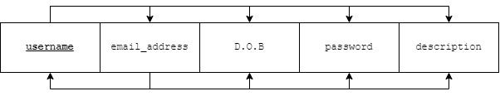

The candidate keys are username, email_address.

Prime attributes = {username, email_address}

Non prime attributes = {D.O.B, password, description}

There are two functional dependencies.

Both satisfy 1NF as all attributes are atomic.

Both also satisfy 2NF as there are no partial dependencies, no non prime attribute is dependent on any proper subset of the candidate keys. (Candidate keys are atomic)

Both also satisfy 3NF as there are no transitive dependencies. Or we can say that for both the functional dependencies, the LHS is a candidate key, hence it is in 3NF.

Both also satisfy BCNF as the LHS of all dependencies are candidate keys.

**USER_PHN_NO TABLE**



Attributes username and phone_no together form a composite key and there are no other attributes.

Hence it is automatically in BCNF. Since all dependencies are trivial.

**CUSTOMER TABLE**

username -> {street, city, state, first_name, last_name}

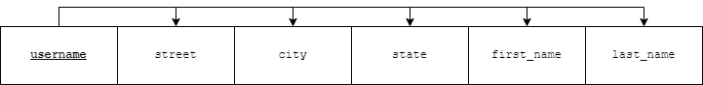

username is a candidate key.

Prime attributes = {username}

Non prime attributes = {street, city, state, first_name, last_name}

There is only one functional dependency.

It satisfies 1NF as all attributes are atomic.

It also satisfies 2NF as there are no partial dependencies, no non prime attribute is dependent on any proper subset of the candidate keys. (Candidate key is atomic)

It also satisfies 3NF as there are no transitive dependencies. Or we can say that for the functional dependency, the LHS is a candidate key, hence it is in 3NF.

It also satisfies BCNF as the LHS of all dependencies are candidate keys.

**ADMINISTRATOR TABLE**



There is only one prime attribute and candidate key username.

It is automatically in BCNF because all dependencies are trivial.

**ORDERS TABLE**

order_id -> {invoice_no, order_date, order_status, username}

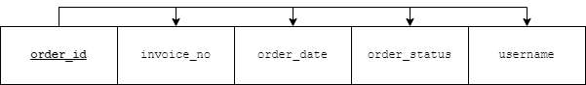

order_id is a candidate key.

Prime attributes = {order_id}

Non prime attributes = {invoice_no, order_date, order_status, username}

There is only one functional dependency.

It satisfies 1NF as all attributes are atomic.

It also satisfies 2NF as there are no partial dependencies, no non prime attribute is dependent on any proper subset of the candidate keys. (Candidate key is atomic)

It also satisfies 3NF as there are no transitive dependencies. Or we can say that for the functional dependency, the LHS is a candidate key, hence it is in 3NF.

It also satisfies BCNF as the LHS of all dependencies are candidate keys.

**TRACKING_DETAILS TABLE**

tracking_id order_id -> {courier_name, update_time, description}

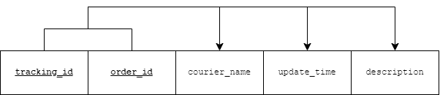

tracking_id order_id is the candidate key.

Prime attributes = {tracking_id, order_id}

Non prime attributes = {courier_name, update_time, description}

There is only one functional dependency.

It satisfies 1NF as all attributes are atomic.

It also satisfies 2NF as there are no partial dependencies, no non prime attribute is dependent on any proper subset of the candidate keys.

It also satisfies 3NF as there are no transitive dependencies. Or we can say that for the functional dependency, the LHS is a candidate key, hence it is in 3NF.

It also satisfies BCNF as the LHS of all dependencies are candidate keys.

**ORDER_DETAILS TABLE**

order_details_id order_id = {discount, amount_to_pay}

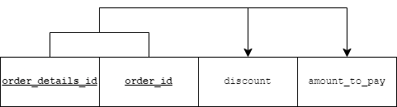

order_details_id order_id is the candidate key.

Prime attributes = {order_details_id, order_id}

Non prime attributes = {discount, amount_to_pay}

There is only one functional dependency.

It satisfies 1NF as all attributes are atomic.

It also satisfies 2NF as there are no partial dependencies, no non prime attribute is dependent on any proper subset of the candidate keys.

It also satisfies 3NF as there are no transitive dependencies. Or we can say that for the functional dependency, the LHS is a candidate key, hence it is in 3NF.

It also satisfies BCNF as the LHS of all dependencies are candidate keys.

**BOOK_INSTANCE TABLE**

copy_instance book_ISBN -> {quantity, order_details_id, order_id}

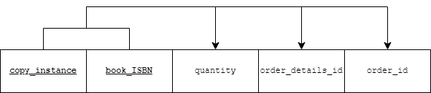

copy_instance book_ISBN is the candidate key.

Prime attributes = {copy_instance, book_ISBN}

Non prime attributes = {quantity, order_details_id, order_id}

There is only one functional dependency.

It satisfies 1NF as all attributes are atomic.

It also satisfies 2NF as there are no partial dependencies, no non prime attribute is dependent on any proper subset of the candidate keys.

It also satisfies 3NF as there are no transitive dependencies. Or we can say that for the functional dependency, the LHS is a candidate key, hence it is in 3NF.

It also satisfies BCNF as the LHS of all dependencies are candidate keys.

**AUTHOR TABLE**

author_id -> {author_name, email_address}

email_address -> {author_id, author_name}

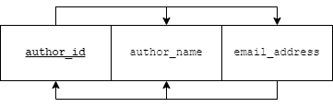

author_id and email_address are the candidate keys.

Prime attributes = {author_id, email_address}

Non prime attributes = {author_name}

There are two functional dependencies.

Both satisfy 1NF as all attributes are atomic.

Both also satisfy 2NF as there are no partial dependencies, no non prime attribute is dependent on any proper subset of the candidate keys. (Candidate keys are atomic)

Both also satisfy 3NF as there are no transitive dependencies. Or we can say that for both the functional dependencies, the LHS is a candidate key, hence it is in 3NF.

Both also satisfy BCNF as the LHS of all dependencies are candidate keys.

**CATEGORY TABLE**

category_id = {category_name, parent_id}

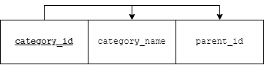

category_id is a candidate key.

Prime attribute = {category_id}

Non prime attribute = {category_name, parent_id}

There is only one functional dependency.

It satisfies 1NF as all attributes are atomic.

It also satisfies 2NF as there are no partial dependencies, no non prime attribute is dependent on any proper subset of the candidate keys.

It also satisfies 3NF as there are no transitive dependencies. Or we can say that for the functional dependency, the LHS is a candidate key, hence it is in 3NF.

It also satisfies BCNF as the LHS of all dependencies are candidate keys.

**BOOK_CATEGORY TABLE**



There are only two prime attributes category_id and book_ISBN.

It is automatically in BCNF because all dependencies are trivial.

**LANGUAGE TABLE**

language_id = {language_name, description}

language_name = {language_id, description}

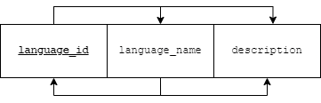

language_id and language_name are candidate keys.

Prime attributes = {language_id, language_name}

Non prime attributes = {description}

There are two functional dependencies.

Both satisfy 1NF as all attributes are atomic.

Both also satisfy 2NF as there are no partial dependencies, no non prime attribute is dependent on any proper subset of the candidate keys. (Candidate keys are atomic)

Both also satisfy 3NF as there are no transitive dependencies. Or we can say that for both the functional dependencies, the LHS is a candidate key, hence it is in 3NF.

Both also satisfy BCNF as the LHS of all dependencies are candidate keys.

**BOOK_LANGUAGE TABLE**



There are only two prime attributes language_id and book_ISBN.

It is automatically in BCNF because all dependencies are trivial.

**BINDING TABLE**

binding_id = {binding _type, description}

binding _type = {binding _id, description}

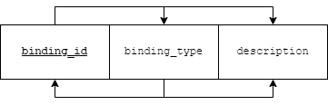

binding _id and binding _type are candidate keys.

Prime attributes = {binding_id, binding _type}

Non prime attributes = {description}

There are two functional dependencies.

Both satisfy 1NF as all attributes are atomic.

Both also satisfy 2NF as there are no partial dependencies, no non prime attribute is dependent on any proper subset of the candidate keys. (Candidate keys are atomic)

Both also satisfy 3NF as there are no transitive dependencies. Or we can say that for both the functional dependencies, the LHS is a candidate key, hence it is in 3NF.

Both also satisfy BCNF as the LHS of all dependencies are candidate keys.

**BOOK_BINDING TABLE**



There are only two prime attributes binding_id and book_ISBN.

It is automatically in BCNF because all dependencies are trivial.

**BOOK TABLE**

book_ISBN -> {book_title, edition, price, E.O.Q, author_id, publisher_id, release_date, page_count, dimension, quantity_in_stock}



book_ISBN is the candidate key.

Prime attributes = {book_ISBN}

Non prime attributes = {book_title, edition, price, E.O.Q, author_id, publisher_id, release_date, page_count, dimension}

There is only one functional dependency.

It satisfies 1NF as all attributes are atomic.

It also satisfies 2NF as there are no partial dependencies, no non prime attribute is dependent on any proper subset of the candidate keys.

It also satisfies 3NF as there are no transitive dependencies. Or we can say that for the functional dependency, the LHS is a candidate key, hence it is in 3NF.

It also satisfies BCNF as the LHS of all dependencies are candidate keys.

**PUBLISHER TABLE**

publisher_id = {publisher_name, email_address, website}

email_address = {publisher_name, publisher_id}

website = {email_address, publisher_name}

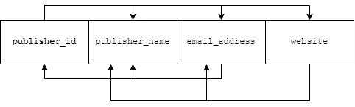

If we check their closures, publisher_id, email_address, website are candidate keys.

All three are prime attributes.

It is automatically in BCNF because all dependencies are trivial.

**SUPPLIES_TO TABLE**

publisher_id supplier_id = {book_ISBN, amount}

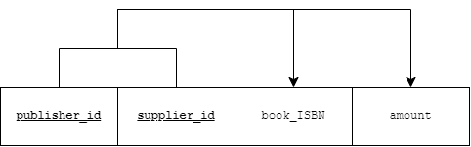

publisher_id supplier_id is the candidate key.

Prime attributes = {publisher_id, supplier_id}

Non prime attributes = {book_ISBN, amount}

There is only one functional dependency.

It satisfies 1NF as all attributes are atomic.

It also satisfies 2NF as there are no partial dependencies, no non prime attribute is dependent on any proper subset of the candidate keys.

It also satisfies 3NF as there are no transitive dependencies. Or we can say that for the functional dependency, the LHS is a candidate key, hence it is in 3NF.

It also satisfies BCNF as the LHS of all dependencies are candidate keys.

**SUPPLIER TABLE**

supplier_id = {email_address, supplier_name, contact_no, street, city, state}

street city state = {supplier_id, email_address, supplier_name, contact_no}

contact_no = {supplier_id}

email_address = {supplier_id}

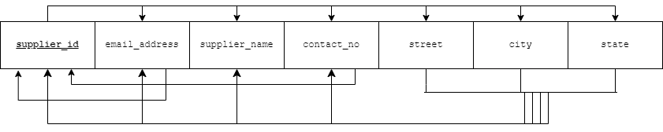

supplier_id, contact_no, email_address and street, city, state are candidate keys.

Prime attributes = {supplier_id, street city state, contact_no, email_address}

Non prime attributes = {supplier_name}

It satisfies 1NF as all attributes are atomic.

It also satisfies 2NF as there are no partial dependencies, no non prime attribute is dependent on any proper subset of the candidate keys.

It also satisfies 3NF as there are no transitive dependencies. Or we can say that for the functional dependency, the LHS is a candidate key, hence it is in 3NF.

It also satisfies BCNF as the LHS of all dependencies are candidate keys.

**PROVIDES_BOOKS TABLE**

supplier_id warehouse_id = {book_ISBN, amount}

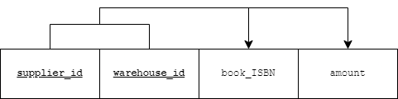

supplier_id warehouse_id is the candidate key.

Prime attributes = {supplier_id, warehouse_id}

Non prime attributes = {book_ISBN, amount}

There is only one functional dependency.

It satisfies 1NF as all attributes are atomic.

It also satisfies 2NF as there are no partial dependencies, no non prime attribute is dependent on any proper subset of the candidate keys.

It also satisfies 3NF as there are no transitive dependencies. Or we can say that for the functional dependency, the LHS is a candidate key, hence it is in 3NF.

It also satisfies BCNF as the LHS of all dependencies are candidate keys.

**WAREHOUSE TABLE**

warehouse_id = {warehouse_name, street, city, state, manager_contact}

street city state = {warehouse_id, warehouse_name}

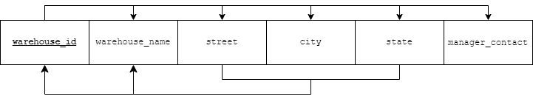

warehouse_id, street city state are the candidate keys.

Prime attributes = {warehouse_id, street, city, state}

Non prime attributes = {warehouse_name}

It satisfies 1NF as all attributes are atomic.

It also satisfies 2NF as there are no partial dependencies, no non prime attribute is dependent on any proper subset of the candidate keys.

It also satisfies 3NF as there are no transitive dependencies. Or we can say that for the functional dependency, the LHS is a candidate key, hence it is in 3NF.

It also satisfies BCNF as the LHS of all dependencies are candidate keys.

**USER_INTERACTION TABLE**

username book_ISBN = {rating, upvote, downvote}

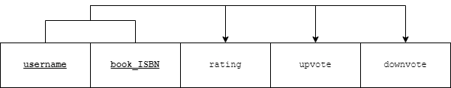

username book_ISBN is the candidate key.

Prime attributes = {username, book_ISBN}

Non prime attributes = {rating, upvote, downvote}

There is only one functional dependency.

It satisfies 1NF as all attributes are atomic.

It also satisfies 2NF as there are no partial dependencies, no non prime attribute is dependent on any proper subset of the candidate keys.

It also satisfies 3NF as there are no transitive dependencies. Or we can say that for the functional dependency, the LHS is a candidate key, hence it is in 3NF.

It also satisfies BCNF as the LHS of all dependencies are candidate keys.

**FAVOURITES TABLE**

favourite_id = {reason}

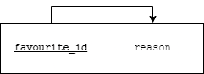

favourite_id is the candidate key.

It is automatically in BCNF as the LHS are all candidate keys.

**USER_FAVOURITE TABLE**



All are prime attributes.

It is automatically in BCNF as all dependencies are trivial.

**COMMENTS TABLE**

comment_id = {comment}

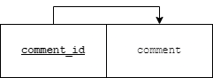

comment_id is the candidate key.

It is automatically in BCNF as the LHS are all candidate keys.

**USER_COMMENT TABLE**



All are prime attributes.

It is automatically in BCNF as all dependencies are trivial.

**WISHLIST_TABLE**



There is only one prime attribute.

It is automatically in BCNF as all dependencies are trivial.

**USER_WISHLIST TABLE**



All are prime attributes.

It is automatically in BCNF as all dependencies are trivial.

**HAVE_BOOKS TABLE**



All are prime attributes.

It is automatically in BCNF as all dependencies are trivial.

**BOOKS_WITH_SUPPLIERS TABLE**

track_id = {book_ISBN, quantity}

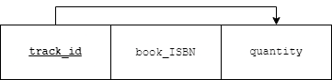

track_id is the candidate key.

It is automatically in BCNF as the LHS are all candidate keys.

**CONTAINS_BOOKS TABLE**



All are prime attributes.

It is automatically in BCNF as all dependencies are trivial.

**BOOKS_IN_WAREHOUSE TABLE**

track_id = {book_ISBN, quantity}

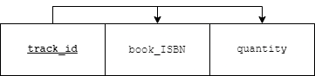

track_id is the candidate key.

It is automatically in BCNF as the LHS are all candidate keys.