Exciting business opportunity!

After dominating the RTP monitoring industry, Voipfuture is looking for new ways to expand the
business. A heated discussion ensued and finally another, mostly untapped market was identified:
casual gaming! Why not combine our flagship RTP monitoring product “Qrystal” with some
addictive gameplay and throw in some micro transactions for good measure ?
After hours of fruitless discussion, one of the team members finally manages to come up with a brand-new new game idea...VoIPTris !

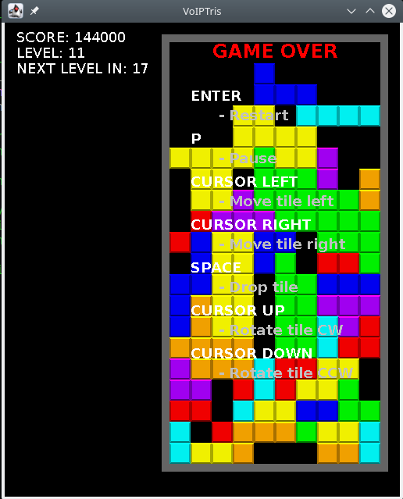Illustration 1: Totally new game idea

The bad news
A few months later a first version of the game is almost ready. Unfortunately, after the one and only
programmer working on the project went on extended parental leave, it was discovered that the
source code to the most important part of the game accidently got deleted... the game logic itself. Since it was deemed too risky to release the game without the ability to make bugfixes to the gameplay and you accidently raised your hand (to scratch your head) during the team meeting, it was decided that you have to re-implement the game logic.

The good news
Your collegue conveniently setup a Github repository with the existing game code and you just need to clone this repository, implement the game logic and you're ready to ship !

Your helpful collegue also provided you with the original requirements for the game logic!

Game Logic

1.) The game takes place on a rectangular playing field that is subdivided into grid cells. One of seven possible tiles appears randomly at the very top of the playing field and then slowly drops down until it either hits the bottom of the playing field or another tile. While the current tile is dropping, it may be moved left/right or rotated clockwise/counter-clockwise. It's also possible to quickly drop the tile (called a "hard drop") but doing so ignores all further user input until the tile has either reached the bottom of the playing field or hit another tile. Once a tile has dropped in place, a new random tile appears at the very top of the playing field. If the newly generated tile intersects with an already existing one at this position, the game is lost. Whenever a row of the playing field is filled completely, it disappears and all tiles that were "suspended" by this row drop down by one row. Completing rows awards points to the player and counts towards the current difficulty level's goal. Once enough rows have been completed, the difficulty level increases, increasing tile drop speed.

Game tiles are placed on a rectangular grid with each tile taking up exactly four grid cells. Here are the available tiles that and the com.voipfuture.voiptris.api.TileType enumeration constants associated with them:

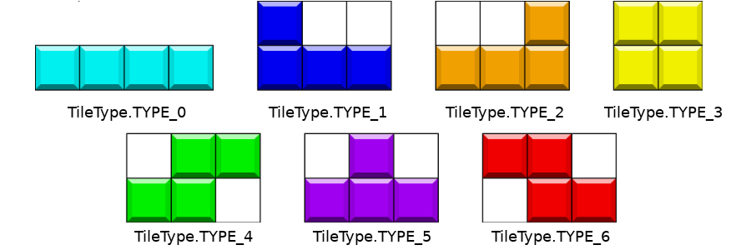Illustration 2: Game tiles
When a new, randomly chosen tile appears at the very top of the playing field, it must be displayed in exactly the configuration shown here (so it must not be rotated in any way). The first populated grid cell of a tile must be at the very top row of the playing field and the tile must be drawn centered (because of the fixed grid this will obviously not work for tiles with an odd width, (playingField.width()/2 – tile.width()/2) as X grid cell is fine).

Score Calculation
The player is only awarded points for completed rows. The actual number of points depends on how many rows were completed by dropping a single tile, with the largest number possible being 4 rows (as there is only one tile that spans 4 grid cells in one dimension).
The player is awarded an extra bonus for completing 4 rows multiple times back-to-back.
Base score:
1 completed row = 100
2 completed rows = 300
3 completed rows = 500
4 completed rows = 800 (first time), 1200 (completing 4 rows again back-to-back)
This base score then gets multiplied with the current difficulty level (game starts at difficulty level 1) to yield the final score.
A few examples:
Completing 3 rows on difficulty level 3 would award: 500 x 3 = 1500 points.
Completing 4 rows and then completing 4 rows again back-to-back would award 800+1200 = 2000 points.

Difficulty levels
The game starts at difficulty level 1. Each difficulty level requires the player to complete a slightly higher number of rows than the previous level while also slightly increasing the tile drop speed.
Tile drop speed formula:
int timerTicks = Math.max((int) (60 - difficultyLevel*2.5f),1);
So the game controller has to move the current tile down by one row every X number of timer ticks (=IGameController#tick(IUserInput) invocations).
Number of rows to complete to advance to next level:
int rowCount = (int) (10+difficultyLevel*1.5f);
Whenever the player has completed this number of rows, the difficulty level increases by one. Quirk: If the player completed more rows than necessary when crossing the current difficulty level's threshold, the excess rows count towards the next difficulty level (so if the player only needs to complete two rows to advance but actually completes four, two rows will be carried over as 'completed' to the next difficulty level, slightly speeding up level advancement).

Your task
Voipfuture GmbH – New hires task 2019/2
Version 1.0.0
Last update: 2019-09-24 / tobias.gierke@voipfuture.com
Your task is to implement that game logic that will later be exercised by the game framework.
Core of the game logic is an com.voipfuture.voiptris.api.IGameController implementation with a proper tick(IUserInputProvider) method.
This method will be invoked every 16 millisecond to process user input (if any) and then advance the game state.
Rendering requires access to the playing field's current state so you need to have a com.voipfuture.voiptris.api.IPlayingField implementation that is provided to the rendering code by the IGameController#getPlayingField() method.
Keyboard input gets translated into com.voipfuture.voiptetris.api.UserInput evens; note that IGameController#tick() is only called every 16 ms so a quick player is able to perform multiple key presses during this time. It's up to you how you want to deal with this (only honor the first, honor all of them..). Make sure to call IUserInputProvider#clearInput() if you want to "forget" any additional input events that might still be in the queue.
Please check out the JavaDoc for more detail information (you can find the project at https://github.com/Voipfuture-GmbH/voiptris)

Other stuff

- No third-party libraries must be used, everything that ships with OpenJDK 11 is fair game
- Your solution must be uploaded as a repository to a GitHub (www.github.com) account.
- After creating your GitHub account, you can simply fork the repository at https://github.com/Voipfuture-GmbH/voiptris and start coding.
- Make sure to do multiple commits while developing your solution so we can observe your thought process. Do not squash your commits.
- The project must build with Apache Maven 3.6.1 (should be the case out-of-the-box if you cloned our repository).

