|  |  |  |  |  |  |  |
| --- | --- | --- | --- | --- | --- | --- |
| PAPER CODE NO. | EXAMINER: | | | Giorgos ChristodoulouTel. No. 0151 795 4259 | | |
| **COMP326** | DEPARTMENT: | | | Computer Science | | |
|  |  |  |  |  |  |  |
|  |  |  |  |  |  |  |
|  |  |  |  |  |  |  |



**SECOND SEMESTER EXAMINATIONS 2018/19**

**Computational Game Theory and Mechanism Design**

**TIME ALLOWED : Two and a Half Hours**

**INSTRUCTIONS TO CANDIDATES**

Answer **FOUR** questions.

If you attempt to answer more questions than the required number of questions (in any section), the marks awarded for the excess questions answered will be discarded (starting with your lowest mark).

PAPER CODE COMP326 page 1 of 6 Continued



1. **QUESTION ONE**
   1. **(5 marks)** Briefly describe why for load balancing games every sequence of best re-sponses is finite.
   2. In the lectures we discussed the LPT scheduling algorithm.
      1. **(4 marks)** Briefly describe the LPT scheduling algorithm.
      2. **(4 marks)** Consider the following instance of the load balancing game:n = 6 tasks with weights

w1 = 24 w2 = 18 w3 = 10 w4 = 10 w5 = 7 w6 = 3

m = 3 machines with speeds

s1 = 5 s2 = 4 s3 = 3

Run the LPT algorithm on this instance and give the resulting assignment in graphi-cal form. What is the makespan of this assignment?

* 1. **(2 marks)** Determine an assignment with minimum makespan.

1. **(5 marks)** Now run LPT on an arbitrary instance of the load balancing game withntaskswith weights w1 w2 wn and m machines. Let t 2 f0, ... , ng denote the time after task t (with weight wt ) has been assigned to a machine by LPT. Show by induction on t that the partial assignment A : [t] 7![m] at time t is a pure Nash equilibrium.
2. **(5 marks)** Show that, for everym2N, there exists an instanceGof the load balancinggame with m identical machines and n = 2m tasks that has a Nash equilibrium assign-ment A : [n] 7![m] with

|  |  |  |  |  |
| --- | --- | --- | --- | --- |
|  | 2 | |  |  |
| cost(A) = 2 | opt(G) . |  |
|  | |  |
|  | m + 1 |  |

PAPER CODE COMP326 page 2 of 6 Continued



1. **QUESTION TWO**
   1. **(5 marks)** In the lectures we discussed Pigou’s example. Describe the instance andcompute the Price of Anarchy. What is the Price of Stability for this example?
   2. Consider the following instance of a single commodity Wardrop game (G, r , c) where a flow of 1 has to be sent from s to t:

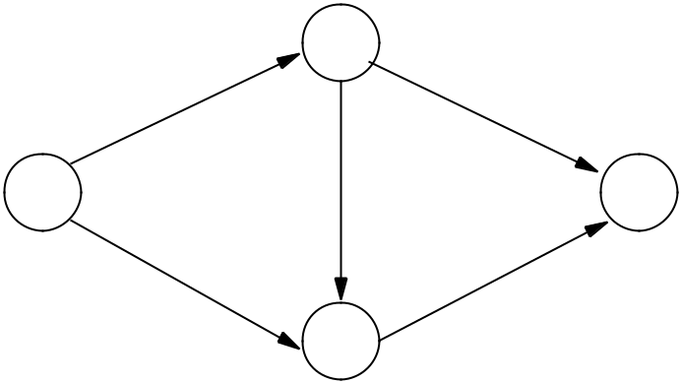

|  |  |  |  |
| --- | --- | --- | --- |
| x + 1 | u |  |  |
|  | 5 |  |
| s | x + 2 | t |  |
| x2 + 6 | v | 2x + 1 |  |
|  |  |  |

* 1. **(2 marks)** Show that in a Wardrop equilibrium no flow will be sent along the edge(s, v).
  2. **(3 marks)** Determine the Wardrop equilibrium for (G,r,c).
  3. **(4 marks)** Construct a new instance (G,r,c) by replacing each cost functioncewithits marginal cost function ce .
  4. **(3 marks)** Determine an optimal flow for the original instance (G,r,c).
  5. **(3 marks)** Compute the price of anarchy (G,r,c).

1. **(5 marks)** Consider the global connection games with theequal-divisionmechanism.Show that the Price of Stability is **at least** Hk , where Hk = 1 + 1=2 + 1=3 + ... + 1=k is the k-th harmonic number.

PAPER CODE COMP326 page 3 of 6 Continued



1. **QUESTION THREE**
   1. **(6 marks)** Does the Gibbard-Satterthwaite Theorem apply to the Facility Location set-ting? Explain your answer.
   2. Consider the Facility Location setting on the line and suppose that there are n players with Single-Peaked preferences 1, ... , n with peaks p1, ... , pn respectively. Consider the social choice rule f that assigns the facility to the **rightmost** declared position.
      1. **(5 marks)** Show thatfis strategy-proof.
      2. **(5 marks)** Show that there exist fixed pointsy1, ... ,yn1, such that

f ( ) = medfp1, p2, ... , pn, y1, ... , yn 1g.

1. Consider the Facility Location setting on the line and suppose that there are n players with Single-Peaked preferences 1, ... , n with peaks p1, ... , pn respectively.
   1. **(5 marks)** Give the following definitions for a social choice rule
      1. strategy-proofness
      2. onto
      3. unanimous
      4. Pareto-optimality
   2. **(4 marks)** Show that if a social choice rule is Pareto-optimal then it is unanimousand onto.

PAPER CODE COMP326 page 4 of 6 Continued



1. **QUESTION FOUR**
   1. **(8 marks)** Apply the VCG mechanism (compute the path and the payments) for the Path-Auction problem of Figure 1, where the numbers on the edges denote the true costs of the agents. (Recall, that in the Path-Auction problem, the agents own the edges of the graph, and they are cost minimizers. Assume that the designer wants to send a single message from node s to node t.)

**1**

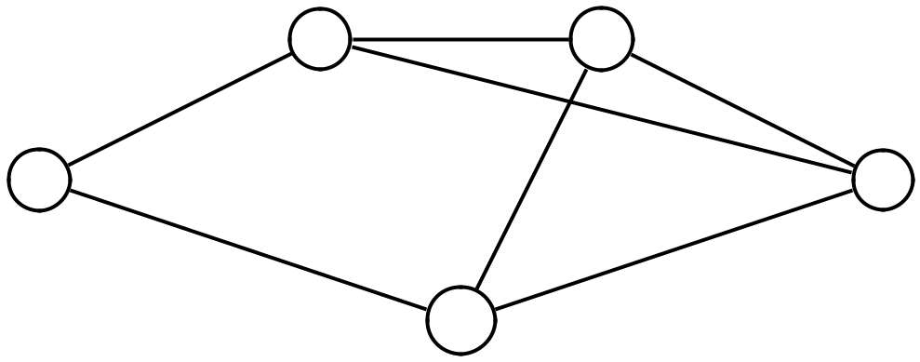

**v** **u**

**4** **4**

**10**

**s** **1** **t**

**10** **2**

**w**

Figure 1: Path-Auction problem

1. i. **(5 marks)** Consider a general social choice setting. Show that every truthful mech-anism (f , p1, ... , pn) satisfies **Weak Monotonicity**.
   1. **(4 marks)** Consider a combinatorial auction setting with a set of itemsM=f1, ... ,mgand n bidders with general valuations, where n 2. Consider the allocation rule that assigns all the items to the player with minimum vi (M). Can we truthfully implement this rule? Justify your answer.

**Hint:** You can use Weak Monotonicity.

1. **(8 marks)** Run the Top Trading Cycle Algorithm for the following instance of the HouseAllocation problem with 5 owners (1, ... , 5) and 5 houses (h1 ... , h5), and preferences as follows

h4 1 h2 1 h1 1 h5 1 h3

h1 2 h5 2 h3 2 h2 2 h4

h4 3 h1 3 h2 3 h5 3 h3

h2 4 h4 4 h3 4 h5 4 h1

h3 5 h4 5 h2 5 h1 5 h5

PAPER CODE COMP326 page 5 of 6 Continued



1. **QUESTION FIVE**
   1. i. **(5 marks)** Run the Gale-Shapley algorithm for the following instance

w4 m1 w2 m1 w3 m1 w1

w3 m2 w2 m2 w1 m2 w4

w3 m3 w4 m3 w2 m3 w1

w1 m4 w3 m4 w4 m4 w2

m3 w1 m1 w1 m4 w1 m2

m4 w2 m2 w2 m3 w2 m1

m4 w3 m2 w3 m3 w3 m1

m1 w4 m4 w4 m3 w4 m2

* 1. **(3 marks)** Does the Gale-Shapley algorithm always terminate? Justify your answer.

1. **(7 marks)** Run the Greedy mechanism (compute the allocation and the payments) forthe following instance of a Combinatorial Auction with 5 single-minded bidders and 6 items:

|  |  |
| --- | --- |
| v1 = 10, | S1 = fa, c, d, eg, |
| v2 = 7, | S2 = fb, c, d, eg, |
| v3 = 4, | S3 = fag, |
| v4 = 4, | S4 = ff g, |
| v5 = 6, | S5 = fbg. |

1. In the lectures on profit maximization, we assumed a setting with one item and n bidders with valuations v1, ... , vn, which are drawn independently at random from some known continuous probability distributions. Let Fi (z) = Pr [vi z] be the probability distribution function from which bidder i’s valuation is drawn and let fi (z) = dFi (z)=dz be its density function.
   1. **(3 marks)** Give the formula of the **virtual valuation** for a bidderiwith valuationvi.
   2. **(7 marks)** Consider an auction with two players and one item. Both the valuationsare drawn from the uniform distribution in [0, 1], v1, v2 U[0, 1]. Recall that in that case it holds Fi (z) = z, fi (z) = 1, for i = 1, 2. Compute the expected revenue of the Vickrey auction with reserve price r = 1=2. Is there a truthful auction with even higher revenue? Justify your answer. Also, provide the virtual valuations for the two players.

PAPER CODE COMP326 page 6 of 6 End