PV Solar Power Plant:
Many countries in the world, where there is a good amount of solar insolation, Photo Voltaic Solar Power has become the most favourable and efficient source of green energy in recent years. The development of efficient PV modules, battery storage, and smart grid technology has further boosted the power generation through PV solar plants, making it a promising source of energy for the future.
A Photovoltaic (PV) power plant, also known as a solar power plant, is a large-scale facility designed to generate a substantial amount of electrical power from solar radiation. This conventional power plant harnesses solar energy to produce electrical power, primarily through the use of solar PV panels. The layout plan of a PV power plant is shown below, which demonstrates how solar PV panels are utilized to produce electrical power on a large scale.

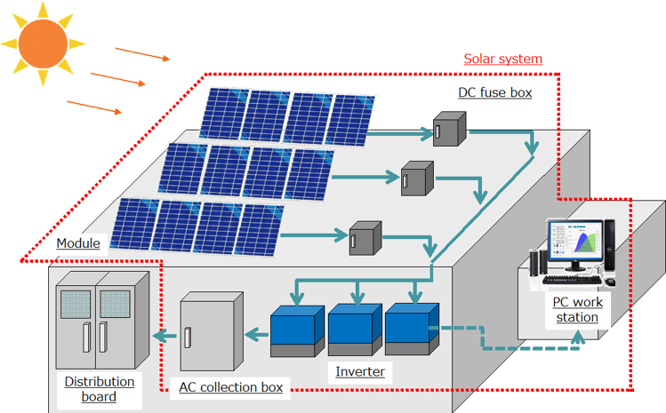

The structure of a solar power plant is illustrated in the image above. Sunlight is captured by PV modules, which in turn generate DC power. This DC power is then transmitted to the inverters via a junction box and string monitoring box. The inverters convert the DC power into AC power, which is stepped up using transformers to match the grid voltage. The AC power is then fed to the grid via switchgear.

Data Description
Our objective is to analyze the available data, gain valuable insights, and tackle any challenges.

Plant_X_Generation_Data.csv: In this data set,
- DATE_TIME – date and time
- PLANT_ID – ID of the power plant
- SOURCE_KEY – key identifying individual monitoring station
- DC_Power – power generated in DC
- AC_POWER – power generated in AC
- DAILY_YIELD – yield monitored from a station
- TOTAL_YIELD – total yield from a station
SolarRecording.csv: In this data set,
- UNIXTime – time in unix format
- Date – date
- Time – time
- Radiation – the amount of radiation received on the surface
- Temperature – ambient temperature
- Pressure – ambient pressure
- Humidity – humidity of the air
- WindDirection(Degrees) – the direction of the wind in degree
- Speed – the speed of the wind
- TimeSunRise – the time of the sun rise of the day
- TimeSunSet – the time of the sun set of the day

