DiggMinSkole: Indoor environment quality and perception data collection in three Norwegian schools for 2023/2024
Azimil Gani Alam ^{a, b}, Alena Bartonova ^{b*}, Britt Ann Kåstad Høiskar ^{b}, Mirjam F. Fredriksen ^{b}, Sam-Erik Walker ^{b}, Aayam Chaulagain ª, Hans Martin Mathisen ª, Kai Gustavsen ^{c}, Tore Fredriksen ^{d}, Guangyu Cao ª
ª Dept. of Energy and Process Engineering, Norwegian University of Science and Technology, Kolbjørn Hejes Vei 1B, N-7034 Trondheim, Norway
^{b} NILU, POB 100, N-2027 Kjeller, Norway
^{c} Norwegian Asthma and Allergy Association, POB 6764, N-0130 Oslo, Norway
^{e} Oslo Municipality (OsloBygg KF), POB 6391, N-0604 Oslo, Norway

Corresponding Author: Alena Bartonova (aba@nilu.no )

Abstract
We provide a comprehensive dataset on Indoor Environment Quality (IEQ) and schoolchildren perception from three schools in Norway, in total nine classrooms. All original data is available as separate datasets per classroom, linked by time stamp and aligned to coordinated universal time.
The IEQ data includes high time-resolution measurements of indoor climate (CO2, VOCs, Air Temperature, Relative Humidity, Barometric Pressure, etc) obtained from standalone sensors, and data from sensors linked to ventilation system at each school (CO2, Air Temperature, Supply air flowrate, etc).
Subjective perceived data was collected in each classroom using a user-feedback platform created for the investigation, administered by teachers twice daily during at least 10 school days. IEQ-related complaints and indoor environment related symptoms were captured. Questions are answered by students anonymously on-line, provided there are at least 10 children present, but no information is available about number of children in class.
This dataset gives for the first time, a high resolution time series of perceived IEQ linked to measured characteristics of indoor environment in school environments. This combination of indoor measurement data and subjective user-feedback has already served as a basis for decision support on mitigation measures in a classroom. It can provide further valuable insights for investigating the relationships between IEQ parameters and occupant perception in school buildings, supporting research on building environment and public health, through quantitative data analytics.

Keywords: Continuous data collection, Time series, Indoor Environment Quality, Indoor Sensors, School Buildings, User-Feedback

- Value of the Data
- The dataset uniquely integrates high-resolution objective measurements from sensors with anonymous user feedback, enabling robust analysis of the perception-reality gap in Indoor Environmental Quality (IEQ).
- It provides a real-world, multi-school case study from a Nordic country (Norway), capturing data from both various school buildings with different ventilation systems.
- Researchers in building science and public health can reuse this data to develop and validate models linking environmental conditions to occupant comfort and health symptoms.
- The structured, time-synchronized dataset serves as a valuable benchmark for developing machine learning algorithms for predictive IEQ control and occupant-centric building management.

- Objective
Indoor Environmental Quality (IEQ) plays a critical role in the health, comfort, and cognitive performance of students in school environments [1, 2] and is increasingly monitored and measured using indoor sensors devices [3]. In Norway, the schools have obligation to keep good IEQ. Data from ventilation systems or building management system are not readily available to the school stakeholders and for this reason, a number of schools install additional low-cost sensor devices to monitor IEQ.
It is well established that subjective user-feedback from building occupants serves as an essential component in assessing IEQ[4, 5]. Subjective responses from students, including adolescents [6], such as satisfaction level, complaints (i.e. perception of reduced IEQ) and symptoms, enable a more comprehensive evaluation of school conditions[7, 8]. Our study investigates ways how the different sources of IEQ monitoring data can be complemented with health-relevant occupant information. We introduce a user-feedback platform to collect perceived IEQ and symptoms reports in school building in real time over a period of several days, and connect this data to the IEQ information.
Recording measured data along with requested user-feedback will bridge the understanding between objective and subjective aspect of IEQ, especially in school buildings to optimize school indoor health and learning performance. This article describes a dataset that uniquely integrates real-time environmental measurements with subjective user feedback from Norwegian schools. The objectives are to describe (1) the experimental design and measurement and (2) the structure of the resulting dataset to enable its reuse. This article consists of the following sections: Experimental Design and Methods, Data Description and Limitations.

- Experimental Design and Methods
  - Location Setup
This project involved 3 (three) schools. A physical inspection gathered data on the building and classrooms included in the study Table 1). All schools have centralized ventilation systems (dedicated outdoor-air systems) that work 100% supplying the fresh air coming into the building and 100% extracting the used air from rooms to the outside. These units are installed on building rooftop. Of course, ventilation systems are already equipped with heating and cooling coil to meet air setpoint temperature. The room temperature, airflow rate and its control function varied across the schools.
School ‘NO-1’ is located in Oslo municipality, a capital city of Norway, built in the 1972 and building installation included the ventilation had been renovated in 2007. This school is for students aged 13–15, with 3 (three) classrooms involved in our data collection campaigns. Ventilation system operated at variable flow rate based-on temperature function, where the main damper fully opens, varying if CO2 concentration in one of the rooms meets 1,000 ppm. Building orientation is dominantly facing east and west. The school building is concrete-based construction.
Another two schools are in a municipality in Western Norway with cool, wet marine climate, mild summers and long, snowy winters, receiving significant rainfall throughout the year. Those two schools are labelled as School ‘NO-2’ (built in 1999) and School ‘NO-3’ (built in 2018), both serving students aged 7–9, with five and three rooms monitored, respectively. Ventilation system in School ‘NO-2’ operated at a constant maximum flow rate during working hours (06AM-05PM). Electric floor heaters have in all first-floor classrooms a surface setpoint temperature of 19 degrees Celsius (ºC). All rooms in School ‘NO-2’ have electric baseboard space heaters, with 21ºC as setpoint temperature. Besides, School ‘NO-3’ has only centralized hydronic heating syste with similar setpoint temperature. Supply airflow variation in School ‘NO-3’ works with variable airflow volume (VAV) speed mode, controlled by ventilation damper with 2 speed level (low or high speed) based on temperature function.
All classrooms we worked on do not have occupants’ sensor or detector. Building orientation at School ‘NO-2’ is dominantly facing south, but School ‘NO-3’ is dominantly facing east and west. Orientations and floor layouts of all buildings are detailed in Table 2 and shown in Figure 1 & Figure 2. School ‘NO-2’ and ‘NO-3’ are steel-based construction.
Table 1. General information on participating schools
School | Construction Year | Students | Sampled rooms: | data collection
(alias name) |  | (years old) |  | round | date
NO-1 | 1972  Renovation: 2007 | 13-15 | 3 rooms.  1st floor: 11  2nd floor: 23 and 27 | 1 | Mar 03rd - Apr 26th, 2023
 |  |  |  | 2 | Nov 11th - 28th, 2023
 |  |  |  | 3 | Feb 26th - Mar 08th, 2024
 |  |  |  | 4 | Apr 14th - 30th, 2024
NO-2 | 1999 | 7-9 | 4 rooms.  1st floor: 141 & 142  2nd floor:  210 & 'temporary building east' | 1 | Mar 08th - Apr26th, 2023
 |  |  |  | 2 | Feb 26th - Apr 30th, 2024
NO-3 | 2018 | 7-9 | 2 rooms,  3rd floor: 302 and 303 | 1 | Mar 13th - Apr 18th, 2023
 |  |  |  | 2 | Apr 03rd - 18th, 2024

Table 2. Characteristics of buildings
SCHOOL | Floor Location | Students (max person) | Room Area ±m² | Window Glazing Area (m²), orientation: |  |  | Room Number | Ventilation - Designed Supply Airflow (max)
 |  |  |  | West | South | East
NO-1 | 1 | 30 | 61 | 13.5 | - | - | 11 | Dynamic-controlled ventilation, each room ±1,200 m3/h
 | 2 | 26 | 57 | 13.5 | - | - | 23
 | 2 | 31 | 61 | - | - | 13.5 | 27
NO-2 | 1 | 29 | 64 | - | 5 | 10.9 | 141 | Max flow rate: 8700 m3/h, branched equally to 7 classrooms
 | 1 | 14 | 58 | - | 6.7 | 13.9 | 142
 | 2 | 28 | 64 | - | 5 | 10.9 | 210
 | 2 |  |  | - | - | -
NO-3 | 3 | 26 | 80 | - | - | 18.8 | 303 | Dynamic-controlled ventilation, each room ±1,200 m3/h
 | 3 | 25 | 80 | - | 18.8 | 18.8 | 302

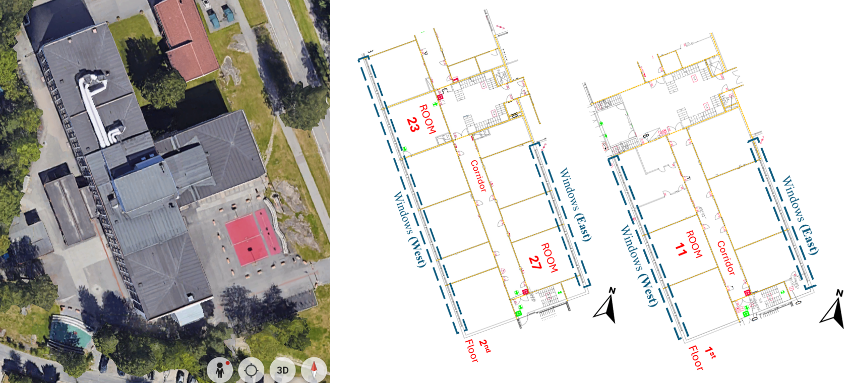
Figure 1. The building situation from Helicopter View by google-map and schematic floor layouts of selected classrooms in School ‘NO-1’
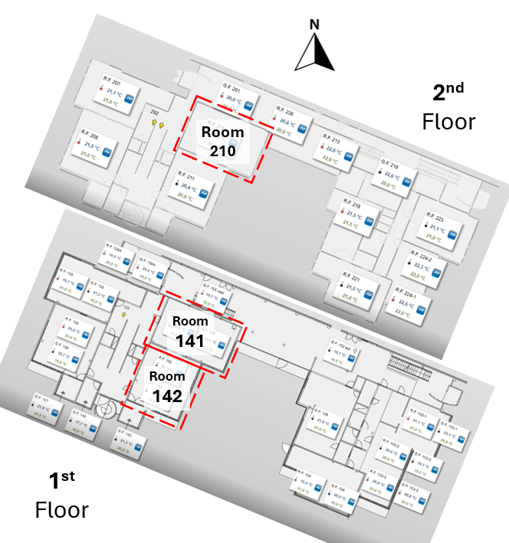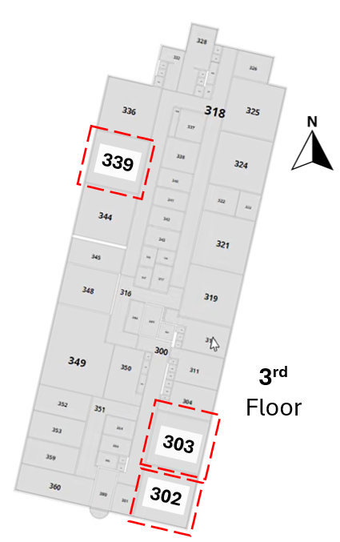
Figure 2 The building situations from Helicopter View by google-map and schematic floor layouts of selected classrooms in: school ‘NO-2’ (left) at 1st & 2nd floor and school ‘NO-3’ (right) at 3rd floor.

  - User Feedback Platform
User feedback was collected using an own-developed web platform InSchool, or ‘IS’. (IEQ satisfaction, IEQ complaints & Building-related Symptoms (BRS)) as shown in Table 3. The data collection was organized by teachers twice daily (morning and afternoon), if 10 or more students were present. The classroom code, student’s entry and timestamp data are stored in the database, the time is converted to UTC+0 time zone format. The flowchart of ‘IS’ illustrating how the user fills the form and what question pages the user is presented with, is illustrated in Figure 4.
The web questionnaire (Table 3) has two levels, first page questions and follow-up questions. Five responses are requested in the first web page - indoor air quality (IAQ), thermal, acoustic, lighting conditions and health perception. Answer choices consist of 4 levels, represented by emoticons: very dissatisfying (red), dissatisfying (orange), satisfying (light green) and very satisfying (dark green) as shown in Figure 3 (left side). If the answer to a given first page question is “very dissatisfying” or “dissatisfying”, a new page appears with follow-up questions, requiring answers yes/no, except for thermal comfort where the scale is one (too cold) to seven (too hot). Translation of the student’s choices to numerical values is given in Figure 3 (right side).

Table 3 Overview of questions’ list in ‘IS’ (online user-feedback platform).
User Feedback System: IEQ Satisfaction & Health Preference
Environmental domains | Displayed questions: |  | Answer choice: | Data label:
 | Original Norwegian | English translation
IAQ | LUFTEN I ROMMET NÅ | The air in the room now | Emoticons (see Figure 3). Translated to numbers from 1 (very satisfying) to 4 (very dissatisfying) | feel_air
Thermal | TEMPERATURE I ROMMET NÅ | Temperature in the room now |  | feel_temp
Lighting | LYS I ROMMET NÅ | Light in the room now |  | feel_bright
Acoustic | STØY I ROMMET NÅ | Noise in the room now |  | feel_noise
(health preference) | HVORDAN ER FORMEN DIN NÅ | How do you feel today? |  | feel_health
User Feedback System: Follow-up questions for IEQ-complaints
Environmental domains | Displayed questions: |  | Answer choice: | Data label:
 | (Original) Norwegian: | (English translation)
IAQ | VOND LUKT | Bad Smell | Yes / No | air_smell
 | DÅRLIG TUNG/ LUFT | Heavy Air | Yes / No | air_heavy
 | STØV OG SKITT | Dust and Dirt | Yes / No | air_dust
 | ELEKTRISK STØT | Electro-static shock | Yes / No | air_electshock
 | TØRR LUFT | Dry Air | Yes / No | air_dry
Lighting conditions | SKARPT LYS FRA SOLA | Excessive light from Sun | Yes / No | bright_sun
 | SKARPT LYS TAKLAMPER | Too bright ceiling lights | Yes / No | bright_lamp_hi
 | SVAKT LYS TAKLAMPER | Too dim ceiling lights | Yes / No | bright_lamp_low
Thermal | TREKK KALD LUFT | Cold Draft | Yes / No | temp_draw
 | FOR MYE VARME FRA SOLSKINN | Too warm from sunshine | Yes / No | temp_heatsun
 | FOR MYE VARME FRA OVNER | Too warm from radiator | Yes / No | temp_heater
 | FOR KALDT PÅ GULVET | Too cold from the floor | Yes / No | temp_coldfloor
 | KALDT / VARMT | Hot / Cold Room Feeling | 7-unit scale  (see Figure 3). | temp_coldhot
User Feedback System: Follow-up questions for BRS
Environmental domains | Displayed questions: |  | Answer choice: | Data label:
 | Original Norwegian | English translation
dermal | TØRRE ØYNE/HÅNDER | Dry Eyes / Hands | Yes / No | health_dryskin
respiratory | HOSTE / SNØRRETE | Cough / Snotty | Yes / No | health_cough
General/ neurotoxic | HODEPINE | Headache | Yes / No | health_head
 | TRØTT/UKONSENTRERT | Tired /  Loss of Concentration | Yes / No | health_tired

The user-feedback is given using an online website. To access the questionnaire, students were required to enter a unique code specific to their classroom; a different barcode was assigned to each room. These unique codes are also recorded, written within the dataset for spatial reference. Each user-feedback submission was automatically assigned a randomly generated session code by the system. This identifier serves to distinguish individual questionnaire responses from one another. This mechanism was implemented because the data was entirely collected anonymously (i.e., no personal identifiers such as name or gender were recorded). The session code is therefore the primary key for differentiating between responses from different individuals. It is important to note that the session code is unique to each submission; if the same individual completes the questionnaire multiple times, different session code is generated for each subsequent session.
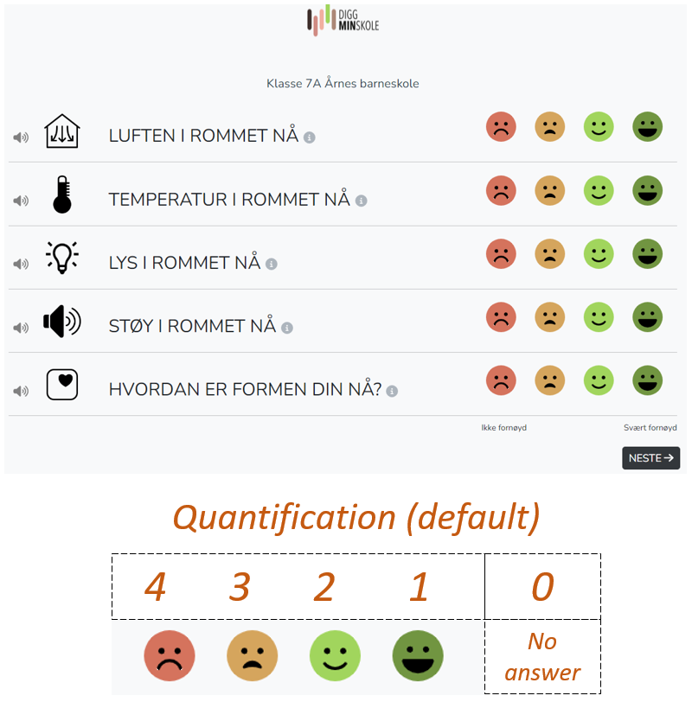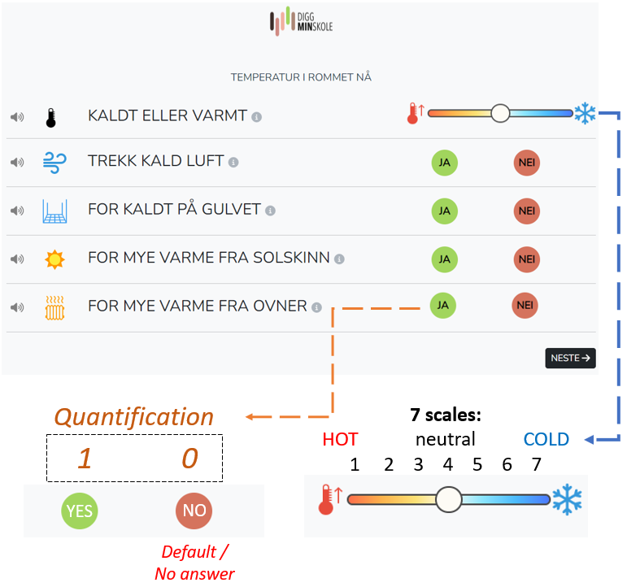
Figure 3 Display of ‘IS’ and the numerical values of selected answers:
IEQ Satisfaction & Health Preference (left); and IEQ-complaints: IAQ domains (right).
Start
IEQ Satisfaction
Health preference
Feel_air >2
Question list of
IEQ-complaints: IAQ
Feel_temp >2

Question list of
IEQ-complaints: Thermal
Feel_bright >2
Question list of
IEQ-complaints: Visual
Feel_health >2

Question list:
BRS
Finish
No
Yes
No
Yes
Yes
Yes
No
Figure 4 Flow chart of user-feedback online experience

  - Environmental Measurement Data
We collected indoor environment quality data using stand-alone sensor devices and data from the existing ventilation system. The sensor devices varied between schools, so that different parameters are available in different locations. Data from the ventilation systems also varied between schools. Both the free-standing devices and the ventilation measurements are done by low-cost sensor technology.

Stand-alone Sensors
One stand-alone sensor device (Airthings®-SpacePlus and Airthings®-SpacePro) was mounted in each class following a standardized installation protocol, mounted at a consistent height on the wall to meet local standard [9], as detailed in Table 4. The devices record data at 5-minute intervals. The sensors installed in each classroom measured indoor air temperature, relative humidity (RH), barometric air pressure, Carbon dioxide (CO₂), total VOCs (TVOCs) concentrations, and particulate matter (PM_{2.5}). According to the manufacturer, relative light intensity is measured by the sensors as percentage and relies on an infrared light captured by the sensor to represent the proportion of detected light relative to the sensor's maximum capacity. Data label in Table 4 is created following the name of parameters and device name (Airthings®). All information regarding sensor technology, resolution, accuracy, measurement range are specified in the metadata file. The standalone sensor data time stamp was converted to UTC+0 (Coordinated Universal Time) in our dataset.
Table 4. Technical sheet on low-cost sensor measurement devices installed in sampled classroom
Parameters | unit | data label | Availability  At school:
CO₂ | ppm | co2_a | NO-1,  NO-2,  and NO-3
Air Temperature | ºC | temp_a
Relative Humidity (RH) | % | rh_a
TVOCs | ppb | voc_a
Barometric Air Pressure | hPa | press_a
Relative Light Intensity | % | bright_a
Particulate Matter (PM_{2.5}) | µg/m³ | pm2.5_a | NO-1 & NO-2

Ventilation System Sensors
All school buildings involved in our research project have a Building Management System (BMS) that monitors and partially controls the building systems (heating, ventilation, lighting, etc.). This BMS is connected to an existing network of indoor measurement sensors installed in each room. The BMS at each schools utilizes these measurement for system monitoring and control of heating and ventilation as explained in section 3.1. The number of measurement parameters provided by the ventilation sensors is not as large as with standalone sensors. Both standalone and ventilation system sensors at most of the classrooms are installed side-by-side on the walls, at a height around 1.5 meters above the floor, in accordance with the relevant installation standard[9]. The sensor data from BMS was recorded in local time in Norway but was converted to UTC+0 (Universal) in our dataset, for consistency with other data (user-feedback and standalone sensors data). School-B provides hourly data, while School-A1 and A2 provide 20-minutes data. All school ventilations are provided by our project partner: Schneider® at School NO-1 and Sauter® at School NO-2 and NO-3. These ventilation providers later are mentioned in section 4.2 and Table 8 as label in instrument ID.
Table 5. Measurements by ventilation system related sensor
School | Location | Parameters | Unit | Resolution | Data Label
NO-1 | All sampled classroom | Indoor carbon dioxide | ppm | 1 | co2_v
 | All sampled classroom | Air Temperature | ºC | 0.1 | temp_v
NO-2 | All sampled classroom | Air Temperature | ºC | 0.1 | temp_v
 | Rooms at 1st floor only | Floor Temperature | ºC | 0.1 | temp_f
 | All sampled classroom | Setpoint Air Temperature | ºC | 0.1 | temp_s
NO-3 | All sampled classroom | Air Temperature | ºC | 0.1 | temp_v
 | All sampled classroom | Setpoint Air Temperature | ºC | 0.1 | temp_s
 | All sampled classroom | Supply airflow rate | m³/hour | 1 | vent_v

- Dataset Description
  - Data Format
Each CSV file should have a single header with a name for each variable in lower-case letters. After the header lines follow one or more lines with data. Each data line in the CSV files contains a common block of identifying information, followed by the measured values. Each CSV file should have a common block of CSV data on each line of the file describing the source of the data. We create this common block of CSV data consist of the following data values:
- The school ID.
- The room ID.
- The date (format: YYYYMMDD).
- The time (format: HH:MM).
- Manufacture ID.
- Instrument ID.
- Session ID (special only for user-feedback platform)
Thus, this block of data will constitute the first 6 values on each line of the CSV file. The school ID is alias name of school building as shown in the room ID could be either a number or an alphanumeric string uniquely identifying the classroom or other type of room being used. Both of those values should be given in lower-case letters. The date and time identify the timing of when the data were collected. We suggest that the file could include a time series of data where date and time stamp on each line uniquely identifies the time when the data were being measured or collected by the ‘IS’. The data should be in chronological order.
Finally, in this common block, the dataset includes a manufacturer ID column which identifies the data source type: 'airthings' (for standalone sensors), 'sdanlegg' (a Norwegian term for BMS, representing the ventilation system sensors), and 'niluapp' (the label name for IS, our user-feedback platform). In addition to the manufacturer ID, an instrument column specifies the origin of the data. For the 'airthings' and 'sdanlegg' datasets, this ID denotes the specific type of sensor from the manufacturer. For the user-feedback platform, the instrument ID contains the unique-code used by the participant when submitting their feedback, as mentioned in Section 2.2. There is supplementary session ID column, which present exclusively in the user-feedback dataset, which links responses to session code as described in Section 3.2.
The subsequent columns after common-block contain the related data in the particular dataset, either user-feedback dataset, standalone sensors dataset or ventilation system sensors dataset as shown in Table 6, Table 7 and Table 8. The column names (data label) and their description or explanation are listed in Table 3 for the ‘IS’ dataset files, in Table 4 for the standalone sensors dataset files, and in Table 5 for the ventilation system sensor dataset files.
Table 6. Example display of user-feedback dataset collected by IS at School ‘NO-1’ at Room 11
school_id | room_id | date | time | manuf_id | instr_id | session_id | feel_air | feel_temp | …..
no-1 | 11 | 15.04.2024 | 06:31 | niluapp | 1F2KLH | 73dc63be… | 2 | 2 | …..
no-1 | 11 | 15.04.2024 | 06:32 | niluapp | 1F2KLH | a6e39d62… | 2 | 1 | …..
no-1 | 11 | 15.04.2024 | 06:31 | niluapp | 1F2KLH | 1b66c284… | 2 | 1 | …..
…. | …. | …. | …. | …. | …. | …. | …. | …. | ….

Table 7. Example display of dataset recorded by Standalone sensor from: School ‘NO-1’ at Room 11
school_id | room_id | date | time | manuf_id | instr_id | temp_a | rh_a | …._..
no-1 | 11 | 31.12.2023 | 23:09 | airthings | spaceplus | 19.2 | 22 | …..
no-1 | 11 | 31.12.2023 | 23:14 | airthings | spaceplus | 19.3 | 22 | …..
no-1 | 11 | 31.12.2023 | 23:19 | airthings | spaceplus | 19.4 | 22 | …..
…. | …. | …. | …. | …. | …. | …. | …. | ….

Table 8. Example display of dataset recorded by ventilation system sensor from: School ‘NO-1’ at Room 11
school_id | room_id | date | time | manuf_id | instr_id | co2_v | temp_v | …._..
no-1 | 11 | 31.12.2023 | 23:00 | sdanlegg | schneider | 390 | 18.1 | …..
no-1 | 11 | 01.01.2024 | 00:00 | sdanlegg | schneider | 391 | 18.1 | …..
no-1 | 11 | 01.01.2024 | 01:00 | sdanlegg | schneider | 391 | 18.0 | …..
…. | …. | …. | …. | …. | …. | …. | …. | ….

  - Structure of the Dataset
There are three main sources of data: (1) the ‘IS’; (2) standalone sensors; (3) ventilation system sensors, and all data was stored as CSV (comma-separated values) format in separate files. The organized hierarchically in the following directory structure:
- There are two main-folders: dataset and Metadata
- The first-level directory is the year of data taken.
- The second level directory beneath the top level should be school’s name
- The third level directory beneath the second level should be the data category (standalone sensors, ventilation system sensors, IS)
- The fourth level directory beneath the third level should be the room number.
Thus, all CSV files from classroom number 23 using the ‘IS’ in the school ‘NO-1’, in the year 2023 will be stored in the directory: /2023/no-1/niluapp/23; while the standalone sensors data measured by AirThings ® will be store in : /2023/no-1/standalone sensors/23. Further, all filenames should be given using only small letters. We create the following name structure for each CSV file (Figure 5):
<sid>_<rid>_<mid>_<iid>_<date>_<time>.csv
where :
- <sid> and <rid> are the school and room IDs,
- <iid> the instrument or provider’s company or platform maker.
- <date> and <time> the date and time values at the beginning of dataset, respectively

Figure 5. Directory tree of provided data

- Limitations
Several methodological limitations are noted. The validity of data is limited by its focus on three specific schools in Norway. The dataset is not representative of all schools across the country due to variations in building design, location, and operational practices. All sensor data as noted in Section 3.3 were used without field calibration, which is a key limitation. The ventilation system sensors are likely to have significant calibration drift due to their age, potentially affecting data accuracy. While the standalone sensors were newly purchased and assumed to be in good condition, this was not verified in a lab. To comply with, this work does not collect demographic or any information about the student cohort or the symptoms they usually suffer while giving the responses.

- Ethical Statement
(FROM THE FORMAT OF JOURNAL: Data in Brief’s Guide for Authors contains detailed information on the ethical guidelines with which all authors must comply. In addition, we ask you to complete the relevant statement(s) below. Please delete those which are not relevant for your data. If your work involved human subjects, please include a statement here confirming that the relevant informed consent was obtained from those subjects, if the research was carried out in accordance with the Declaration of Helsinki, and if it includes the Ethical committee approval and the protocol number. A copy of the consent form (in English) can be submitted either in a data repository or under the section ‘Consent form’ while submitting the manuscript to the system.)
(maybe like this? Just revise it if it doesn’t match) This project collected data from human subjects. The participants were asked by their teacher to participate, and they participated anonymously. Information about this data collection was submitted to a review by the Norwegian research data repository, and is considered in accordance with and in line with the Declaration of Helsinki and other national requirements. No individual biodata or any students’ personal information (name, personal photos, background, etc) were collected.

- Data Availability
All data is provided online using license CC-BY (XXXXX) and downloadable through the link : https://zenodo.org/XXXXXXXXXXXX. (all above will be revised once uploaded)

- Acknowledgements
(copy-paste from first published article, please Alena and Guangyu if you may revise if necessary)
This work co-financed by Digg-Min-Skole Project (Research Council of Norway project number: 331830) under the coordination of NILU. The ‘IS’ was developed by NILU using internal funding. We extend our heartfelt gratitude to Kent Hart, Alfred Canet Mansanet, Randi Margrethe Høgh and John Charles Almen for their assistance in creating the various project protocols, tools and approaches. And above all, we are grateful to the pupils, students, teachers, school administrations and technicians of the participating schools for their valuable inputs to the study, and for their participation.

- Declaration of Competing Interest
(from the writing template of the journal)
The authors declare that they have no known competing financial interests or personal relationships that could have appeared to influence the work reported in this paper.

- References
[COPY-PASTE FROM JOURNAL TEMPLATE: In this section, please provide a numbered list of references. References are limited to a maximum of 20 and irrelevant self-citation is not allowed.
Please format all in-text citations by number(s) in square brackets in line with the text. The actual authors can be referred to, but the reference number(s) must always be given.]
1. Øvrevik, J., et al., Inneklima i skoler og barnehager: Helsemessig betydning for barn og unge. 2016.
2. Daisey, J.M., W.J. Angell, and M.G. Apte, Indoor air quality, ventilation and health symptoms in schools: an analysis of existing information. Indoor air, 2003. 13(1).DOI: 10.1034/j.1600-0668.2003.00153.x.
3. Tran, M.T., et al., Review of parameters measured to characterize classrooms’ indoor environmental quality. Buildings, 2023. 13(2): p. 433.DOI: 10.3390/buildings13020433.
4. Sakellaris, I.A., et al., Perceived indoor environment and occupants’ comfort in European “modern” office buildings: The OFFICAIR study. International journal of environmental research and public health, 2016. 13(5): p. 444.DOI: 10.3390/ijerph13050444.
5. Al horr, Y., et al., Impact of indoor environmental quality on occupant well-being and comfort: A review of the literature. International Journal of Sustainable Built Environment, 2016. 5(1): p. 1-11.DOI: 10.1016/j.ijsbe.2016.03.006.
6. Haugland, S., et al., Subjective health complaints in adolescence: A cross-national comparison of prevalence and dimensionality. The European Journal of Public Health, 2001. 11(1): p. 4-10.
7. Sun, S., et al., Indoor air-quality data-monitoring system: Long-term monitoring benefits. Sensors, 2019. 19(19): p. 4157.DOI: 10.3390/s19194157.
8. Khan, D.S., J. Kolarik, and P. Weitzmann, Application of an occupant voting system for continuous occupant feedback on thermal and indoor air quality–Case studies in office spaces. Energy and Buildings, 2021. 251: p. 111363.DOI: 10.1016/j.enbuild.2021.111363.
9. (NEMITEK), N.V.E.-o.M.f., Ventilasjonsteknikk del I, in 8.1.1. Oppholdssonen. 2019.

