**Упражнение для самостоятельной работы 27. Используя консольную**

**утилиту traceroute (и tracert), освежите значения и заполните не-**

**достающие записи в таблице ниже. Определите соответствие доменного имени и IP-адреса; определите цепочку маршрутизаторов, по которым прокладывается маршрут и задержку в каждом узле.**

**1.**traceroute to www.sb.by (185.66.70.5), 30 hops max, 60 byte packets

1 192.168.100.1 (192.168.100.1) 0.899 ms 1.079 ms 1.212 ms

2 * * *

3 mm-201-80-84-93.dynamic.pppoe.mgts.by (93.84.80.201) 7.991 ms 6.184 ms 6.245 ms

4 core4.net.belpak.by (93.85.80.169) 6.715 ms 6.794 ms 11.324 ms

5 10.0.4.37 (10.0.4.37) 8.763 ms 8.831 ms 8.910 ms

6 core2.net.belpak.by (93.85.80.57) 8.610 ms 6.676 ms 6.553 ms

7 core1.net.belpak.by (93.85.80.33) 7.897 ms 7.941 ms 7.949 ms

8 as12406.by-ix.net (195.137.180.11) 6.496 ms 6.538 ms 6.659 ms

9 mailer.sb.by (185.66.70.5) 7.415 ms !X 7.453 ms !X 7.397 ms !X

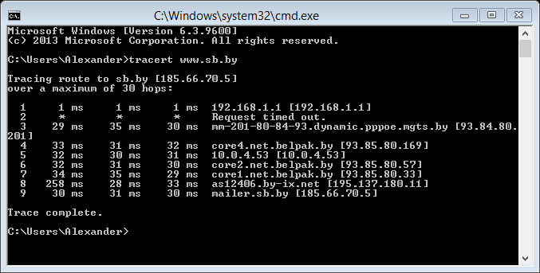

**2.** traceroute to minsk.gov.by (93.85.84.179), 30 hops max, 60 byte packets

1 192.168.100.1 (192.168.100.1) 0.878 ms 0.928 ms 1.207 ms

2 * * *

3 mm-201-80-84-93.dynamic.pppoe.mgts.by (93.84.80.201) 12.328 ms 6.661 ms 6.723 ms

4 core4.net.belpak.by (93.85.80.169) 7.306 ms 7.381 ms 9.989 ms

5 10.0.4.37 (10.0.4.37) 8.377 ms 8.442 ms 8.506 ms

6 core2.net.belpak.by (93.85.80.57) 11.995 ms 7.892 ms 7.861 ms

7 gw3.datacenter.beltelecom.by (93.84.125.169) 4.313 ms 4.723 ms 4.722 ms

8 10g.datacenter.beltelecom.by (178.124.134.49) 6.973 ms 7.369 ms 7.487 ms

9 178.124.134.43 (178.124.134.43) 7.530 ms 7.526 ms 8.481 ms

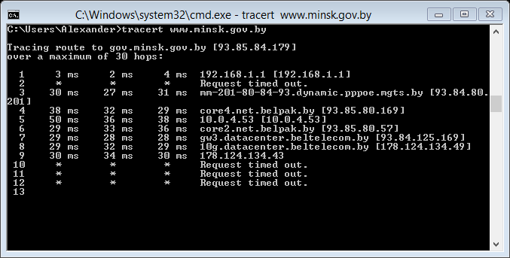

**3.**traceroute to www.tut.by (178.124.133.66), 30 hops max, 60 byte packets

1 192.168.100.1 (192.168.100.1) 0.814 ms 1.012 ms 1.260 ms

2 * * *

3 mm-201-80-84-93.dynamic.pppoe.mgts.by (93.84.80.201) 6.882 ms 6.937 ms 7.125 ms

4 core4.net.belpak.by (93.85.80.169) 6.992 ms 9.189 ms 9.247 ms

5 10.0.4.37 (10.0.4.37) 13.307 ms 13.523 ms 13.588 ms

6 core2.net.belpak.by (93.85.80.57) 13.678 ms 6.654 ms 6.600 ms

7 gw4.datacenter.beltelecom.by (93.84.125.173) 5.794 ms 5.860 ms 6.141 ms

8 10g.datacenter.beltelecom.by (178.124.134.49) 6.211 ms 7.317 ms 6.387 ms

9 178-124-133-66.hoster.by (178.124.133.66) 6.435 ms 3.880 ms 6.719 ms

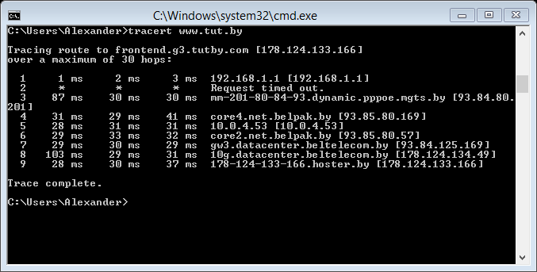

**4.**traceroute to www.pravo.by (91.149.157.62), 30 hops max, 60 byte packets

1 192.168.100.1 (192.168.100.1) 0.825 ms 1.024 ms 1.066 ms

2 * * *

3 mm-201-80-84-93.dynamic.pppoe.mgts.by (93.84.80.201) 6.817 ms 6.879 ms 6.960 ms

4 core4.net.belpak.by (93.85.80.169) 9.003 ms 7.016 ms 7.097 ms

5 10.0.4.37 (10.0.4.37) 10.570 ms 10.647 ms 10.736 ms

6 core2.net.belpak.by (93.85.80.57) 10.431 ms 5.695 ms 5.632 ms

7 gw4.datacenter.beltelecom.by (93.84.125.173) 5.352 ms 5.489 ms 5.668 ms

8 10g.datacenter.beltelecom.by (178.124.134.49) 5.723 ms 5.829 ms 6.083 ms

9 91-149-157-62.hosterby.com (91.149.157.62) 7.504 ms 6.584 ms 9.369 ms

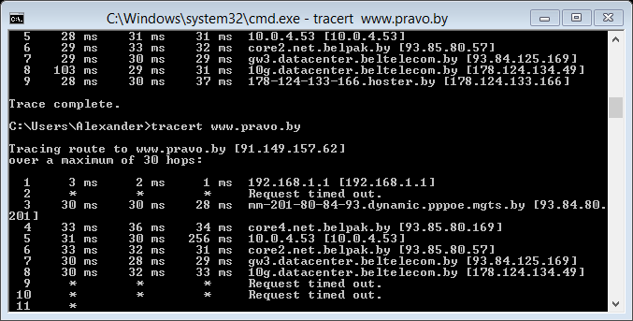

**5.**traceroute to www.nbrb.by (212.98.162.9), 30 hops max, 60 byte packets

1 192.168.100.1 (192.168.100.1) 2.647 ms 2.814 ms 2.935 ms

2 * * *

3 mm-201-80-84-93.dynamic.pppoe.mgts.by (93.84.80.201) 8.406 ms 8.399 ms 8.796 ms

4 core4.net.belpak.by (93.85.80.169) 9.086 ms 11.492 ms 11.516 ms

5 10.0.4.37 (10.0.4.37) 19.541 ms 19.712 ms 19.777 ms

6 core2.net.belpak.by (93.85.80.57) 11.963 ms 5.206 ms 5.354 ms

7 core1.net.belpak.by (93.85.80.33) 8.601 ms 8.869 ms 8.952 ms

8 as12406.by-ix.net (195.137.180.11) 5.257 ms 5.318 ms 5.064 ms

9 nbrb.by (212.98.162.9) 7.732 ms 7.325 ms 3.971 ms

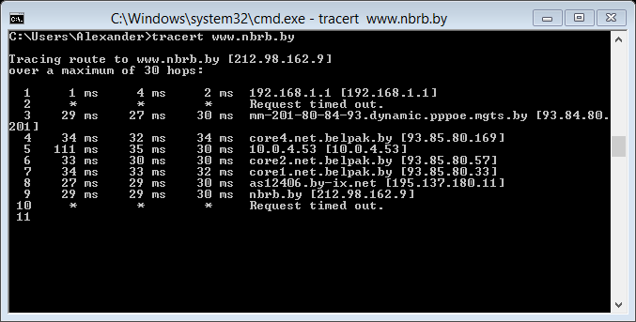

**6.**traceroute to lenta.ru (81.19.76.11), 30 hops max, 60 byte packets

1 192.168.100.1 (192.168.100.1) 0.727 ms 0.970 ms 1.277 ms

2 * * *

3 mm-201-80-84-93.dynamic.pppoe.mgts.by (93.84.80.201) 6.772 ms 6.838 ms 6.912 ms

4 core4.net.belpak.by (93.85.80.169) 7.853 ms 7.929 ms 9.487 ms

5 10.0.4.37 (10.0.4.37) 7.164 ms 7.222 ms 11.499 ms

6 core2.net.belpak.by (93.85.80.57) 9.312 ms 6.958 ms 6.965 ms

7 ie2.net.belpak.by (93.85.80.54) 11.070 ms 11.072 ms *

8 asbr3.net.belpak.by (93.85.80.106) 6.829 ms * *

9 a197-cr04-be16.msk.stream-internet.net (195.34.36.13) 21.554 ms 21.554 ms 20.529 ms

10 m9-cr05-ae13.77.msk.stream-internet.net (212.188.2.61) 18.267 ms 17.624 ms 15.096 ms

11 m9-cr04-be14.77.msk.stream-internet.net (212.188.42.57) 16.027 ms m9-cr04-be12.77.msk.stream-internet.net (212.188.28.174) 15.987 ms m9-cr04-be3.77.msk.stream-internet.net (195.34.53.186) 15.294 ms

12 m9-cr02-po6.msk.stream-internet.net (195.34.59.242) 14.872 ms 14.540 ms 14.738 ms

13 rambler-m9.msk.stream-internet.net (195.34.36.166) 43.367 ms 43.477 ms 43.925 ms

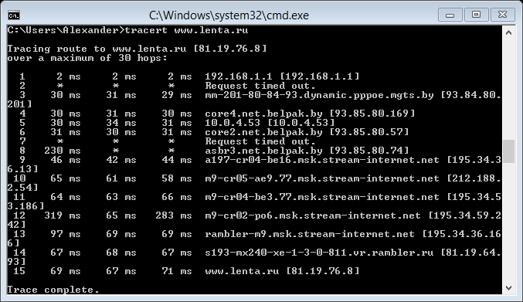

**7.**traceroute to www.bsuir.by (195.50.1.121), 30 hops max, 60 byte packets

1 192.168.100.1 (192.168.100.1) 1.826 ms 2.761 ms 3.278 ms

2 * * *

3 mm-201-80-84-93.dynamic.pppoe.mgts.by (93.84.80.201) 8.866 ms 8.946 ms 8.714 ms

4 core4.net.belpak.by (93.85.80.169) 10.339 ms 9.024 ms 10.398 ms

5 10.0.4.37 (10.0.4.37) 9.928 ms 10.004 ms 10.102 ms

6 core2.net.belpak.by (93.85.80.57) 11.449 ms 6.525 ms 6.484 ms

7 core1.net.belpak.by (93.85.80.33) 6.584 ms 6.633 ms 6.711 ms

8 as5498.by-ix.net (195.137.180.23) 6.351 ms 6.764 ms 7.228 ms

9 195.50.3.2 (195.50.3.2) 7.001 ms 7.051 ms 7.479 ms

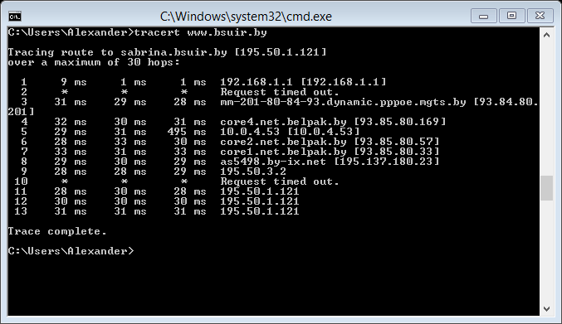

**8.**traceroute to www.informatics.by (178.159.240.240), 30 hops max, 60 byte packets

1 192.168.100.1 (192.168.100.1) 0.719 ms 0.921 ms 1.220 ms

2 * * *

3 mm-201-80-84-93.dynamic.pppoe.mgts.by (93.84.80.201) 6.806 ms 6.858 ms 6.938 ms

4 core4.net.belpak.by (93.85.80.169) 9.473 ms 9.502 ms 9.581 ms

5 10.0.4.37 (10.0.4.37) 10.164 ms 10.201 ms 10.278 ms

6 core2.net.belpak.by (93.85.80.57) 10.370 ms 7.310 ms 7.177 ms

7 core1.net.belpak.by (93.85.80.33) 6.948 ms 9.620 ms 9.689 ms

8 gw1.datacenter.beltelecom.by (93.84.125.161) 7.135 ms 6.095 ms 5.890 ms

9 10g.datacenter.beltelecom.by (178.124.134.49) 5.913 ms 5.637 ms 5.712 ms

10 10g.datacenter.beltelecom.by (178.124.134.58) 5.778 ms 5.777 ms 4.654 ms

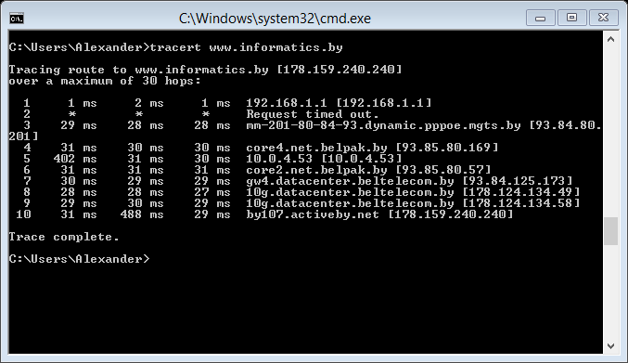

|  |  |  |  |
| --- | --- | --- | --- |
| Из таблицы | Доменное имя | Из консоли | Ресурс |
| 212. 98. 168. 51 | www.sb.by | 185.66.70.5 | Советская Белоруссия |
| 93. 85. 84. 179 | minsk.gov.by | 93. 85. 84. 179 | Минский городской исполнительный комитет |
| 178. 124. 133. 66 | www.tut.by | 178. 124. 133. 66 | Tut.by media |
| 91. 149. 157. 62 | www.pravo.by | 91. 149. 157. 62 | Национальный правовой Интернет-портал Республики Беларусь |
| 212. 98. 162. 9 | www.nbrb.by | 212. 98. 162. 9 | Национальный банк РБ |
| 81. 19. 85. 116 | lenta.ru | 81.19.76.10 | Новости |
| 195. 50. 1. 121 | www.bsuir.by | 195. 50. 1. 121 | БГУИР |
| 91. 149. 157. 152 | www.informatics.by | 178.159.240.240 | Кафедра информатики |

**Упражнение для самостоятельной работы 29. Иизвестными вам уже**

**средствами, определите номера автономных систем нашего домена**

**\*.by, найдите несколько автономных систем домена *.ru. Новыми**

**данными дополните нижеприведенную таблицу; проверьте записи в**

**уже существующих строках.**

**1.**C:\Users\Alexander>nslookup www.sb.by

Server: 192.168.1.1

Address: 192.168.1.1

Non-authoritative answer:

Name: sb.by

Address: 185.66.70.5

Aliases: www.sb.by

**2.** C:\Users\Alexander>nslookup www.minsk.gov.by

Server: 192.168.1.1

Address: 192.168.1.1

Non-authoritative answer:

Name: www.minsk.gov.by

Address: 93.85.84.179

**3.** C:\Users\Alexander>nslookup www.tut.by

Server: 192.168.1.1

Address: 192.168.1.1

Non-authoritative answer:

Name: frontend.g3.tutby.com

Addresses: 178.124.133.65

178.124.133.66

178.124.133.165

178.124.133.166

Aliases: [www.tut.by](http://www.tut.by)

**4.** C:\Users\Alexander>nslookup www.pravo.by

Server: 192.168.1.1

Address: 192.168.1.1

Non-authoritative answer:

Name: www.pravo.by

Address: 91.149.157.62

**5.** C:\Users\Alexander>nslookup www.nbrb.by

Server: 192.168.1.1

Address: 192.168.1.1

Non-authoritative answer:

Name: www.nbrb.by

Address: 212.98.162.9

**6.** C:\Users\Alexander>nslookup www.lenta.ru

Server: 192.168.1.1

Address: 192.168.1.1

Non-authoritative answer:

Name: www.lenta.ru

Addresses: 81.19.76.11

81.19.76.8

81.19.76.9

81.19.76.10

**7.** C:\Users\Alexander>nslookup www.bsuir.by

Server: 192.168.1.1

Address: 192.168.1.1

Non-authoritative answer:

Name: sabrina.bsuir.by

Address: 195.50.1.121

Aliases: [www.bsuir.by](http://www.bsuir.by)

**8.** C:\Users\Alexander>nslookup www.informatics.by

Server: 192.168.1.1

Address: 192.168.1.1

Non-authoritative answer:

Name: www.informatics.by

Address: 178.159.240.240

|  |  |  |  |
| --- | --- | --- | --- |
| Нац-банк | www.nbrb.by | mnt-by: AS12406-MNT | Bisiness network jv |
| БГУИР | www.bsuir.by | mnt-by: AS5498-MNT | Education and Science Comp. |
| Tyт-бай | www.tut.by | mnt-by: AS6697-MNT | Minsk, Belarus |
| Евроспорт | [www.eurosport.ru](http://www.eurosport.ru) | mnt-by: COLT-FR-MNT | EUROSPORT |
| Кафедра информатики Бгуир | [www.informatics.by](http://www.informatics.by) | mnt-by: AS6697-MNT | Beltelecom DC |
| Rambler Internet Holding LLC Internet | [www.lenta.ru](http://www.lenta.ru) | mnt-by: RAMBLER-MNT | Rambler Internet Holding LLC |
| Национальный правовой интернет-портал  РБ | [www.pravo.by](http://www.pravo.by) | mnt-by: AS6697-MNT | Mobile Service Ltd. |

**ping**

1. **sb.by**

C:\Users\Alexander>ping www.sb.by

Pinging sb.by [185.66.70.5] with 32 bytes of data:

Reply from 185.66.70.5: bytes=32 time=29ms TTL=56

Reply from 185.66.70.5: bytes=32 time=30ms TTL=56

Reply from 185.66.70.5: bytes=32 time=32ms TTL=56

Reply from 185.66.70.5: bytes=32 time=34ms TTL=56

Ping statistics for 185.66.70.5:

Packets: Sent = 4, Received = 4, Lost = 0 (0% loss),

Approximate round trip times in milli-seconds:

Minimum = 29ms, Maximum = 34ms, Average = 31ms

**2.** C:\Users\Alexander>ping 93.85.84.179

Pinging 93.85.84.179 with 32 bytes of data:

Request timed out.

Request timed out.

Request timed out.

Request timed out.

Ping statistics for 93.85.84.179:

Packets: Sent = 4, Received = 0, Lost = 4 (100% loss),

**3.** tut.by

C:\Users\Alexander>ping 178.124.133.66

Pinging 178.124.133.66 with 32 bytes of data:

Reply from 178.124.133.66: bytes=32 time=29ms TTL=56

Reply from 178.124.133.66: bytes=32 time=29ms TTL=56

Reply from 178.124.133.66: bytes=32 time=28ms TTL=56

Reply from 178.124.133.66: bytes=32 time=31ms TTL=56

Ping statistics for 178.124.133.66:

Packets: Sent = 4, Received = 4, Lost = 0 (0% loss),

Approximate round trip times in milli-seconds:

Minimum = 28ms, Maximum = 31ms, Average = 29ms

**4.www.pravo.by**

C:\Users\Alexander>ping 91.149.157.62

Pinging 91.149.157.62 with 32 bytes of data:

Request timed out.

Request timed out.

Request timed out.

Request timed out.

Ping statistics for 91.149.157.62:

Packets: Sent = 4, Received = 0, Lost = 4 (100% loss),

**5.**www.nbrb.by

C:\Users\Alexander>ping 212.98.162.9

Pinging 212.98.162.9 with 32 bytes of data:

Request timed out.

Request timed out.

Request timed out.

Request timed out.

Ping statistics for 212.98.162.9:

Packets: Sent = 4, Received = 0, Lost = 4 (100% loss),

**6.** lenta.ru

C:\Users\Alexander>ping 81.19.85.116

Pinging 81.19.85.116 with 32 bytes of data:

Request timed out.

Request timed out.

Request timed out.

Request timed out.

Ping statistics for 81.19.85.116:

Packets: Sent = 4, Received = 0, Lost = 4 (100% loss),

**7. www.bsuir.by**

C:\Users\Alexander>ping 195.50.1.121

Pinging 195.50.1.121 with 32 bytes of data:

Reply from 195.50.1.121: bytes=32 time=29ms TTL=116

Reply from 195.50.1.121: bytes=32 time=28ms TTL=116

Reply from 195.50.1.121: bytes=32 time=29ms TTL=116

Reply from 195.50.1.121: bytes=32 time=30ms TTL=116

Ping statistics for 195.50.1.121:

Packets: Sent = 4, Received = 4, Lost = 0 (0% loss),

Approximate round trip times in milli-seconds:

Minimum = 28ms, Maximum = 30ms, Average = 29ms

**8.** [**www.informatics.by**](http://www.informatics.by)

C:\Users\Alexander>ping 91.149.157.152

Pinging 91.149.157.152 with 32 bytes of data:

Reply from 91.149.157.152: bytes=32 time=120ms TTL=56

Reply from 91.149.157.152: bytes=32 time=31ms TTL=56

Reply from 91.149.157.152: bytes=32 time=28ms TTL=56

Reply from 91.149.157.152: bytes=32 time=30ms TTL=56

Ping statistics for 91.149.157.152:

Packets: Sent = 4, Received = 4, Lost = 0 (0% loss),

Approximate round trip times in milli-seconds:

Minimum = 28ms, Maximum = 120ms, Average = 52ms