**TRƯỜNG CAO ĐẲNG CÔNG NGHỆ THỦ ĐỨC**

**KHOA CÔNG NGHỆ THÔNG TIN**

**--------------------------------**



Software Requirement Specification

Hotel manager

Version 1.2

**LẬP TRÌNH IOS**

**Instructor**: Tieu Kim Cuong

**Students do:**

Dao Tan Quoc Viet

Quat Quang Sang

Tran Thai Hoang

**Revision History**

| Date | Version | Description | Author | Revised by |
| --- | --- | --- | --- | --- |
| 28/4/2023 | 1.0 | Phiên bản đầu tiên. | Thái Hoàng | Group |
| 5/5/2023 | 1.1 | Hình ảnh mockup mô tả. | Quốc Việt | Group |
| 5/5/2023 | 1.2 | Hoàn thiện nội dung. | Quốc Việt | Group |
|  |  |  |  |  |

Contents

**CHAPTER 1. INTRODUCE** 5

**CHAPTER 2. SYSTEM DESIGN ANALYSIS** 6

**Functional Requirements** 6

2.1 Feature/Component #1: Login screen 6

2.1.1 User Interfaces 6

2.1.2 Functional Requirements 7

2.2 Feature/Component #2: Main screen 9

2.2.1 Main screen Interfaces 9

2.2.2 Functional Requirements 11

2.3 Feature/Component #3: Room list screen 12

2.3.1 Room list Interfaces 12

2.3.2 Functional Requirements 13

2.4 Feature/Component #4 Booking room 14

2.4.1 Booking room Interfaces 14

2.4.2 Functional Requirements 15

2.5 Feature/Component #5: Room information screen 17

2.5.1 Room information Interfaces 17

2.5.2 Functional Requirements 18

2.6 Feature/Component #6: Change room information 19

2.6.1 Change Room information Interfaces 19

2.6.2 Functional Requirements 20

2.7 Feature/Component #7: Add service screen. 21

2.7.1 Add service Interfaces 21

2.7.2 Functional Requirements 22

2.8 Feature/Component #8: Cancellation of reservation 23

2.8.1 Interfaces 23

2.8.2 Functional Requirements 24

2.9 Feature/Component 9#: Pay screen 25

2.9.1 Interfaces 25

2.9.2 Functional Requirements 27

2.10 Feature/Component 10#: List bill 28

2.10.1 Interfaces 28

2.10.2 Functional Requirements 29

2.11 Feature/Component 11#: Create new account 30

2.11.1 Interfaces 30

2.11.2 Functional Requirements 31

# **CHAPTER 1. INTRODUCE**

Hotel management software is a comprehensive solution to manage the operations of a hotel, including room management, reservations, payments, services and more. With this software, hotels can enhance performance and improve customer experience.

The SRS (Software Requirements Specification) report is an important document in the software development process, covering the functional and non-functional requirements of the software. The SRS report is the basis for designing, building and testing the software.

SRS report for hotel management software Objective Purpose outlines the requirements needed to develop a superior software product that makes hotel management easier and more efficient. In this report, we will focus on the main features of hotel management software, especially the room management, booking, payment and service features.

# **CHAPTER 2. SYSTEM DESIGN ANALYSIS**

# **Functional Requirements**

## Feature/Component #1: Login screen

### User Interfaces

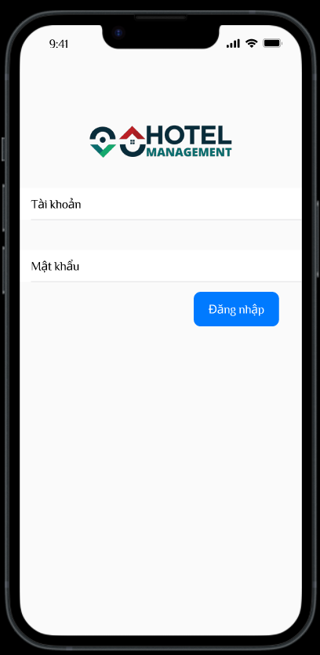

1. : Login screen

### Functional Requirements

|  |  |  |  |
| --- | --- | --- | --- |
| **Item** | **Description** | **Action** | **Response** |
| Login screen | Details main screen includes:   * Username Lable * Passwords Lable * Login Button | N/A | N/A |
| Username Textview | Input Username | Tap on the textview and Input username. | Show keyboard for user input. |
| Passwords textview | Input Passwords | Tap on the textview and Input passwords. | Show keyboard for user to enter as password. |
| Login Button | Used to login into this application. | Tap on the Login button. | When you click the Login button, the username and password will be compared.   * If user does not enter username and password:A dialog box will appear stating that username and password cannot be left blank. * If Username and password are wrong compared to username and password in firebase: A dialog box with incorrect username or password wrong. * If Username and Password are correct as in Firebase:Display the main screen. |

## Feature/Component #2: Main screen

### Main screen Interfaces

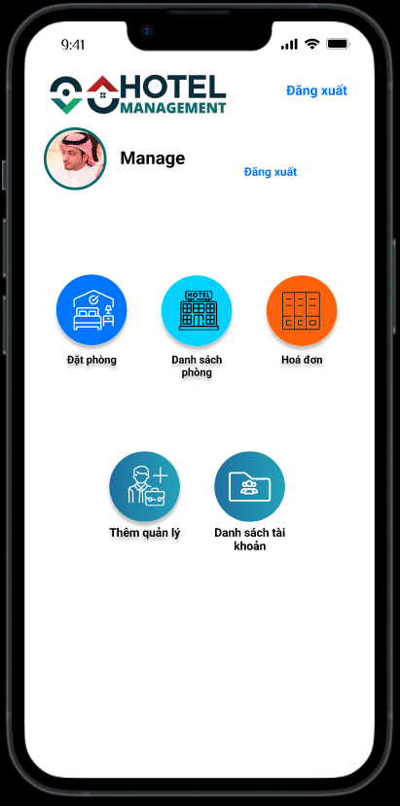

1. Main screen Management

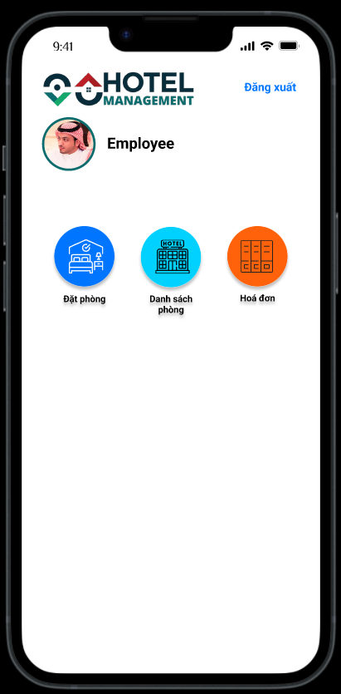

1. Main screen emlyee

### Functional Requirements

|  |  |  |  |
| --- | --- | --- | --- |
| **Item** | **Description** | **Action** | **Response** |
| Screen | 6 buttons corresponding to 6 functions in the main screen of the manager:   * Logout * Book room * List room * Bill list * Add manage * List manage   4 buttons corresponding to 4 functions in the main screen of the employee | N/A | N/A |
| Log out | Click logout when user want to return to the login page. | Click logout | Return login page |
| 5 Functions | With the remaining 5 functions:   * Book room * List room * Bill list * Add manage * List manage | Click 1/5 to go to the function user want to perform | Bring to the interface that needs to be manipulated successfully |
|  |  |  |  |

## Feature/Component #3: Room list screen

### Room list Interfaces

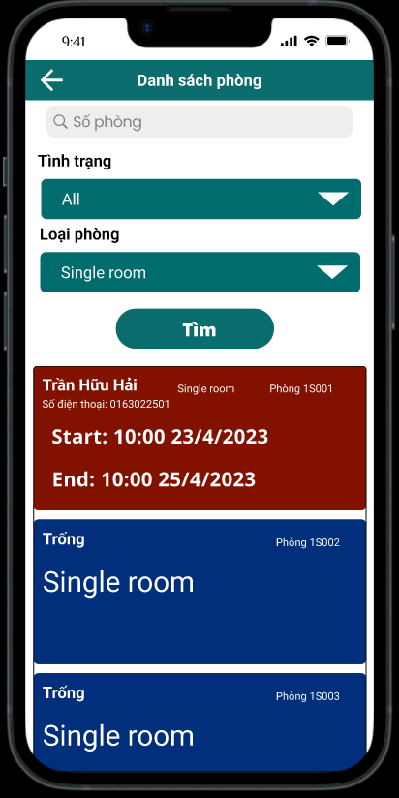

1. Room manager

### Functional Requirements

|  |  |  |  |
| --- | --- | --- | --- |
| **Item** | **Description** | **Action** | **Response** |
| Screen | - Funcion   * Back * Combo box status * Combo box type * Search button * Room card | N/A | N/A |
| Button Back | When the user presses back, it returns to the main screen | Tap Back | Return to main screen successfully |
| Combo box status | Options: Available rooms, Booked rooms, All | Tap combo box status | Show list options |
| Combo box type | Options: Single room, Double room, Collective room, Meeting room. | Tap conbo box type | Show list options |
| Search button | N/A | Tap Search | When tapping the button, a list will be displayed with the selected option and the room name that approximates the room name entered in the Search input. |
| Room card | Background is red when the room is booked, blue when the room is available. | Tap card | Go to the room information screen if the room is booked.. |

## Feature/Component #4 Booking room

### Booking room Interfaces

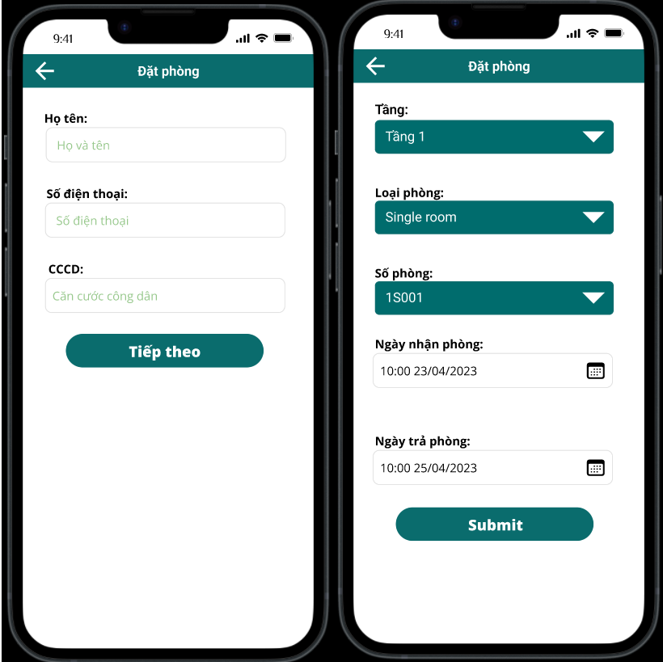

1. Book room screen

### Functional Requirements

|  |  |  |  |
| --- | --- | --- | --- |
| **Item** | **Description** | **Action** | **Response** |
| Customer information Screen | - Details Customer information screem includes:   * Name customer input * Phone customer input * Citizen identification input   Funtion:   * Back * Next | N/A | N/A |
| Button Next | If the user does not enter the information, an error message will be displayed | Tap Next | Display a message asking for information |
| Button Next | Enter name, phone, id customer | Tap Next | Return Room information screen |
| Button Back | When presser back,return main screen. | Tap back | Return main screen |
| Room information Screen | * Details Room Information screen includes: * Combobox floors * Combobox Type room * Combobox ID room * Datepicker Check-in * Datepicker Check-out * Submit | N/A | N/A |
| Combobox Floors | All floors in the hotel | Tap Floors | Show list number of floors |
| Combobox Type room | All rooms are empty on the floor. | Tap floors | Show list ID room in floor |
| Datepicker Check-in | Defaut date is todate. | Tap icon | Show picker date |
| Datepicker Check-out | Defaut date is 2 days late | Tao icon | Show picker date |
| Submit button | When tap submit, return main screen and save booking information. | Tap Submit | Successful booking, return to the main screen |
| Back button | When the user presses back, it return Cusromer information screen. | Tap Back | Return Customer Information screen |

## Feature/Component #5: Room information screen

### Room information Interfaces

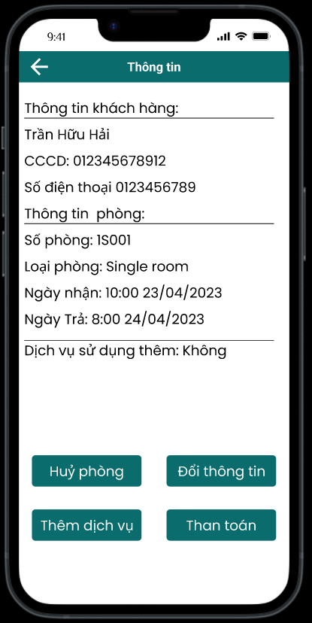

1. Room information screen

### Functional Requirements

|  |  |  |  |
| --- | --- | --- | --- |
| **Item** | **Description** | **Action** | **Response** |
| Screen | Components in the screen:   * Customer information * Room information * Services   Funtion   * Back * Cancel booking * Change information * More services * Pay | N/A | N/A |
| Customer information | Show information(Name, phone, id) customer booking this room. | N/A | N/A |
| Room information | Show information (Id, type, check-in, check-out, services) this room. | N/A | N/A |
| Button Back | When presser back, return List room screen | Tap back | Return list room screen |
| 4 funtion | With the remaining 5 functions:   * Cancel booking * Change information * More services * Pay | Click 1/5 to go to the function user want to perform | Bring to the interface that needs to be manipulated successfully |

## 

## Feature/Component #6: Change room information

### Change Room information Interfaces

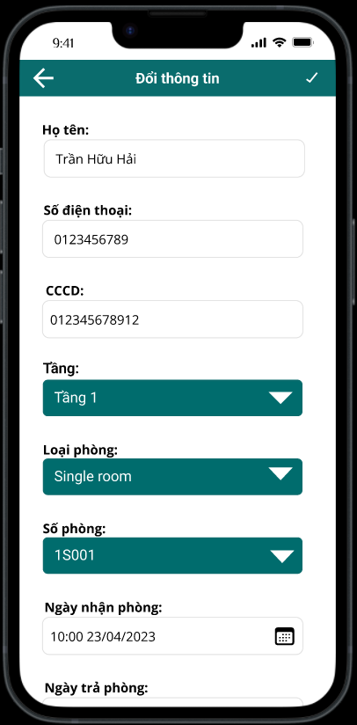

1. Change room information screen

### Functional Requirements

|  |  |  |  |
| --- | --- | --- | --- |
| **Item** | **Description** | **Action** | **Response** |
| Screen | * Details Screen includes: * Combobox floors * Combobox Type room * Combobox ID room * Datepicker Check in * Datepicker check out * Back button * Save button | N/A | N/A |
| Change Combobox floors | When change option combobox floors, list options ID room change accordingly. | Tap combobox and change option | List options ID room change accordingly. |
| Back button | When presser back, return list room screen | Tap back | Return list room screen |
| Save button | Tap this button will update information booking and return List room screen | Tap save | Update informaton reservation. Return List room screen |

## Feature/Component #7: Add service screen.

### Add service Interfaces

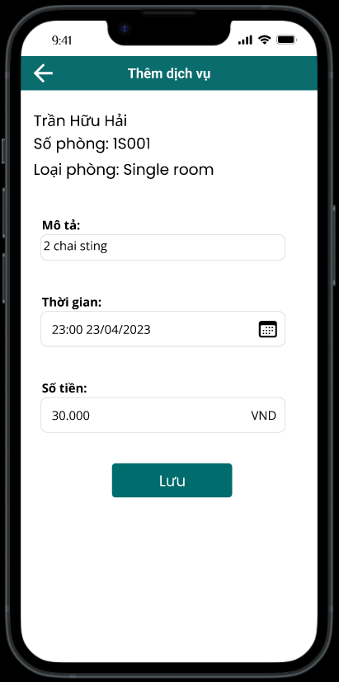

1. Add service screen.

### Functional Requirements

|  |  |  |  |
| --- | --- | --- | --- |
| **Item** | **Description** | **Action** | **Response** |
| Screen | - Details screen includes:   * Back button * Save button * Decription input * Price input * Information booking | N/A | N/A |
| Information booking | Including: Name customer, id room, type room | N/A | N/A |
| Back button | When presser back, return information booking screen | Tap back | Return information booking screen |
| Save button | Save when input decription | Tap save | Save service for information booking |

## Feature/Component #8: Cancellation of reservation

### Interfaces

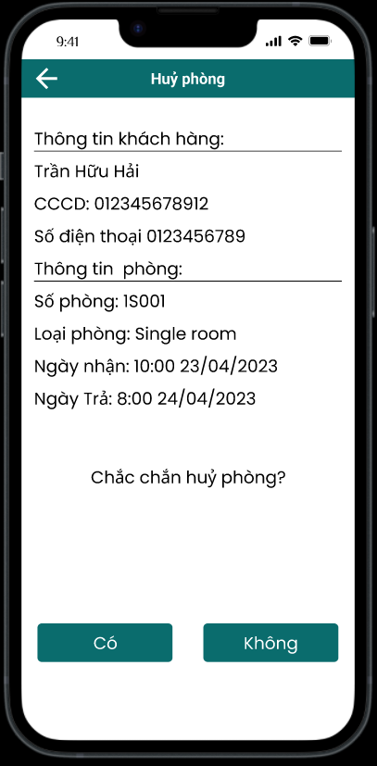

1. : Cancellation of booking screen

### Functional Requirements

|  |  |  |  |
| --- | --- | --- | --- |
| **Item** | **Description** | **Action** | **Response** |
| **Screen** | Details screen includes:   * Information booking * Button yes/no | N/A | N/A |
| **Information** | Information Customer  Information room | N/A | N/A |
| **Button yes** | When the button is pressed, the reservation will be canceled and returned to the room list screen. | Tap Yes | The reservation will be canceled and returned to the room list screen. |
| **Button no** | When the button is pressed, return information room screen. | Tap No | Return information room screen. |

## Feature/Component 9#: Pay screen

### Interfaces

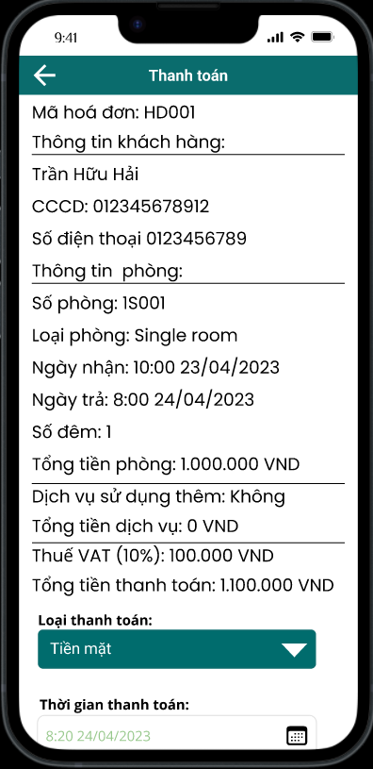

1. Pay screen

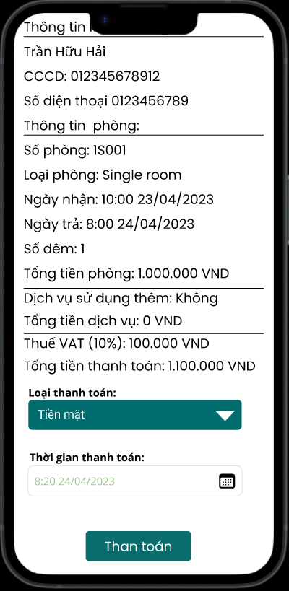

1. Pay screen

### Functional Requirements

|  |  |  |  |
| --- | --- | --- | --- |
| **Item** | **Description** | **Action** | **Response** |
| Screen | Details screen includes:   * Information * Type pay * Time pay * Button Pay | N/A | N/A |
| Information | Customer information, room information, service information, cost, VAT, total payment. | N/A | N/A |
| Type pay | Options: pay by card, pay by cash | N/A | N/A |
| Time pay | Default is today | N/A | N/A |
| Button pay | If the user does not enter the information, an error message will be displayed | Tap pay | Display a message asking for information |
| Button pay | Enter all required information | Tap Pay | Save bill, return main screen. |
|  |  |  |  |

## Feature/Component 10#: List bill

### Interfaces

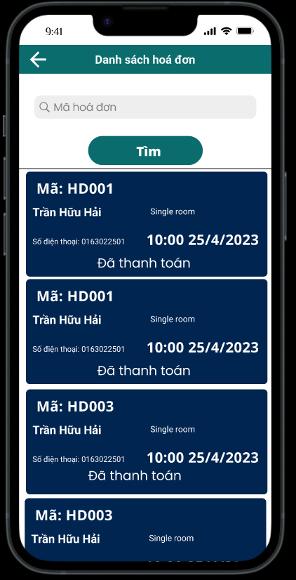

1. List bill

### Functional Requirements

|  |  |  |  |
| --- | --- | --- | --- |
| **Item** | **Description** | **Action** | **Response** |
| Screen | Details screen includes:   * Back button * ID bill input * Search button | N/A | N/A |
| Back button | When presser back, return information booking screen | Tap back | Return information booking screen |
| ID bill input | User can input id bill. | N/A | N/A |
| Search button | When search pressed, bill list shows the results of bill with similar codes. | 1. Input ID bill  2. Tap search | 2. Bill list shows the results of bill with similar codes |

## Feature/Component 11#: Create new account

### Interfaces

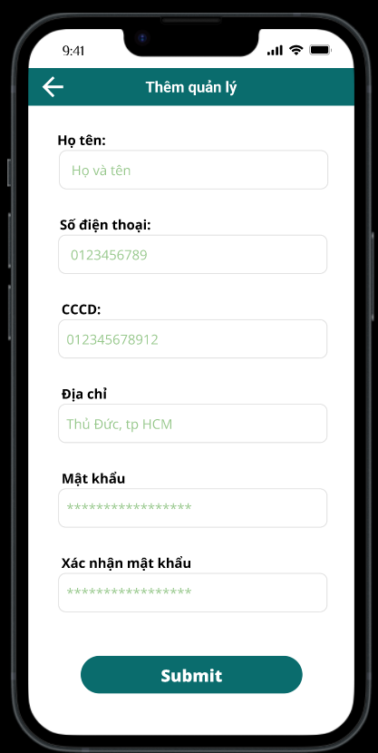

1. Add account

### Functional Requirements

|  |  |  |  |
| --- | --- | --- | --- |
| **Item** | **Description** | **Action** | **Response** |
| Screen | Details screen includes:   * Name * Phone * ID * Address * Password * Password confirmation * Submit | N/A | N/A |
| Phone input | Only number | N/A | N/A |
| Submit button | If the user does not enter the information, an error message will be displayed | Tap Submit | Display a message asking for information |
| Submit button | If the user enters the wrong password confirmation, an error message will be displayed | Tap Submit | Display a message asking for information |
| Submit button | Enter all required information | Tap submit | Save new account, return main screen. |

## 

***---------- End of Document ----------***