
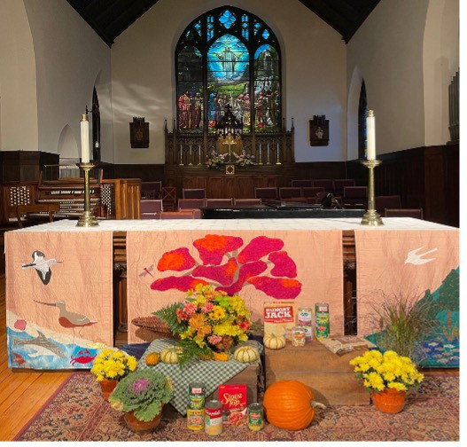

Scan the QR code above with a phone to access this form electronically
Christ Episcopal Church – 2026 Pledge Card

Name(s)
FINANCIAL OFFERING FOR 2026

In thanksgiving for all of God's blessings, I/We pledge: (select preferred frequency)
$ per week $ per month $ per quarter $ annually My/Our total annual commitment to support Christ Church in 2026 is $ This pledge represents: an increased commitment  a first time pledge commitment
TIME AND TALENT
I/we would like also like information about one of the following ministries in need of volunteers (please note name of volunteers)- thank you!:

□ Cooking for St. Paul’s Shelter, Share Sunday and Outreach Opportunities:
Help collect food on first Sunday and dropoff. Prepare and deliver food at local homeless shelter
Name(s)
□ An Affinity Group (Women’s Group, Dad's group, Men's Fellowship, Needlers)
Join in meetings with people who have a shared connection or "affinity" for mutual support
Name(s)
□ Parishioner Visits or Nursing Home Services:
Help by visiting someone at home or in the hospital or send cards and more.
Name(s)
□ Lay Eucharistic Leader, Reader, Usher, Acolyte, Altar Guild:
Assist in leading and preparing our sacred space for worship. Please circle one or
more above. Name(s)

Please complete the following with any NEW information for you or your household:
Phone Number(s)

Email(s)
you for your prayerful response and your faithfulness!
Thank

□ Check if you have considered Christ Church in your estate planning or if you would like information
□ Check if you would like info on transferring stocks as part of your giving

