

Artificial intelligence
Assignment #1

Name | Umer Waseem
Section | 6A
Roll Number | 22F-3054
Code:
from PIL import Image, ImageDraw
import tkinter as tk
from typing import List, Tuple
import heapq
from collections import deque

class SearchAlgorithm:
@staticmethod
def get_neighbors(x: int, y: int, grid: List[List[str]]) -> List[Tuple[int, int]]:
neighbors = []
directions = [(0, 1), (1, 0), (0, -1), (-1, 0)]
for dx, dy in directions:
nx, ny = x + dx, y + dy
if 0 <= nx < len(grid) and 0 <= ny < len(grid[0]) and grid[nx][ny] != '-1':
neighbors.append((nx, ny))
return neighbors

@staticmethod
def get_start_target(grid: List[List[str]]) -> Tuple[Tuple[int, int], Tuple[int, int]]:
start = target = (-1, -1)
for i in range(len(grid)):
for j in range(len(grid[0])):
if grid[i][j] == 's':
start = (i, j)
elif grid[i][j] == 't':
target = (i, j)
return start, target

@staticmethod
def ucs(grid: List[List[str]]) -> Tuple[int, List[Tuple[int, int]]]:
start, target = SearchAlgorithm.get_start_target(grid)
pq = [(0, start)]
heapq.heapify(pq)

distances = {start: 0}
came_from = {start: None}
visited = set()

while pq:
current_dist, current = heapq.heappop(pq)
if current == target:
break

if current in visited:
continue

visited.add(current)
x, y = current

for neighbor in SearchAlgorithm.get_neighbors(x, y, grid):
nx, ny = neighbor
new_dist = current_dist + 1
if neighbor not in distances or new_dist < distances[neighbor]:
distances[neighbor] = new_dist
came_from[neighbor] = current
heapq.heappush(pq, (new_dist, neighbor))

if target not in came_from:
return -1, []

path = []
while target:
path.append(target)
target = came_from[target]
path.reverse()
return 1, path

@staticmethod
def dfs(grid: List[List[str]]) -> Tuple[int, List[List[str]]]:
start, target = SearchAlgorithm.get_start_target(grid)
stack = [start]
visited = set()
came_from = {start: None}

while stack:
current = stack.pop()
if current == target:
break

if current in visited:
continue

visited.add(current)
x, y = current

for neighbor in SearchAlgorithm.get_neighbors(x, y, grid):
if neighbor not in visited and neighbor not in stack:
stack.append(neighbor)
came_from[neighbor] = current

if target not in came_from:
return -1, []

path = []
while target:
path.append(target)
target = came_from[target]
path.reverse()
return 1, path

@staticmethod
def bfs(grid: List[List[str]]) -> Tuple[int, List[Tuple[int, int]]]:
start, target = SearchAlgorithm.get_start_target(grid)
queue = deque([start])
visited = set()
came_from = {start: None}

while queue:
current = queue.popleft()
if current == target:
break

if current in visited:
continue

visited.add(current)
x, y = current

for neighbor in SearchAlgorithm.get_neighbors(x, y, grid):
if neighbor not in visited and neighbor not in queue:
queue.append(neighbor)
came_from[neighbor] = current

if target not in came_from:
return -1, []

path = []
while target:
path.append(target)
target = came_from[target]
path.reverse()
return 1, path

@staticmethod
def best_first_search(grid: List[List[str]]) -> Tuple[int, List[Tuple[int, int]]]:
start, target = SearchAlgorithm.get_start_target(grid)

def manhattan_distance(node1, node2):
x1, y1 = node1
x2, y2 = node2
return abs(x1 - x2) + abs(y1 - y2)

pq = [(manhattan_distance(start, target), start)]
heapq.heapify(pq)
came_from = {start: None}
visited = set()

while pq:
_, current = heapq.heappop(pq)
if current == target:
break

if current in visited:
continue

visited.add(current)
x, y = current

for neighbor in SearchAlgorithm.get_neighbors(x, y, grid):
if neighbor not in visited:
heapq.heappush(pq, (manhattan_distance(neighbor, target), neighbor))
came_from[neighbor] = current

if target not in came_from:
return -1, []

path = []
while target:
path.append(target)
target = came_from[target]
path.reverse()
return 1, path

@staticmethod
def a_star_search(grid: List[List[str]]) -> Tuple[int, List[List[str]]]:
start, target = SearchAlgorithm.get_start_target(grid)

def manhattan_distance(node1, node2):
x1, y1 = node1
x2, y2 = node2
return abs(x1 - x2) + abs(y1 - y2)

pq = [(0 + manhattan_distance(start, target), 0, start)]
heapq.heapify(pq)
distances = {start: 0}
came_from = {start: None}
visited = set()

while pq:
_, current_dist, current = heapq.heappop(pq)
if current == target:
break

if current in visited:
continue

visited.add(current)
x, y = current

for neighbor in SearchAlgorithm.get_neighbors(x, y, grid):
new_dist = current_dist + 1
if neighbor not in distances or new_dist < distances[neighbor]:
distances[neighbor] = new_dist
priority = new_dist + manhattan_distance(neighbor, target)
heapq.heappush(pq, (priority, new_dist, neighbor))
came_from[neighbor] = current

if target not in came_from:
return -1, []

path = []
while target:
path.append(target)
target = came_from[target]
path.reverse()
return 1, path

@staticmethod
def generate_grid_image(grid: List[List[str]], path: List[Tuple[int, int]], filename: str) -> None:
cell_size = 50
rows, cols = len(grid), len(grid[0])
img = Image.new("RGB", (cols * cell_size, rows * cell_size), "white")
draw = ImageDraw.Draw(img)

colors = {
'0': "white",
'-1': "black",
's': "green",
't': "red",
'path': "blue"
}

for i in range(rows):
for j in range(cols):
x0, y0 = j * cell_size, i * cell_size
x1, y1 = x0 + cell_size, y0 + cell_size
color = colors[grid[i][j]]
draw.rectangle([x0, y0, x1, y1], fill=color, outline="gray")

for x, y in path:
x0, y0 = y * cell_size, x * cell_size
x1, y1 = x0 + cell_size, y0 + cell_size
draw.rectangle([x0, y0, x1, y1], fill=colors['path'], outline="gray")

img.save(filename)

class GridApp:
def __init__(self, master):
self.master = master
self.master.title("Search Algorithm Visualizer")

self.canvas = tk.Canvas(self.master, width=500, height=500)
self.canvas.pack()

self.dfs_button = tk.Button(self.master, text="DFS", command=self.run_dfs)
self.dfs_button.pack(side="left")

self.bfs_button = tk.Button(self.master, text="BFS", command=self.run_bfs)
self.bfs_button.pack(side="left")

self.ucs_button = tk.Button(self.master, text="UCS", command=self.run_ucs)
self.ucs_button.pack(side="left")

self.best_first_button = tk.Button(self.master, text="Best First", command=self.run_best_first)
self.best_first_button.pack(side="left")

self.a_star_button = tk.Button(self.master, text="A*", command=self.run_a_star)
self.a_star_button.pack(side="left")

self.grid = [
['0', '0', '0', '0', '0', '0', '0', '0', '0', '0'],
['0', '0', '0', '0', '0', '0', '-1', '0', '0', '0'],
['0', '0', '0', '0', '0', '0', '-1', '0', '0', '0'],
['0', '0', '0', '0', '0', '0', '-1', '0', '0', '0'],
['0', '0', '0', '0', '0', '0', '-1', '0', 's', '0'],
['0', 't', '0', '0', '0', '0', '-1', '0', '0', '0'],
['0', '0', '0', '0', '0', '0', '-1', '0', '0', '0'],
['0', '0', '0', '0', '0', '0', '0', '0', '0', '0']
]

def display_image(self, path):
img = tk.PhotoImage(file=path)
self.canvas.create_image(0, 0, anchor="nw", image=img)
self.canvas.image = img

def run_dfs(self):
found, path = SearchAlgorithm.dfs(self.grid)
if found == 1:
SearchAlgorithm.generate_grid_image(self.grid, path, "dfs_output.png")
self.display_image("dfs_output.png")

def run_bfs(self):
found, path = SearchAlgorithm.bfs(self.grid)
if found == 1:
SearchAlgorithm.generate_grid_image(self.grid, path, "bfs_output.png")
self.display_image("bfs_output.png")

def run_ucs(self):
found, path = SearchAlgorithm.ucs(self.grid)
if found == 1:
SearchAlgorithm.generate_grid_image(self.grid, path, "ucs_output.png")
self.display_image("ucs_output.png")

def run_best_first(self):
found, path = SearchAlgorithm.best_first_search(self.grid)
if found == 1:
SearchAlgorithm.generate_grid_image(self.grid, path, "best_first_output.png")
self.display_image("best_first_output.png")

def run_a_star(self):
found, path = SearchAlgorithm.a_star_search(self.grid)
if found == 1:
SearchAlgorithm.generate_grid_image(self.grid, path, "a_star_output.png")
self.display_image("a_star_output.png")

root = tk.Tk()
app = GridApp(root)
root.mainloop()

Output

DFS
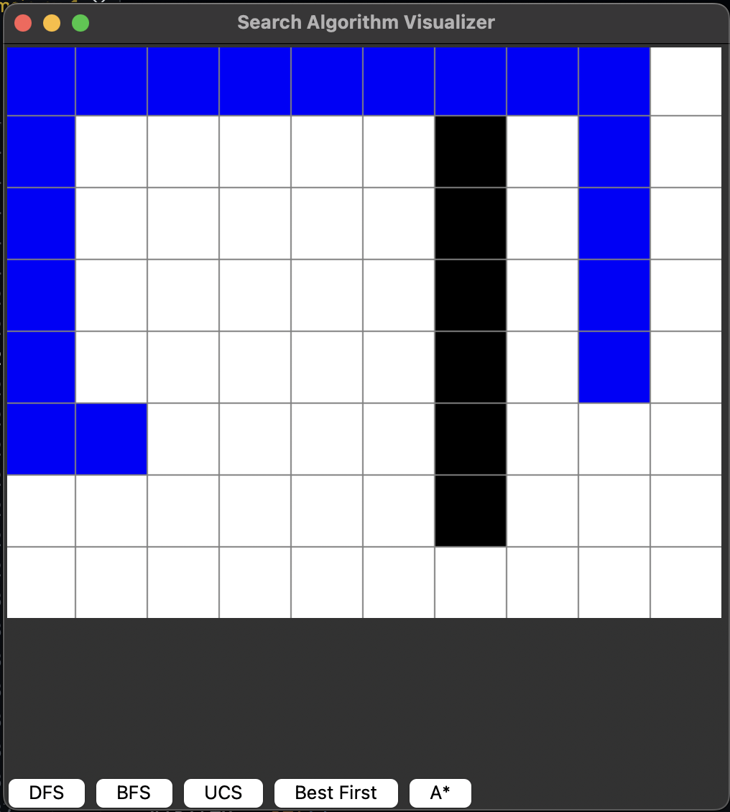

BFS
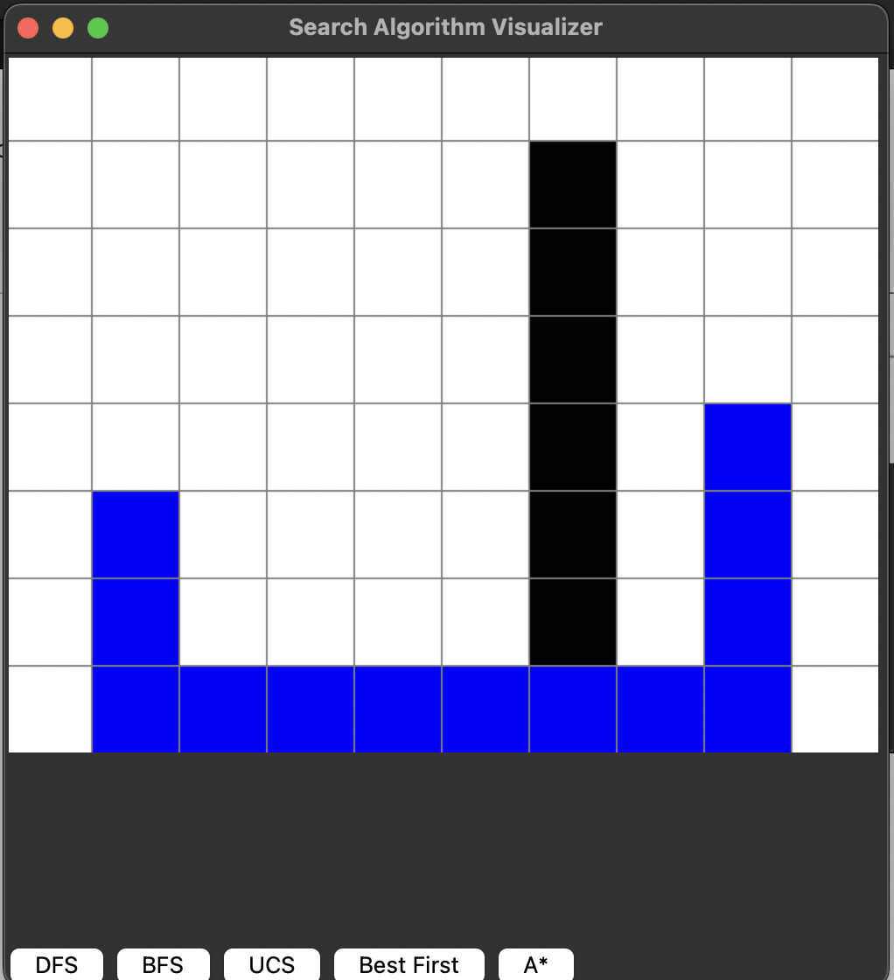

UCS

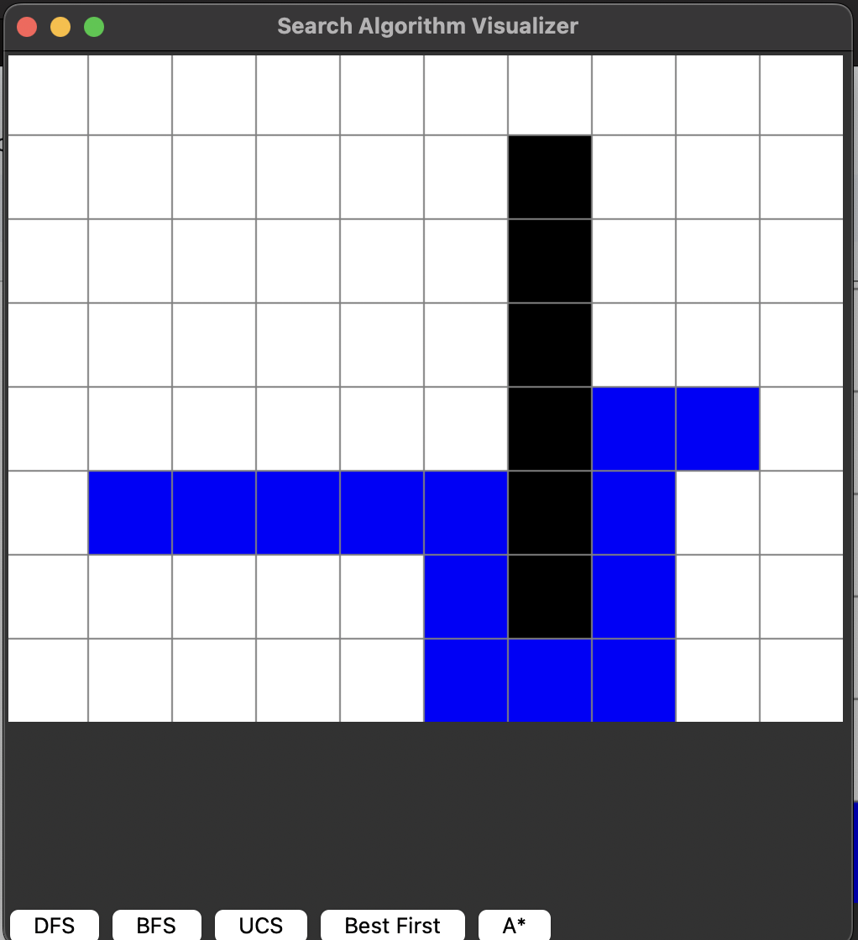

Best First
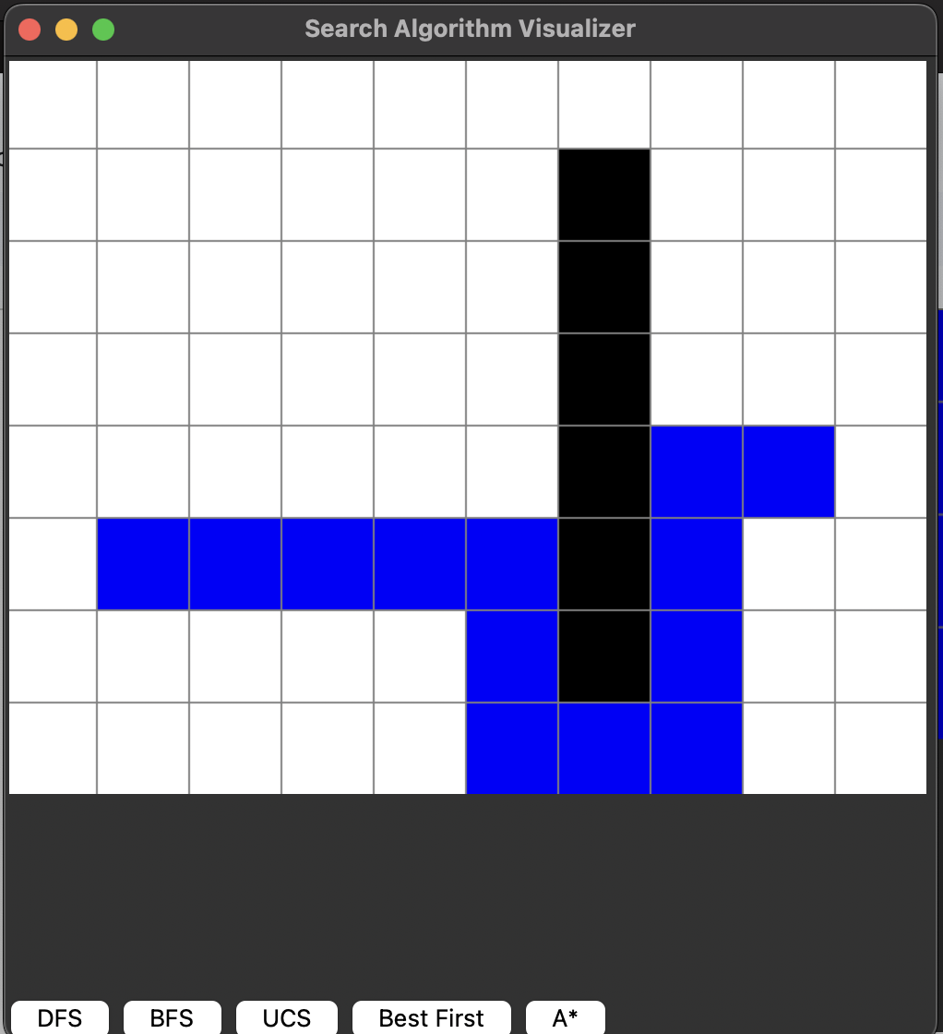

A*
