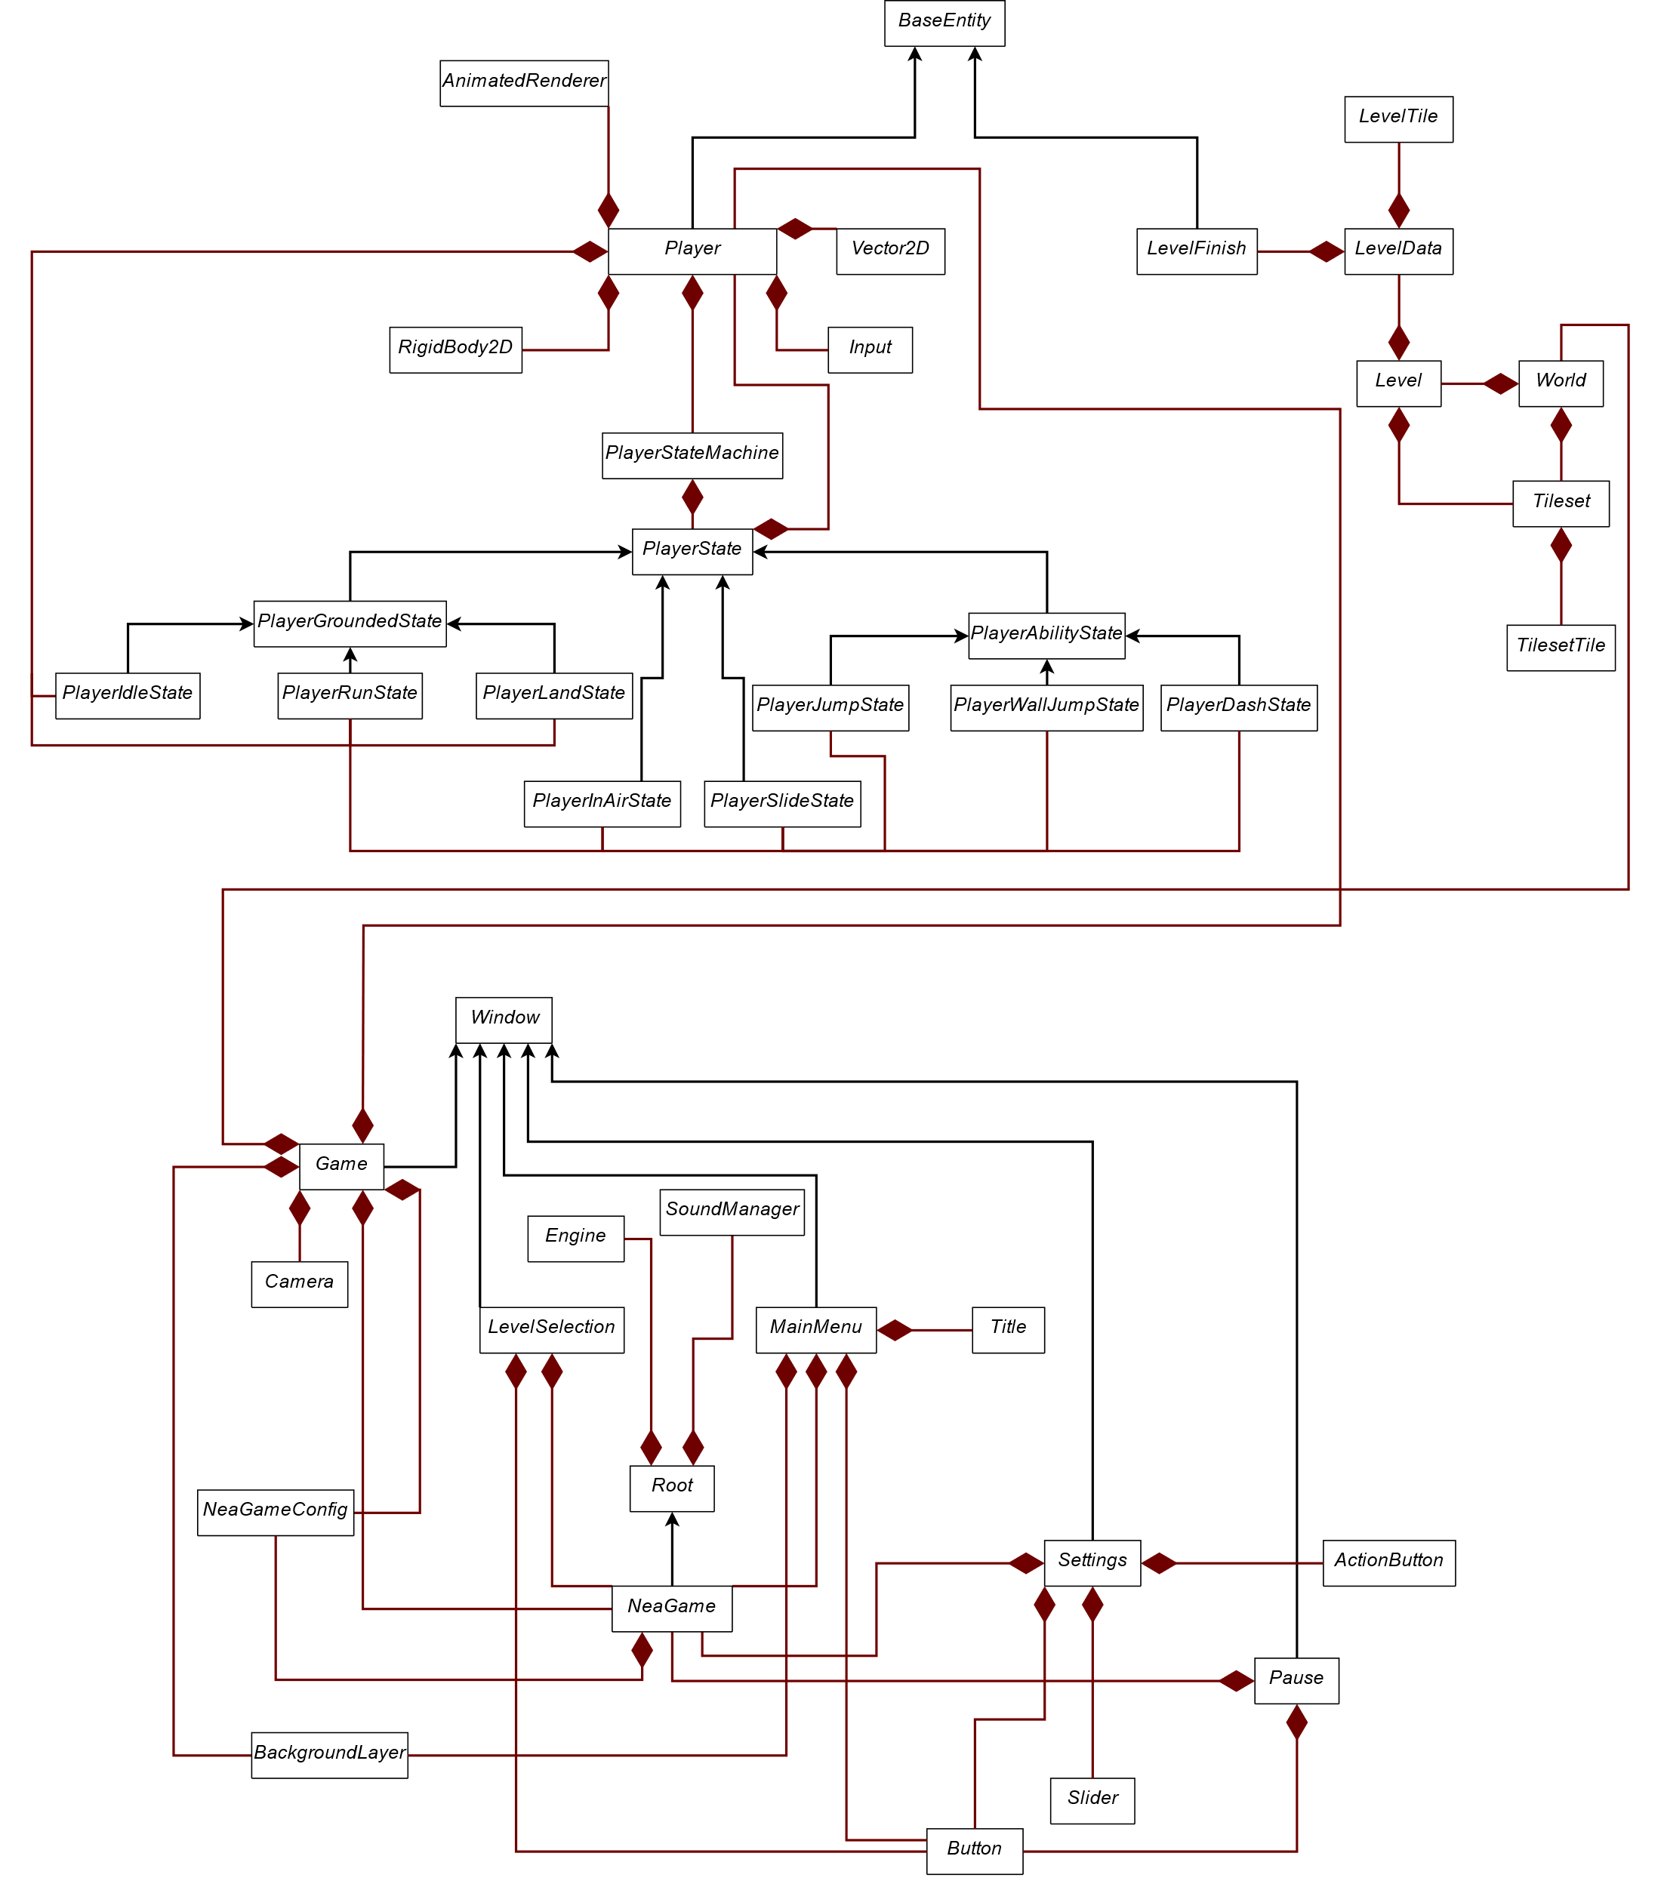Aggregation Diagram

Inheritance Diagram