去掉状态栏中的蓝牙快速设置图标

（1）问题描述：

去掉状态栏中的蓝牙快速设置图标。如下图红色标识图标：

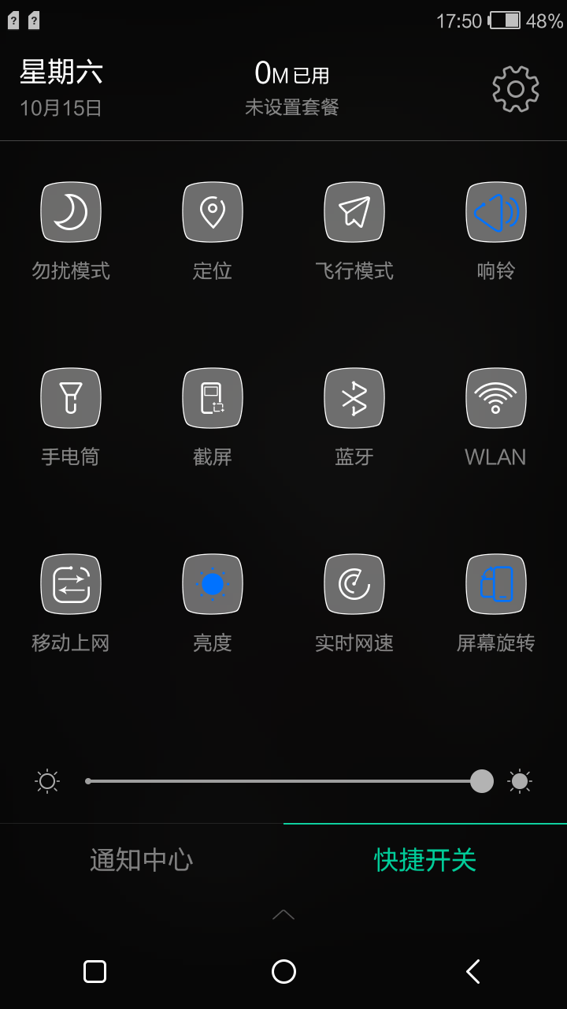

（2）芯片：

MTK6735

（3）系统版本：

Android 5.1, ali 3.2.0 2in1

（4）标签：

Android, mtk6735_ali3.2.0_21in1, SystemUI, Android 5.1, ali 3.2.0 2in1, ali

（5）解决办法：

1. 删除AliSystemUI/res/values/arrays.xml下面文件中的红色标注的代码：

<string-array name="quickSettingSlots" translatable="false">

<item>NoDisturbMode</item>

<item>Location</item>

<item>AirplaneMode</item>

<item>SilentMode</item>

<item>FlashLight</item>

<item>ScreenShot</item>

<item>Bluetooth</item>

<item>Wifi</item>

<item>MobileData</item>

<item>Brightness</item>

<item>Traffic</item>

<item>AutoRotate</item>

<item>LockScreen</item>

<item>ShutDown</item>

<item>Reboot</item>

<item>WifiHotSpot</item>

<item>ScreenRecord</item>

<item>Setting</item>

</string-array>

<!-- item>QRCode</item -->

<array name="quickSettingOffIcons">

<item>@drawable/aui_ic_no_disturb_mode_normal</item>

<item>@drawable/aui_ic_location_normal</item>

<item>@drawable/aui_ic_flightmode_normal</item>

<item>@drawable/aui_ic_mute</item>

<item>@drawable/aui_ic_flashlight_normal</item>

<item>@drawable/aui_ic_screenshot_normal</item>

<item>@drawable/aui_ic_bluetooth_normal</item>

<item>@drawable/aui_ic_wlan_normal</item>

<item>@drawable/aui_ic_mobiledata_normal</item>

<item>@drawable/aui_ic_brightness_2_activated</item>

<item>@drawable/aui_ic_networkspeed_normal</item>

<item>@drawable/aui_ic_system_backup_normal</item>

<item>@drawable/aui_ic_lockscreen_normal</item>

<item>@drawable/aui_ic_shutdown_normal</item>

<item>@drawable/aui_ic_restart_normal</item>

<item>@drawable/aui_ic_wlanhotspot_normal</item>

<item>@drawable/aui_ic_screenrecording_normal</item>

<item>@null</item>

</array>

<!-- item>@drawable/aui_ic_qrcode</item -->

<array name="quickSettingOnIcons">

<item>@drawable/aui_ic_no_disturb_mode_activated</item>

<item>@drawable/aui_ic_location_activated</item>

<item>@drawable/aui_ic_flightmode_activated</item>

<item>@drawable/aui_ic_vibrate</item>

<item>@drawable/aui_ic_flashlight_activated</item>

<item>@drawable/aui_ic_screenshot_activated</item>

<item>@drawable/aui_ic_bluetooth_activated</item>

<item>@drawable/aui_ic_wlan_activated</item>

<item>@drawable/aui_ic_mobiledata_activated</item>

<item>@drawable/aui_ic_brightness_3_activated</item>

<item>@drawable/aui_ic_networkspeed_activated</item>

<item>@drawable/aui_ic_system_backup_activated</item>

<item>@drawable/aui_ic_lockscreen_activated</item>

<item>@drawable/aui_ic_shutdown_activated</item>

<item>@drawable/aui_ic_restart_activated</item>

<item>@drawable/aui_ic_wlanhotspot_activated</item>

<item>@drawable/aui_ic_screenrecording_activated</item>

<item>@drawable/aui_ic_sort_activated</item>

</array>

<!-- item>@drawable/aui_ic_qrcode_activated</item -->

<array name="quickSettingThirdIcons">

<item>@null</item>

<item>@null</item>

<item>@drawable/aui_ic_flightmode_disabled</item>

<item>@drawable/aui_ic_sound</item>

<item>@null</item>

<item>@null</item>

<item>@drawable/aui_ic_bluetooth_disabled</item>

<item>@drawable/aui_ic_wlan_disabled</item>

<item>@null</item>

<item>@drawable/aui_ic_brightness_4_activated</item>

<item>@null</item>

<item>@null</item>

<item>@null</item>

<item>@null</item>

<item>@null</item>

<item>@drawable/aui_ic_wlanhotspot_disabled</item>

<item>@null</item>

<item>@null</item>

</array>

<!-- item>@null</item -->

<array name="quickSettingFourthIcons">

<item>@null</item>

<item>@null</item>

<item>@null</item>

<item>@null</item>

<item>@null</item>

<item>@null</item>

<item>@null</item>

<item>@null</item>

<item>@null</item>

<item>@drawable/aui_ic_brightness_1_activated</item>

<item>@null</item>

<item>@null</item>

<item>@null</item>

<item>@null</item>

<item>@null</item>

<item>@null</item>

<item>@null</item>

</array>

<!-- <item>@null</item> -->

<array name="quickSettingOffIcons2">

<item>@drawable/aui_ic_setting_no_disturb_mode_normal</item>

<item>@drawable/aui_ic_setting_location_normal</item>

<item>@drawable/aui_ic_setting_flightmode_normal</item>

<item>@drawable/aui_ic_vibrate</item>

<item>@drawable/aui_ic_setting_flashlight_normal</item>

<item>@drawable/aui_ic_setting_screenshot_normal</item>

<item>@drawable/aui_ic_setting_bluetooth_normal</item>

<item>@drawable/aui_ic_setting_wlan_normal</item>

<item>@drawable/aui_ic_setting_mobiledata_normal</item>

<item>@drawable/aui_ic_brightness_3_activated</item>

<item>@drawable/aui_ic_setting_networkspeed_activated</item>

<item>@drawable/aui_ic_setting_system_backup_normal</item>

<item>@drawable/aui_ic_setting_lockscreen_normal</item>

<item>@drawable/aui_ic_setting_shutdown_normal</item>

<item>@drawable/aui_ic_setting_restart_normal</item>

<item>@drawable/aui_ic_setting_wlanhotspot_normal</item>

<item>@drawable/aui_ic_setting_screenrecording_activated</item>

<item>@drawable/aui_ic_sort_activated</item>

</array>

2. 删除上述代码时，一定要注意删除的位置必须一致，如果不一致，会导致显示混乱或者报错。