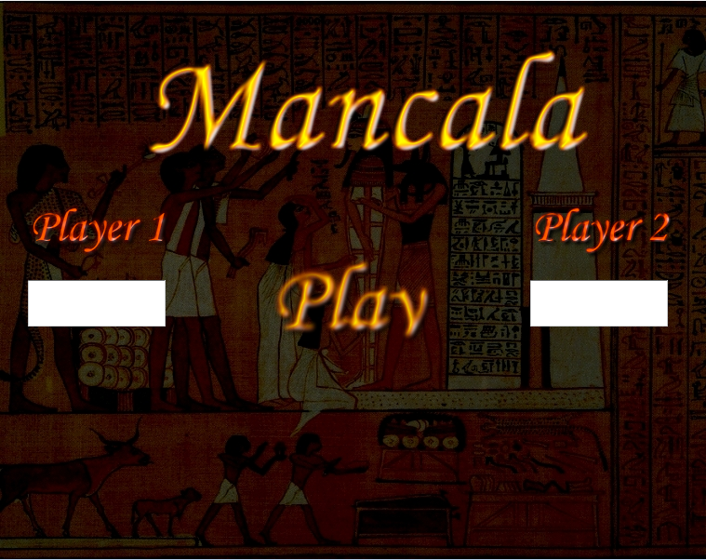

Sergei Laada

Alari Lukk

Priit Rand

Mirjam Rauba

Kersti Üts

***Systems modeling 2010***

Project Report: Mancala game

# Summary

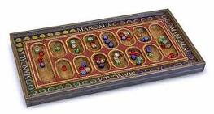This is a report of the course project completed for Systems Modeling at Tartu University in 2010.

The goal was to develop a multiplayer version of the game Mancala.

It describes the role of the project participants, the execution and main design decisions made within the project and all its final deliverables.

# Contents

Summary 1

Contents 2

List of participants 3

Project overview 4

Project plan 4

Discovery & Scoping phase 4

Development phase 4

Testing & Validation 4

Repository guide 5

Design decision guide 6

# List of participants

|  |  |  |
| --- | --- | --- |
| Name | Strengths | Project Tasks |
| Sergei Laada | Programming | Coding |
| Alari Lukk | Programming, system modeling | Object and class diagrams, team management & coordination |
| Priit Rand | Analysing | Object diagrams |
| Mirjam Rauba | Testing, communication | User stories,  team management & coordination |
| Kersti Üts | Documentation | Documentation review & updates |

# Project overview

## Project plan

### Discovery & Scoping phase

The preparation for the project started on September 9th 2010 with the initial meeting of all the project participants. The goal of the meeting was for each group member to become familiar with each other and the project requirements as well as learn the rules for the game itself.

The results:

* Strengths and weaknesses of each group member were identified
* Roles and tasks assigned according to member profiles
* First 6 user stories for the Mancala game project documented

### Development phase

Over a period of the next 9 weeks (16.09 – 18.11.2010) a weekly meeting was held on Thursdays at Tartu University’s Faculty of Mathematics and Computer Sciences for the project participants to discuss the project’s design and development questions and give an update on the progress of the individual tasks.

Because of the previous strong programming experience of one the project team members (Sergei), it was decided that the game will be written in ActionScript language targeting Adobe Flash Player platform.

Main milestones in Development phase:

* September 12th: shared Google Docs document created for capturing the user stories (mainly by Mirjam)
* October 30th: project repository created on github.com by Sergei
* November 5th: initial class diagram presented by Alari
* November 13th - 18th: the project’s main executable and documentation files uploaded to repository and continuously updated by Sergei

### Testing & Validation

A final meeting was held on November 25th to assess the project’s progress and open issues before the submission deadline on November 30th.

# Repository guide

The executable and documentation files were collected in a repository on github.com.

The main structure of the repository:

|  |  |  |
| --- | --- | --- |
| Repository |  | Description |
| Mancala |  | Main project folder |
|  | Mancala.exe | The application file for the game (Adobe Flash Player) |
|  | Initializer.fla  Initializer.swf | The initialization class (.fla) and its release format file (.swf) |
|  | /src | Contains all classes (graphic, event, working) |
|  | /src/Events | Contains all event classes |
|  | /src/Graphics | Contains all graphic classes |
|  | /resources | Contains graphic files and links |
|  | User_stories | Contains the user stories for the game |
|  | About_code_design.doc | Code documentation guide |
|  | About_the_project.doc | User manual guide |
|  | About_the_game.doc | Background information on Mancala |

# Design decision guide

The initial step in the development of the project was familiarizing with the requirements and documenting the user stories.

Based on the user stories, object diagrams were created and a class diagram for the Mancala game completed.

Because of previous programming experience of one the project team members (Sergei), it was decided that the game will be written in ActionScript language.

A more detailed guide for code and model documentation and design pattern usage can be found in a separate project document: About_code_design.doc.