About the project

User interface
Project consists of Class files situated in src folder and Initializer.fla file where graphics is situated. To test the game there is a need to execute Initializer.swf or Mancala.exe file. After that the following window will appear:

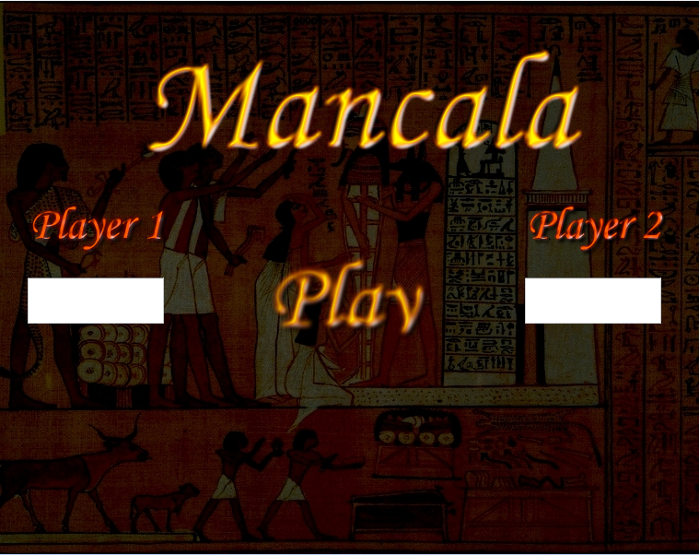

User can enter his name and opponent name. If it is not done default names will be used. Default names are: Player 1 and Player 2. User can press Play button. After that main game screen will be shown:

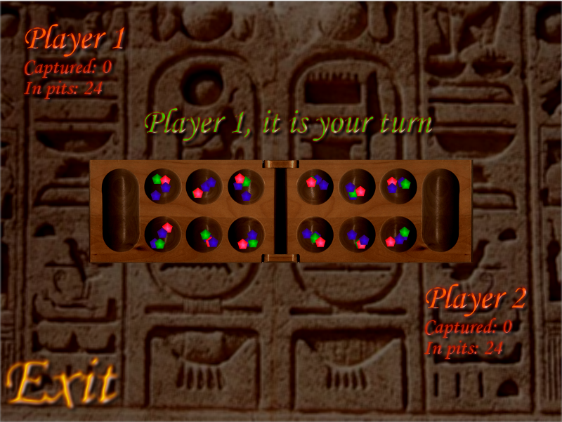

On this screen user can see a lot of information. “Player 1” is a name of the first player, “Player 2” is a name of the second player. Each player have information about captured gems and about the gems that are in pits. On the game start there is no captured gems, each pit have four: two blue, one red and one green gems. Mancalas are empty. Information label shows whose turn it is. Now it shows “Player 1, it is your turn”. User can press Exit button on the left bottom corner of the window to exit the game. Then user will see startup screen again. User can enter new player names or just press Play, then user will see names that were entered previously. For example user enters name “UserName” and opponent name “Opponent” then when user press Exit (player names will be empty) and Play again, he will see player names: “UserName” and “Opponent”.

Game flow
Users are making their turns after each other. First is player one turn. User can choose one of his pits. Opponent pits are disabled. First player pits are in first row and second player pits are in second row. User can see pit information when mouse is over the pit, even if pit is disabled. Pit information consists of gem number in pit. Each player have mancala pit. First player mancala is on the left of the board, second player mancala is on the right.
When player selects a pit, all pits become disabled and it is not possible to choose another one as long as animation is in progress. After that selection all gems in selected pit are removed, then according to the number of removed gems pits on the right are updated. Updated means that one gem from selected pit is added to the next pit. This action is performed as long as there is at least a single gem. For example there are four gems in a selected pit, then a single gem is added to the four following pits, selected pit become empty.

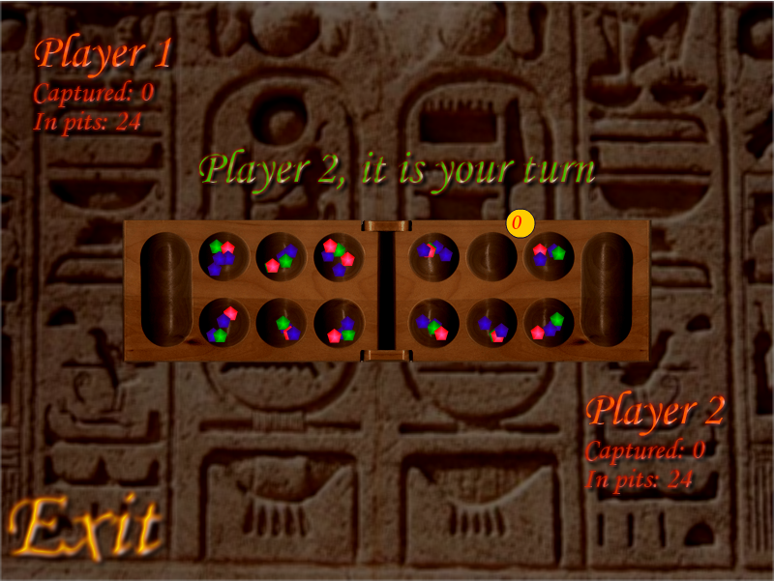

If pit that have to be updated is players mancala then gem is added there too, after that next pit is updated. If pit that have to be updated is opponent mancala then this mancala isn`t updated, but missed, and next pit is updated.
Each time when all pits are updated after the turn both player gem information labels are updated. This means that are updated captured gems and gems in pits information. Captured shows how many gems are in each player mancala, gems in pits shows how many gems are in each player pits.
If last gem fall into the active player mancala, then this player gets additional turn and can select his pit once more.
If last gem fall into the pit where was no gems, that means falled gem is the only gem in a pit, then this gem is collected to active player mancala, also all gems from parallel pit are also collected to active player mancala.

Ending the game
If there is no gems in first player or second player pits then game is finished and table with game result is shown:

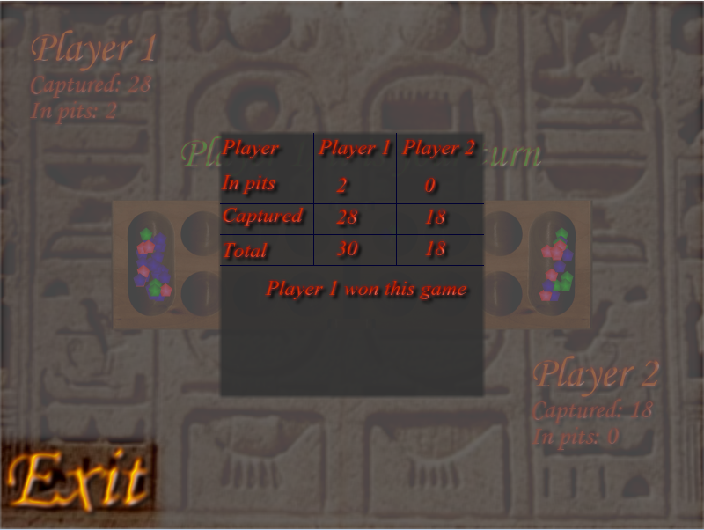

On it there is information about the players (player names), information about collected gems, gems that are left in pits and a total amount of gems each player owns. Also is shown who won the game. User can press Exit to start the game from the start.
References
http://www.lidertour.by/egypt2.htm
http://www.ajax4.net/play/MancalaGame.aspx

