User stories
Pre-precondition:
In Mancala game there is used board with twelve cups and two mancalas. The game is played by two players, each player has six cups and one mancala. How the cups and mancalas are set on the board is shown in the figure below.
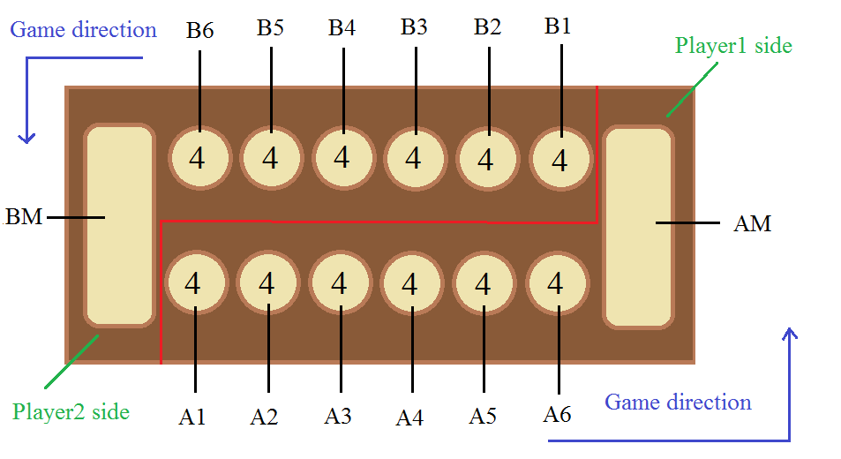
At the beginning of the game there is four stones in each cup. It makes 48 stones in total for the game.
In the figure above there is shown also the direction of the game. It shows in which direction the stones are played.

User Story 1
Title: Mart captures two of Mari's stones opposite his sixth cup
Precondition: Precondition of the user story is shown in the figure below (referred to pre-precondition). It's Mart's turn.
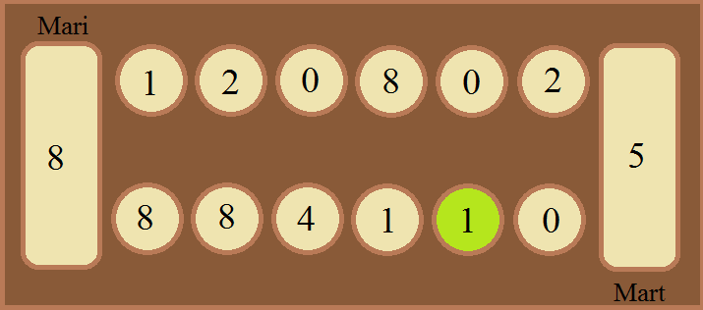
Action: Mart picks up the stone from the fifth cup from left (marked with green in the precondition figure) on his side of the board and places it to the next cup (the sixth cup from the left). Since Mari has 2 stones in the cup opposite Mart's sixth cup, Mart captures 2 stones from Mari's cup and the 1 stone from his own sixth cup.
Postcondition: Postcondition of the user story is shown in the figure below. All the cups changed are colored orange.
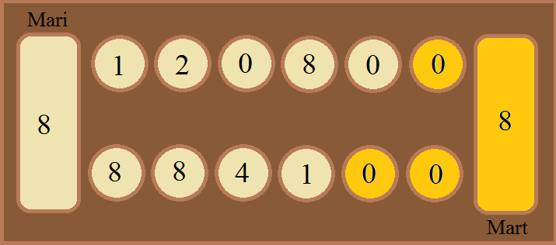

User Story 2
Title: Mart plays seven stones from his fifth cup
Precondition: Precondition of the user story is shown in the figure below (referred to pre-precondition). It's Mart's turn.
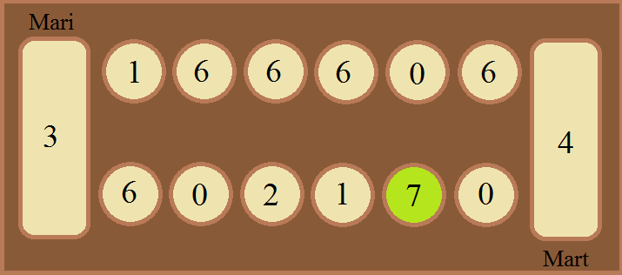
Action: Mart picks up the stones from the fifth cup from left (marked with green in the precondition figure) on his side of the board and places them one by one into the following cups, right from the cup where he took those stones. The second stone he places into his mancala and captures one point. The last (seventh) stone he places into Mari's fifth cup and so Mart doesn't get and extra turn.
Postcondition: Postcondition of the user story is shown in the figure below. All the cups changed are colored orange.
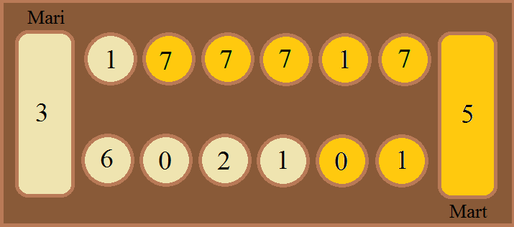

User Story 3
Title: Mart plays one stone from his sixth cup
Precondition: Precondition of the user story is shown in the figure below (referred to pre-precondition). It's Mart's turn.
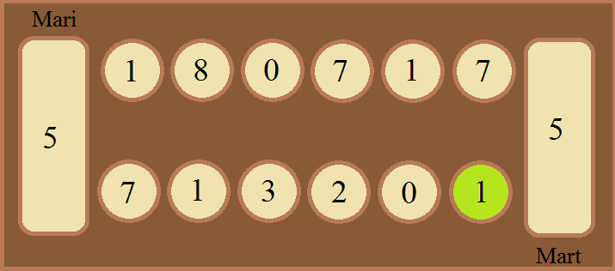
Action: Mart picks up the stone from sixth cup from the left (marked with green in the precondition figure) on his side of the board and places it to his mancala. Doing that he gets a point and an extra turn.
Postcondition: Postcondition of the user story is shown in the figure below. All the cups changed are colored orange.
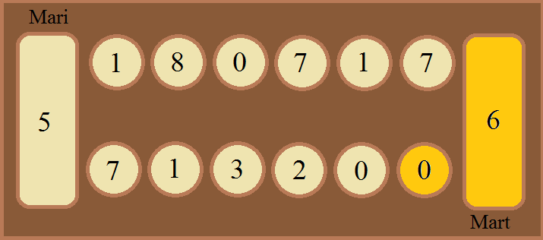

User Story 4
Title: Mart plays three stones from his second cup
Precondition: Precondition of the user story is shown in the figure below (referred to pre-precondition). It's Mart's turn.
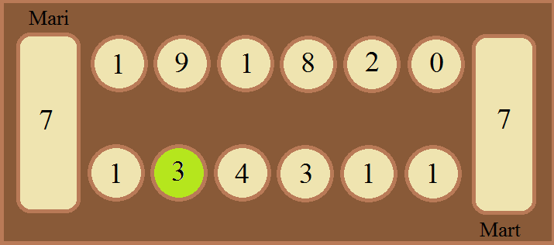
Action: Mart picks up the stones from second cup from the left (marked with green in the precondition figure) on his side of the board and places them one by one into the following cups, right from the cup where he took those stones. He places the last (third) stone into fifth cup from the left on his side of the board and so he doesn't get a point, neither an extra turn.
Postcondition: Postcondition of the user story is shown in the figure below. All the cups changed are colored orange.
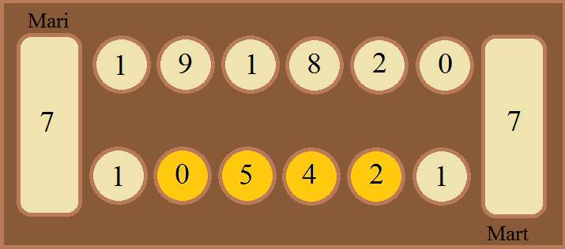

User Story 5
Title: Mart plays one last stone from his sixth cup
Precondition: Precondition of the user story is shown in the figure below (referred to pre-precondition). It's Mart's turn.
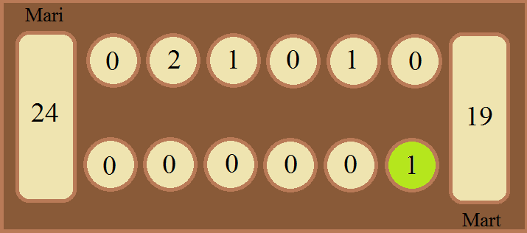
Action: Mart picks up the stone from sixth cup from the left (marked with green in the precondition figure) on his side of the board and places it to his mancala. Doing that he gets a point and finishes the game because he doesn't have any stones left in his side of the board. But he doesn't win the game because he has less stones in his mancala than Mari has in her's.
Postcondition: Postcondition of the user story is shown in the figure below. All the cups changed are colored orange. In total Mari gets 28 points because the stones left in her side of the board are also counted.
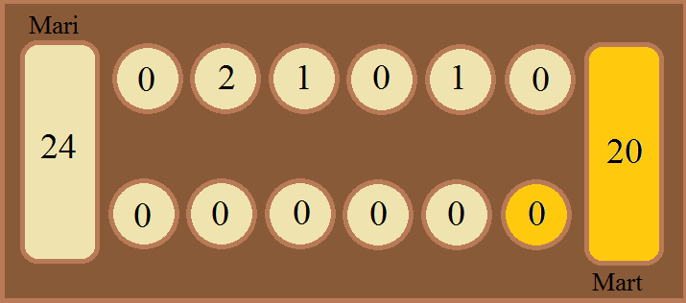

User Story 6
Title: Mart plays one last stone from his sixth cup and wins
Precondition: Precondition of the user story is shown in the figure below (referred to pre-precondition). It's Mart's turn.
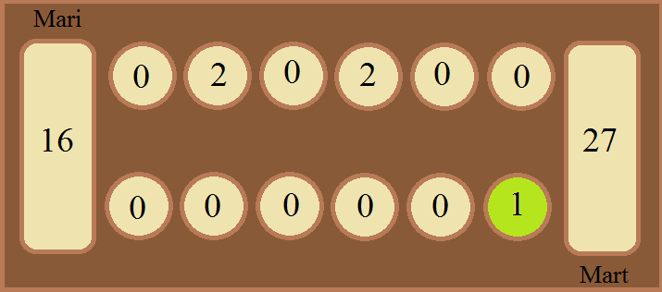
Action: Mart picks up the stone from sixth cup from the left (marked with green in the precondition figure) on his side of the board and places it to his mancala. Doing that he gets a point and finishes the game because he doesn't have any stones left in his side of the board. Also he win's the game because he has more stone's in his mancala than Mari has in her's mancala and her side of the board.
Postcondition: Postcondition of the user story is shown in the figure below. All the cups changed are colored orange. In total Mari gets 20 points because the stones left in her side of the board are also counted.
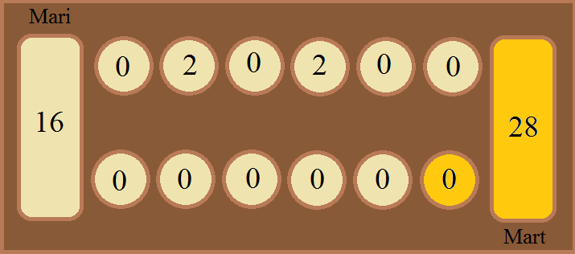

User Story 7
Title: Mart plays eleven stones from his sixth cup
Precondition: Precondition of the user story is shown in the figure below (referred to pre-precondition). It's Mart's turn.
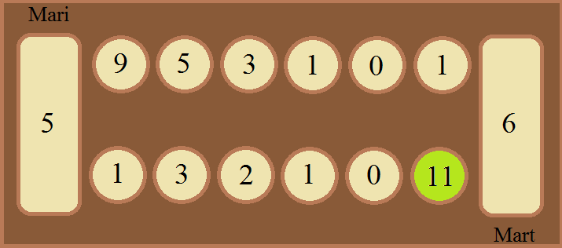
Action: Mart picks up the stones from sixth cup from the left (marked with green in the precondition figure) on his side of the board and places them one by one into the following cups, right from the cup where he took those stones. He puts the first stone in his mancala and gets a point. The seventh stone he puts in sixth cup on Mari's side of the board and the eight stone in first cup on his side of the board. He doesn't put a stone in Mari's mancala. The last stone he puts in the fourth cup from the left in his side of the board so he doesn't get an extra turn.
Postcondition: Postcondition of the user story is shown in the figure below. All the cups changed are colored orange.
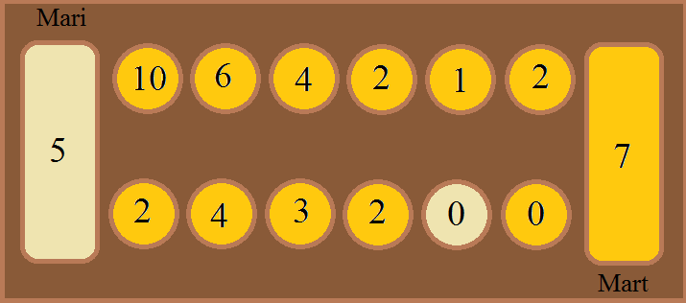

User Story 8
Title: Mart plays fourteen stones from his sixth cup
Precondition: Precondition of the user story is shown in the figure below (referred to pre-precondition).
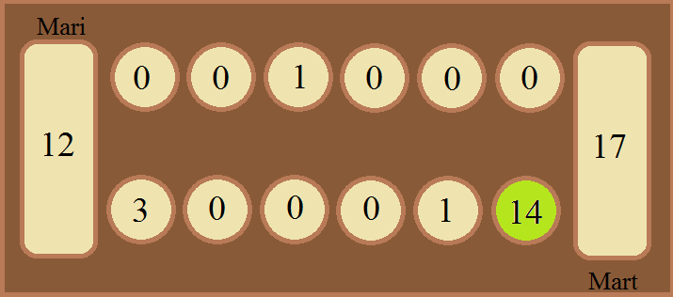
Action: Mart picks up the stones from sixth cup from the left (marked with green in the precondition figure) on his side of the board and places them one by one into the following cups, right from the cup where he took those stones. He puts the first ston in his mancala and gets a point. The seventh stone he puts in sixth cup on Mari's side of the board and the eight stone in first cup on his side of the board. The last (fourteenth) stone he puts also in his mancala and by doing that he gets second point and an extra turn.
Postcondition: Postcondition of the user story is shown in the figure below. All the cups changed are colored orange (dark orange means that the cup is changed twice).
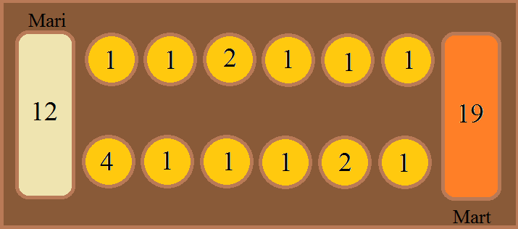

User Story 9
Title: Mart plays one last stone from his sixth cup and ends the game in draw
Precondition: Precondition of the user story is shown in the figure below (referred to pre-precondition). It's Mart's turn.
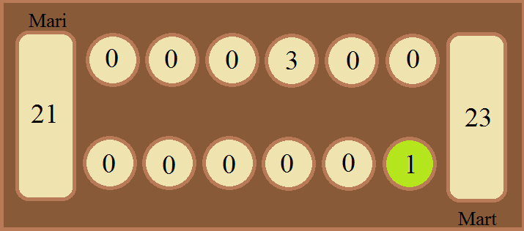
Action: Mart picks up the stone from sixth cup from the left (marked with green in the precondition figure) on his side of the board and places it to his mancala. Doing that he gets a point and finishes the game because he doesn't have any stones left in his side of the board.
Postcondition: Postcondition of the user story is shown in the figure below. All the cups changed are colored orange. In total Mari gets 24 points because the stones left in her side of the board are also counted. The game ends in a draw.
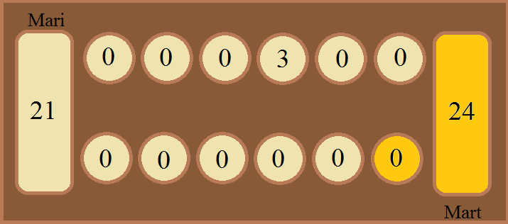

User Story 10
Title: Mart captures two of Mari's stones by playing two stones from his fourth cup
Precondition: Precondition of the user story is shown in the figure below (referred to pre-precondition). It's Mart's turn.
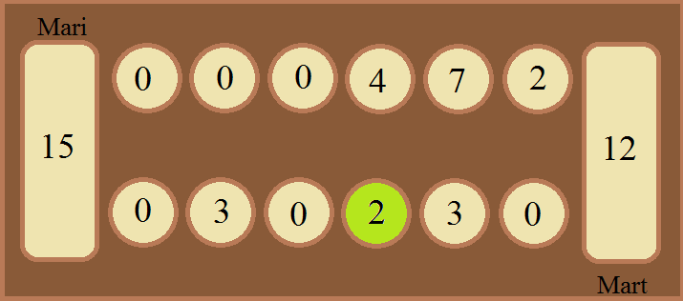
Action: Mart picks up the stones from fourth cup from the left (marked with green in the precondition figure) on his side of the board and places them one by one into the following cups, right from the cup where he took those stones. The last (second) stone he places into sixth cup from the left in his side of the board. Since there is two stones in the opposite cup in Mari's side of the board he captures all three stones.
Postcondition: Postcondition of the user story is shown in the figure below. All the cups changed are colored orange.
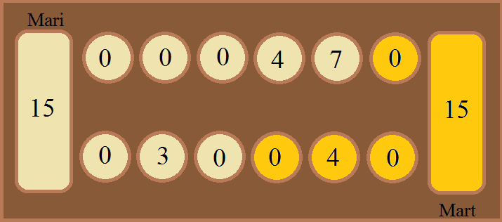

User Story 11
Title: Mart gets a point by playing four stones from his third cup
Precondition: Precondition of the user story is shown in the figure below (referred to pre-precondition). It's Mart's turn.
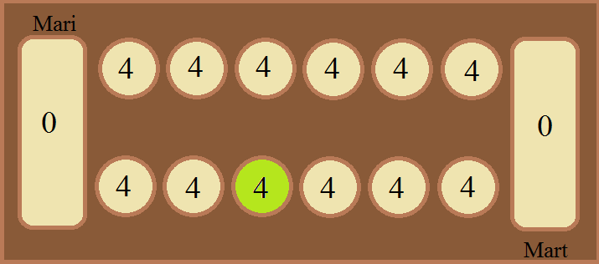
Action: Mart picks up the stones from third cup from the left (marked with green in the precondition figure) on his side of the board and places them one by one into the following cups, right from the cup where he took those stones. The last (fourth) stone he places into his mancala and gets one point. Also he gets an extra turn because the last stone was put into the mancala.
Postcondition: Postcondition of the user story is shown in the figure below. All the cups changed are colored orange.
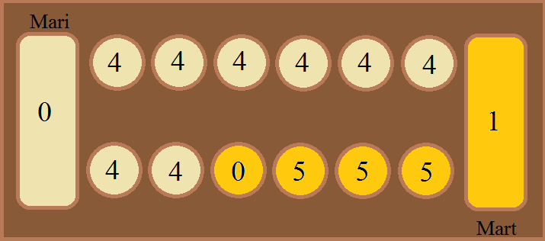

User Story 12
Title: Mart gets one point by playing four stones from his sixth cup
Precondition: Precondition of the user story is shown in the figure below (referred to pre-precondition). It's Mart's turn.
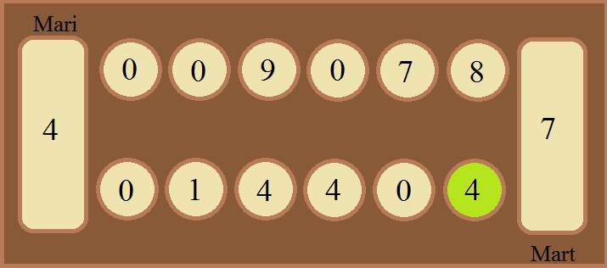
Action: Mart picks up the stones from sixth cup from the left (marked with green in the precondition figure) on his side of the board and places them one by one into the following cups, right from the cup where he took those stones. The first stone he places into his mancala and gets a point. The last (fourth) stone he places into third cup from right on Mari's side of the board. (Even though the last stone was put into empty cup and opposite that cup is four stones, Mari doesn't capture these stones because it was Mart's turn.)
Postcondition: Postcondition of the user story is shown in the figure below. All the cups changed are colored orange.
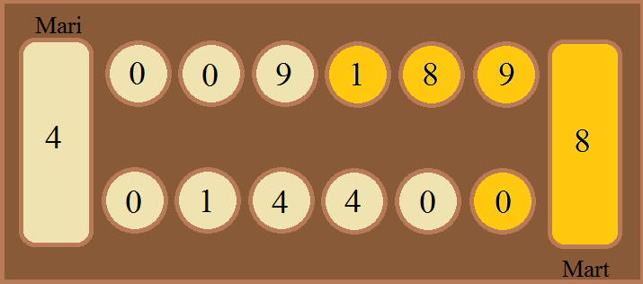

User Story 13
Title: Mart captures six of Mari's stones by playing one stone from his first cup
Precondition: Precondition of the user story is shown in the figure below (referred to pre-precondition). It's Mart's turn.
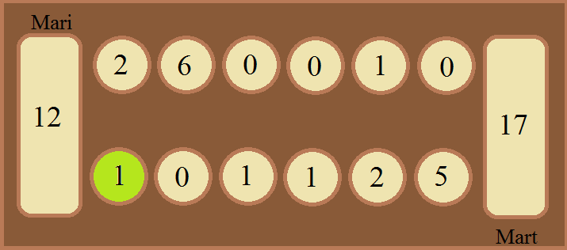
Action: Mart picks up the stone from sixth cup from the left (marked with green in the precondition figure) on his side of the board and places it to the cup right from the cup where he picked it up. Since the cup where he put the stone was empty before the turn and there is six stones in the opposite cup in Mari's side of the board he captures all seven stones.
Postcondition: Postcondition of the user story is shown in the figure below. All the cups changed are colored orange.
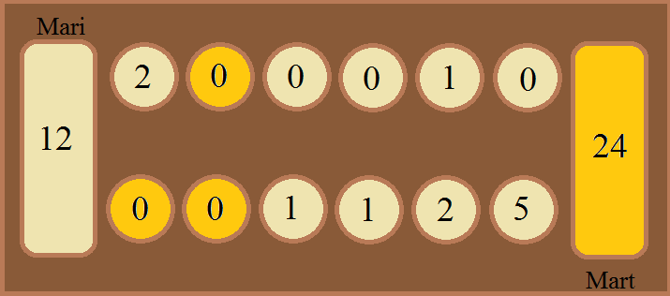

User Story 14
Title: Mart plays four stones from his fifth cup
Precondition: Precondition of the user story is shown in the figure below (referred to pre-precondition). It's Mart's turn.
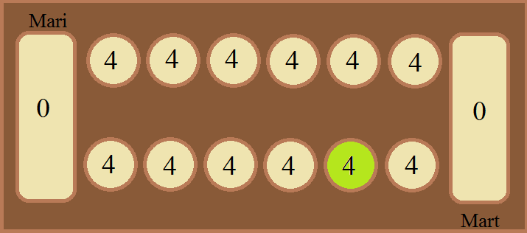
Action: Mart picks up the stones from fifth cup from the left (marked with green in the precondition figure) on his side of the board and places them one by one into the following cups, right from the cup where he took those stones. The second stone he places into his mancala and gets one point. The last (fourth) stone he places into second cup from right on Mari's side of the board so he doesn't get an extra turn.
Postcondition: Postcondition of the user story is shown in the figure below. All the cups changed are colored orange.
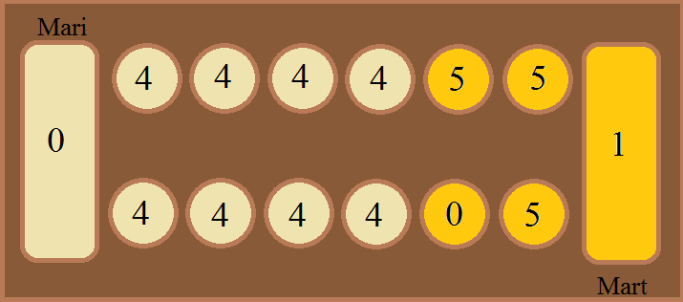

User Story 15
Title: Mart plays four stones from his second cup
Precondition: Precondition of the user story is shown in the figure below (referred to pre-precondition). It's Mart's turn.
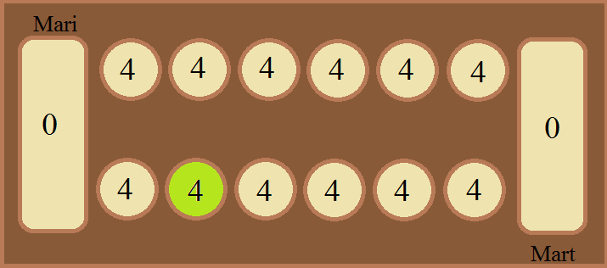
Action: Mart picks up the stones from second cup from the left (marked with green in the precondition figure) on his side of the board and places them one by one into the following cups, right from the cup where he took those stones. The last (fourth) stone he places into sixth cup from left on his side of the board so he doesn't get any points.
Postcondition: Postcondition of the user story is shown in the figure below. All the cups changed are colored orange.
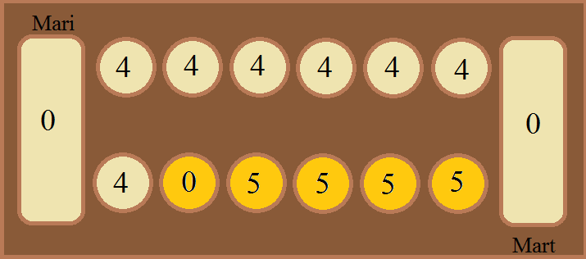

User Story 16
Title: Mart plays one last stone from his sixth cup
Precondition: Precondition of the user story is shown in the figure below (referred to pre-precondition). It's Mart's turn.
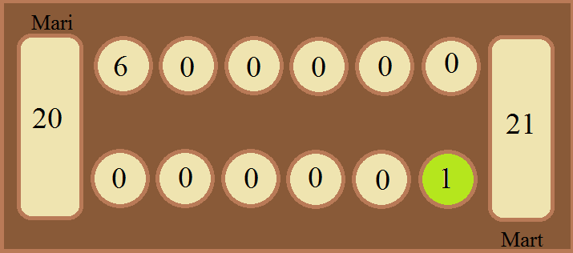
Action: Mart picks up the stone from sixth cup from the left (marked with green in the precondition figure) on his side of the board and places it to his mancala. Doing that he gets a point and finishes the game because he doesn't have any stones left in his side of the board.
Postcondition: Postcondition of the user story is shown in the figure below. All the cups changed are colored orange. Mari wins the game because she has 26 stones in her mancala and her side of the board in total, Mart only has 22 stones in his mancala.
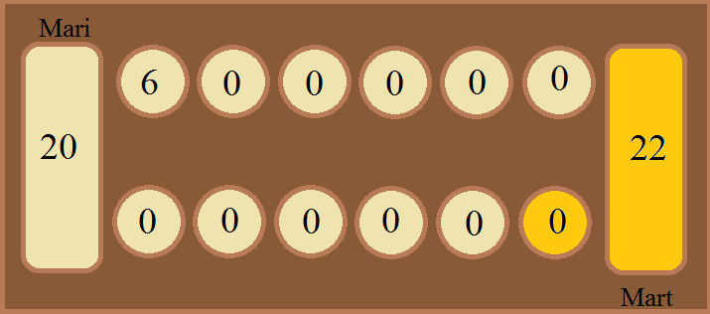

User Story 17
Title: Mart plays lsix stones from his sixth cup and ends the game
Precondition: Precondition of the user story is shown in the figure below (referred to pre-precondition). It's Mart's turn.
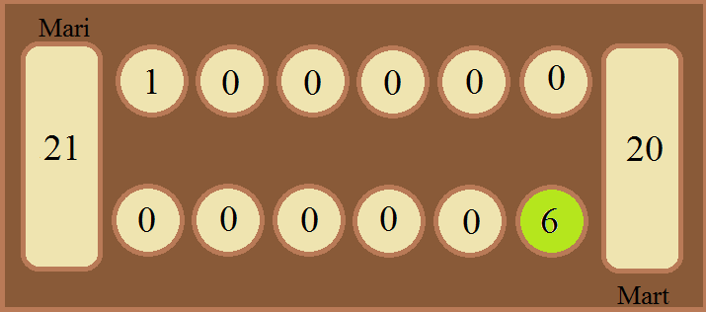
Action: Mart picks up the stones from sixth cup from the left (marked with green in the precondition figure) on his side of the board and places them one by one into the following cups, right from the cup where he took those stones. The first stone he puts into his mancala and captures one point. Other five stones he places into the cups in Mari's side of the board. Doing that he finishes the game because he doesn't have any stones left in his side of the board.
Postcondition: Postcondition of the user story is shown in the figure below. All the cups changed are colored orange. Mari wins the game because she has 27 stones in her mancala and her side of the board in total, Mart only has 21 stones in his mancala.
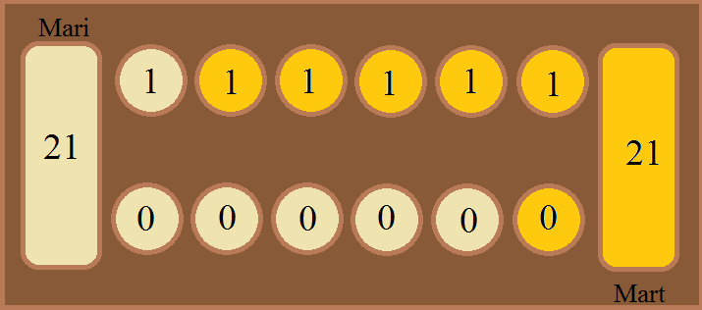

User Story 18
Title: Mart plays four stones from his sixth cup
Precondition: Precondition of the user story is shown in the figure below (referred to pre-precondition). It's Mart's turn.
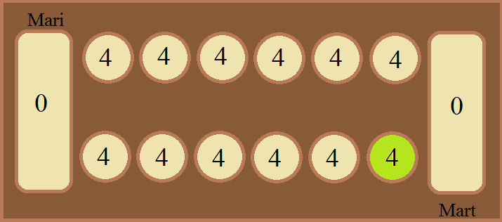
Action: Mart picks up the stones from sixth cup from the left (marked with green in the precondition figure) on his side of the board and places them one by one into the following cups, right from the cup where he took those stones. The first stone he puts into his mancala and captures one point. The last stone goes to third cup from right on Mari's side of the board. Doing that he doesn't get an extra turn.
Postcondition: Postcondition of the user story is shown in the figure below. All the cups changed are colored orange.
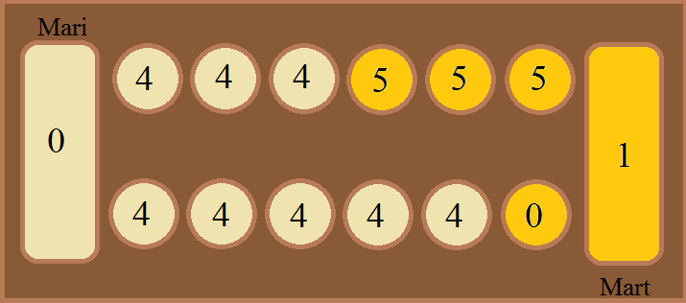

User Story 19
Title: Mart plays on stone from his second cup
Precondition: Precondition of the user story is shown in the figure below (referred to pre-precondition). It's Mart's turn.
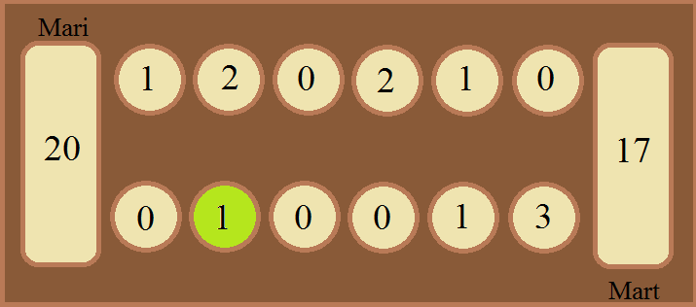
Action: Mart picks up the stone from second cup from the left (marked with green in the precondition figure) on his side of the board and places it to the cup right from the cup where he picked it up. Since the cup where he put the stone was empty before the turn although the opposite cup is empty he captures the stone which was but into the empty cup.
Postcondition: Postcondition of the user story is shown in the figure below. All the cups changed are colored orange.
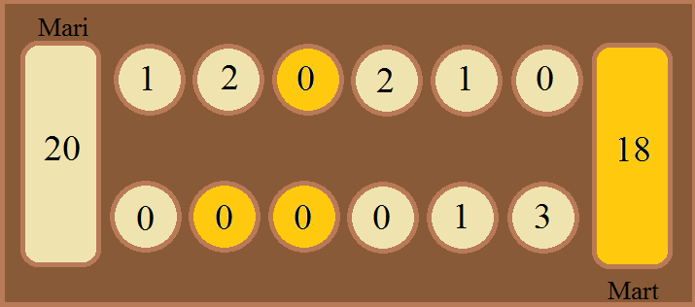

User Story 20
Title: Mart plays three stones from his second cup
Precondition: Precondition of the user story is shown in the figure below (referred to pre-precondition). It's Mart's turn.
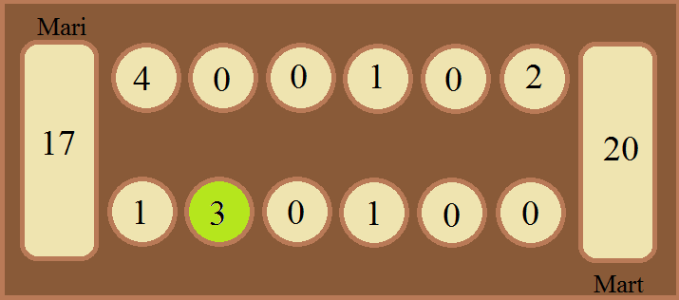
Action: Mart picks up the stones from second cup from the left (marked with green in the precondition figure) on his side of the board and places them one by one into the following cups right from the cup where he picked them up. Since the cup where he put the last stone was empty before the turn although the opposite cup is empty he captures the stone which was but into the empty cup.
Postcondition: Postcondition of the user story is shown in the figure below. All the cups changed are colored orange.
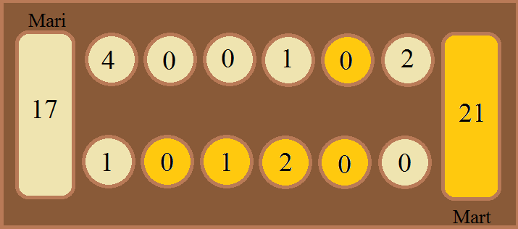

User Story 21
Title: Mart tries to pick up stones from Mari's cup
Precondition: Precondition of the user story is shown in the figure below (referred to pre-precondition). It's Mart's turn.
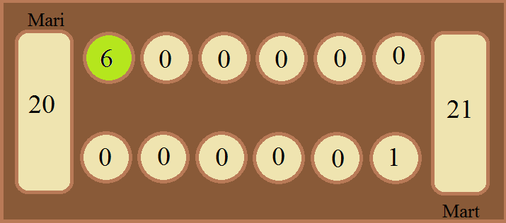
Action: Mart click's on sixth cup (marked with green in the precondition figure) from right on Mari's side of the board. Nothing happens.
Postcondition: It's still Mart's turn. No states of the cups and mancalas are changed.

User Story 22
Title: Mart tries to pick up stones from Mari's Mancala
Precondition: Precondition of the user story is shown in the figure below (referred to pre-precondition). It's Mart's turn.
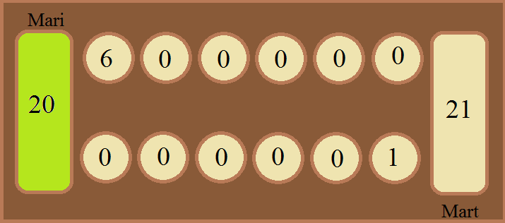
Action: Mart clicks on Mari's mancala (marked with green in the precondition figure). Nothing happens.
Postcondition: It's still Mart's turn. No states of the cups and mancalas are changed.

User Story 23
Title: Mart tries to pick up stones from empty cup
Precondition: Precondition of the user story is shown in the figure below (referred to pre-precondition). It's Mart's turn.
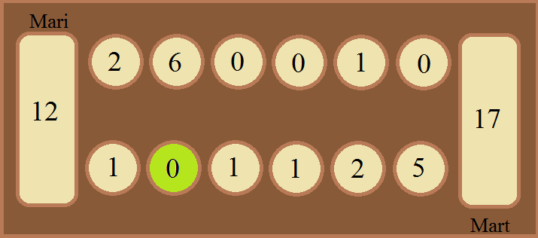
Action: Mart click's on second cup (marked with green in the precondition figure) from left on his side of the board. Nothing happens.
Postcondition: It's still Mart's turn. No states of the cups and mancalas are changed.

User Story 24
Title: Mart and Mari start the game with given names
Precondition: The Mancala game has been opened and the starting screen is viewed. In the starting view there is two text fields for Player 1 and Player 2 names and a button "Play". Mart and Mari have been decided that Mart is typing in the names and Mart gets to be Player 1.
Action: Mart types in the Player 1 field "Mart" and into the Player 2 field "Mari" and clicks "Play" button.
Postcondition: Game view of Mancala game is shown. "Mart" is shown in player 1 name space and "Mari" is shown on player 2 name space. And the game board is set up as in pre-precondition.

User Story 25
Title: Starting the game with one given name and one default name
Precondition: The Mancala game has been opened and the starting screen is viewed. In the starting view there is two text fields for Player 1 and Player 2 names and a button "Play". Mart and Mari have been decided that Mart is typing in the names and Mart gets to be Player 1.
Action: Mart types in the Player 1 field "Mart" and into the Player 2 field he doesn't type anything and clicks "Play" button.
Postcondition: Game view of Mancala game is shown. "Mart" is shown in player 1 name space and "Player 2" is shown on player 2 name space. And the game board is set up as in pre-precondition.

User Story 26
Title: Starting game with default names
Precondition: The Mancala game has been opened and the starting screen is viewed. In the starting view there is two text fields for Player 1 and Player 2 names and a button "Play". Mart and Mari have been decided that Mart starts the game.
Action: Mart doesn't type in any names and clicks "Play" button.
Postcondition: Game view of Mancala game is shown. "Player 1" is shown in player 1 name space and "Player 2" is shown on player 2 name space. And the game board is set up as in pre-precondition.

User Story 27
Title: Starting new game after finising a game
Precondition: Mart and Mari has finished the game and the summary of the game is shown to them. In the screen there is also an "Exit" button. Mart and Mari have been decided that Mart starts the new game. In the game they used their own names that were shown in the name spaces.
Action: Mart clicks "Exit" button and his is directed to the starting screen where he clicks "Start" button.
Postcondition: Game view of Mancala game is shown. "Mart" is shown in player 1 name space and "Mari" is shown on player 2 name space. And the game board is set up as in pre-precondition.

User Story 28
Title: Exiting the game after finishing
Precondition: Mart and Mari has finished the game and the summary of the game is shown to them. In the screen there is also an "Exit" button.
Action: Mart clicks the "Exit" button.
Postcondition: The starting screen of Mancala game is viewed.

User Story 29
Title: Exiting the game while game is not finished
Precondition: Mart and Mari are in the middle of the game but they decided to finish it. There is and "Exit" button on the screen.
Action: Mart clicks the "Exit" button.
Postcondition: The starting screen of Mancala game is viewed.

User Story 30
Title: Closing the game
Precondition: Mart and Mari are tired of playing and they want to quit the game.
Action: Mart clicks the button in the top right corner of the game window.
Postcondition: The Mancala game window is closed.

