**1. OpenServer**

1.1 Download Open Server Panel Basic: <https://ospanel.io/>

1.2 Run downloaded file.

1.3 Install OpenServer to D:\ (or C:\ or E:\ -- not in a subfolder).

1.4 Go to D:\OpenServer\domains and create folder for your project (for example D:\OpenServer\domains\Project)

1.5 Open D:\OpenServer and run file Open Server.exe as administrator.

1.6 Click on the tray icon and select Settings

1.7 Open tab Modules and select:

HTTP – Apache PHP 7

PHP – PHP 7

Click Save.

**2. Composer**

2.1 Run OpenServer as administrator

2.2 Click on the tray icon and click Run.

2.3 Click on the tray icon -> Дополнительно –> Консоль

2.4 Go to <https://getcomposer.org/> and click Download.

You see this page and need 4 lines in Command-line-installation

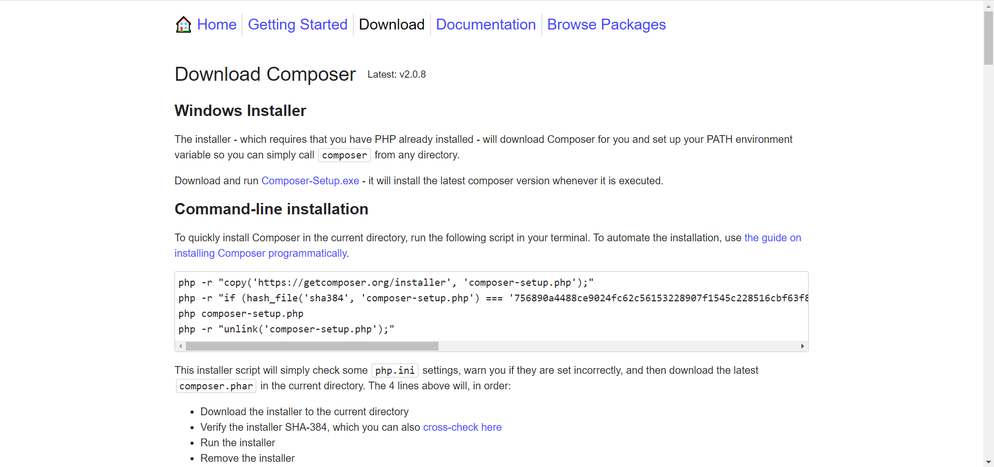

2.5 Go to your project’s folder in console:

cd d:\OpenServer\domains\Project

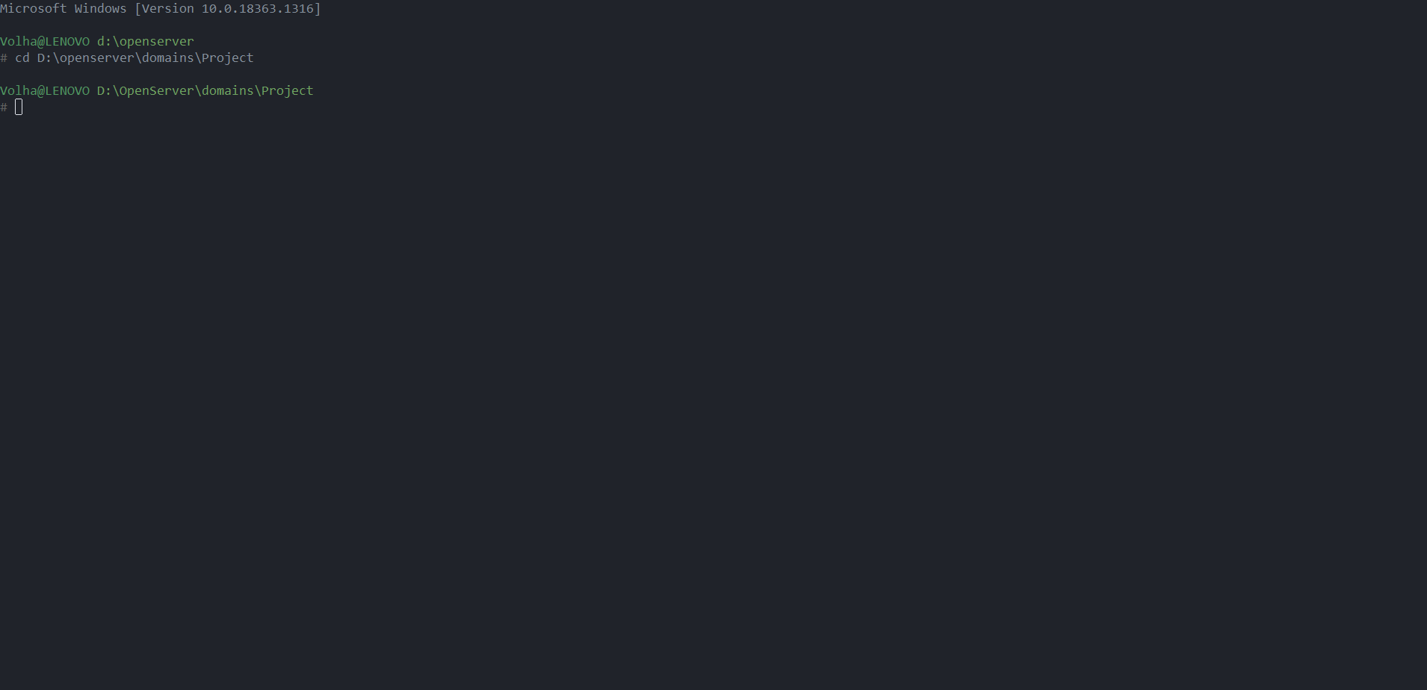

2.6 Copy the first line -> Enter.

2.6 Copy the second line -> Enter.

2.7 Copy the third line -> Enter.

2.8 Copy the fourth line -> Enter.

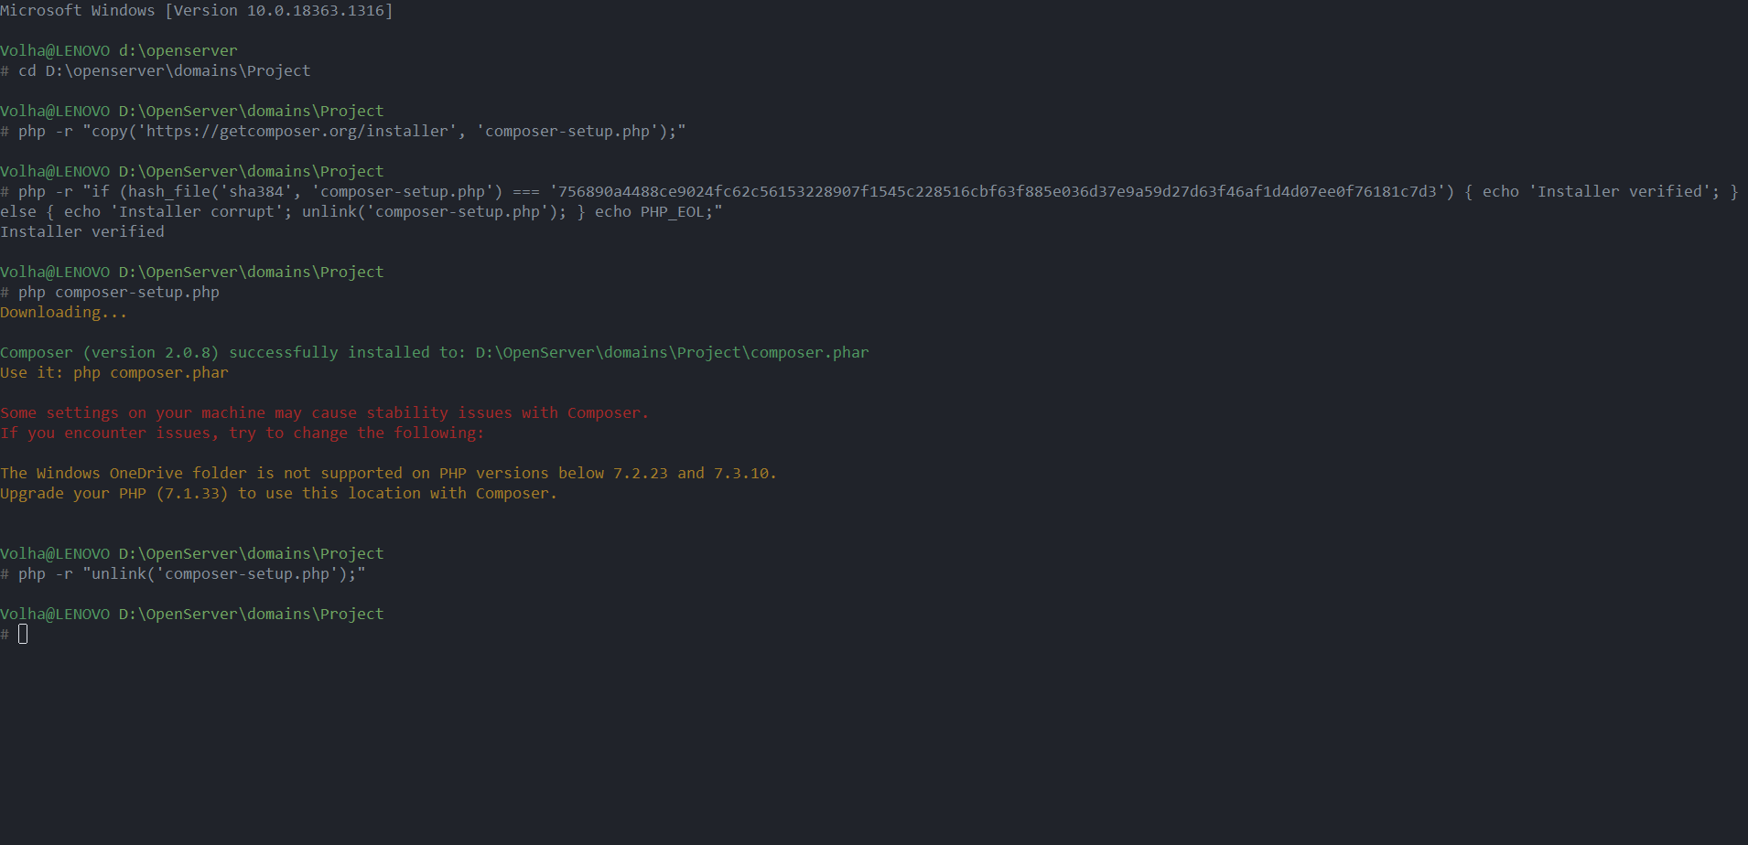

2.9 Write:

php composer.phar init

Welcome to composer config generator!

Package name : -> codeception/project*(name of your project)* -> Enter

Description: -> Enter

Author: -> n -> Enter

Minimum stability: -> Enter

Package Type: -> Enter

License: -> Enter

Would you like to define your dependencies: -> yes -> Enter

Search for a package: -> codeception/codeception -> Enter

Enter the version: -> Enter

Search for a package: -> Enter

Would you like to define…: -> Enter

Search for a package: -> Enter

Do you confirm generation?: -> yes -> Enter

Would you like to install dependencies now: -> yes -> Enter

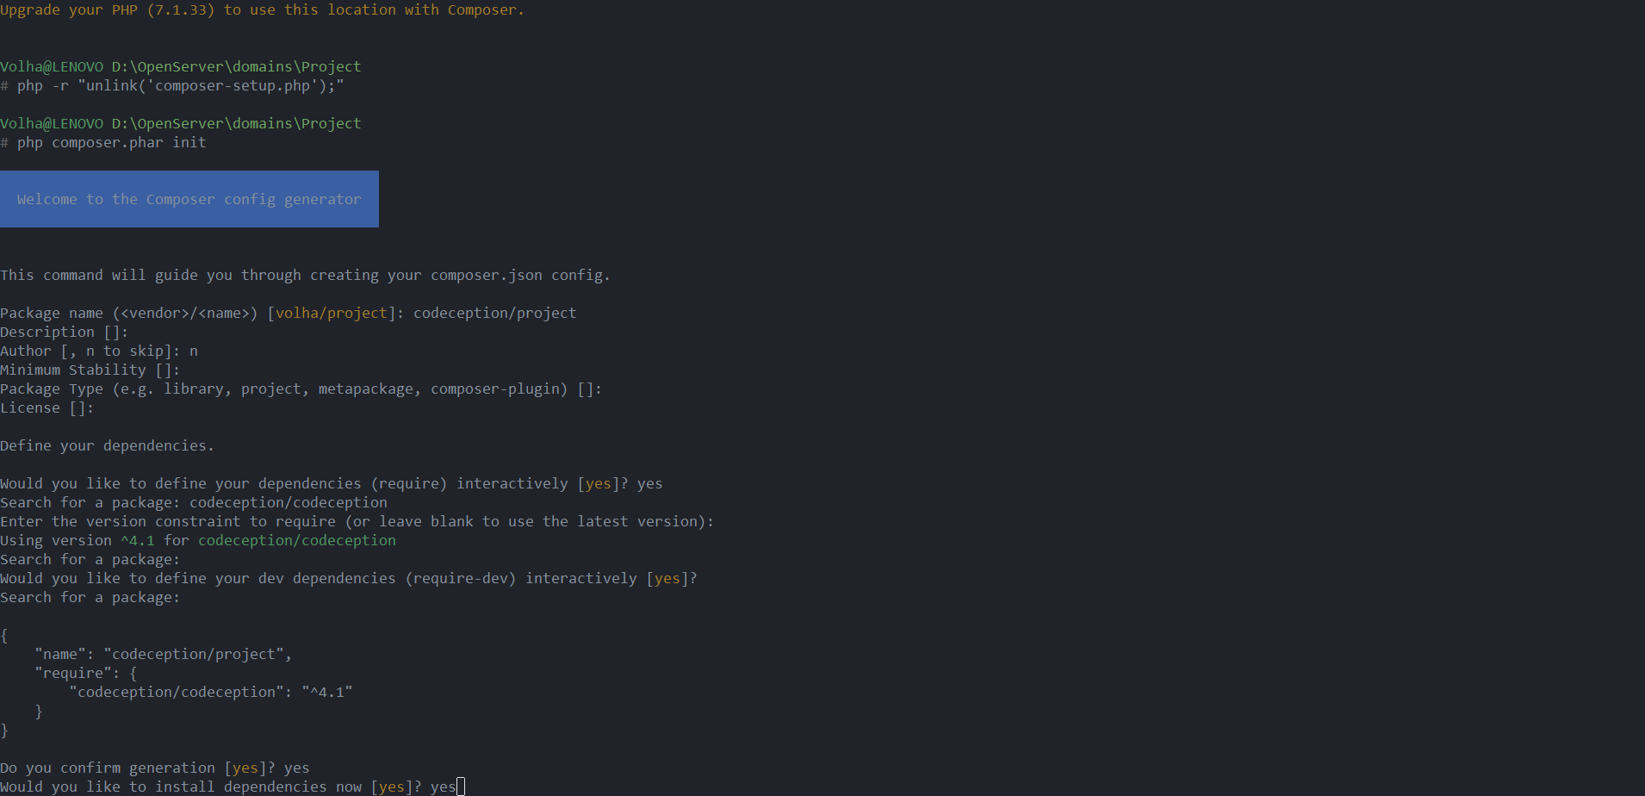

2.10 Write:

php composer.phar install

**3. Codeception**

3.1 Go to <https://codeception.com/>

3.2 Docs -> Install -> Download -> Click here

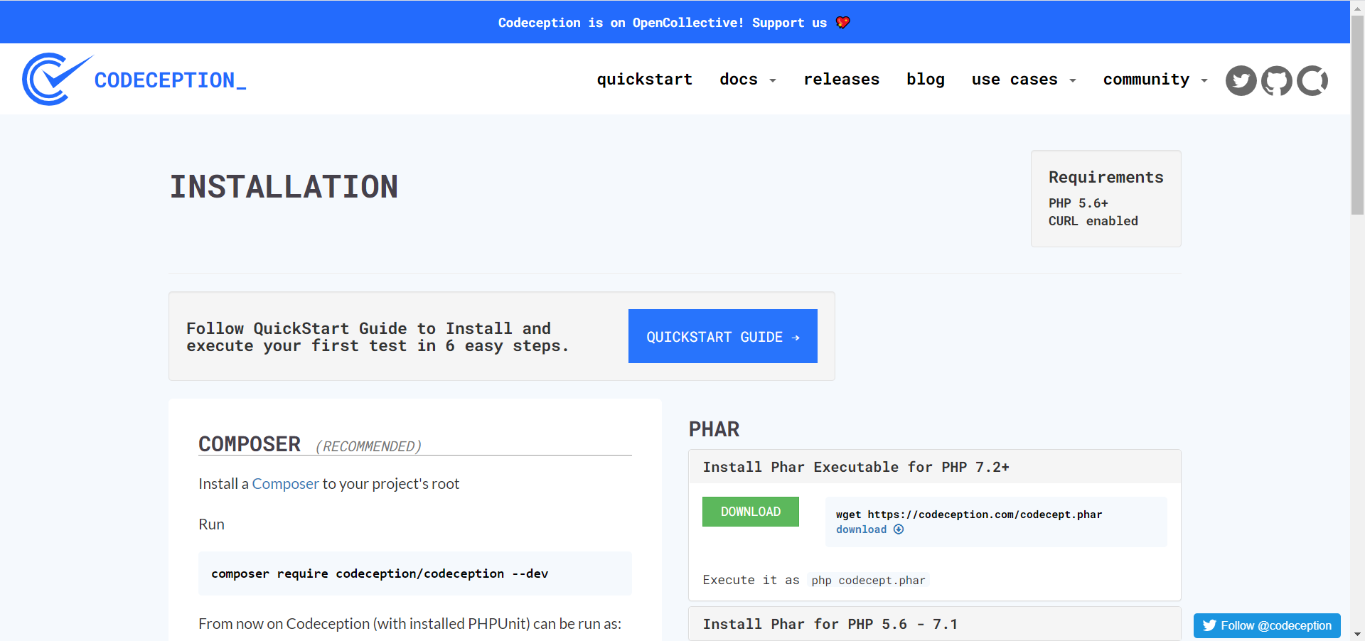

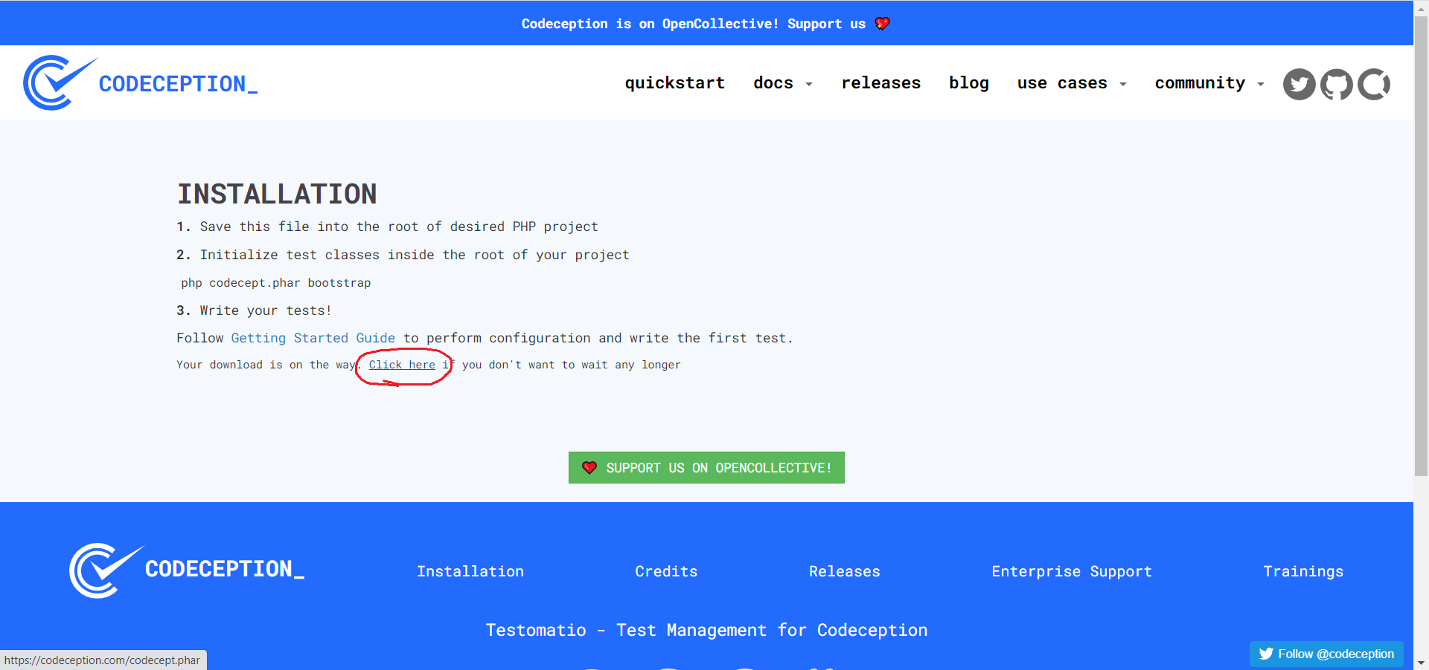

3.3 Save file in the folder of your project (d:\OpenServer\domains\Project)

3.4 In the openserver console write:

php codecept.phar bootstrap

3.5 Do you want to run “composer update”: -> y -> Enter

**4. Selenium and Chromedriver**

4.1 Go to <https://www.selenium.dev/downloads/> and download Selenium Server (Grid)

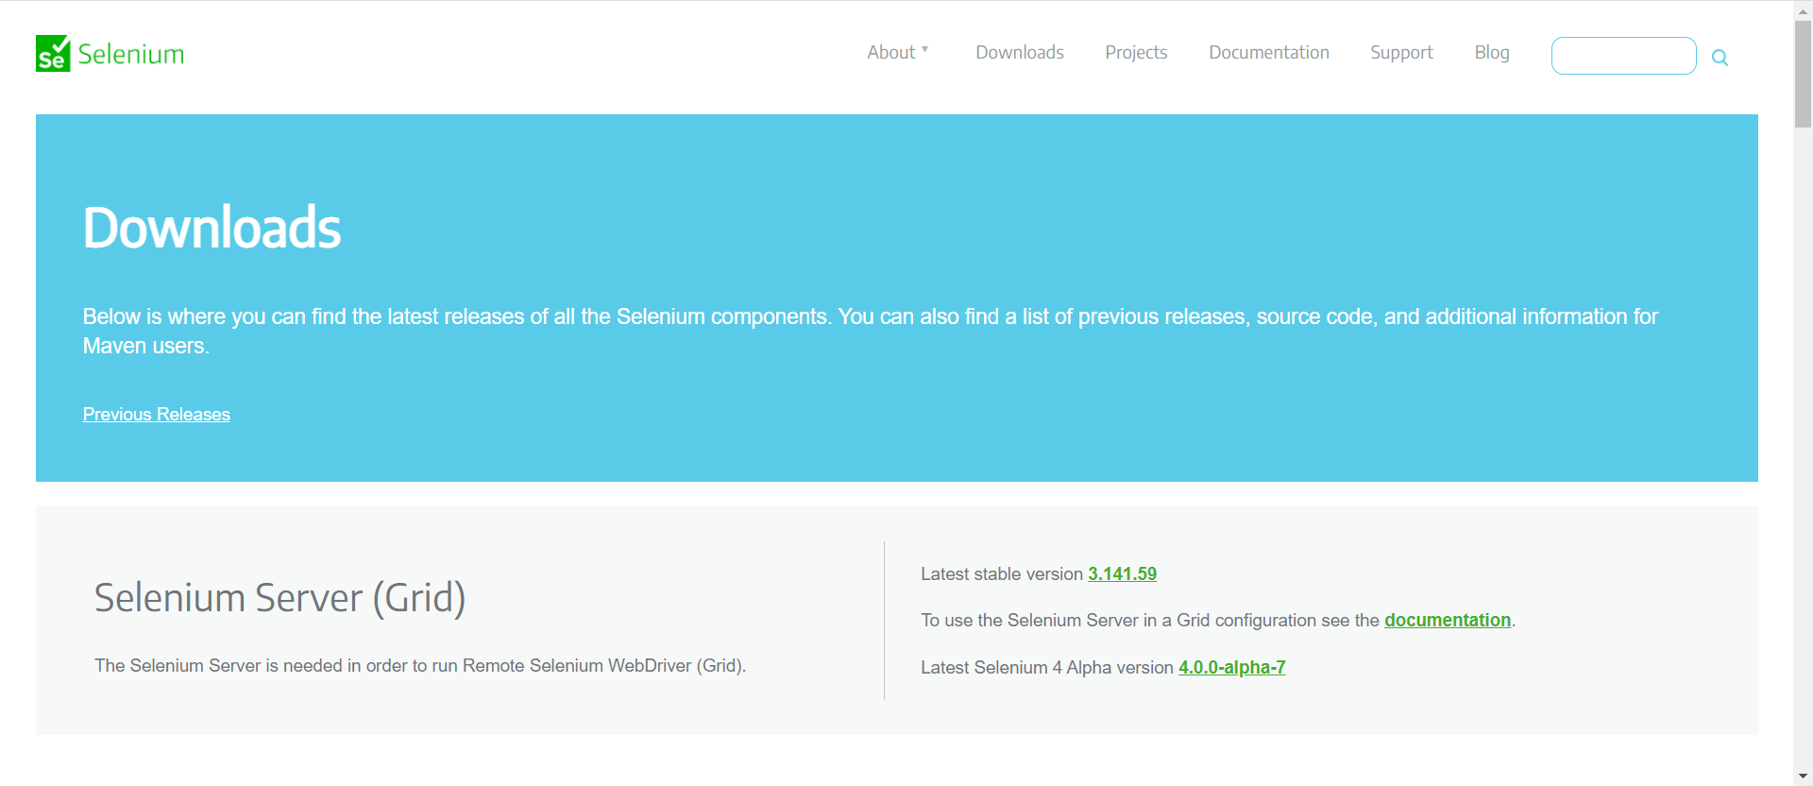

4.2 Save file to the folder of your project.

4.3 Download Chromedriver for your browser.

4.3 Save chromedriver to the folder of your project.

**5. How to run tests**

5.1 Save your file test1Cest.php in the folder D:\OpenServer\domains\Project\tests

5.2 Run OpenServer and open console.

5.3 Go to the folder of your project:

cd d:\OpenServer\domains\Project

5.4 Copy the name of selenium file and run it in console

5.5 Write:

chromedriver --url-base=/wd/hub

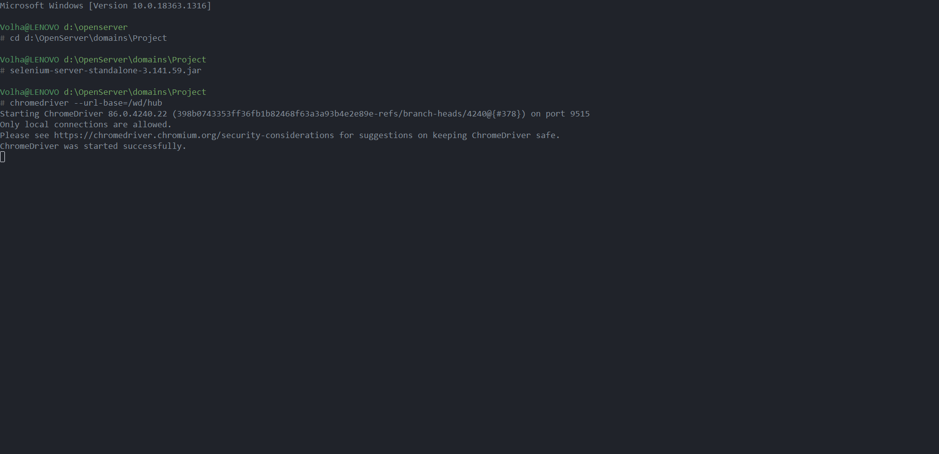

5.6 Open new tab in the console (click the green button).

5.7 Go to the folder of your project:

cd d:\OpenServer\domains\Project

5.8 Write:

vendor\bin\codecept run acceptance test1Cest.php –steps

5.9 If you want to run all tests, write:

vendor\bin\codecept run acceptance --steps