汪的修改（版本1）

spark-submit \
--class edu.ecnu.ShuffleExperiment \
--master local[4] \
--driver-memory 4G \
--conf spark.shuffle.manager=hash \
/home/djk/Documents/shuffle-experiment-sort/target/scala-2.10/spark-shuffle-experiment-1.0.0.jar hash

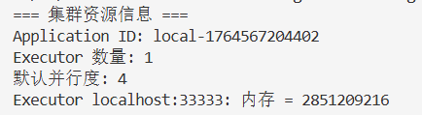
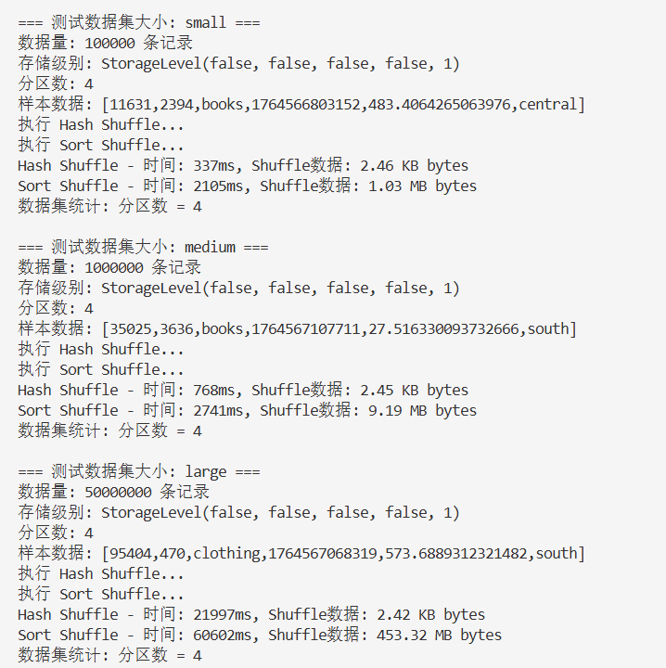

spark-submit \
--class edu.ecnu.ShuffleExperiment \
--master local[4] \
--driver-memory 4G \
--conf spark.shuffle.manager=sort \
/home/djk/Documents/shuffle-experiment-sort/target/scala-2.10/spark-shuffle-experiment-1.0.0.jar sort

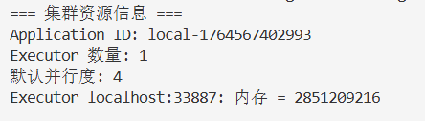
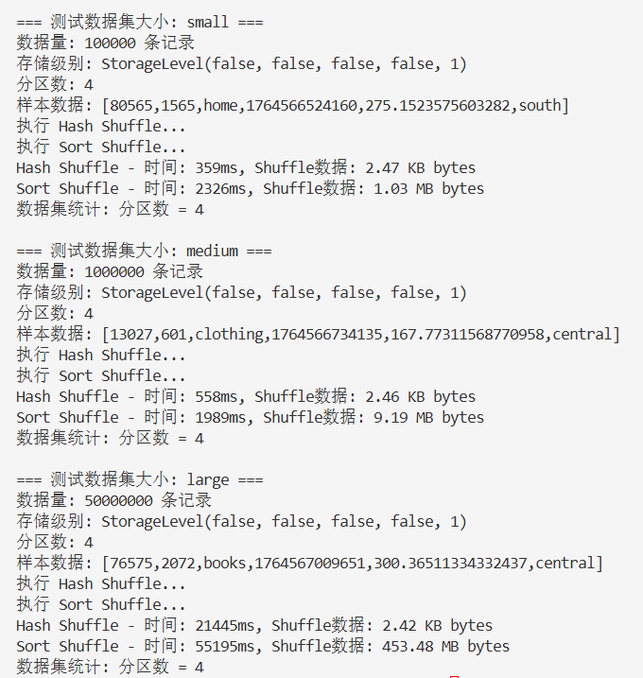

汪的修改（版本2）
运行 Hash Shuffle 实验 （本地）
spark-submit \
--class edu.ecnu.ShuffleExperiment \
--master local[4] \
--driver-memory 4G \
--conf spark.shuffle.manager=hash \
target/scala-2.10/spark-shuffle-experiment-1.0.0.jar hash
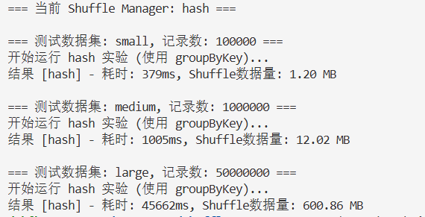
运行 Sort Shuffle 实验 （本地）
spark-submit \
--class edu.ecnu.ShuffleExperiment \
--master local[4] \
--driver-memory 4G \
--conf spark.shuffle.manager=sort \
target/scala-2.10/spark-shuffle-experiment-1.0.0.jar sort
