202 [2D]

Разработчик: Власов Андрей Юрьевич aka Volk Dabro
Год выпуска: 2015
Жанр: Платформер (Arcade)
Язык интерфейса: Русский | English
Системные требования: OC Android
Описание:

202 - is an interesting game in which you have to overcome obstacles. All of these obstacles, 202, and alas not everyone will be able to overcome them all. You are given an unlimited number of attempts, each of which you can improve your score. This game will be able to help you on tedious pairs or in long queues with interest to spend your time. Good luck to everyone, enjoy the game :)
Скриншоты:
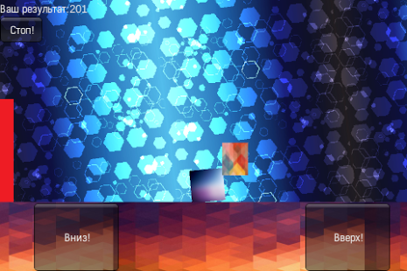
Данная игра была опубликована мной в 2015 году в GooglePlay (PlayMarket)
Ссылка: https://play.google.com/store/apps/details?id=com.VolkDabro.twootwo

